**CS 276: Week 2 Lab NAME: ___BLAKE BRYANT________**

1. Write an anonymous block that will do the following, with IF/THEN/ELSE constructs:
2. In the database you created this week with the scripts on Moodle you’ll find AGENT and HOUSE_SALE tables. Read in agent number row 201 and the sale price of the house, and calculate the commission which applies.
3. Based on the agent level (H = High, M = Mid-Level, L = Low)
4. Low = the commission is 5% of the sale price, and the bonus is $5,000
5. Mid-Level = the commission is 10% of the sale price, and the bonus is $10,000
6. High = the commission is 15% of the sale price, and the bonus is $25,000
7. Print out the House Sale Price, the Commission Amount, the Bonus Amount, and the Total Amount.
8. Paste a screen print of your code and results of execution here and don’t forget to upload your SQL file to the proper link on Moodle.

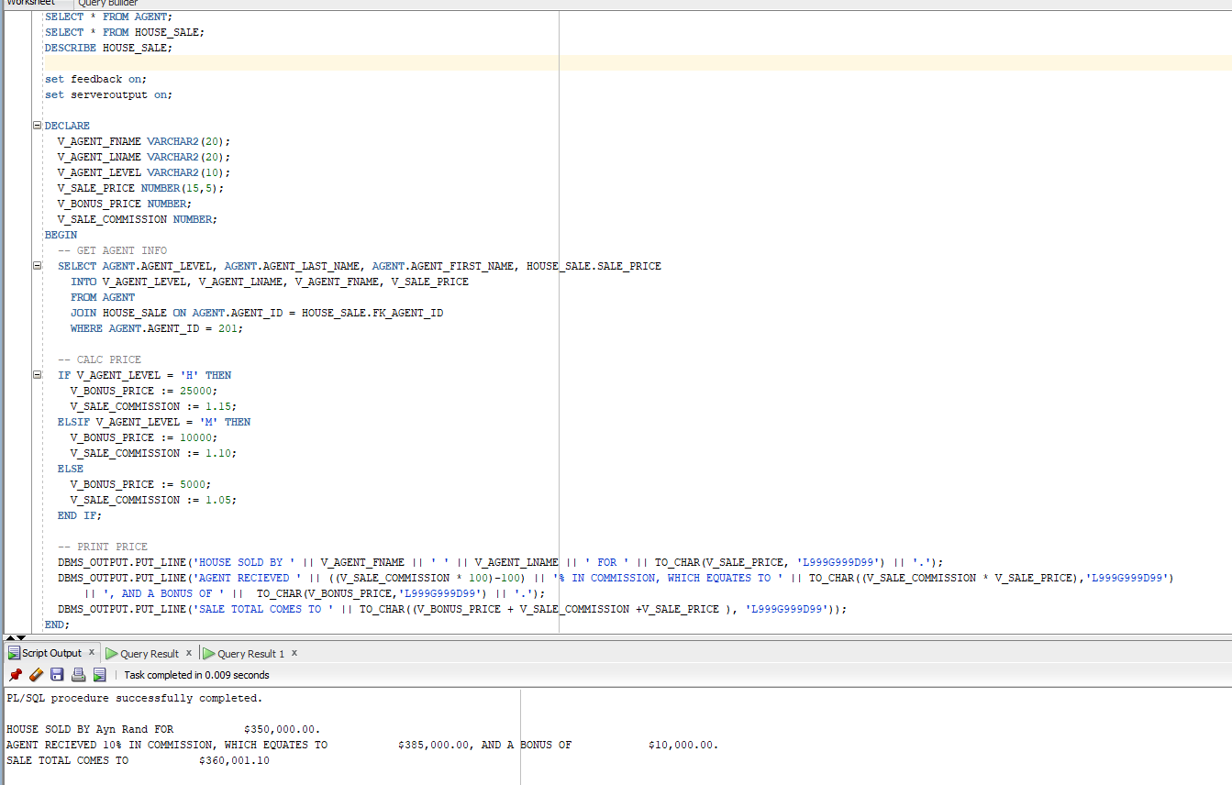

1. Now write the above using a CASE statement. Paste a screen print of your code and results of execution here and don’t forget to upload your SQL file to the proper link on Moodle.

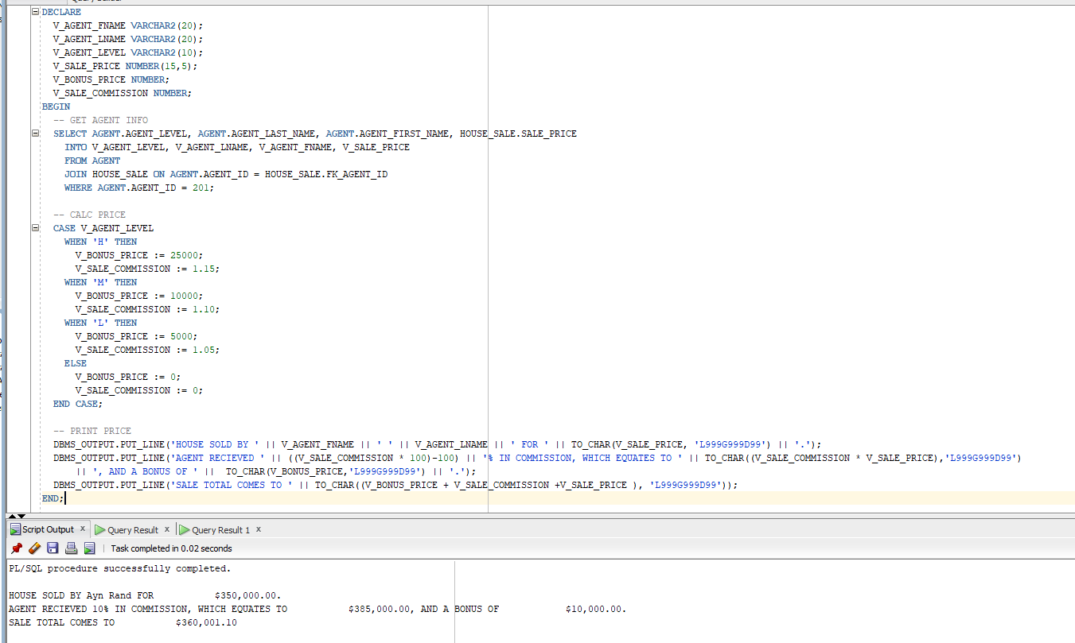

1. Write an anonymous block that will do the following, either with IF/THEN/ELSE constructs or with a CASE statement or searched CASE statement:
2. Read in the four different counts of freshmen (code F), sophomores (code S), juniors (code J), and seniors (code R) from the STUDENT table.
3. We have created a new class – “Advanced Basket Weaving” that has 20 seats available.
4. The first available seats in the class should go to seniors, then juniors, then sophomores, then freshmen.
5. If there are over 20 seniors, then print out “There are only seniors in the class”
6. Calculate the number of seats left based on the class level, and print out the following (as an example):

“There are 11 seniors in the class”

“There are 9 juniors in the class”

“There are 5 sophomores on the wait list”

“There are 3 freshmen on the wait list”

1. Paste a screen print of your code and results of execution here and don’t forget to upload your SQL file to the proper link on Moodle.

