**CS 276 Lab 3 on Looping Name: __Blake Bryant__________**

1. Write an anonymous block that will:
   1. Create a cursor (or a cursor loop, your choice) that will select the customer ID, order ID, last payment date and current balance from each record in the CHARGES table.
   2. Loop through the following for each record
      1. If the last payment date is < 30 days no late payments will apply
      2. If the last payment date is between 30 and 60 days a 10% late payment will apply
      3. If the last payment date is between 60 and 120 days a message should output saying “Customer ID” (customer number) “must go to collections”
      4. Close the cursor

Paste a screen shot of your code and the results of executing your code here:

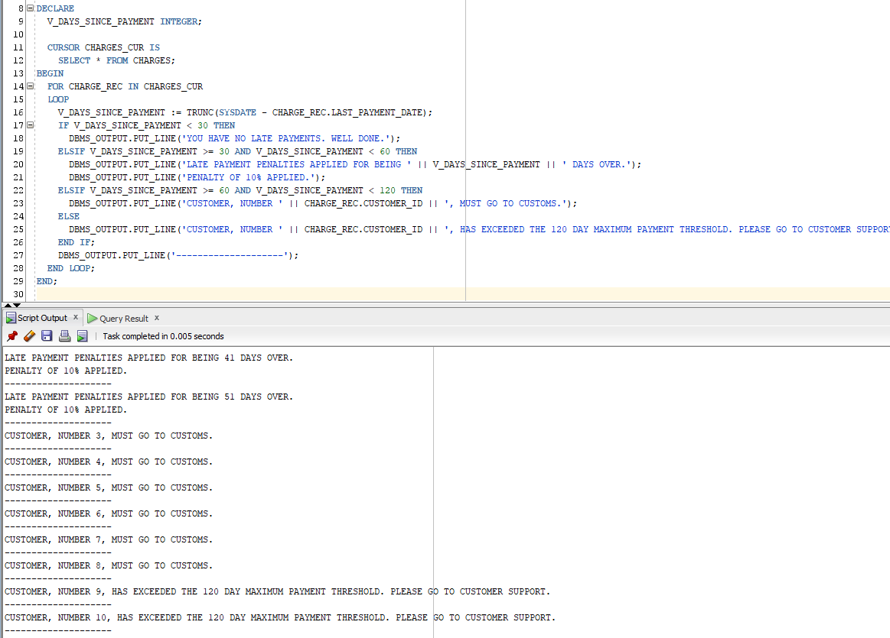

1. Is the cursor you created above an explicit or implicit cursor?

Write your answer in bold here.

**The code above utilizes an implicit cursor, essentially handling the opening, closing, and fetching of record data in the cursor. Therefore, the above code uses an implicit cursor.**

3) I have two tables: A STUDENT table, and an ENROLLMENT table (sound familiar?). I need to calculate each student’s GPA for **this term**.

The calculation for GPA (for this lab) is as follows:

If the grade is an A, the weight is 4 points.

If the grade is a B, the weight is 3 points.

If the grade is a C, the weight is 2 points.

If the grade is a D, the weight is 1 point.

An F receives 0 points.

The calculation for someone who received 2 A’s, 1 B, and 1 C would be as follows:

2 A’s = 8 points

1 B = 3 points

1 C = 2 points

The total GPA would then be 13/4 = 3.25

Write an anonymous block that will:

1. Read in the student’s information as well as their enrollment information through a cursor (or cursors)
2. Calculate the current term GPA into a scalar variable
3. Print out the following for each student:
4. Student First Name
5. Student Last Name
6. Current Term GPA

Paste a screen shot of your code and the results of executing your code here:

