**CS 276 Spring 2020**

Part 1: Create a Procedure

1. Start with your code from the first exercise in lab 2 where you’re checking for Low, Mid, and High using an if-elsif construct. Modify your code so that it become a procedure. Name your procedure agent_bonus. It should have an IN parameter of p_agent_id and four OUT parameters of p_sales_price, p_bonus, p_commission and p_total. That is rather than print these four values out in the procedure your procedure will return them to the calling block of code. (Note: the “p” in p_agent_id and other parameters stands for parameter.
2. Use an anonymous block to call your procedure passing 201 for the agent it. This means your WHERE clause in the SELECT INTO becomes WHERE agent_id = p_agent_id. Print out the four values being returned in the anonymous block. That is your output is done in the anonymous block as a test of your procedure, rather than outputting the values in the procedure itself.
3. Now change the agent id your passing to the procedure to 205 which is not a valid agent id and notice your result when you run your anonymous block code to call the procedure again. You should receive a no data found error.

Part 2: Adding Exception Handling

1. Add an Exception section to the agent_bonus procedure that outputs separate messages for the NO_DATA_FOUND system error and the TOO_MANY_ROWS system error. See <https://www.techonthenet.com/oracle/exceptions/named_system.php>
2. Add exception handling to the agent_bonus procedure that outputs a message in the Exception section when the agent level is something other than M, L or H. That is declare an exception, add an ELSE clause where you RAISE the exception.
3. Now test your procedure again by passing 205 for the agent id. Your code should have “handled” the NO_DATA_FOUND system error.
4. Now change the AGENT_LEVEL in the AGENT table for agent 201 to a value other than M, L, or H and run your anonymous block passing 201 for the agent. Your code should have “handled” your programmer-defined exception.
5. Paste screen shots here of your procedure and anonymous block code and of the output produced using 201 as the agent id where the agent level is valid, using 201 where the agent level is not valid, and 205 as the agent id. Note when you finished with this assignment be sure to change the agent level for agent 201 back to ‘M’ in the agent table.

**Part 1 Documentation:**

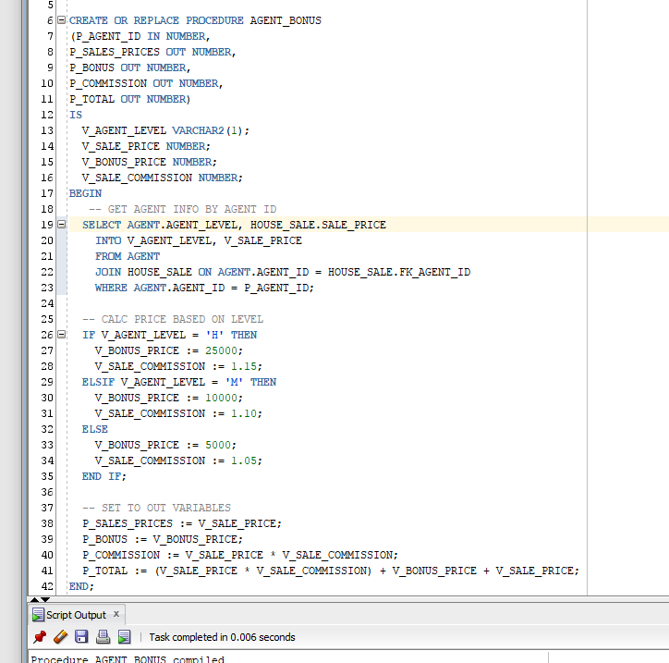

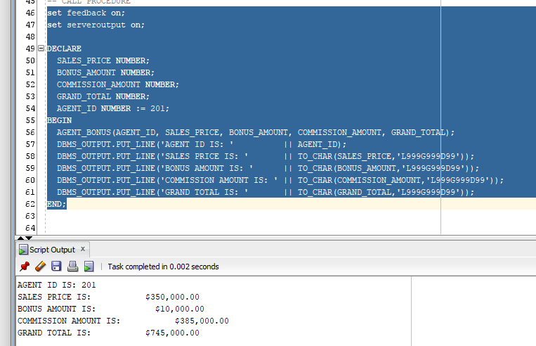

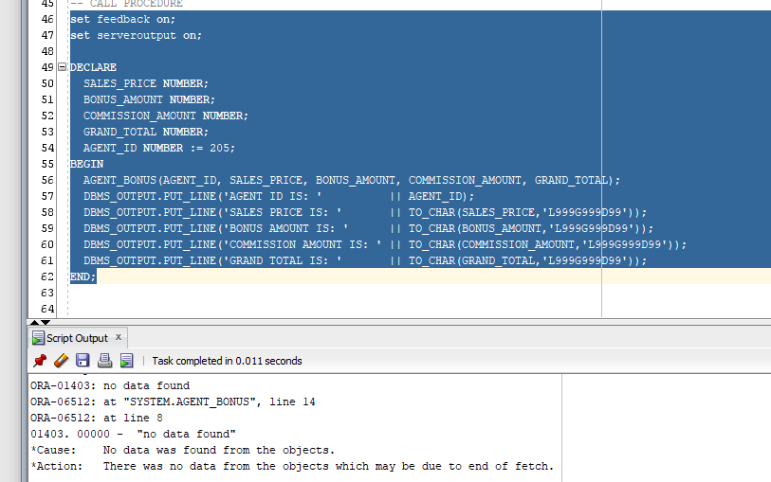

**Part 2 Documentation:**

