CS 276 Week 5 Assignment – Records

**PART 1:**

1. Declare a programmer defined record based on the following table:

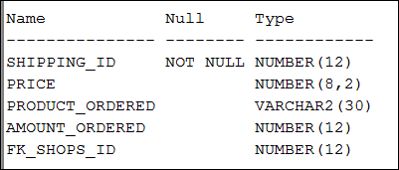

**Paste a screen shot of your code here:**

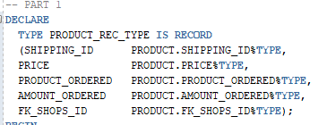

1. Why won’t the following code run?

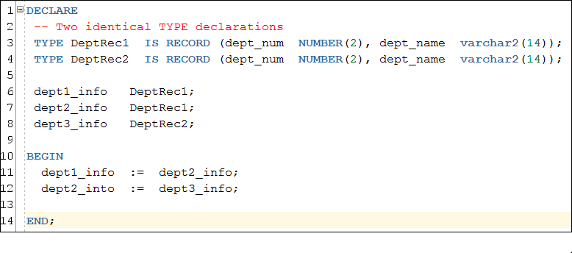 **Write your answer here:**

**Answer:** Since PL/SQL requires the declaration of data types when a variable is instantiated, it would stand to reason that the code above will throw an error because, despite having the same record structure, DeptRec2 and DeptRec1 are two DIFFERENT record types. Therefore, the assignment of a variable with type DeptRec1 to a variable with type DeptRec2 will result in PL/SQL throwing a type/assignment error.

**PART 2:**

**For this activity use the tables in the database when been using for the majority of the exercises in this course. Specifically you’ll use the TEACHER, DEPARTMENT and SECTION tables. Create a package that includes the following two procedures. The procedures should be accessible by modules outside the package.**

**First procedure: Given the teacher the procedure should return a record that includes all five fields that are in the TEACHER table. The procedure should handle an exception for an invalid department id. Assume that the only valid department ids are BUS, CSI, ENG and MTH. Just print a message to handle the exception.**

**Second procedure: Given the teacher record the procedure should return a count of the number of sections that teacher has taught and return the full department name the teacher works under. Use the DEPARTMENT table to get the department name (example: Computer Science for department id CSI).**

**Write an anonymous block that is not part of the package that tests your package by**

1. **Calling the first procedure to get the teacher record using the teacher_id of ‘L0234567’**
2. **Calling the second procedure and passing the teacher record just obtained**
3. **Prints the teacher information, including the full department name and the count of the sections taught.**

**Paste screen shots of your code and the results of your anonymous block executing here:**

