**CS 276: Lab 6 Name: Blake Bryant**

This exercise is intended to provide practice with collections, procedures and packages. Use the same database you used for the midterm exam. It is suggested you read the entire assignment before you begin.

1. Create a procedure that has an IN parameter of a pledge id and returns in an OUT parameter a collection that contains all the payments that have been made for that pledge id. You may use any of the three types of collections discussed in class this week. It is your choice. One approach is to use a cursor to get all the payments for that pledge id and use the cursor to place all the payments into the collection. This procedure should handle the exception of No Data Found for a pledge id that does not exist by outputting an appropriate message.

CREATE OR REPLACE PACKAGE PAYMENT_LAB_PCK IS

TYPE LIST_OF_PAYMENTS IS TABLE OF PAYMENT%ROWTYPE

INDEX BY PLS_INTEGER;

END PAYMENT_LAB_PCK;

CREATE OR REPLACE PROCEDURE CREATE_PAYMENT_COLLECTION

(PLEDGE_ID_ARG IN NUMBER,

PAYMENT_LIST OUT PAYMENT_LAB_PCK.LIST_OF_PAYMENTS)

IS

-- GET PAYMENT DATA

CURSOR PAYMENT_CUR IS

SELECT *

FROM PAYMENT

WHERE PAYMENT.IDPLEDGE = PLEDGE_ID_ARG;

-- SETUP ROW INDEX

ROW_INDEX PLS_INTEGER := 0;

BEGIN

-- FILL ARRAY

FOR PAYMENT_REC IN PAYMENT_CUR

LOOP

-- PUT RECORD DATA INTO ARRAY

PAYMENT_LIST (ROW_INDEX) := PAYMENT_REC;

-- INCREMENT INDEX

ROW_INDEX := ROW_INDEX + 1;

END LOOP;

EXCEPTION

WHEN NO_DATA_FOUND THEN

DBMS_OUTPUT.PUT_LINE('A NO DATA ERROR HAS OCCURED IN THE AGENT BONUS. MOST LIKELY BECAUSE PLEDGE ID DOES NOT EXIST IN DATABASE.');

END;

-- TEST PAYMENT COLLECTION

SELECT * FROM PAYMENT WHERE IDPLEDGE = 109;

DESCRIBE PAYMENT;

DECLARE

-- PAYMENT COLLECTION

PAYMENT_LIST PAYMENT_LAB_PCK.LIST_OF_PAYMENTS;

BEGIN

-- GET PAYMENT DATA

CREATE_PAYMENT_COLLECTION(109, PAYMENT_LIST);

-- PRINT ARRAY

FOR INDX IN PAYMENT_LIST.FIRST .. PAYMENT_LIST.LAST

LOOP

DBMS_OUTPUT.PUT_LINE('------------------------------------------');

DBMS_OUTPUT.PUT_LINE('Payment ID is: ' || PAYMENT_LIST(INDX).IDPAY);

DBMS_OUTPUT.PUT_LINE('Payment amount is: ' || PAYMENT_LIST(INDX).PAYAMT);

DBMS_OUTPUT.PUT_LINE('Payment date is: ' || PAYMENT_LIST(INDX).PAYDATE);

DBMS_OUTPUT.PUT_LINE('Payment method is: ' || PAYMENT_LIST(INDX).PAYMETHOD);

END LOOP;

END;

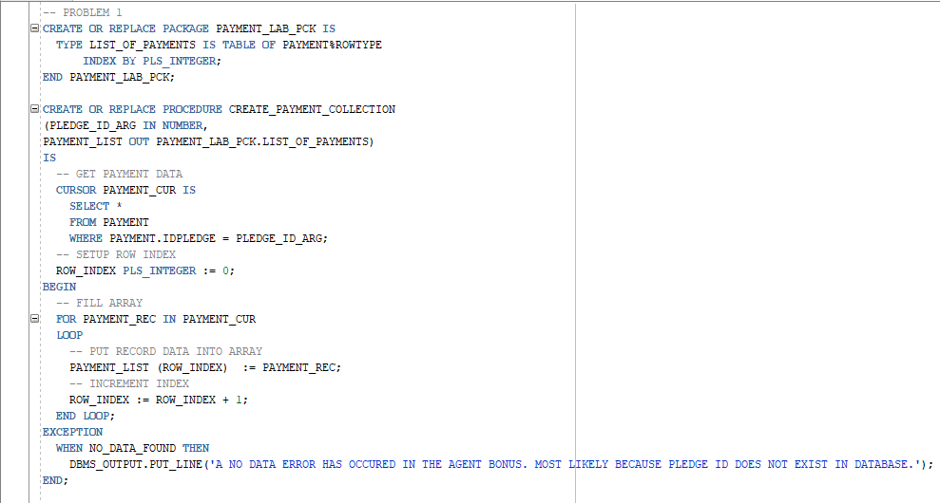

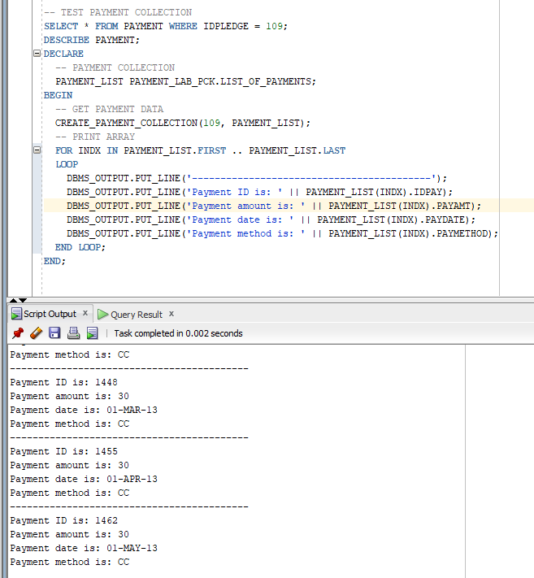

1. Create a second procedure that has an IN parameter of the pledge id and returns in an OUT parameter the sum of all the payments for that pledge id and returns in another OUT parameter the average of all the payments for that pledge id. This procedure must call the first procedure using the pledge id it was given. It should use the collection it gets back from the first procedure to calculate the sum and the average of the payments.

-- PROBLEM 2

CREATE OR REPLACE PROCEDURE AVERAGE_PAYMENTS

(PLEDGE_ID_ARG IN NUMBER,

PAYMENT_AMT_SUM OUT NUMBER,

PAYMENT_AMT_AVERAGE OUT NUMBER)

IS

-- PAYMENT COLLECTION

PAYMENT_LIST PAYMENT_LAB_PCK.LIST_OF_PAYMENTS;

PAYMENT_SUM_COUNTER NUMBER := 0;

BEGIN

-- GET PAYMENT DATA

CREATE_PAYMENT_COLLECTION(109, PAYMENT_LIST);

-- CALCULATE SUM AND AVERAGE

FOR INDX IN PAYMENT_LIST.FIRST .. PAYMENT_LIST.LAST

LOOP

PAYMENT_SUM_COUNTER := PAYMENT_LIST(INDX).PAYAMT + PAYMENT_SUM_COUNTER;

END LOOP;

PAYMENT_AMT_SUM := PAYMENT_SUM_COUNTER;

PAYMENT_AMT_AVERAGE := (PAYMENT_SUM_COUNTER / PAYMENT_LIST.COUNT);

END;

-- TEST PROBLEM 2

DECLARE

PLEDGE_ID NUMBER := 109;

PAYMENT_SUM NUMBER;

PAYMENT_AVERAGE NUMBER;

BEGIN

-- CALCULATE PAYMENT DATA

AVERAGE_PAYMENTS(PLEDGE_ID, PAYMENT_SUM, PAYMENT_AVERAGE);

-- PRINT OUTPUT

DBMS_OUTPUT.PUT_LINE('Pledge id is: ' || PLEDGE_ID);

DBMS_OUTPUT.PUT_LINE('Pledge sum is: ' || PAYMENT_SUM);

DBMS_OUTPUT.PUT_LINE('Pledge average is: ' || PAYMENT_AVERAGE);

END;

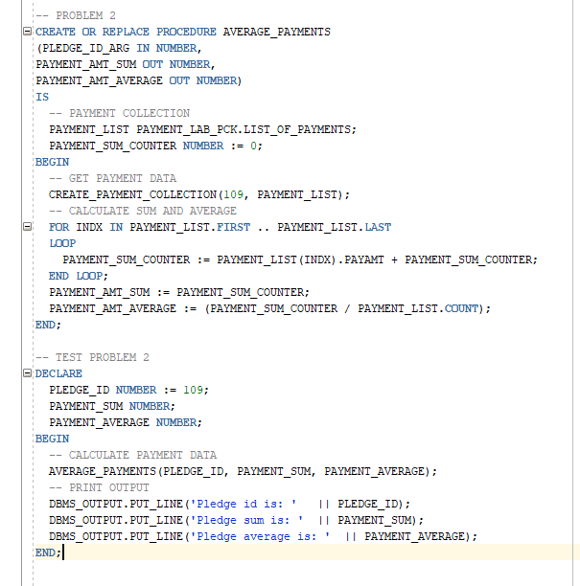

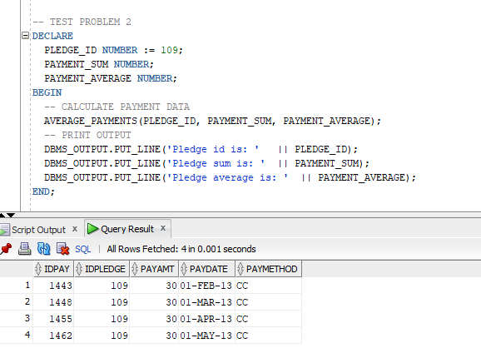

1. Create an anonymous block that calls the second procedure passing a pledge id of 107. Your anonymous block should output the pledge id, the donor first name and last name that made that pledge, the total of the payments, and the average of the payments.

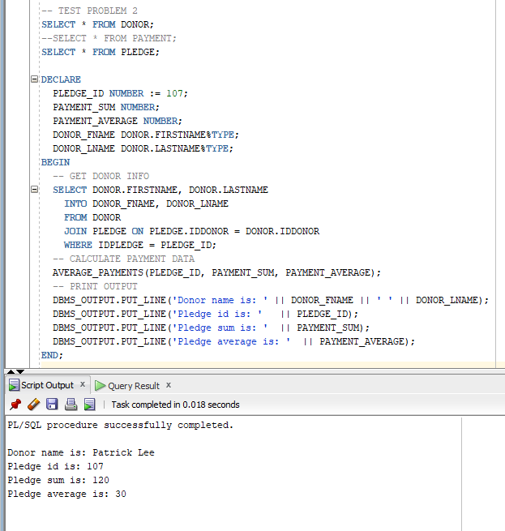

1. Place the two procedures in a package where they are both able to be called from modules outside the package. Place the anonymous block outside the package.

**See screenshots below**

1. Paste below screen shots of all your code in the entire package and the anonymous block, and paste a screen shot of the results of running your anonymous block with a pledge id of 107.

