**CS 276 – Lab 7 Name: Blake Bryant**

1. Download the Week8.sql for lab 7 from the Moodle shell and execute it.
2. Write a function that will return the state of the Purchaser, when given the purchaser_id. None of the modules your write in this lab need to be within a package.

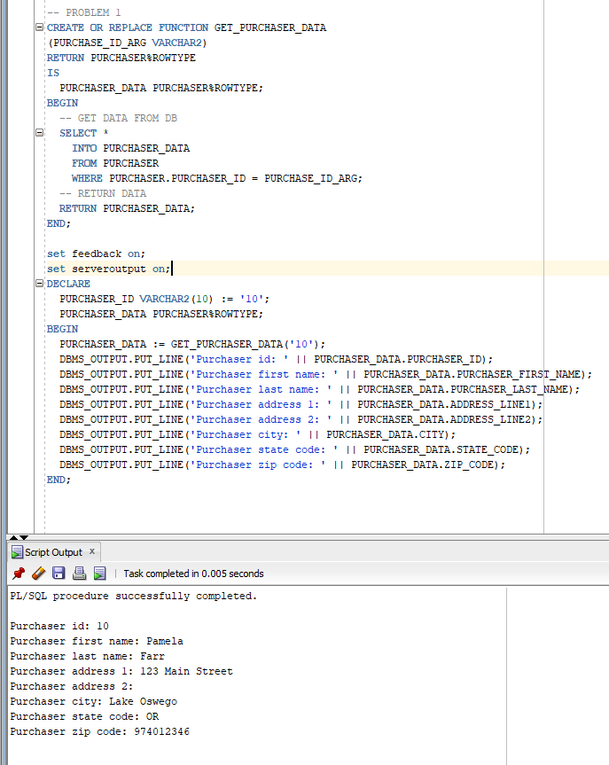

1. Write a function that will return the tax rate when given the state code.

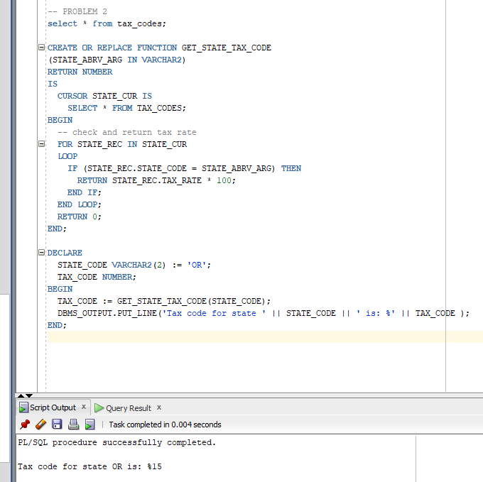

1. Write a function that will return the total cost to the purchaser given the purchaser_id, product_id and quantity purchased. The total cost should be calculated as

Total cost = product price * quantity * (1 + tax rate)

This function should use the previous two functions to determine the tax rate.

1. Write a function that given a product_id returns the product name.
2. Write a stored procedure that given the purchaser_id, product_id and quantity purchased will do the following:
   1. Updates the product amount in the product table by subtracting the quantity purchased from the previous product amount and storing the updated product amount in the product table
   2. Uses the two functions above to get the total cost and the product name.
   3. Prints out the purchaser_id, their first name and last name, the product name, quantity purchased and the total cost of the purchase
3. Testing and submitting your code:
4. Use a select statement to show the current product amount for all products.

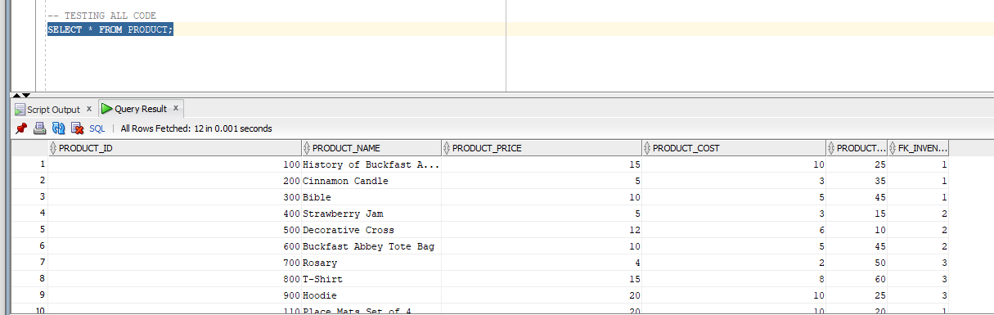

1. Test your code by calling the procedure with purchaser_id of 30, product_id of 400, quantity purchased of 4.

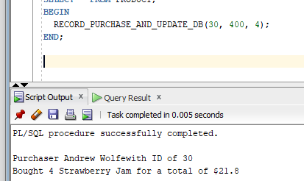

1. Use a select statement to show product amount in the product table was reduced by the quantity purchased.

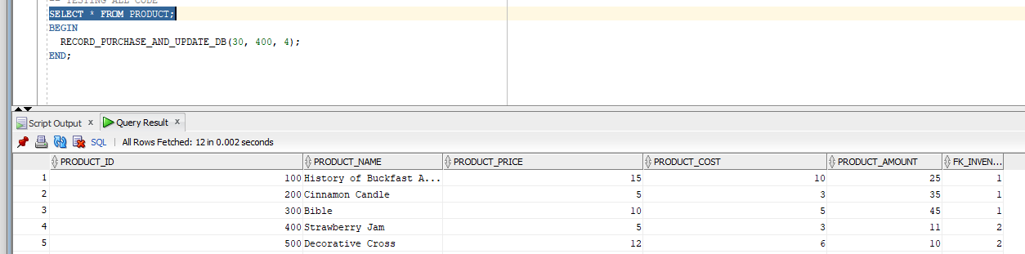

1. Paste screen shots below of the results of 7a, b and c. Also provide screen shots of the code in your 4 functions and 1 procedure.

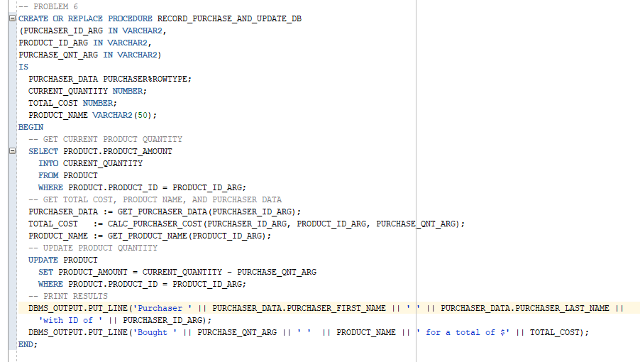

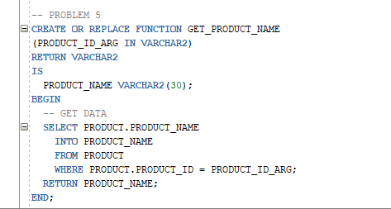

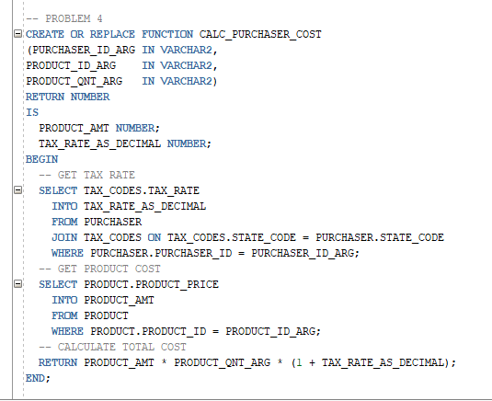

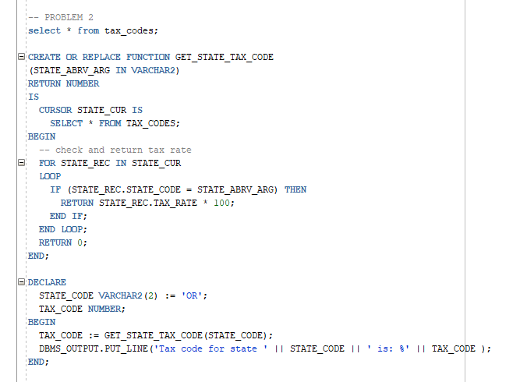

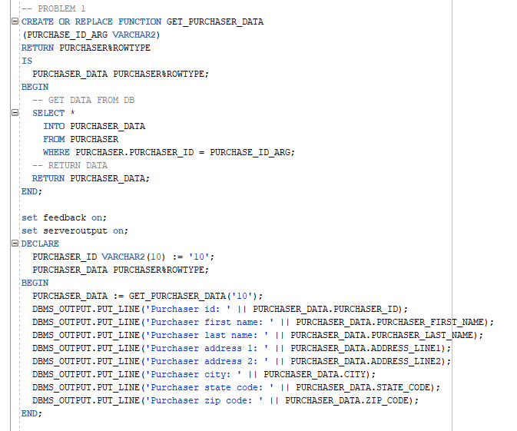

1. Upload this file to the appropriate link in Moodle.