Increasing returns to agricultural intensification at Angkor, Cambodia
Sarah Klassen^{1*}, Scott G. Ortman², José Lobo³, and Damian Evans⁴

Author Information

¹Department of Anthropology, University of British Columbia and Archaeological Sciences, Leiden University
²Department of Anthropology and Institute of Behavioral Science, University of Colorado Boulder; Santa Fe Institute
³School of Sustainability, Arizona State University
⁴École française d'Extrême-Orient, 22 Avenue du Président Wilson, 75116 Paris, France
Contributions
SK, SO, and JL contributed to the planning of this research; SK, SO, and JL drafted the manuscript; SK, SO, JL and DE edited the manuscript, SK, SO, and JL contributed to the analysis; SK and SO compiled the data; SK contributed data; SK and SO designed the figures. All authors discussed the results and commented on the manuscript.
Corresponding author
Sarah Klassen (https://orcid.org/0000-0001-5110-713X)
Supplementary Information

Ethnographic evidence for increasing returns from irrigated rice production: Figure S1 presents ethnographic data collected from communidades in the Indian state of Goa, ca. 1965 (1). The population measure is the number of tenants who worked the rice paddies in a community, the area measure is the hectares of rice paddy in production in that community, and the output measure is the khandi (1 khandi = 266 pounds) of rice produced by that group per year. The two data series show that communidades with more tenants produced greater output per person, even as they cultivated fewer hectares per person. These data provide more direct documentary evidence that community-scale organization in agricultural production can generate increasing returns to labor and are generally consistent with the archaeological results from Angkor discussed in the main text.

Figure S1: Relationships between farming labor, land, and outputs in communidade rice paddies in Goa, India, ca. 1965. Data are from Axelrod and Fuerch 2006: Table 2.

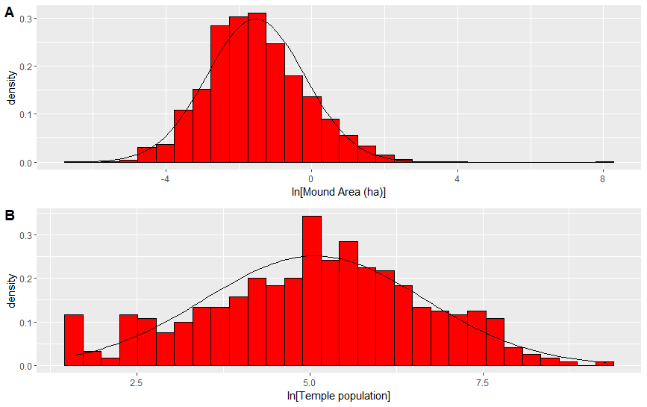
Figure S2: Distribution of occupation mound areas and resulting temple community populations across the agricultural hinterland of Angkor: A, mound areas; B, population estimates during Period 6, based on the amorphous settlement model, and after taking purchasing into account. Note that both distributions exhibit reasonable fits to log-normal distributions. The lower tail of mound areas is somewhat compressed, most likely due to biased destruction of smaller mounds; and jaggedness in the lower tail of temple community populations is due to the use of a minimal residential population for very small mounds. Based on this analysis, the mean population of temple communities is 471, and the largest temple community population is 10,780.

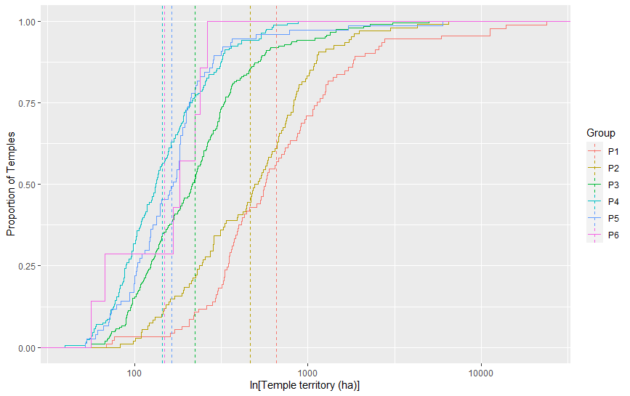

Figure S3. Cumulative distributions of new temple territories, by dedication period. Dashed lines represent the mean temple territory for each period.
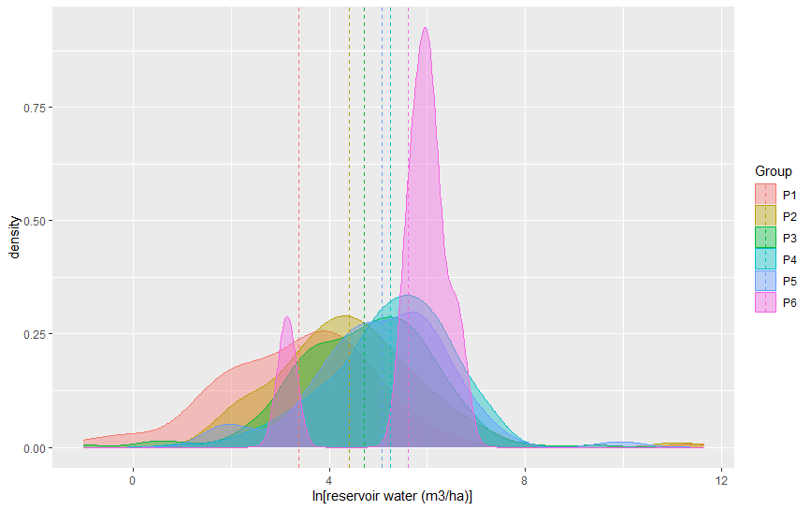

Figure S4. Density plots for reservoir water (m³ per hectare of land), by construction period of the associated temple, assuming reservoirs were built at the same time as agricultural temples. Dashed lines represent group means.

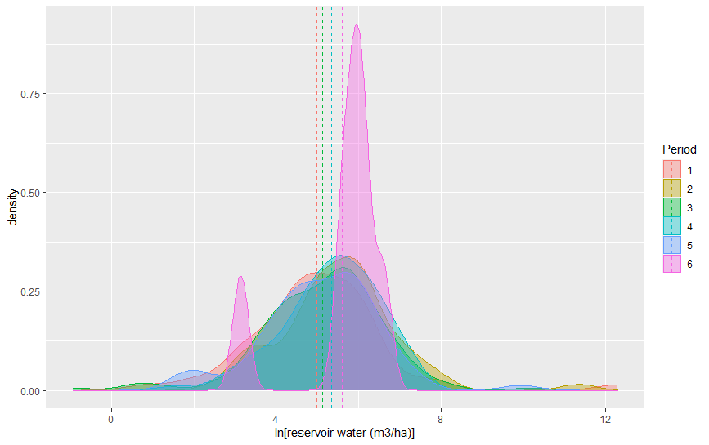

Figure S5. Density plots for reservoir water (m³ per hectare of land), by construction period of the associated temple, assuming preserved reservoirs reflect conditions on the landscape during the final period. Dashed lines represent group means.

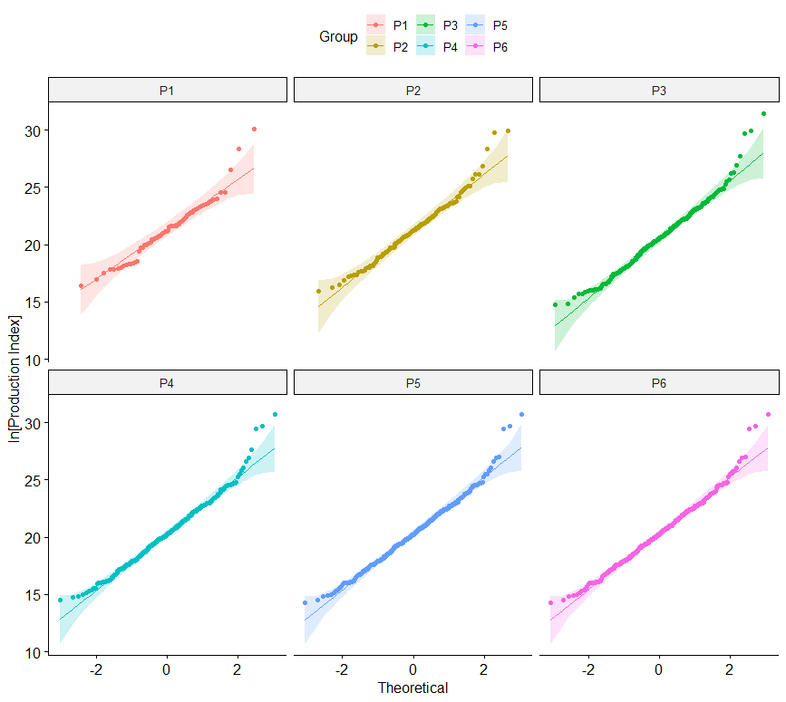

Fig. S6. QQ plots of temple community production indices, by period.

Table S1. Depth Regressions for features in the Angkor Metropolitan Area.

 | Total | R² | Regression equation | Total features within the Greater Angkor region
Reservoir | 6161 | 0.027 | y = -0.0873 + 0.263*ln(x) | 9,876
Reservoir embankment | 509 | 0.325 | y = 0.377 + 0.199(x) | 2,817
Moats | 224 | 0.3459 | y = -2.43 + 0.578*ln(x) | 922
Temples | 150 | 0.043 | y = 1.43 + 0.0000685(x) | 1009*
*Of these, 921 temples are in the Greater Angkor region and have predicted dates.

Table S2: Features in the civic-ceremonial zone and the Angkor Metropolitan Area.
 | AMA | Civic-ceremonial zone
Reservoirs  Total Count  Total Volume | 4,625  16.16 km³ | 5,253  0.28 km³
Moats  Total Count  Total Volume | 789  0.02 km³ | 133  0.004 km³
Temples  Total Count  Total Area | 749  2.09 km² | 262  0.89 km²

Table S3: Reservoirs and moats that were grouped with temples in the Angkor Metropolitan Area.
 | Temple | No temple
Reservoirs  Total Count  Total Volume / Area | 2163  16.0 km² | 2462  0.16 km²
Moats  Total Count  Total Volume / Area* | 687  0.0055 km² | 102  0.0144km²
References

1. Axelrod P & Fuerch M (2006) Common Ground: Risk, Scarcity, and Shared Resources in Goan Agriculture. Human Ecology 34(1):79-98.

