Week 6 - AYU - Pod

Table of Contents



## 1. Classification Tree

library(CASdatasets)  
library(tidyverse)  
library(caret)  
data(credit)  
df <- credit  
df <- df %>% rename(target=class)  
  
df <- df %>%   
 mutate(target = as.factor(target))  
  
  
library(caret)  
set.seed(2020)  
splitIndex <- createDataPartition(df$target, p = .70,   
 list = FALSE)  
df_train <- df[ splitIndex,]  
df_test <- df[-splitIndex,]  
  
library(rpart) #load the rpart package  
# Create a tree  
tree_model <- rpart(target ~ ., data = df_train,  
 control = rpart.control(maxdepth = 3))  
library(rattle)  
fancyRpartPlot(tree_model)

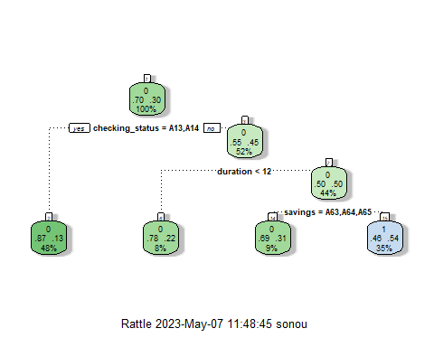

tree_model$variable.importance

## checking_status savings duration credit_history purpose   
## 36.549990 11.805346 7.251034 5.127909 4.255073   
## age credit_amount   
## 3.559540 3.454994

barplot(tree_model$variable.importance)

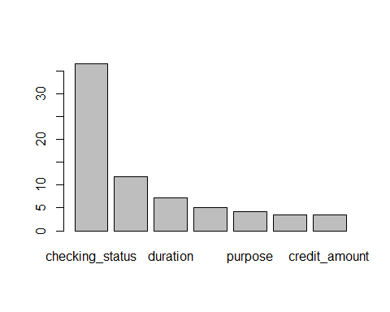

pred <- predict(tree_model, df_test, type = "class")  
#Evaluate the predictions  
cm <- confusionMatrix(data = pred, reference = df_test$target, positive = "1")  
cm$overall[1]

## Accuracy   
## 0.71

Question: We will work with the [Actuarial Loss dataset](actuarual_loss.csv). The data dictionary is as follows.

ClaimNumber: Unique policy identifier DateTimeOfAccident: Date and time of accident DateReported: Date that accident was reported Age: Age of worker Gender: Gender of worker MaritalStatus: Martial status of worker. (M)arried, (S)ingle, (U)nknown. DependentChildren: The number of dependent children DependentsOther: The number of dependants excluding children WeeklyWages: Total weekly wage PartTimeFullTime: Binary (P) or (F) HoursWorkedPerWeek: Total hours worked per week DaysWorkedPerWeek: Number of days worked per week ClaimDescription: Free text description of the claim InitialIncurredClaimCost: Initial estimate by the insurer of the claim cost UltimateIncurredClaimCost: Total claims payments by the insurance company. This is the field you are asked to predict in the test set. Claim_Cost_Category: 1 for claim cost higher than the median cost and 0 otherwise.

* Partition the data into 70% training and 30% testing.
* Create a decision tree with maximum depth of 5 on the training data to predict the claim cost category (i.e., claim_cost_category is your target variable).
* Plot the decision tree
* Calculate the accuracy of the decision tree on the test data.
* Plot the bar chart of the variable importance according to the tree.

## 2. Random Forest for classification

Question: Continue work with the same Actuarial Loss dataset

* Train a random forest of 1000 trees and mtry=5 to predict claim cost category on the training data.
* Calculate the accuracy of the forest on the testing data.

## 3. Regression Tree

library(tidyverse)  
library(caret)  
df <- read_csv('german_credit.csv')  
df <- df %>% rename(target=credit_amount)  
  
library(caret)  
set.seed(2020)  
splitIndex <- createDataPartition(df$target, p = .70,   
 list = FALSE)  
df_train <- df[ splitIndex,]  
df_test <- df[-splitIndex,]  
  
library(rpart) #load the rpart package  
# Create a tree  
tree_model <- rpart(target ~ ., data = df_train,  
 control = rpart.control(maxdepth = 3))  
library(rattle)  
fancyRpartPlot(tree_model)

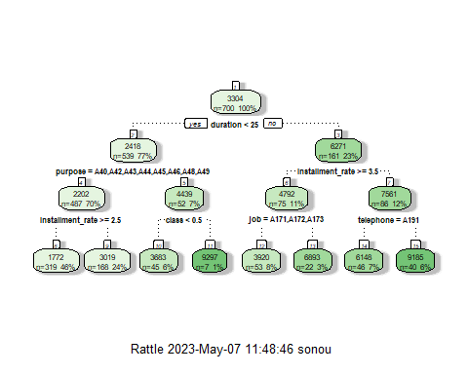

tree_model$variable.importance

## duration installment_rate purpose job   
## 1903362509 478063388 342539050 210511875   
## telephone class age employment   
## 197319823 190914218 104201587 80132056   
## property_magnitude residence_since credit_history other_payment_plans   
## 59195947 36839309 16373026 12488806   
## personal_status   
## 6244403

barplot(tree_model$variable.importance)

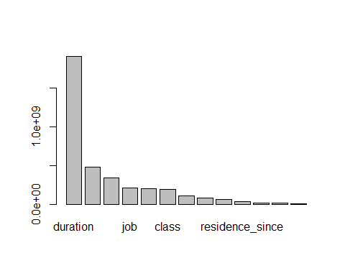

pred1 <- predict(tree_model, df_test)  
#Evaluate the predictions  
postResample(pred = pred1, obs = df_test$target)

## RMSE Rsquared MAE   
## 2252.9604437 0.3400649 1477.7516971

* Create a decision tree with maximum depth of 3 on the training data to predict the ultimate claim cost(i.e., UltimateIncurredClaimCost is your target variable).
* Plot the decision tree
* Calculate the RMSE, Rsquared and MAE of the decision tree on the test data.
* Plot the bar chart of the variable importance according to the tree.

## 4. Random Forest for Regression

library(ranger)  
forest_model <- ranger(target ~ ., data=df_train, importance='impurity', mtry=3, num.trees = 500,)  
pred2 <- predict(forest_model, df_test)  
#Evaluate the predictions  
postResample(pred = pred2$predictions, obs = df_test$target)

## RMSE Rsquared MAE   
## 1933.4688282 0.5334729 1340.4880132

Question: Continue work with the same Actuarial Loss dataset

* Train a random forest of 1000 trees and mtry=5 to predict the ultimate claim cost on the training data.
* Calculate the RMSE, Rsquared and MAE of the decision tree on the test data.