Week 5 - AYU - Individual

**Problem 1** (Sample - Question 9)

A classification tree is being constructed to predict if an insurance policy will lapse. A random sample of 100 policies contains 30 that lapsed. You are considering two splits:

* Split 1: One node has 20 observations with 12 lapses and one node has 80 observations with 18 lapses.
* Split 2: One node has 10 observations with 8 lapses and one node has 90 observations with 22 lapses.

The total Gini index after a split is the weighted average of the Gini index at each node, with the weights proportional to the number of observations in each node.

The total entropy after a split is the weighted average of the entropy at each node, with the weights proportional to the number of observations in each node.

Determine which of the following statements is/are true?

I. Split 1 is preferred based on the total Gini index. II. Split 1 is preferred based on the total entropy. III. Split 1 is preferred based on having fewer classification errors.

1. I only
2. II only
3. III only
4. I, II, and III
5. The correct answer is not given by (A), (B), (C), or (D)

**Problem** (Sample - Question 10)

Determine which of the following statements about random forests is/are true?

I. If the number of predictors used at each split is equal to the total number of available predictors, the result is the same as using bagging.

1. When building a specific tree, the same subset of predictor variables is used at each split.
2. Random forests are an improvement over bagging because the trees are decorrelated.
3. None
4. I and II only
5. I and III only
6. II and III only
7. The correct answer is not given by (A), (B), (C), or (D).

**Problem** (Sample - Question 25)

Determine which of the following statements concerning decision tree pruning is/are true.

I. The recursive binary splitting method can lead to overfitting the data.

1. A tree with more splits tends to have lower variance.
2. When using the cost complexity pruning method, $α=0$ results in a very large tree.
3. None
4. I and II only
5. I and III only
6. II and III only
7. The correct answer is not given by (A), (B), (C), or (D).

**Problem** (Sample - Question 26)

Each picture below represents a two-dimensional space where observations are classified into two categories. The categories are representing by light and dark shading. A classification tree is to be constructed for each space.

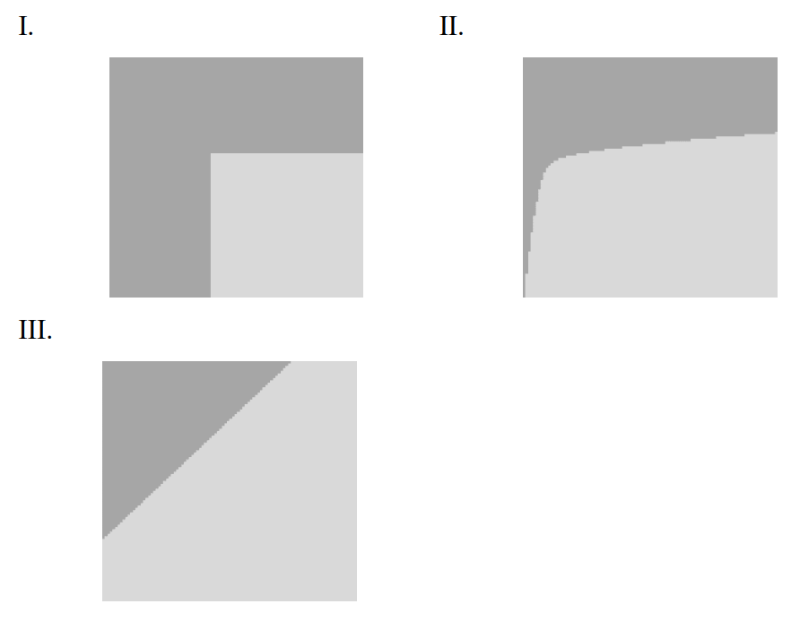

Determine which space can be modeled with no error by a classification tree.

1. I only
2. II only
3. III only
4. I, II, and III
5. The correct answer is not given by (A), (B), (C), or (D).

**Problem** (Sample - Question 29)

Determine which of the following considerations may make decision trees preferable to other statistical learning methods.

I. Decision trees are easily interpretable.

1. Decision trees can be displayed graphically.
2. Decision trees are easier to explain than linear regression methods.
3. None
4. I and II only
5. I and III only
6. II and III only
7. The correct answer is not given by (A), (B), (C), or (D).

**Problem** (Sample - Question 33) The regression tree shown below was produced from a dataset of auto claim payments. Age Category (agecat: 1, 2, 3, 4, 5, 6) and Vehicle Age (veh_age: 1, 2, 3, 4) are both predictor variables, and log of claim amount (LCA) is the dependent variable.

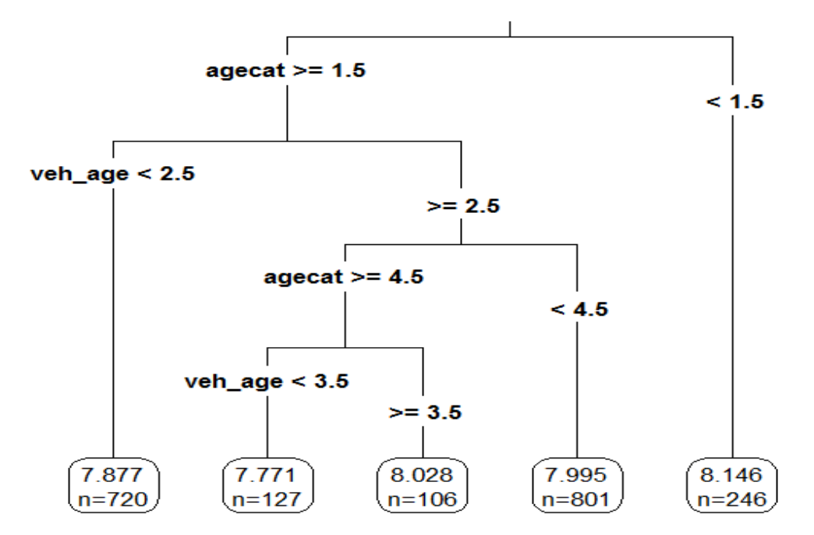

Consider three autos I, II, III:

I: An Auto in Age Category 1 and Vehicle Age 4

II: An Auto in Age Category 5 and Vehicle Age 5

III: An Auto in Age Category 5 and Vehicle Age 3

Rank the estimated LCA of Autos I, II, and III.

1. LCA(I) < LCA(II) < LCA(III)
2. LCA(I) < LCA(III) < LCA(II)
3. LCA(II) < LCA(I) < LCA(III)
4. LCA(II) < LCA(III) < LCA(I)
5. LCA(III) < LCA(II) < LCA(I)

**Problem** (Sample - Question 48) The following tree was constructed using recursive binary splitting with the left branch indicating that the inequality is true.

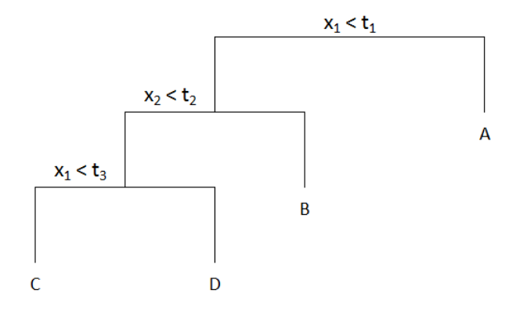

Determine which of the following plots represents this tree.

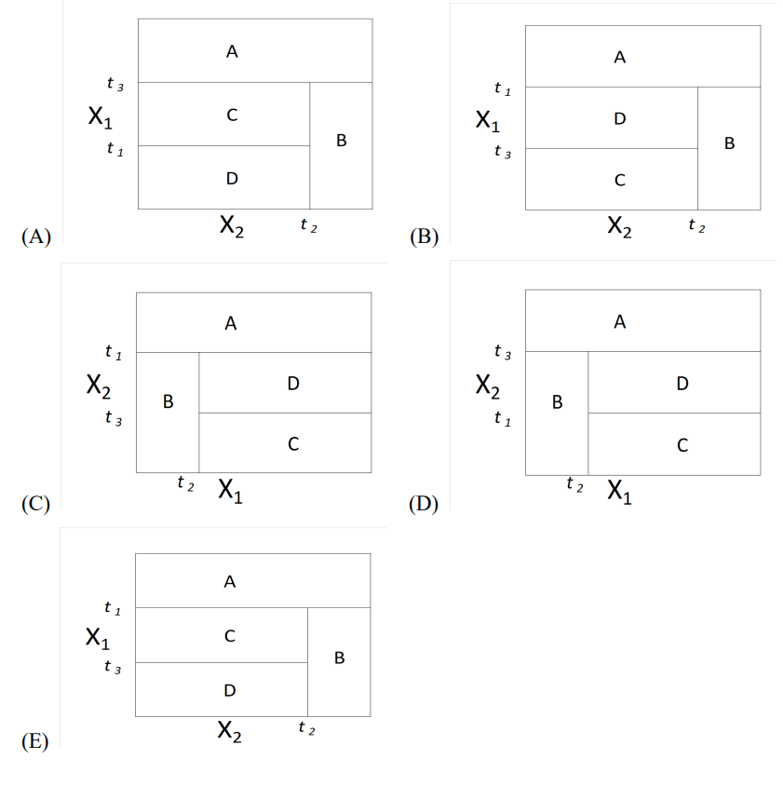

**Problem** (Sample - Question 51)

You are given the following regression tree predicting the weight of ducks in kilograms (kg):

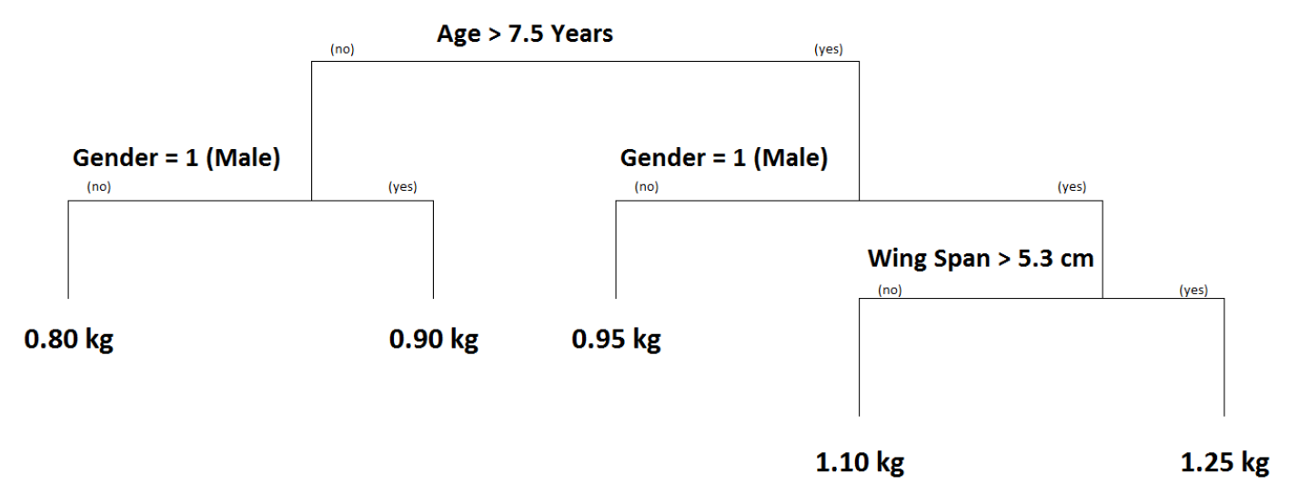

You predict the weight of the following three ducks:

X: Wing Span = 5.5 cm, Male, Age = 7 years Y: Wing Span = 5.8 cm, Female, Age = 5 years Z: Wing Span = 5.7 cm, Male, Age = 8 years

Determine the order of the predicted weights of the three ducks.

1. X < Y < Z
2. X < Z < Y
3. Y < X < Z
4. Y < Z < X
5. Z < X < Y

**Problem** (Sample - Question 57)

You are given:

1. The following observed values of the response variable, R, and predictor variables X, Y, Z:

| R | 4.75 | 4.67 | 4.67 | 4.56 | 4.53 | 3.91 | 3.90 | 3.90 | 3.89 |
| --- | --- | --- | --- | --- | --- | --- | --- | --- | --- |
| X | M | F | M | F | M | F | F | M | M |
| Y | A | A | D | D | B | C | B | D | B |
| Z | 2 | 4 | 1 | 3 | 2 | 2 | 5 | 5 | 1 |

1. The following plot of the corresponding regression tree:

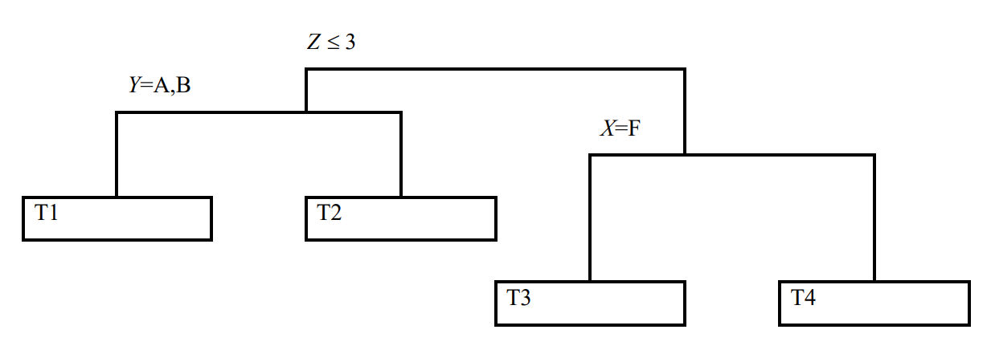

Calculate the Mean Response (MR) for each of the end nodes.

1. MR(T1) = 4.39, MR(T2) = 4.38, MR(T3) = 4.29, MR(T4) = 3.90
2. MR(T1) = 4.26, MR(T2) = 4.38, MR(T3) = 4.62, MR(T4) = 3.90
3. MR(T1) = 4.26, MR(T2) = 4.39, MR(T3) = 3.90, MR(T4) = 4.29
4. MR(T1) = 4.64, MR(T2) = 4.29, MR(T3) = 4.38, MR(T4) = 3.90
5. MR(T1) = 4.64, MR(T2) = 4.38, MR(T3) = 4.39, MR(T4) = 3.90

**Problem** (Sample - Question 63)

You have constructed the following regression tree predicting unit sales (in thousands) of car seats. The variable ShelveLoc has possible values Good, Medium, and Bad

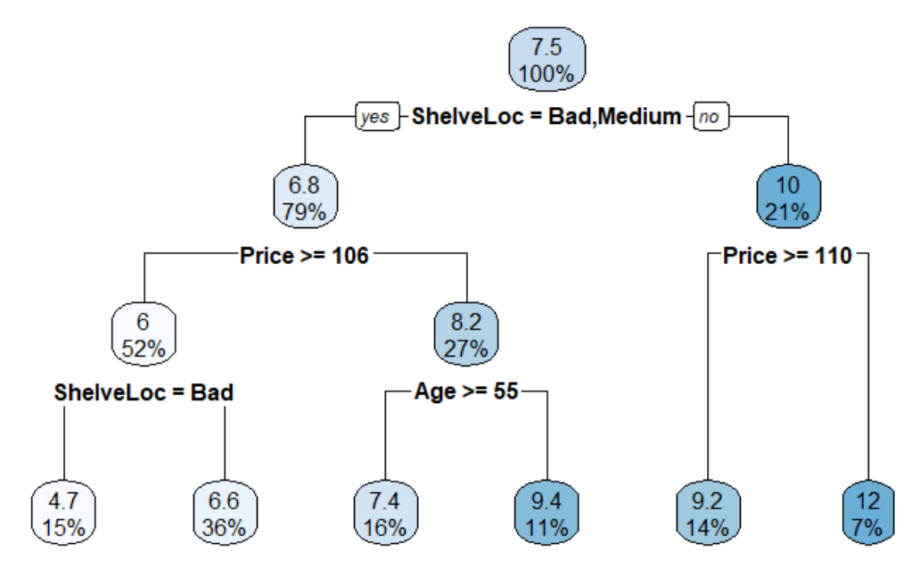

| Variable | Observed Value |
| --- | --- |
| ShelveLoc | Good |
| Price | 120 |
| Age | 57 |
| Advertising | 12 |

Determine the predicted unit sales (in thousands) for the above observation based on the regression tree.

1. 4.7
2. 6.6
3. 7.4
4. 9.2
5. 9.4

**Problem** (Sample - Question 41)

For a random forest, let p be the total number of features and m be the number of features selected at each split.

Determine which of the following statements is/are true.

I. When $m=p$, random forest and bagging are the same procedure.

1. $\frac{p−m}{p}$ is the probability a split will not consider the strongest predictor.
2. The typical choice of $m$ is $p/2$.
3. None
4. I and II only
5. I and III only
6. II and III only
7. The correct answer is not given by (A), (B), (C), or (D)