1.

2.

3.

4.

5. E

6.

7.

8.

9.

10.

11.



12.

13.

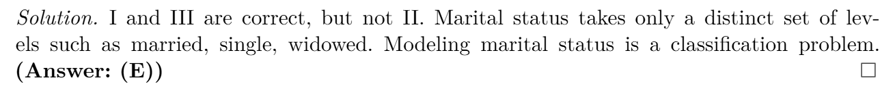

14.

15.

16.

17.

18.

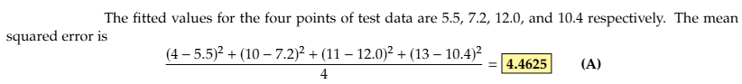

19.

20.

21.

22.

23.

24.

25.

B

26.

28.

29.

30.

31.

32.

33.

34.

35.

