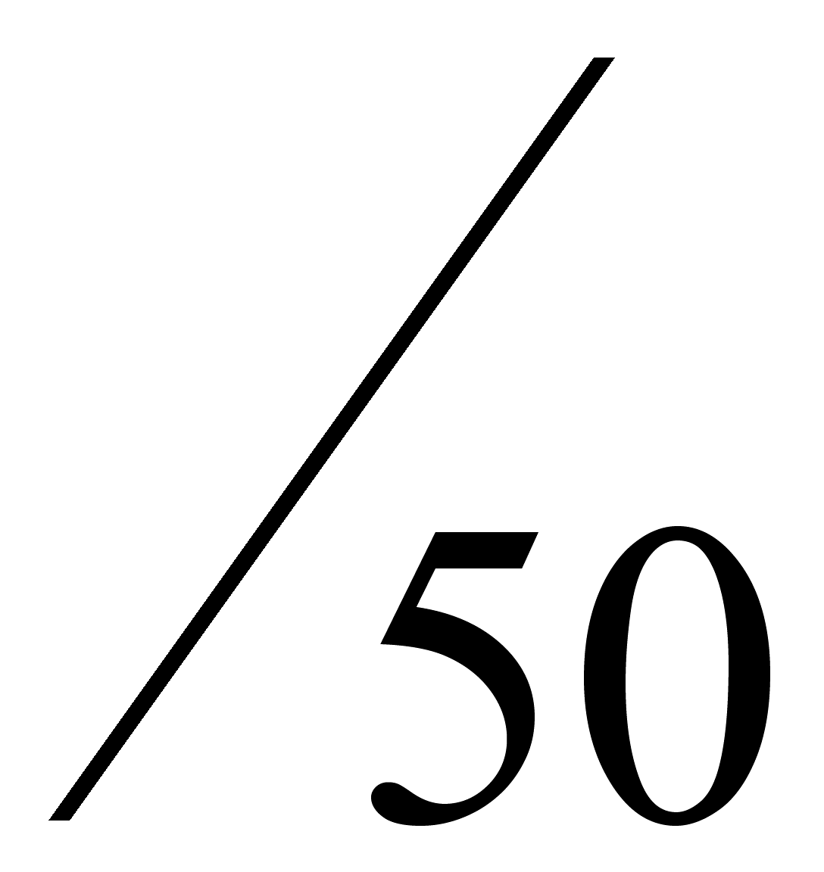Name: _______________________________________ Date: _____________
Math 110
Quiz 2 – Exponential Functions

Show all work for full credit!!! Round all answers to 2 decimal places.

- (8 pts) To save for a child’s college education, parents deposit $8,000 one time into an account that pays 3.75% annual interest compounded daily.
- What will the value of the investment be in 18 years?

- How much interest will be earned in 18 years?

- How long will it take for the investment to reach $20,000?

- (3 pts) What interest rate will allow $8500 to grow to $12,000 in 7 years if interest is compounded quarterly?

- (13 pts) Suppose that a stock’s price is rising at the rate of 7% per year, and that it continues to increase at this rate. Right now, one share of this stock is $43.
  - Write an equation that represents the value of the stock, where t represents years.

  - Estimate the value of one share of the stock in 3 years.

  - When will on share of the stock be worth $100?

  - Sketch a graph. Find the horizontal asymptote, x-intercept, and y-intercept.

- (8 pts) $20,000 is placed into an account that earns 3.5% interest continuously compounded.
- How much will be in the account after 5 years?

- How much interest is earned in those 5 years?

- How long will it take for the investment to double?

- (4 pts) How much money must be initially deposited into an account with 2.9% interest compounded monthly if you want to have $15,000 in 8 years?

- (2 pts) The average rent for a one-bedroom apartment in Providence can be modeled by
$R\left(t\right)=1855{\left(1.032\right)}^{t}$, where $R(t)$ is the rent in dollars and t = 0 represents the year 2023.
  - What was the average rent in 2023?

  - Is the rent increasing or decreasing? By what percentage?

- (12 pts) A company’s total cost, in millions of dollars, can be modeled by
$C\left(x\right)=-40e^{-0.13t}+120$, where t is the time in years since the start-up date.

  - Sketch a graph. Find the horizontal asymptote, x-intercept, and y-intercept.

  - Interpret the meaning of the y-intercept.

  - Interpret the meaning of the horizontal asymptote.

  - When will the company’s total cost be at $100 million?

**BONUS (5 pts) **

Given the supply function $p=20{\left(1.1\right)}^{\frac{q}{10}}$ and the demand function $p=50{\left(0.95\right)}^{\frac{q}{10}},$find the equilibrium point.

