Exam 4. Practice 3.
You may use a basic calculator and formula sheets. Your sheets must contain formulas only, no examples. Phones and all other smart devices are forbidden. Any AI usage will result in an automatic F for the exam. Show ALL your work for credits.
Notice: For all the maximization problems, it is required to do the three-step process to solve the problem.
- Find $f'\left(x\right)$. Simplify 1c.
- $f\left(x\right)=-2x^{3}+3x+19$
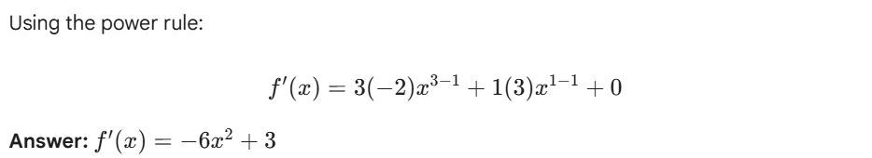
- $f\left(x\right)=\frac{2}{x^{3}}-\frac{4}{x^{7}}-5x+2026$
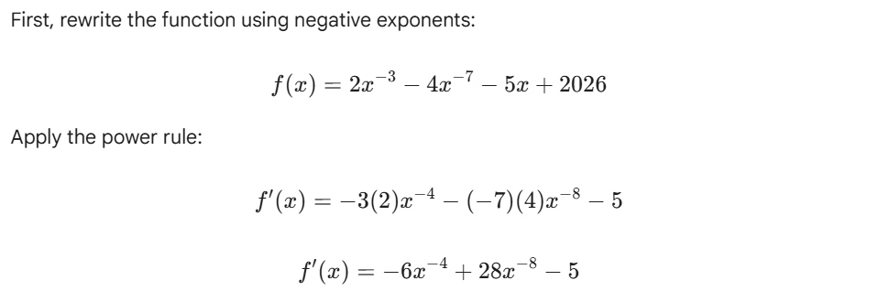
- $f\left(x\right)=\frac{{3x}^{3}+1}{3x^{3}-1}$
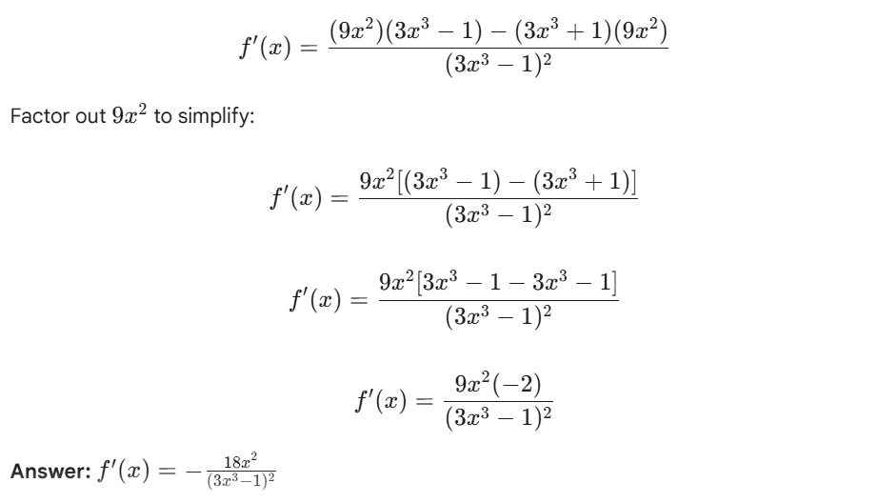
- $f\left(x\right)=({2x}^{2}+1)({3x}^{3}+x)$

 