Linear Inequalities, Systems, and Linear Programming

- Graphing Linear Inequalities

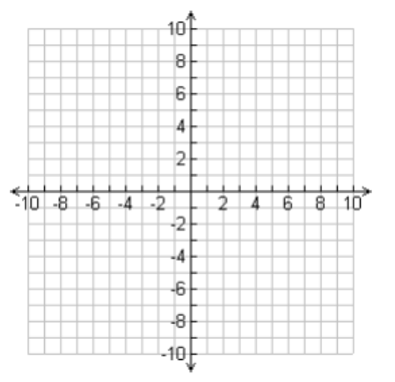
Example 1: Graph $3x+2y≥6$

Example 2: Graph $x-3y>9$

Example 3:
- Graph $x≤2$ b. Graph $y>-5$

- Graphing Systems of Linear Inequalities

Example 4: Graph $\begin{matrix}3x+2y≤6 \\ 2x-5y≥10\end{matrix}$

Example 5: Graph $\begin{matrix}x+y<1 \\ 2x-y<4\end{matrix}$

Example 6: Graph $\begin{matrix}x+2y≤10 \\ x>3\end{matrix}$

Example 7: Graph $\begin{matrix}2x+3y≥12 \\ 7x+4y≥28\end{matrix}$
$\begin{matrix}y≤6 \\ x≤5\end{matrix}$

- Linear Programming

Example 8: The feasible region determined by a system of constraints is given. Find the minimum and maximum values of the objective function for the given feasible region

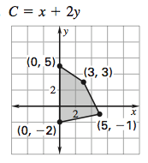

Example 9:

The feasible region determined by a system of constraints is given. Find the minimum and maximum values of the objective function for the given feasible region.
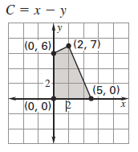

Minimum: Maximum:

Example 10:

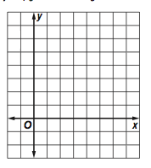
Graph the constraints:

Find the vertices of the feasibility region.

Test each vertex in the objective function C = –x + 3y

Minimum: Maximum:

Example 11:

Graph the constraints:

Find the vertices of the feasibility region.

Test each vertex in the objective function C = 5x + 6y.

Minimum: Maximum:

Example 12:

Graph the constraints:

Find the vertices of the feasibility region.

Test each vertex in the objective function C = 3x – y .

Minimum: Maximum:
Example 13: You are selling bracelets and necklaces. It costs $1 to make a bracelet and it requires 2 hours to create. It costs $3 to make a necklace and it requires 1 hour to complete. You have a budget of $18 and a total of 16 hours to work on the bracelets and necklaces. You make a profit of $5 on each bracelet and $8 on each necklace. How many bracelets and necklaces should be made to maximize profit? What is the maximum profit?

- Define the variables

- Write the constraints

- Write the objective function

Example 14: You grow and sell cucumbers and carrots. It costs $2 to grow a bushel of cucumbers and it requires 10 sq. yards of land. It costs $3 to grow a bushel of carrots and it takes 6 square yards of land. You have a budget of $210 and a total of 600 square yards of land available. If you make a profit of $5 on each bushel of cucumbers and $8 profit on each bushel of carrots, how many bushels of each should you grow to maximize your profit?
- Define the variables

- Write the constraints

- Write the objective function

Example 15: A receptionist for a veterinarian needs to schedule appointments. She allots 20 minutes for a routine office visit and 40 minutes for a surgery. The veterinarian cannot do more than 6 surgeries per day. The office has 7 hours available for appointments. If an office visit costs $55 and most surgeries cost $125, how many office visits and surgeries will maximize the income the veterinarian practice receives per day? What is the maximum income?
- Define the variables

- Write the constraints

- Write the objective function

Example 16: A carpenter makes bookcases in 2 sizes, large and small. It takes 4 hours to make a large bookcase and 2 hours to make a small bookcase. The profit on a large bookcase is $35, and on a small bookcase the profit is $20. The carpenter can only spend 32 hours per week making bookcases and must make at least 2 of the large and at least 4 of the small each week. How many small and large bookcases should the carpenter make to maximize profit? What is the maximum profit?
- Define the variables

- Write the constraints

- Write the objective function

Example 17: Nike Inc. stock sells for $167 a share and has a 3-year average annual return of $52 a share. The beta value is .93. Walt Disney Co. sells for $169 a share and has a 3-year aver-age annual return of $24 a share. The beta value is 1.17. Roselyn wants to spend no more than $8,000 investing in these two stocks, but she wants to earn at least $1200 in annual revenue. Roselyn also wants to minimize the risk. Determine the number of shares of each stock that Roselyn should buy.
- Define the variables

- Write the constraints

- Write the objective function

Example 18: As part of your weight training regimen, you want to consume lean sources of protein. You want to consume at least 300 Calories a day from at least 48 grams of protein. One ounce of chicken provides 35 Calories and 8.5 g of protein. One ounce of tofu provides 20 Calories and 2.5 g of protein. Your local supermarket charges $0.31 an ounce for chicken and $0.16 an ounce for tofu. How much of each food should you eat each day if you want to meet your requirements with the lowest cost? What is this daily cost?
- Define the variables

- Write the constraints

- Write the objective function

Example 19: Mariana wants to invest up to $5000 in stocks. The share price for CVS is $89 and
the share price for Verizon is $53. Based on the average of 10-year returns, CVS would produce in a year a profit of $10 a share, and Verizon would produce a profit of $4 a share. Mariana would like to obtain at least $440 in profit. A measure of risk for each of these stocks is the beta value. The lower the beta value, the less risk associated with that stock. If the beta value for CVS is .81 and the beta value for Verizon is .43, how many shares of each stock should Mariana purchase to minimize the risk as measured by the beta value?

- Define the variables

- Write the constraints

- Write the objective function

Example 20: An investor has $60,000 to invest in a stock and a mutual fund. The stock yields 8% per year and the mutual fund yields 5%. The mutual fund requires a minimum investment of $9,000, and the investor requires that at least twice as much should be invested in stock as in the mutual fund. How much should be invested in the stock and how much in the mutual fund to maximize the return? What is the maximum return?

- Define the variables

- Write the constraints

- Write the objective function

