Applications of Linear Functions

- Supply, demand and Equilibrium
You Try 1:

The demand for your college newspaper is 2,000 copies each week if the paper is given away free of charge and drops to 800 each week if the charge is $1.50 per copy.

However, the university is prepared to supply only 600 copies per week free of charge but will supply 1,500 each week at $1.50 per copy.

- Write the demand and supply functions.

- Find the equilibrium point. For supply to equal demand, the newspaper must be priced at how much apiece?

- Graph both the demand and supply function on the same axis.

- Cost – Revenue and Break-Even
You Try 2: A product can be made for $120 per unit. The total cost to provided 100 units is $15,800.

- Assuming that the cost function is linear, find its rule.
- What are the fixed costs?
You Try 3:
A company manufactures a 65-inch smart TV that sells to retailers for $550. The costs can be described by a linear cost function with fixed costs of $213,000 and a variable cost per item of $250.

- Find the cost function
- Find the revenue function
- Graph and label the cost and revenue functions on the same set of axes. Label the break-even point.
- Find the profit function
- How much profit will they make by producing and selling 5000 TVs?
- How many units must be produced and sold in order to obtain a profit of $50,000?

- Simple Interest

You try 4


You try 5


You try 6

- Depreciation and Appreciation

You try 7

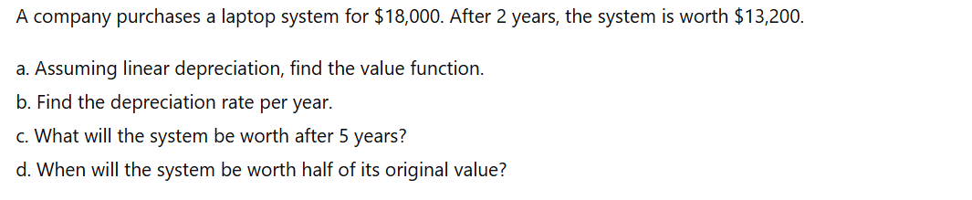

You try 8



