Exam 4. Practice 1.
You may use a basic calculator and formula sheets. Your sheets must contain formulas only, no examples. Phones and all other smart devices are forbidden. Any AI usage will result in an automatic F for the exam. Show ALL your work for credits.
- Find $f'\left(x\right)$. Simplify 1c.
- $f\left(x\right)=3x^{3}-7x+9$

- $f\left(x\right)=\frac{3}{x^{6}}+\frac{4}{x^{7}}+\frac{5}{x^{9}}+3x+1$
- $f\left(x\right)=\frac{x^{2}+1}{x^{2}-1}$
- $f\left(x\right)=(x^{3}+1)({2x}^{3}+5)$

- The per-day cost function of the manufacture of portable MP3 players is given by

$$C\left(x\right)=128,000+30x+x^{3}$$

where x is the number of MP3 players manufactured per day. Assume that the company cannot manufacture more than 100 MP3 players per day.
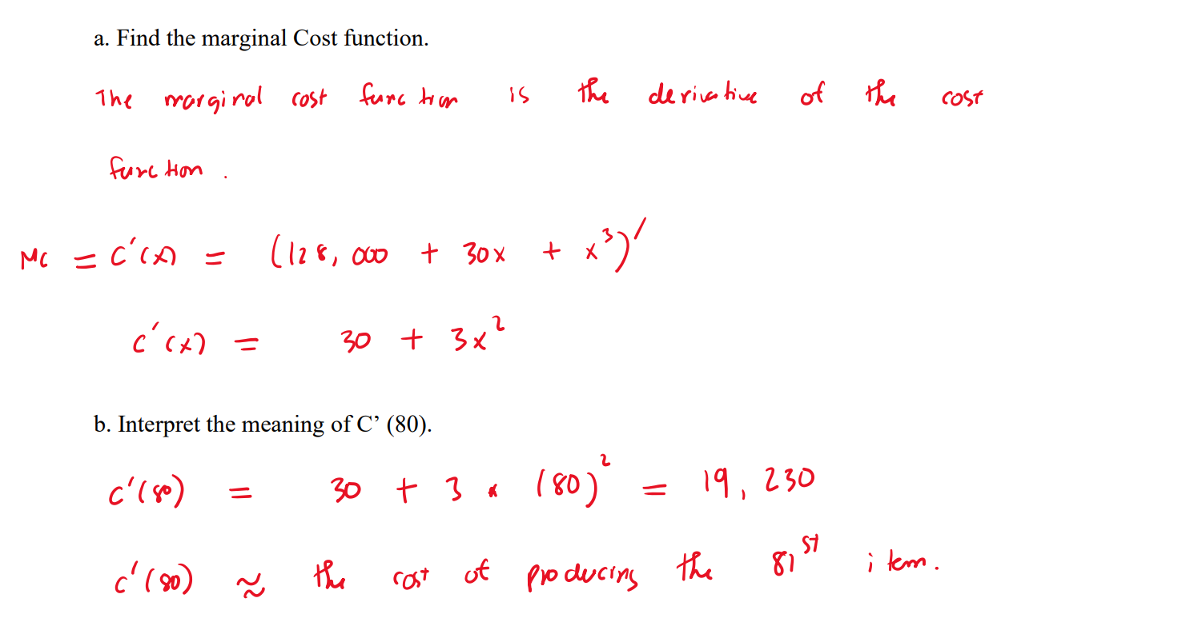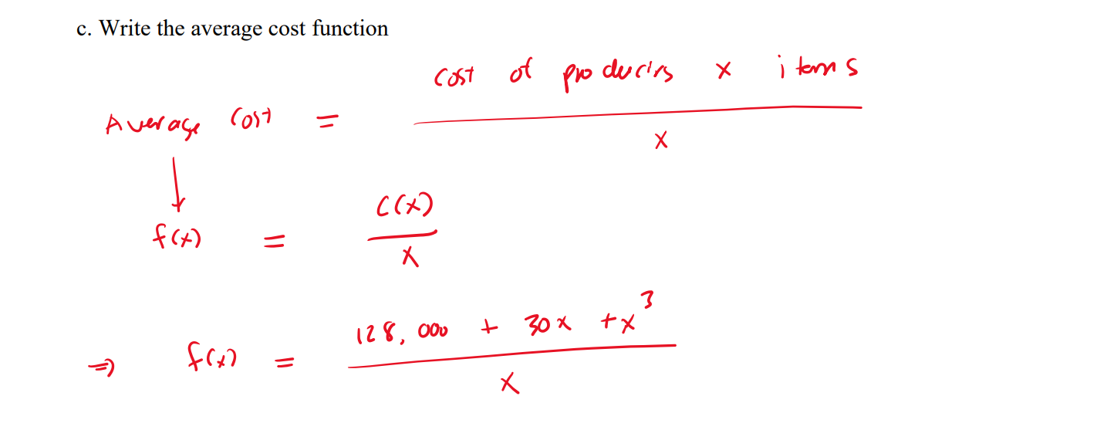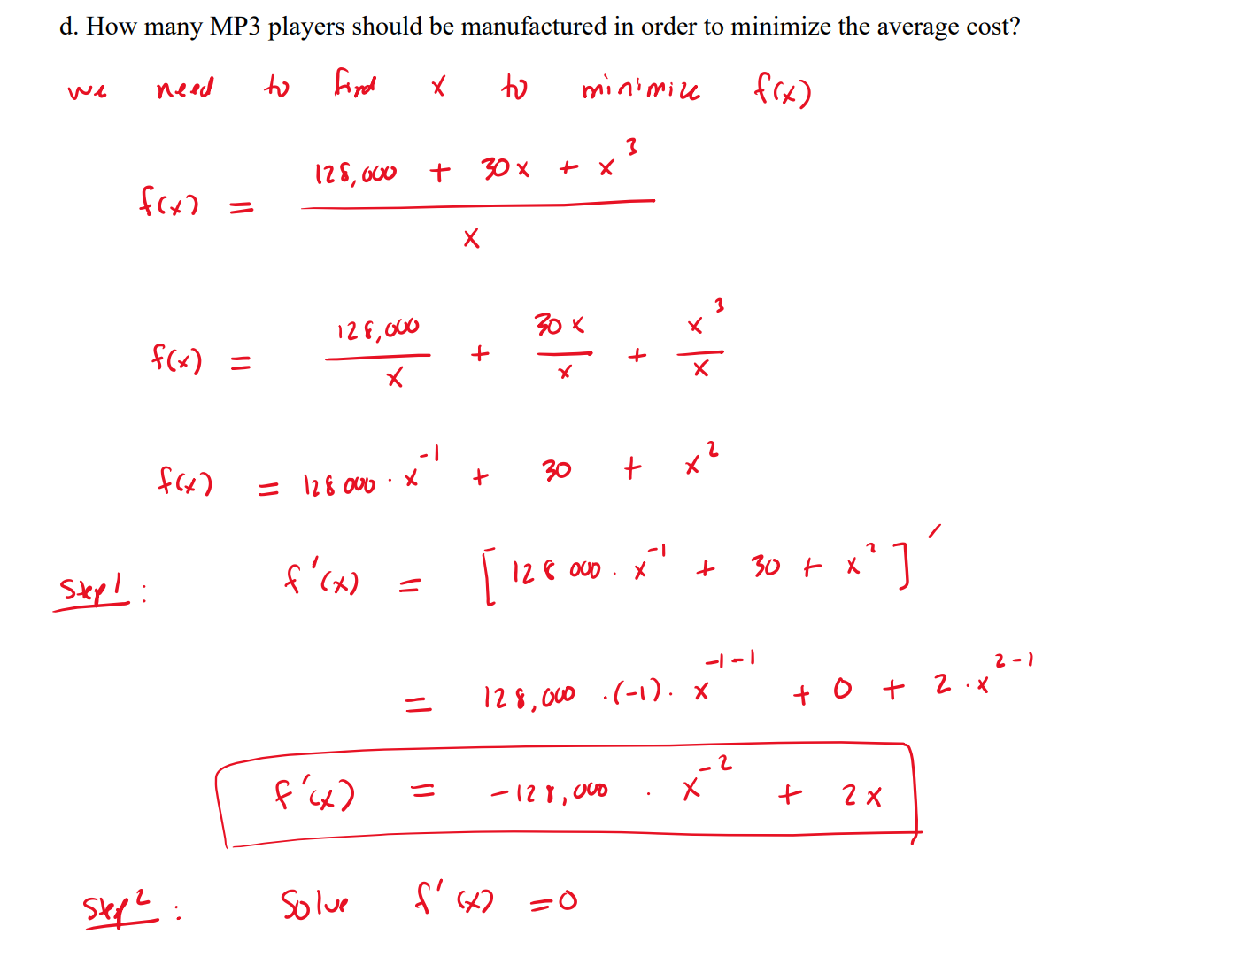
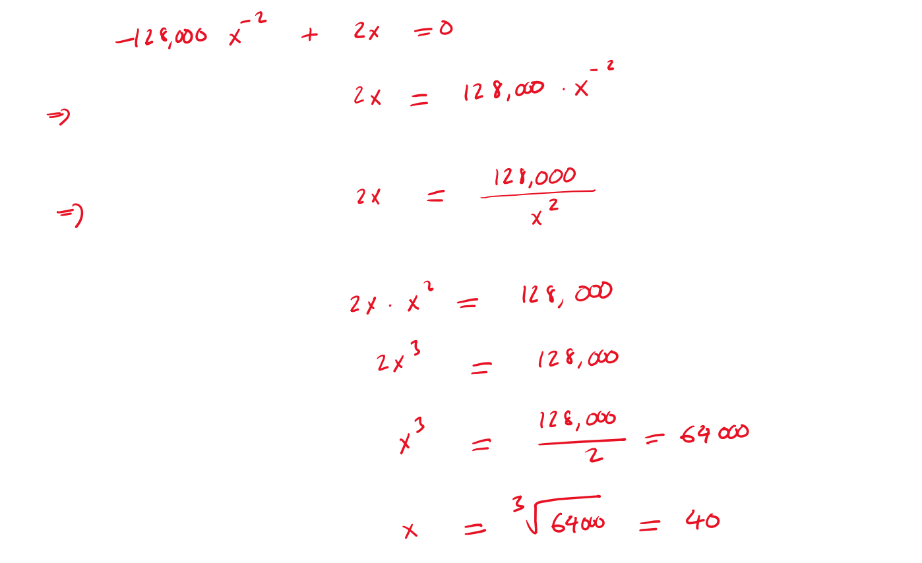
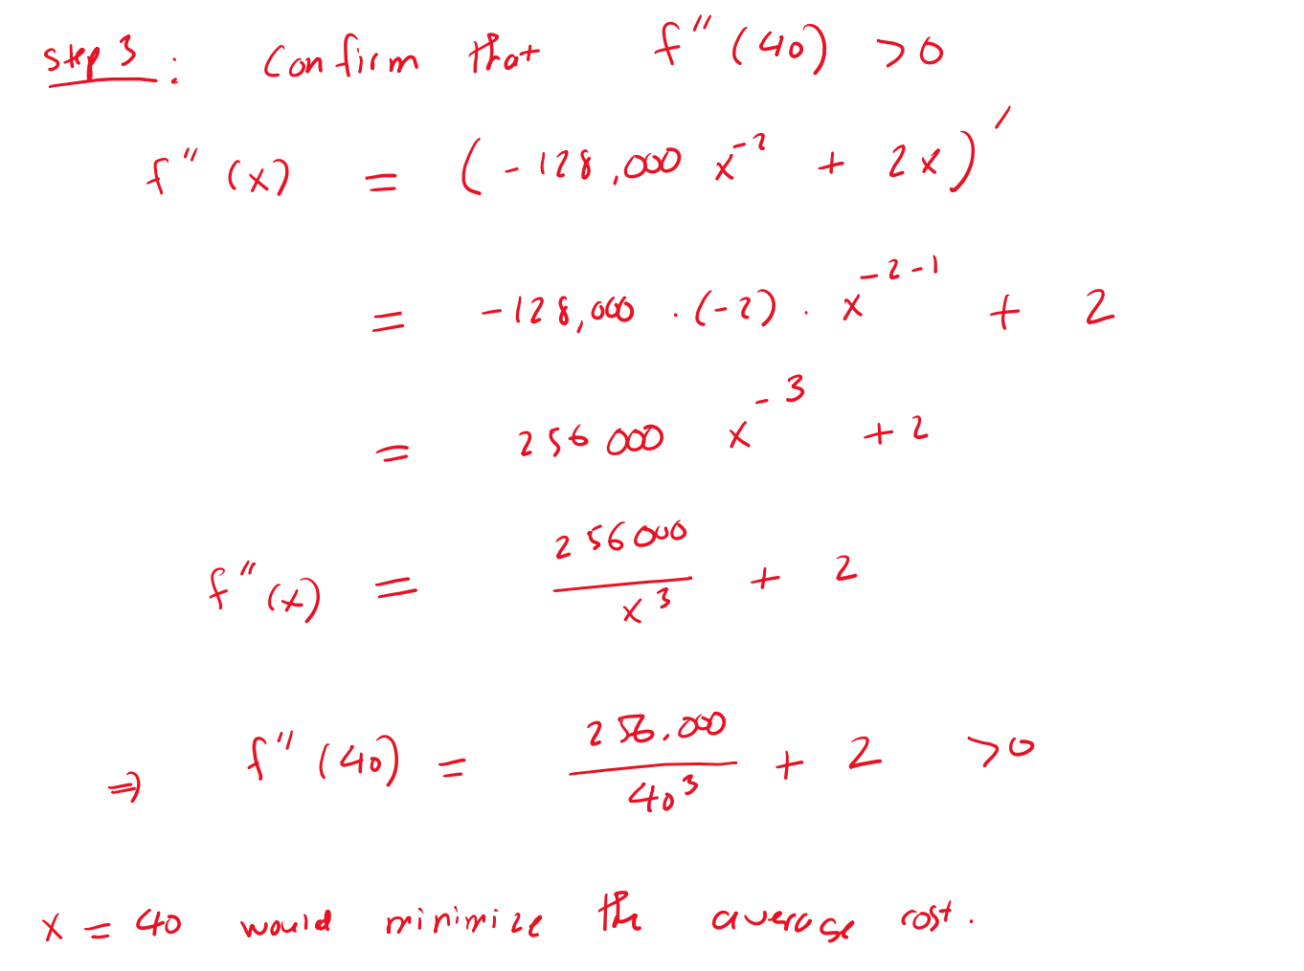
- A luxury watch manufacturer has determined that the daily price p (in dollars) they can charge is related to the quantity x they produce by the following quadratic demand function.

$$p\left(x\right)= -x^{2}+120x+2700$$

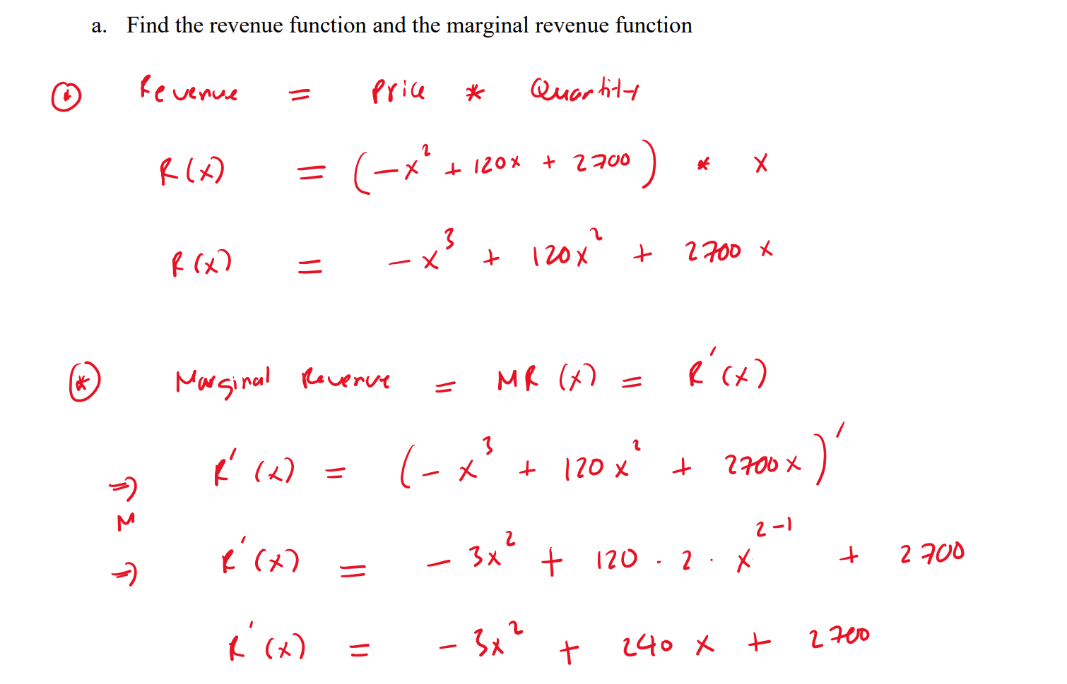
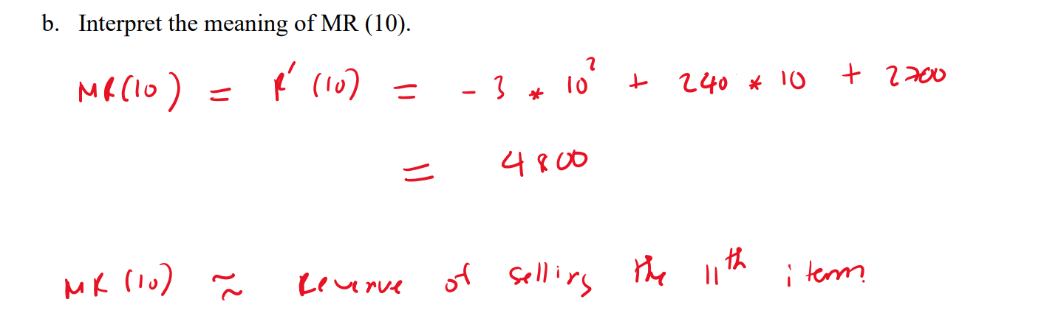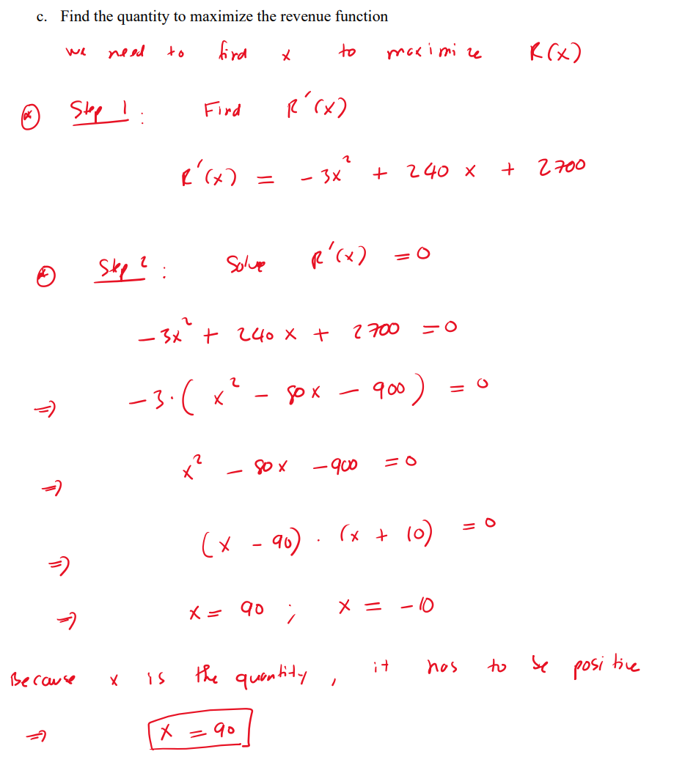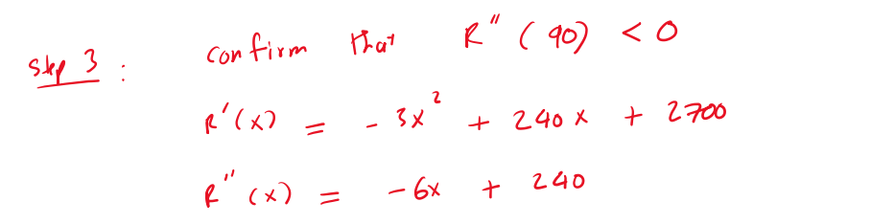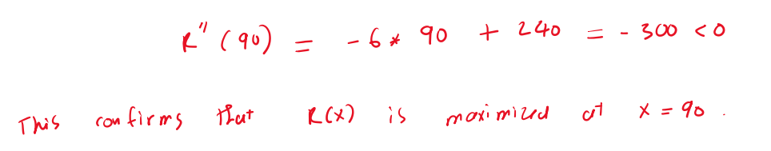

- A company determines that when x units of a product are produced each month, they will be sold at the price of

$$p=22.2-1.2x$$

dollars per unit. The total cost of producing the x units will be
$$C\left(x\right)=0.4x^{2}+3x+40$$

