Exam 4. Practice 1.
You may use a basic calculator and formula sheets. Your sheets must contain formulas only, no examples. Phones and all other smart devices are forbidden. Any AI usage will result in an automatic F for the exam. Show ALL your work for credits.
- Find $f'\left(x\right)$. Simplify 1c.
- $f\left(x\right)=2x^{7}-8x+9$
- $f\left(x\right)=\frac{3}{x^{3}}+\frac{4}{x^{3}}+\frac{5}{x^{}}+3x+1$
- $f\left(x\right)=\frac{{3x}^{}+1}{4x^{}+1}$
- $f\left(x\right)=(x^{2}+1)(x^{13}+x)$

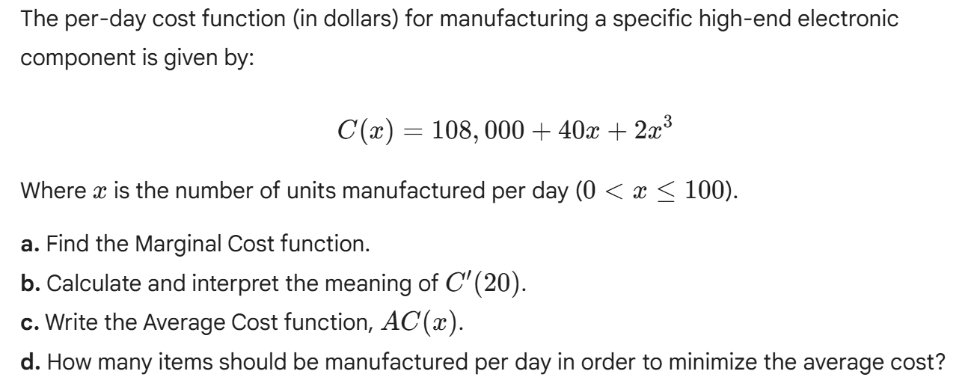

- 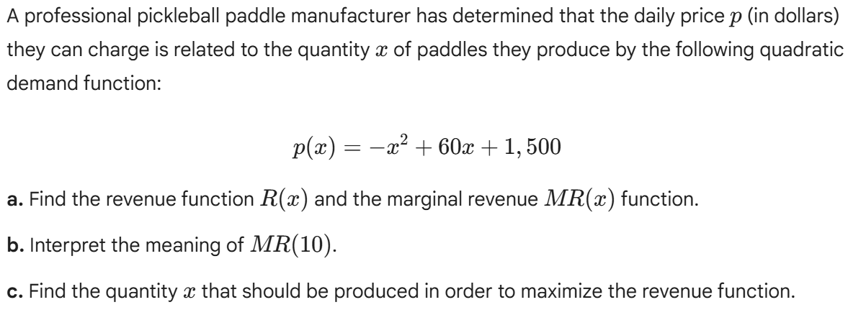

- A company determines that when x units of a product are produced each month, they will be sold at the price of

$$p=22.2-1.2x$$

dollars per unit. The total cost of producing the x units will be
$$C\left(x\right)=0.4x^{2}+3x+40$$

- Find the profit function and the marginal profit (MP) function
- Interpret the meaning of MP(5).
- How many units should the company produce to maximize the profit?

