Exam 3 –Practice 1.
You may use a basic calculator and formula sheets. Your sheets must contain formulas only, no examples. Phones and all other smart devices are forbidden. Any AI usage will result in an automatic F for the exam. Show ALL your work for credits.
- Solve each exponential equation.
- $9^{x}=7$

- ${6⋅7}^{4x+1}-11=5$
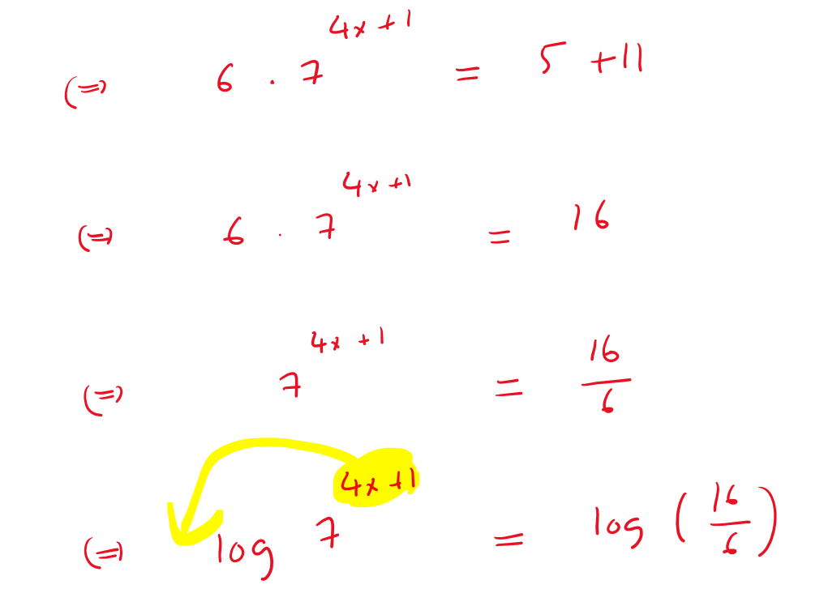

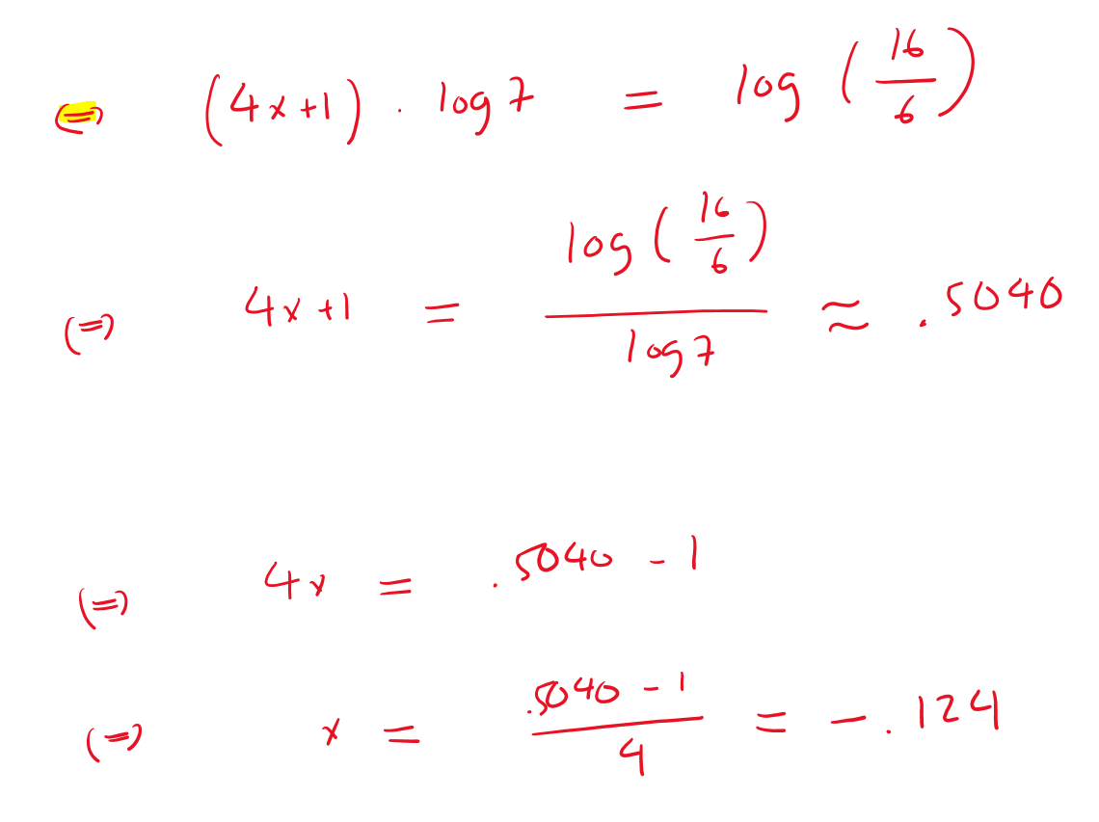

- $7^{4x+1}=9^{2x+3}$
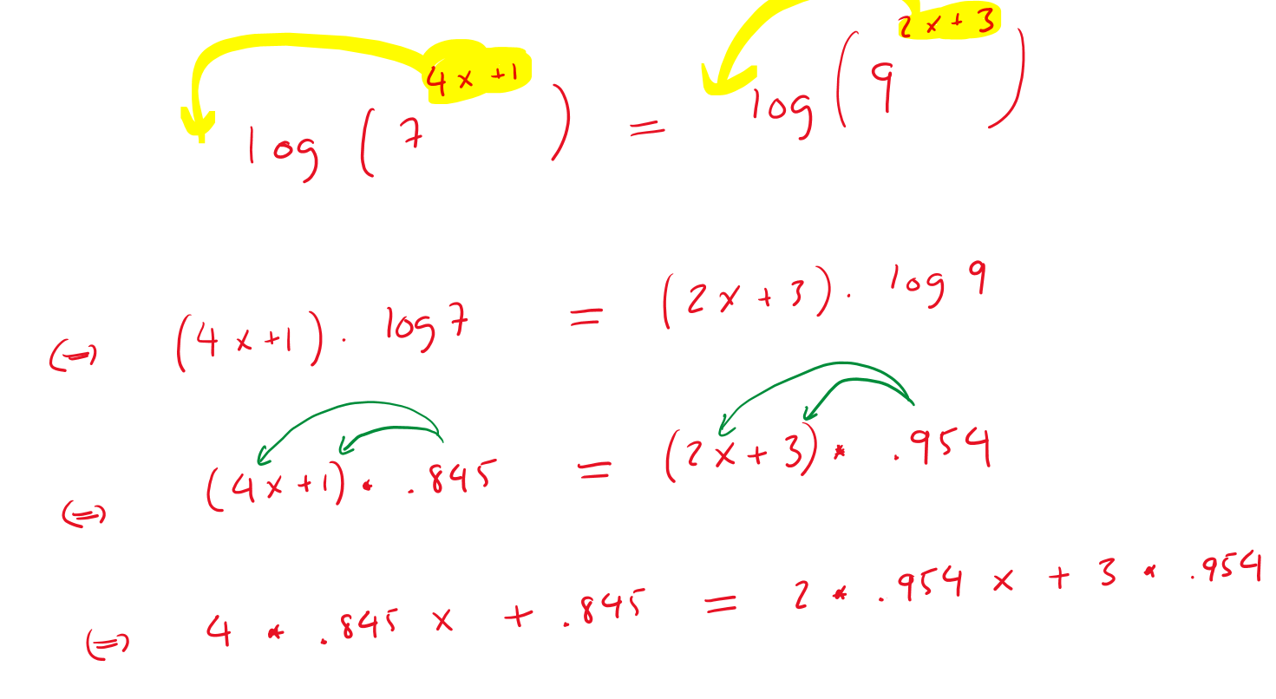

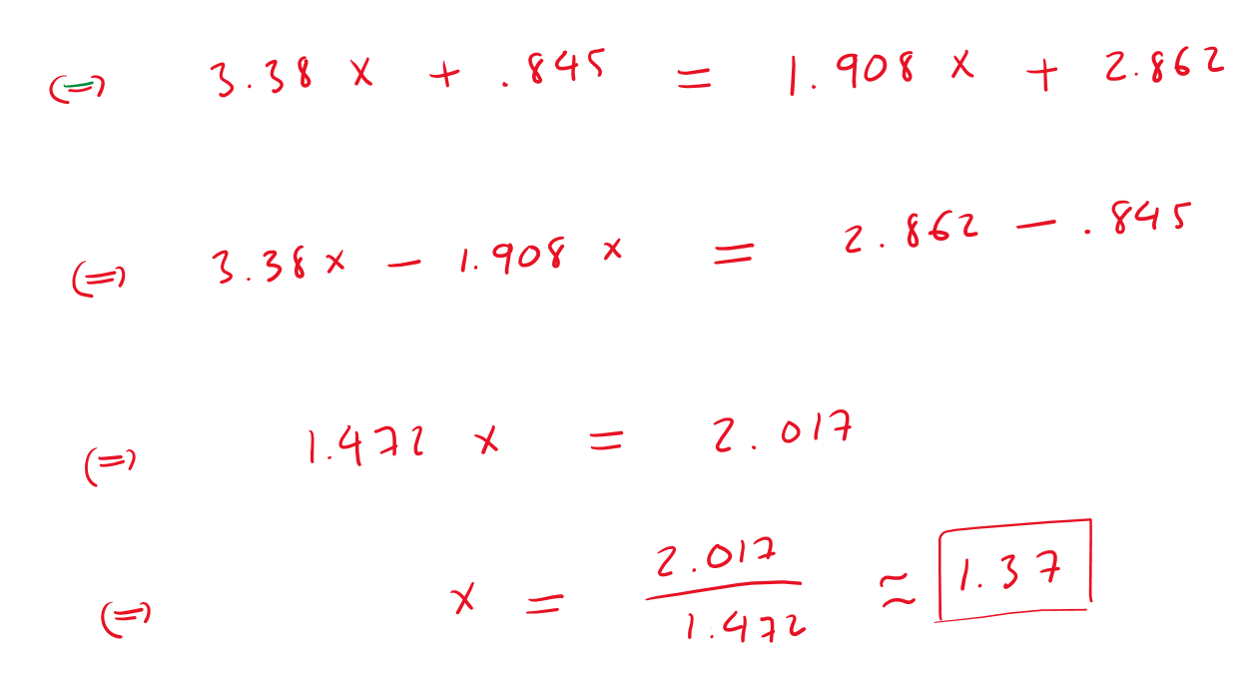

- The number of bachelor’s business degrees (in thousands) conferred in the United States can be modeled by an exponential function. In 2010, 279,000 business degrees were conferred, and the number of degrees has risen 2% each year.

- Write an equation to model the number of business degrees conferred.
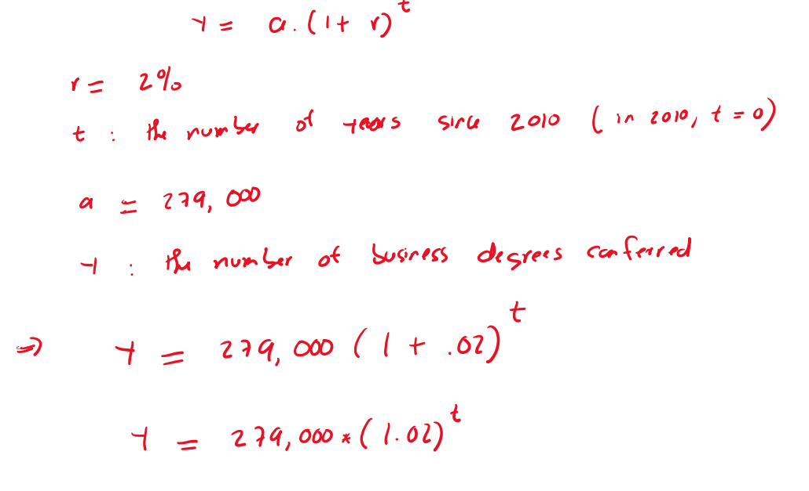
- Graph the equation
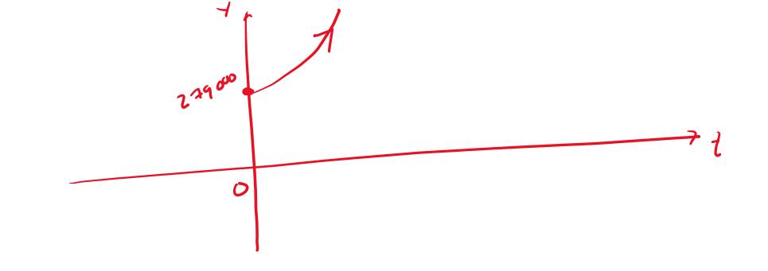
- What was the first year in which 475,000 business degrees were conferred?
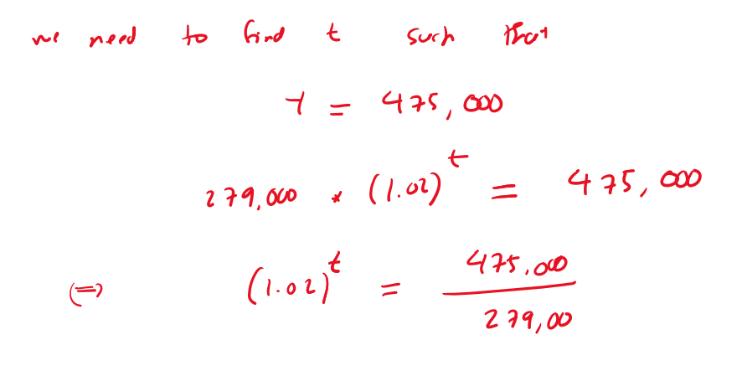
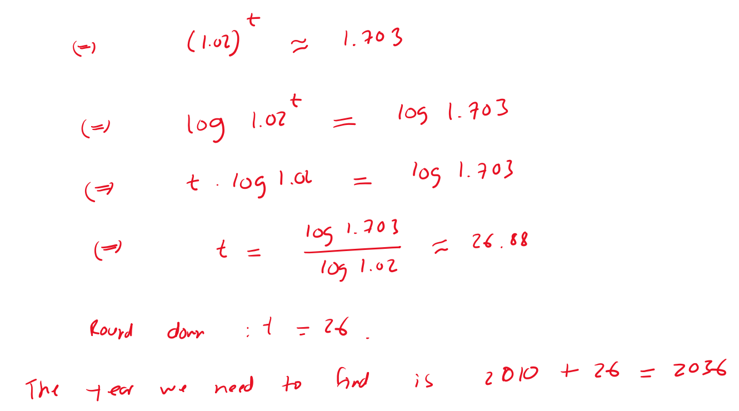
- Use the model to estimate how many degrees will be conferred in 2027.
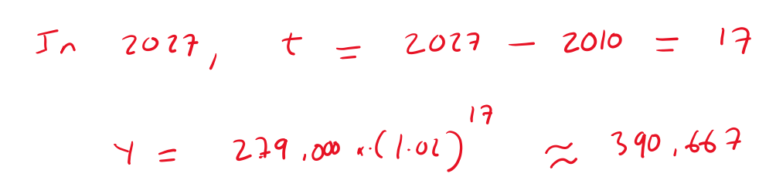
- A piece of machinery is purchased for $40,000. The business estimates that its value will decrease 43% each year.
  - Write an equation to model the value of the machinery after t years.

  - Graph the equation

  - What is the value of the machinery after 2 years?
  - When will the machinery be worth $5,000?

- A rookie player in the NFL just signed his first 7-year contract. To prepare for his future, he deposits $150,000 at the end of each year for 7 years in an account with 3.1% compounded annually.
a. How much will he have in his account after 7 years?
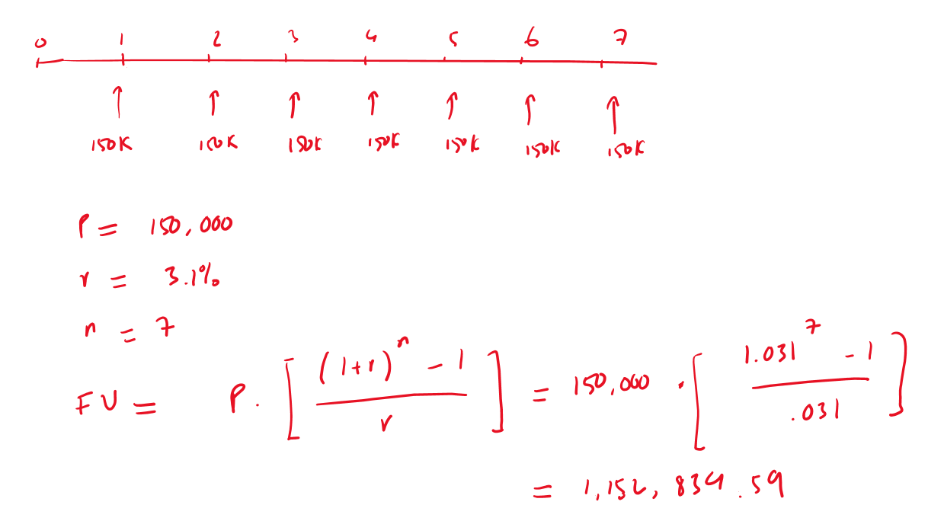
b. How much interest was earned over the 7 years?
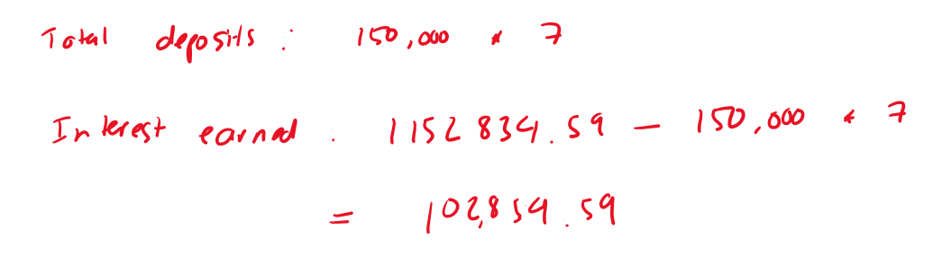

5. A wealthy family member has funded an annuity that will pay you $1500 at the end of each year for six years. If the interest rate is 8%, compounded annually, find the present value of the annuity.
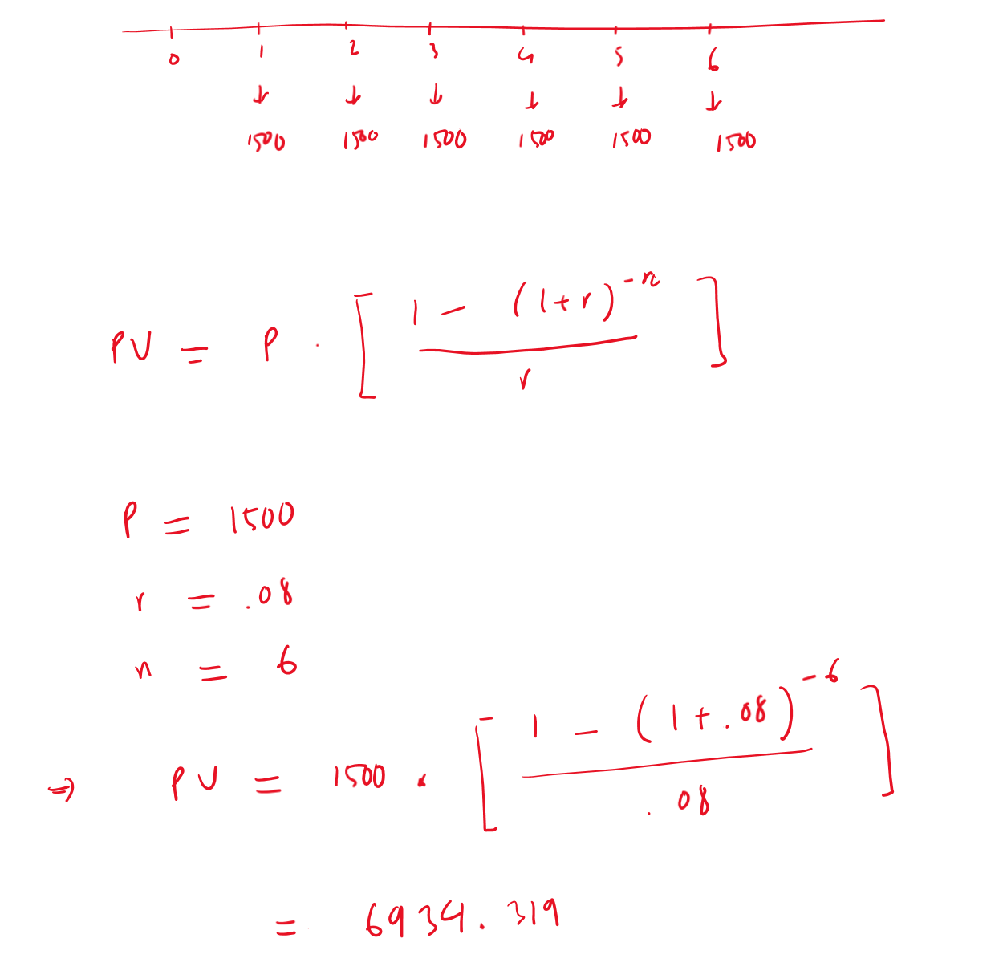

6. The average used car price is $32,000. The average interest rate is currently 6.39% for a 60-month loan (5 years). If you have $5,000 for a down payment,
a. what can you expect the monthly payment to be?
Formula: 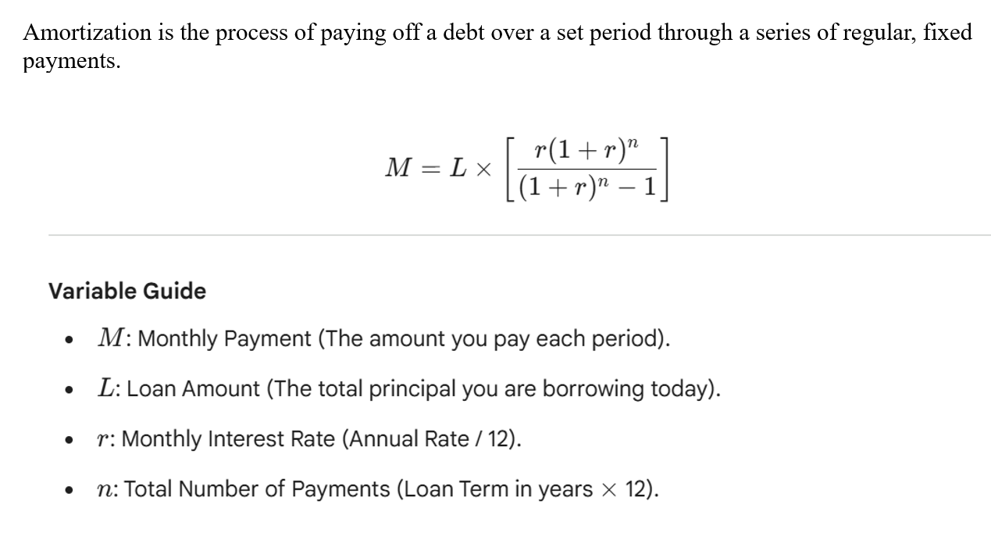
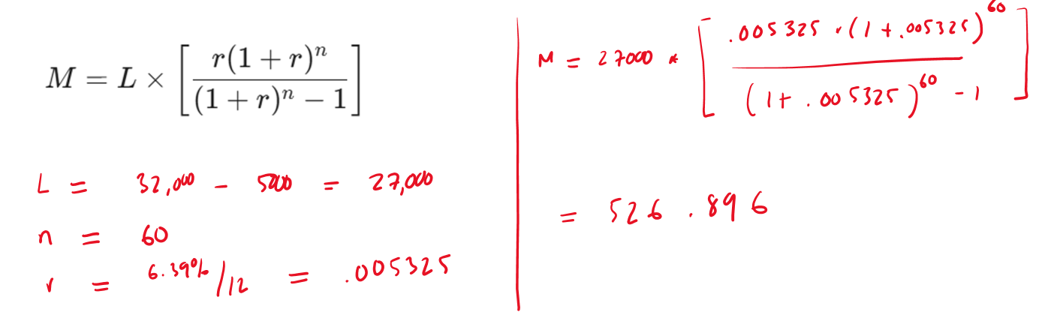

b. How much will you pay in total for the car?
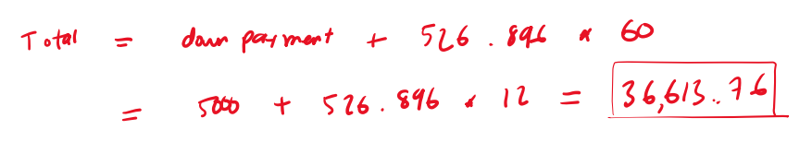
7. In 2023, the average amount of student loan debt for a bachelor’s degree recipient at a private university was $54,921. Assume an annual interest rate of 6.87%
- Find the monthly payment and calculate the total interest paid over the course of the loan for a 10-year payment plan.
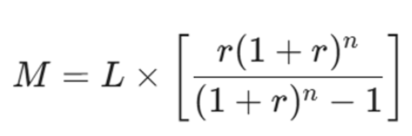

- Find the monthly payment and calculate the total interest paid over the course of the loan for a 20-year payment plan.

