Exam 1 – Practice 2
Exam Guidelines This is an in-class, written exam with a 75-minute time limit.
- Permitted Materials: You may use a basic calculator and a formula sheet.
- Formula Sheet Restrictions: Your sheet must contain formulas only; no examples or worked problems are permitted. All sheets will be inspected at the start of the exam.
- Prohibited Items: Phones and all other smart devices are strictly forbidden.
- Academic Integrity: The use of AI is prohibited. Any AI usage will result in an automatic F for the exam and may lead to failing the entire course.
- Graph the below line.
- $y=-2x+3$
- $y= -3$
- $x= -2$
- Write the equation of the line
- passing through two points (1, 0) and (2, -3)
- with the slope of 3 and passing through (1, -2)

- Match each equation to its corresponding graph. 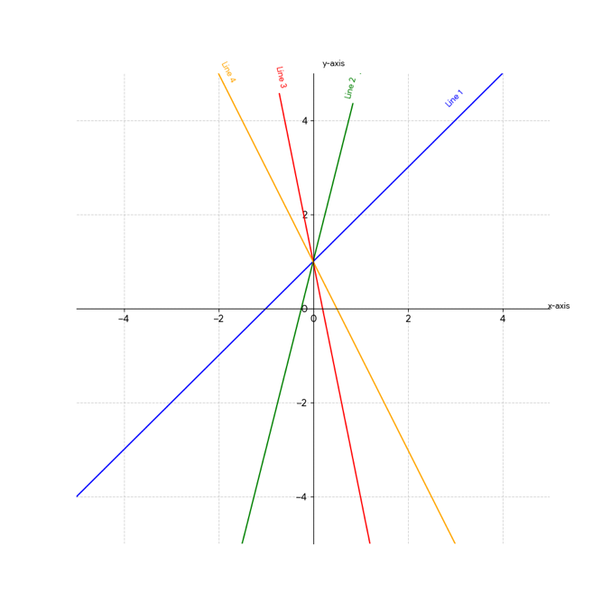
- $y=x+1$
- $y=-5x+1$
- $y=4x+1$
- $y=-2x+1$

4. You operate a small farmers’ market stand that sells fresh organic honey. Market research shows that you can sell 200 jars per month if the price is $6 per jar, but sales drop to 80 jars per month if the price is raised to $14 per jar. On the supply side, local beekeepers are willing to supply 60 jars per month when the price is $5 per jar, but they will increase production to 180 jars per month if the price rises to $13 per jar.
a. Write the linear demand function and the linear supply function.

b. Find the equilibrium point. At what price must the honey be sold so that quantity supplied equals quantity demanded?

c. Graph both the demand and supply functions on the same set of axes.

5. A company that manufactures custom hoodies has fixed monthly costs of $75,000 and variable costs of $40 per hoodie produced. Each hoodie sells for $110.
a. Find the cost function.

- Find the revenue function.

- Graph and clearly label the cost and revenue functions on the same set of axes. Identify and label the break-even point.

- Find the profit function.

- How much profit will the company make by producing and selling 2,000 hoodies?

- How many hoodies must be produced and sold in order to obtain a profit of $75,000?

- Two investment options that earn simple interest are available.
Investment A starts with $1,500 and earns simple interest at an annual rate of 3%.
Investment B starts with $2,400 and earns simple interest at an annual rate of 1.5%.
a. Write a linear equation that represents the total amount of money in each investment after $t$ years.
b. How much money will there be in Investment A after 4 years?
c. When will Investment A reach $1,860?
d. Determine which investment grows faster and explain your answer by comparing the slopes of the two equations.
e. Determine whether the two investments will ever have the same total value. If so, find when this occurs.
f. Plot both investment functions on the same coordinate system.

