Exponential Applications Day 1

- Exponential growth and decay

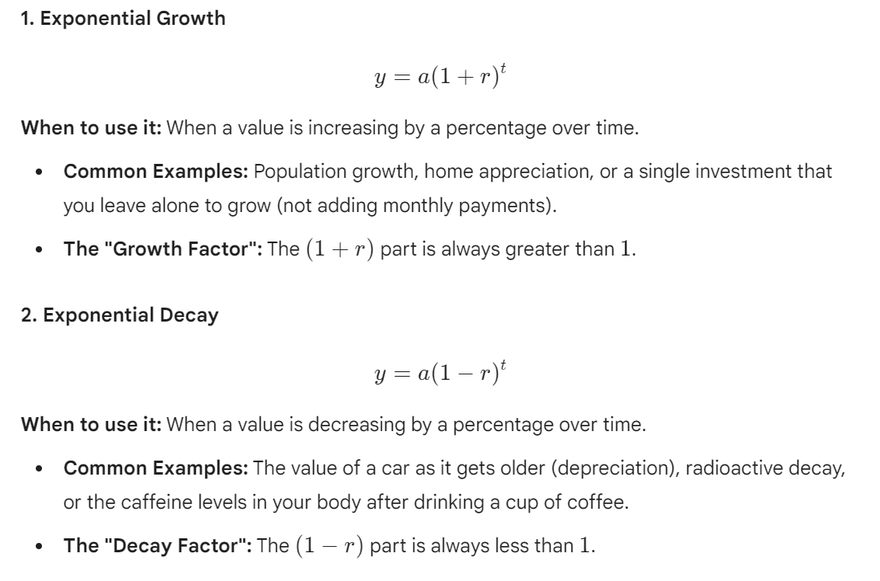

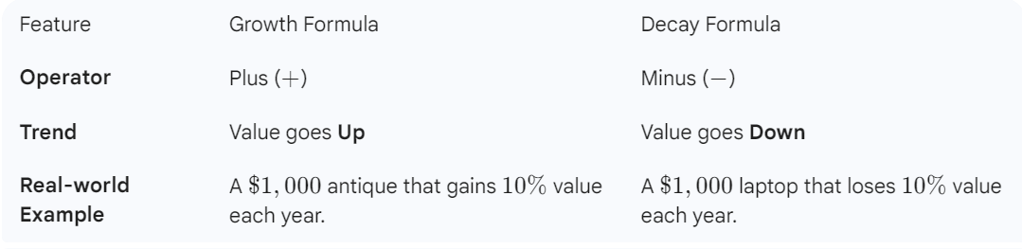

Example 1: The number of bachelor’s business degrees (in thousands) conferred in the United States can be modeled by an exponential function. In 2010, 279,000 business degrees were conferred, and the number of degrees has risen 2% each year.
- Write an equation to model the number of business degrees conferred.

- Graph the equation

- What was the first year in which 475,000 business degrees were conferred?

- Use the model to estimate how many degrees will be conferred in 2024.

Example 2: A piece of machinery is purchased for $40,000. The business estimates that its value will decrease 43% each year.
- Write an equation to model the value of the machinery after t years.

- Graph the equation

- What is the value of the machinery after 2 years?

- When will the machinery be worth $5,000?

- Interest

- Compound Interest

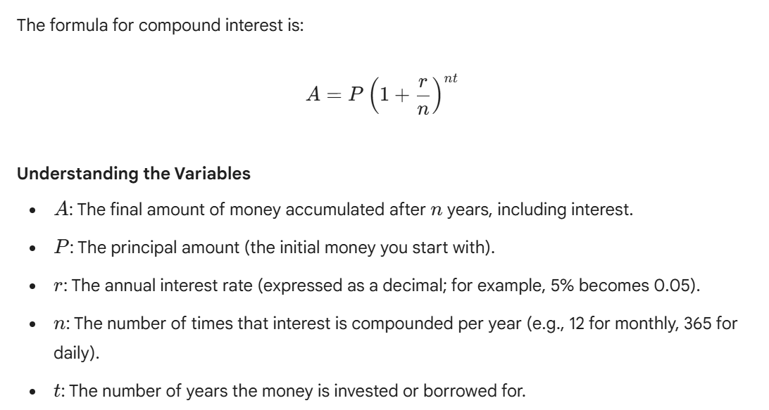

Example 5: You place $5,000 in a certificate of deposit (CD) with a 3% interest rate for 18 months. Find the value of the CD at the different compounding periods. Then find the interest earned.
- Annually

- Semiannually

- Quarterly

- Monthly

- Weekly

- Daily

Example 6: What amount deposited today at 2.8% compounded monthly will amount to $6000 in 5 years?

Example 7: You want to buy your first car upon graduation. You would like to have $4,000 as a down payment. Find the interest rate, with quarterly compounding, that will allow you to grow $2,500 to $4,000 in four years.

Example 8: You have $2000 from high school graduation. You place it in a high yield savings account with 4.35% interest compounded monthly and make no additional deposits. How long will it take for your money to double?

- Continuously compounding interest

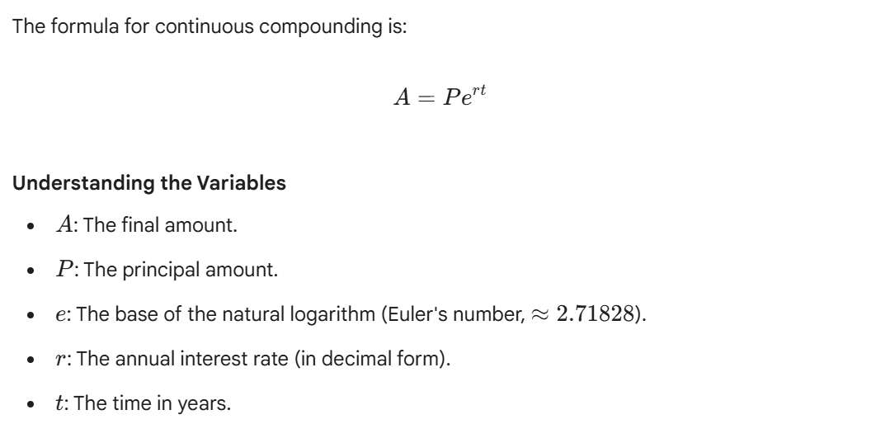

Example 9: If you invest $8,000 at an annual interest rate of 1.9% compounded continuously for 3 years, how much will you have at the end of the three years? How much interest did you earn?

Example 10: You are saving up for a down payment on your first home. You would like to have $20,000. You are giving yourself 10 years to get to this amount. You have found an account that offers continuous compounding. What does the interest rate need to be to grow $10,000 to $20,000 over 10 years?

Example 11: Following the birth of their granddaughter, two grandparents want to make an initial investment that will grow to $10,000 by the child’s 20th birthday. Interest is compounded continuously at 6%. What should the initial investment be?

Example 12: How long will it take a company’s $50,000 investment to triple if it is invested in an account offering continuous compounding at 4.9%?

