Exponential Applications 2

- Annuity

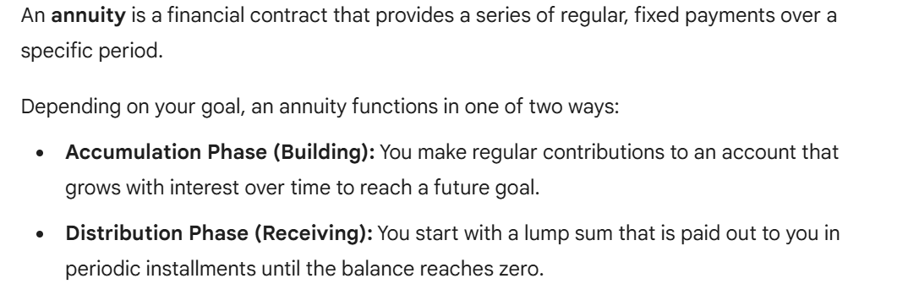

  - Building An Annuity - Future Value

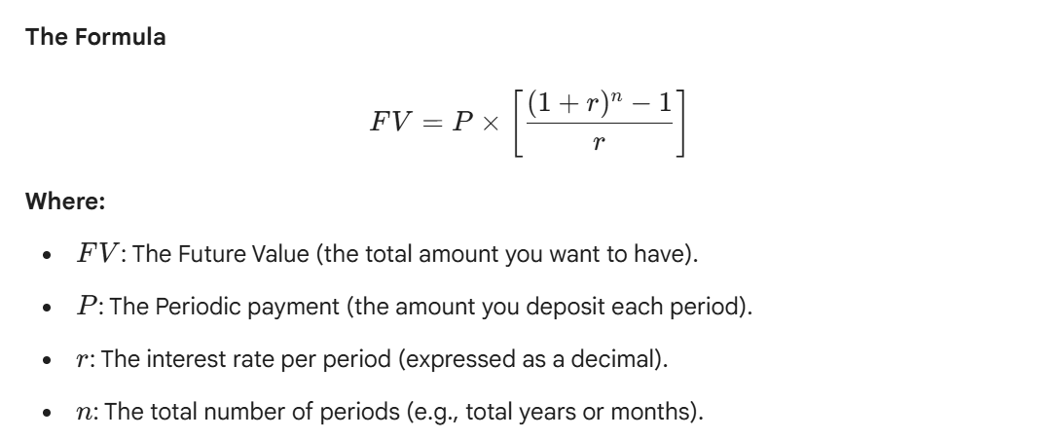

Example 1: A rookie player in the NFL just signed his first 7-year contract. To prepare for his future, he deposits $150,000 at the end of each year for 7 years in an account with 3.1% compounded annually.

- How much will he have in his account after 7 years?

- How much interest was earned over the 7 years?

Example 2: When a worker first starts out, they do not have a lot of extra money to put into savings. They are able to invest $400 per month at 2.3% compounded monthly for the first 10 years. After those 10 years, they are making more money and can afford to put more money into an account each month. The worker transfers all of the money they have from their first account into a new account with 2.89% interest. They put $700 per month into this account for 20 years. How much money will be in the account at the end of the 30 years?

  - Receiving An Annuity- Present Value

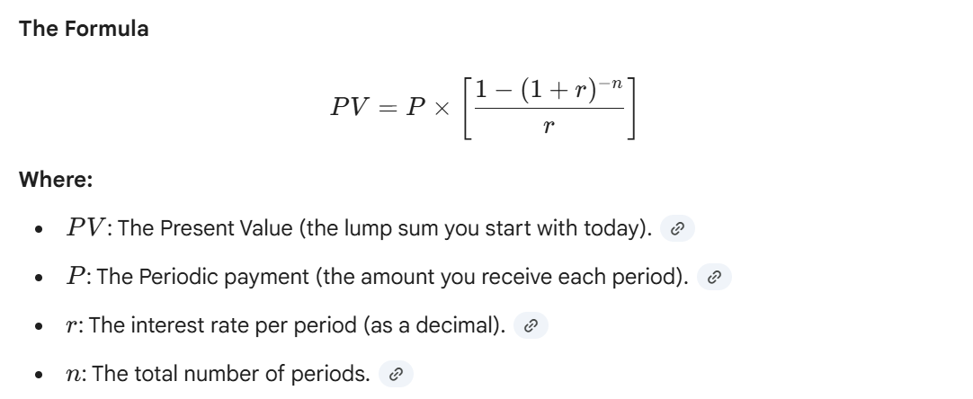

Example 3: A wealthy family member has funded an annuity that will pay you $1500 at the end of each year for six years. If the interest rate is 8%, compounded annually, find the present value of the annuity.

Example 4: To supplement his pension in the early years of his retirement, Ryan plans to use $124,500 of his savings as an ordinary annuity that will make monthly payments to him for 20 years. If the interest rate is 2.8%, how much will each payment be?
- Loans and Amortization

Amortization is the process of paying off a debt over a set period through a series of regular, fixed payments.

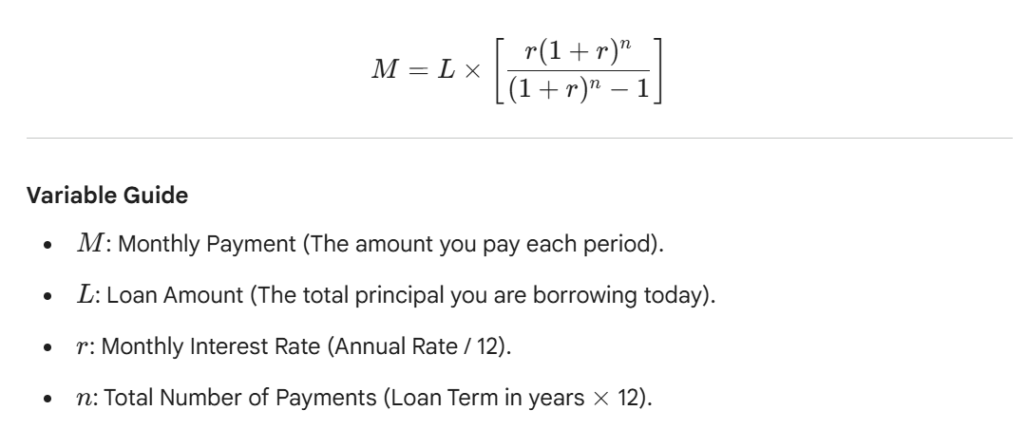

Example 5: The average used car price is $32,000. The average interest rate is currently 6.39% for a 60-month loan (5 years). If you have $5,000 for a down payment, what can you expect the monthly payment to be? How much will you pay in total for the car?

Example 6: The average rate for a 30-year fixed mortgage is 7.5%. Assume a down payment of 20% on a home purchase of $315,000.
- Find the monthly payments needed.

- How much will be paid in total over the life of the loan?

Example 7: In 2023, the average amount of student loan debt for a bachelor’s degree recipient at a private university was $54,921. Assume an interest rate of 6.87%
- Find the monthly payment and calculate the total interest paid over the course of the loan for a 10-year payment plan.

- Find the monthly payment and calculate the total interest paid over the course of the loan for a 20-year payment plan.

