Name: _____________________________________________ Date: _____________
$$/100$$
Math 110
Exam 1

Show all work for full credit. Round all answers to 2 decimal places, unless otherwise noted.

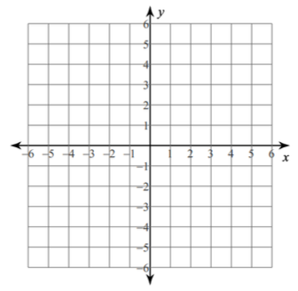
- (10 pts) Given $y=x^{2}-4x-5$
  - Find the vertex

  - Find the x-intercepts

  - Find the y-intercept

  - Graph

- (10 pts) The profit made by a small business on the production and sale of x items is
$$P\left(x\right)=-x^{2}+128x-1300$$

- What is the y-intercept? Interpret the meaning in the context of the problem.

- Find the number of items that should be produced and sold to maximize profit.

- What is the maximum profit?

- When profit is zero, the company is said to break even. Determine the number of items (to the nearest whole number) that must be manufactured and sold so that the company breaks even.

- (22 pts) A company that produces professionally-used digital cameras has fixed costs of $57,200 and variable cost per camera of $300. Each camera sells for $1400. If x is the number of cameras produced and sold:
  - Find the cost function

  - Find the revenue function

  - Find the break-even point

  - Graph and label the cost and revenue functions.

  - Is the company gaining or losing money when 100 cameras are produced and sold? Explain why.

  - Find the profit function

  - How much profit will they make if they produce and sell 75 cameras?

  - How many cameras must be produced and sold in order to obtain a profit of $451,000?

- (10 pts) On a certain route, a bus carries 100 passengers, each paying $30. A market survey indicates that for each $5 increase in the ticket price, the bus company will lose 4 passengers. The revenue function, where $x$ is defined as the number of $5 price increases, can be modeled by
$$R\left(x\right)=(100-4x)(30+5x)$$
  - Multiply out $R\left(x\right)$

  - Find the number of $5 price increases that will maximize the revenue.

  - Find the new bus fare

  - Find the number of passengers

  - Find the new maximum revenue

- (4 pts) The number of houses in the United States with solar panels can be modeled by
$y=333,333x+200,000$, where x = 0 corresponds to 2012

  - What is the slope?

  - Interpret the meaning of the slope in the context of the problem

  - What is the y-intercept?

  - Interpret the meaning of the y-intercept in the context of the problem.

- (10 pts) Solve by factoring or the quadratic formula
  - $2x^{2}-4x-6=0$ b. ${3x}^{2}+6x-10=0$

- (22 pts) After graduation, a student decides to start their own company selling refurbished laptops. The following revenue function represents the revenue derived from selling “$x$” laptops.
$R\left(x\right)=-4x^{2}+800x$
  - How many laptops need to be sold to achieve maximum revenue?

  - What is the maximum revenue?

  - At what price should the laptops be sold to achieve the maximum revenue?

  - Find the x-intercepts of $R(x)$

  - Graph $R\left(x\right)$. Label (as coordinates) all intercepts and the vertex.

  - After how many laptops does the company stop making revenue?

- (10 pts) A bakery buys a new oven for $40,000. After 10 years, its value will be $5000.
  - Find a linear equation relating the value of the oven, y, to its age, x.

  - Find the value of the oven after 7 years.

  - When will the oven be worth half of its original value?

  - Interpret the meaning of the slope.

