Exam 2 – Practice 1 Math 110.
Exam Guidelines This is an in-class, written exam with a 75-minute time limit.
- Permitted Materials: You may use a basic calculator and formula sheets.
- Formula Sheet Restrictions: Your sheets must contain formulas only; no examples or worked problems are permitted. All sheets will be inspected at the start of the exam.
- Prohibited Items: Phones and all other smart devices are strictly forbidden.
- Academic Integrity: The use of AI is prohibited. Any AI usage will result in an automatic F for the exam and may lead to failing the entire course.
- Show ALL your work for credits.

- Solve each quadratic by factoring or the quadratic formula.
- $2x^{2}=4x$
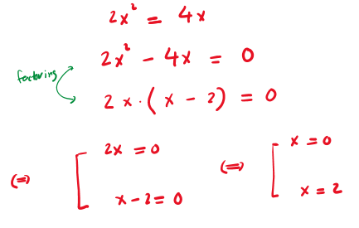
- $x^{2}-6x+10=0$
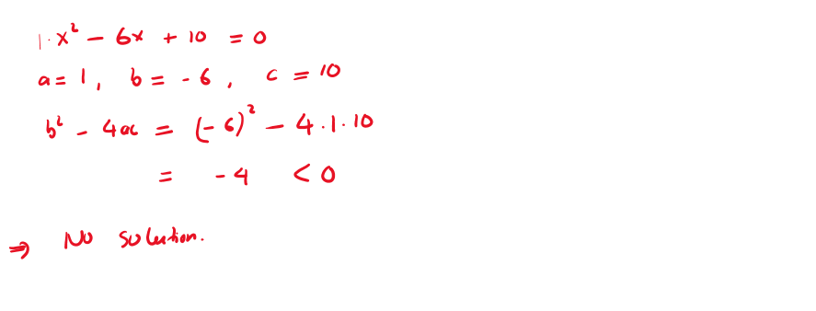
- $x^{2}-6x+9=0$
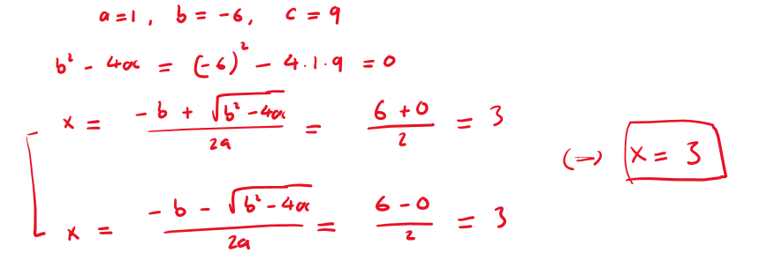
- $x^{2}+7x=-10$
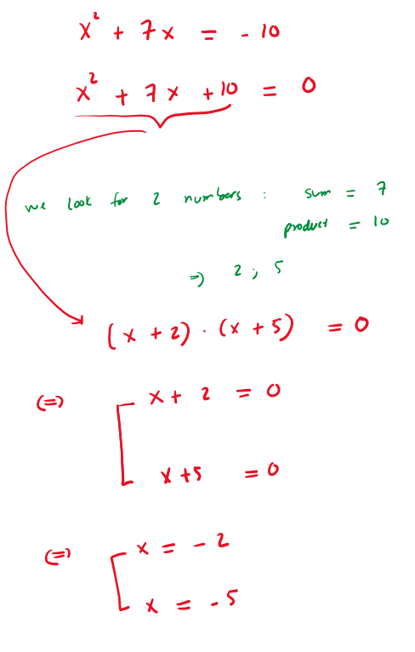
- Graph of the quadratic functions. Label the vertex and another point.
- $y=x^{2}+2x+3$
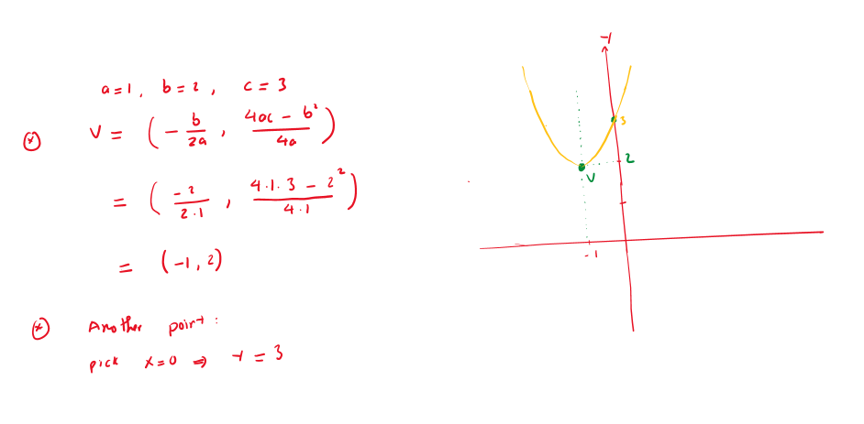
- $y=-2x^{2}+4x+4$
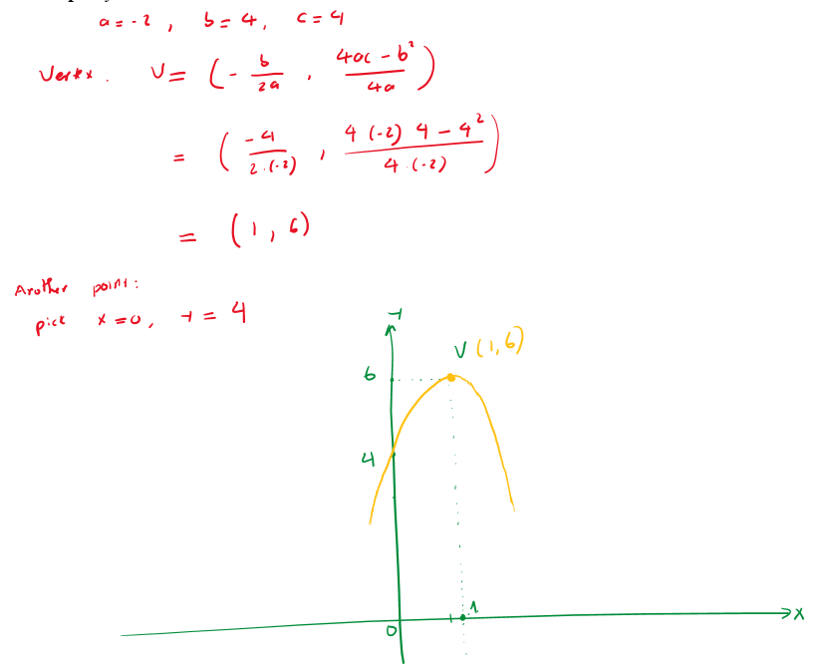

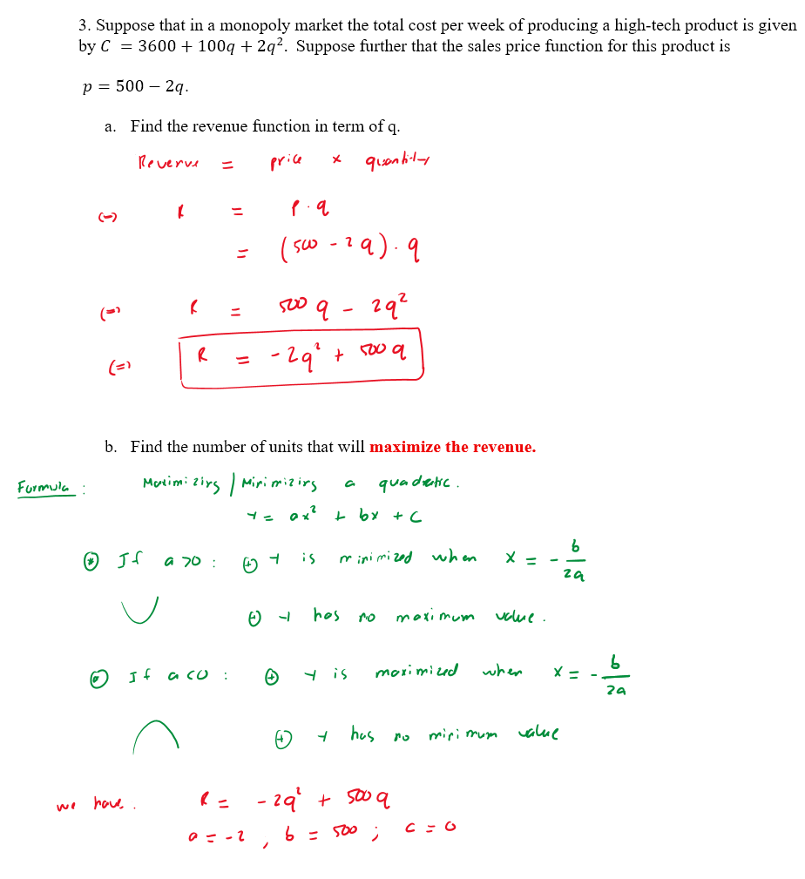

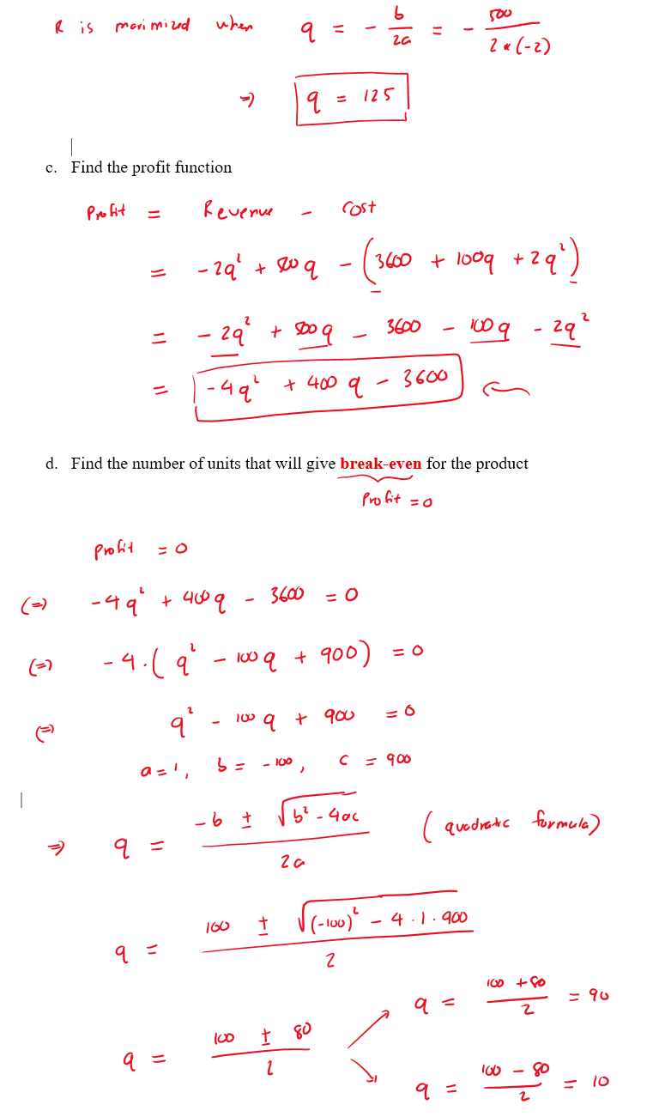
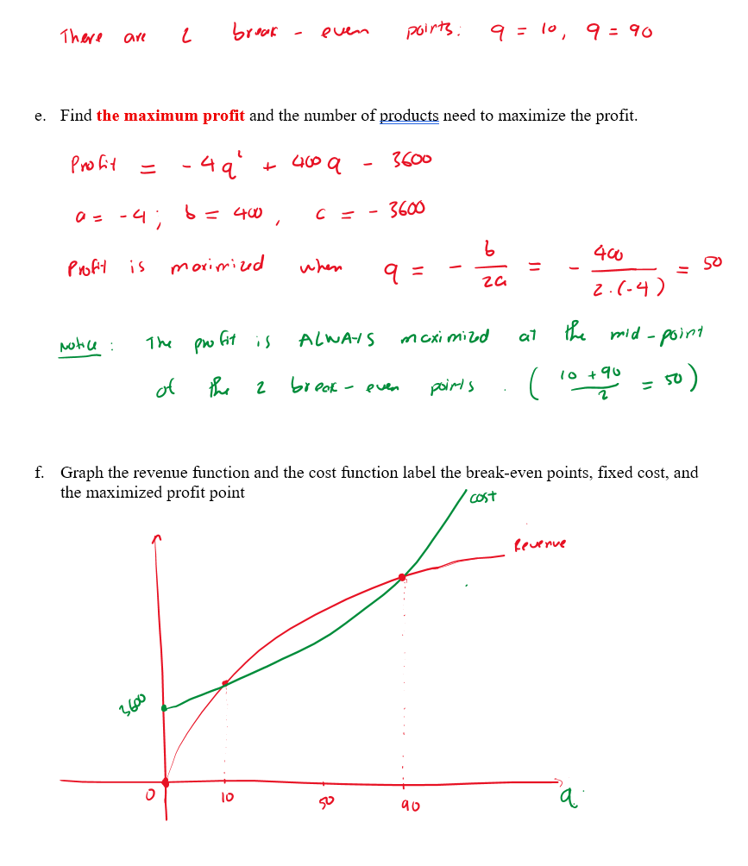

- On a certain route, an airline carries 8000 passengers per month, each paying $50. A market survey indicates that for each $1 increase in the ticket price, the airline will lose 100 passengers.

- What is the airline’s current revenue?

- Create an income (revenue) function if “$x$” is defined as the number of $1 price increases

- Find the number of $1 price increases that will maximize the revenue.

- Find the new ticket price (that will maximize the revenue)

- Find the number of passengers at that price in d.

- Find the new maximum income (income at that price in d)

- If the supply function for a commodity is given by $p=10q^{2}+2q$ and the demand function is given by $p=150-6q^{2}$, find the point of market equilibrium (Supply equals Demands). 