Exam 1. Math 110. Name:___________________
Exam Guidelines This is an in-class, written exam with a 75-minute time limit.
- Permitted Materials: You may use a basic calculator and formula sheets.
- Formula Sheet Restrictions: Your sheets must contain formulas only; no examples or worked problems are permitted. All sheets will be inspected at the start of the exam.
- Prohibited Items: Phones and all other smart devices are strictly forbidden.
- Academic Integrity: The use of AI is prohibited. Any AI usage will result in an automatic F for the exam and may lead to failing the entire course.
- Show ALL your work for credits.
- Graph the below line.
- $y=-3x+1$

- $y= -1$

- $x= 1$

- Write the equation of the line
- passing through two points (2, 2) and (0, 1)

- with the slope of 4 and passing through (1, 1)

- Match each equation to its corresponding graph. 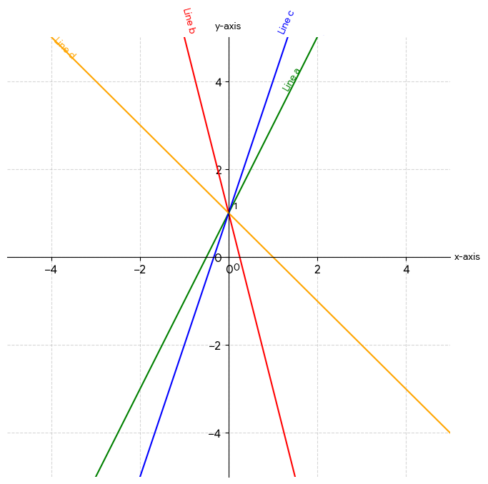
- $y=2x+1$
- $y=-4x+1$
- $y=3x+1$
- $y=-x+1$
4. You run a small stand at a weekend market selling fresh fruit smoothies.
Market research shows that you can sell 180 smoothies per week if the price is $4 per smoothie, but sales decrease to 60 smoothies per week if the price is increased to $10 per smoothie.
On the supply side, local vendors are willing to supply 50 smoothies per week when the price is $3 per smoothie, and they will increase production to 170 smoothies per week if the price rises to $9 per smoothie.
a. Write the linear demand function and the linear supply function.

b. Find the equilibrium point. At what price must the smoothies be sold so that quantity supplied equals quantity demanded?

5. A company that manufactures custom stainless-steel water bottles has fixed monthly costs of $90,000 and variable costs of $35 per bottle produced. Each bottle sells for $95.
a. Find the cost function.

b. Find the revenue function.

c. Graph and clearly label the cost and revenue functions on the same set of axes.
Identify and label the break-even point.

d. Find the profit function.
e. How much profit will the company make by producing and selling 1,800 bottles?
f. How many bottles must be produced and sold in order to obtain a profit of $60,000?

6. Two investment options that earn simple interest are available.
Investment A starts with $1,000 and earns simple interest at an annual rate of 5%.
Investment B starts with $2,000 and earns simple interest at an annual rate of 2%.
a. Write a linear equation that represents the total amount of money in each investment after $t$ years.

b. How much money will there be in Investment A after 4 years?
c. When will Investment A reach $1,860?
d. Determine which investment grows faster and explain your answer by comparing the slopes of the two equations.

e. Determine whether the two investments will ever have the same total value. If so, find when this occurs.

f. Plot both investment functions on the same coordinate system.

