Exam 3. Practice 2’s answers keys.
You may use a basic calculator and formula sheets. Your sheets must contain formulas only, no examples. Phones and all other smart devices are forbidden. Any AI usage will result in an automatic F for the exam. Show ALL your work for credits.
- Solve each exponential equation.
- $5^{x}=9$
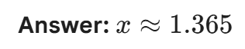

- ${4⋅7}^{-4x+1}-1=2$

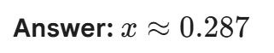
- ${10}^{4x+1}=3^{-2x+3}$
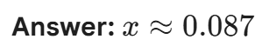
- A new artificial intelligence startup is valued at $2.5 million when it first launches in 2024. Market analysts predict the company's value will grow exponentially at a rate of 15% per year for the first 5 years.
- Write an equation to model the startup's valuation (V) in millions of dollars after t years.
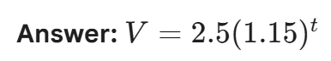
- Graph the equation
- According to the model, in what year will the company's valuation first exceed $10 million?
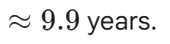
- The founders decide that if the valuation reaches $15 million, they will sell the company. Use the model to estimate which year they will likely reach this milestone.
- A manufacturing plant purchases a precision robotic arm for $82,000. Because of wear and tear and the release of newer models, the plant estimates that the robot’s value will decrease by 22% each year.
  - Write an equation to model the value of the robotic arm after t years.
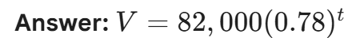
  - Graph the equation
  - What is the estimated value of the robotic arm after 4 years?
  - After how many years will the equipment be worth less than $15,000?
- A young couple decides to start a college savings fund for their child. They plan to deposit $4,000 at the end of each year for 18 years into an account that earns 5.2% interest compounded annually.
a. How much will be in the account after 18 years?
b. How much total interest was earned over the 18-year period?

5. You have inherited a trust fund that will pay you $8,000 at the end of each year for the next 15 years. However, you have the option to take a single lump-sum payment today instead of waiting for the annual installments.
If the current market interest rate is 4.2% compounded annually, what is the present value of this trust fund today?
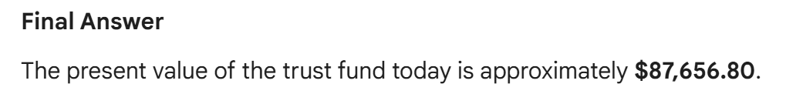
6. A person takes out a $30,000 loan to purchase a pre-owned vehicle. The credit union offers a fixed annual interest rate of 9% for a 60-month (5-year) term.
a. What can the buyer expect the monthly payment to be?
b. How much will they pay in total for the car by the end of the 60 months?
7. An entrepreneur takes out a $45,000 loan to launch a boutique coffee shop. The loan has an annual interest rate of 7.25%.
- Find the monthly payment and calculate the total interest paid for a 3-year (36 months) repayment plan.

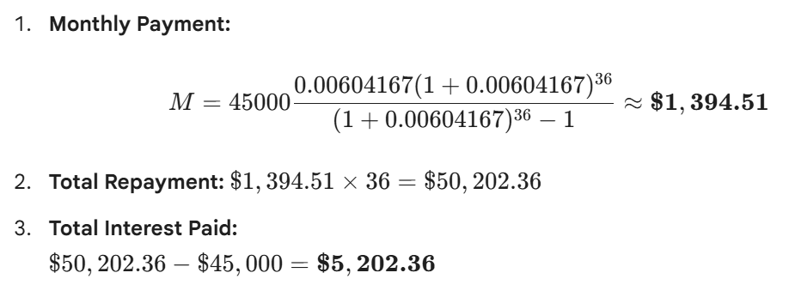

- Find the monthly payment and calculate the total interest paid for a 10-year (120 months) repayment plan.

