Quiz 3 Practice

- Based on data from Major League Baseball, the average price of a ticket to a major league game can be approximated by $p\left(x\right)=0.03x^{2}+0.56x+36.82$, where x is the number of years after 2008 and $p(x)$ is in dollars.
- Find the average price of a ticket to a major league game in 2015
- Find average price of a ticket to a major league game in 2025
- What is the average rate of change in the price of tickets to a major league game from 2015 to 2025? Include the correct units.

- For a recently released novel, the function $y=25000{\left(0.85\right)}^{t}$ models the number of books sold t months after the book was released.
  - Find the number of books sold 2 months after it was released.
  - Find the number of books sold 6 months after it was released.
  - Find the average rate of change in the number of books sold between month 2 and month 6. Make sure to include correct units.

- A manager wanted to analyze the online shoe sales for his business. He collected data for the number of pairs of shoes sold each hour over a 14-hour time period. Find the average rate of change of the number of pairs of shoes sold between hour 4 and hour 10.
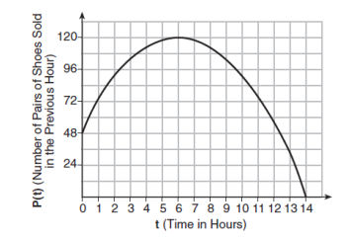

- The graph below shows the miles traveled by a family on a recent road trip. Find the average rate of change of the distance traveled by the family between hour 1 to hour 10.
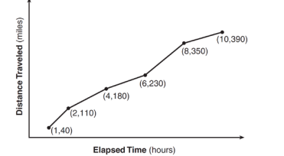

Find the derivative.

- $f\left(x\right)=4x^{3}-6x^{2}-5x-8$ | - $f\left(x\right)=5x^{8}-x^{7}+9x^{5}$
- $y=\frac{x^{8}+6x^{7}+10x^{5}}{x^{4}}$ | - $y={\left(6x+1\right)}^{2}$
- $f\left(x\right)=e^{6x^{3}-2x^{2}+3x-1}$ | - $f\left(x\right)=\ln\left(10x^{5}-4x^{3}+2\right)$
- $y=\left(3x^{4}-x^{2}\right)\left(x^{3}-4x\right)$ | - $y=\frac{x^{3}-4}{6x^{2}+3}$
- $f\left(x\right)=\frac{e^{9x}}{7x^{2}}$ | - $f\left(x\right)=6x^{4}ln⁡(2x)$
- $y=4x^{3}+8x^{2}-9x+14$ | - $y=5x^{5}+8x^{4}-2x$
- $f\left(x\right)=\frac{3x^{6}+7x^{5}-3x^{3}}{x^{2}}$ | - $f\left(x\right)=\left(8x-3\right)(x+5)$
- $f\left(x\right)=e^{10x^{2}-6x+5}$ | - $f\left(x\right)=\ln\left(8x^{3}-9\right)$
- $y=\left({3x}^{2}-9x\right)\left(x^{5}-11\right)$ | - $y=\frac{2x^{4}+x}{3x^{2}-9}$
- $f\left(x\right)=\frac{3x^{3}}{e^{5x}}$ | - $f\left(x\right)=9x^{2}ln⁡(4x)$

- If $f\left(x\right)=7x^{4}-5x^{3}+4x-10 ,$find $f^{'}\left(2\right)$

- If $f\left(x\right)={3x}^{5}-4x^{3}+5x^{2}-7x,$find $f^{'}\left(1\right)$

