Name: _______________________________________ Date: ____________
$$/50$$
Math 110
Quiz 3: Average and Instantaneous Rates of Change
Show all work for full credit.

- (4 pts) More Americans are buying organic fruit and vegetables and products made with organic ingredients. The amount $A(t)$, in billions of dollars, spent on organic food and beverages t years after 2000 can be approximated by $A\left(t\right)=0.06x^{2}+0.4x+9.45$
  - Find the amount of money Americans spent on organic food in 2010

  - Find the amount of money Americans spent on organic food in 2024

  - Find the average rate of change in the amount of money Americans spent on organic food from 2010 to 2024. Make sure to include correct units.

- (2 pts) The graph below shows the United States population from 1900 to 2010, as recorded by the U.S. Census Bureau. What was the average rate of change in the population from 1920 to 1980? Make sure to include correct units.

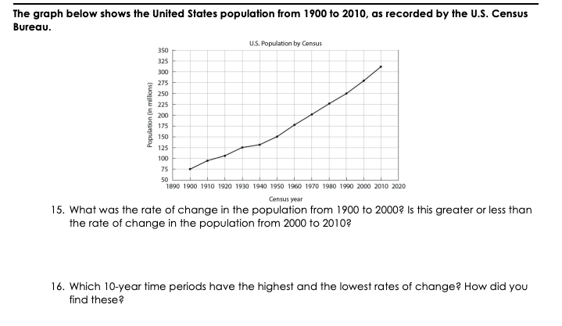

Find the derivative. (22 pts)
- $y={8x}^{4}-6x^{2}+1$ | - $f\left(x\right)=-4x^{5}-10x^{3}+6x$
- $f(x)={(x-2)}^{2}$ | - $y=\frac{x^{4}-6x^{3}+2x^{2}}{x}$
- $y=e^{4x^{2}-3x+2}$ | - $f\left(x\right)=\ln\left(5x^{2}-4\right)$

- (2 pts) If $f\left(x\right)={3x}^{3}-4x^{2}+5x-7,$find $f^{'}\left(1\right)$

Find the derivative. (20 pts)

- $f(x)=\left(x^{2}+1\right)\left(5x^{3}-3x\right)$ | - $f\left(x\right)=\frac{3x^{4}+2}{3x^{3}-7}$
- $y=\frac{e^{6x}}{x^{4}}$ | - $y=x^{3}ln⁡(x)$

