Linear Programming
Problem 1
A baker makes two types of treats: Cupcakes (x) and Cookies (y).
- Time Constraint: It takes 2 hours to bake a batch of cupcakes and 1 hour for cookies. He has 8 hours available.
- Space Constraint: He can only fit 5 total batches in his display case.
- Objective: He makes a profit of $30 per batch of cupcakes and $20 per batch of cookies. Find the number of cupcake batches (x) and cookie batches (y) that maximize the profit.
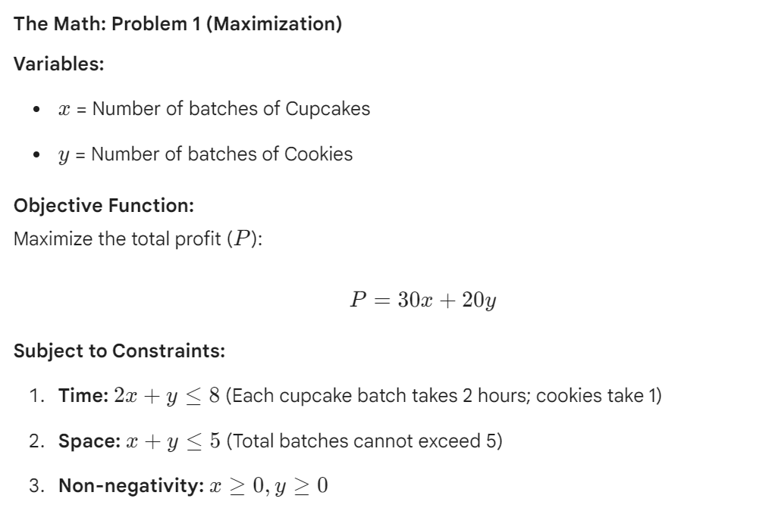

You try
A small shop builds two types of custom computers: Gaming PCs (x) and Office PCs (y).
- Time Constraint: A Gaming PC takes 3 hours to build, and an Office PC takes 1 hour. The shop has 9 hours of building time available today.
- Component Constraint: Due to a parts shortage, they can only build a total of 5 computers maximum.
- Objective: They earn $50 for every Gaming PC and $30 for every Office PC. Find the number of Gaming PCs (x) and Office PCs (y) that maximize the profit.

Problem 2
An athlete needs to meet daily nutritional requirements using Protein Shakes (x) and Energy Bars (y).
- Protein Constraint: Each shake has 2 units of protein, and each bar has 1 unit. He needs at least 5 units a day.
- Energy Constraint: Each shake has 1 unit of energy, and each bar has 3 units. He needs at least 10 units a day.
- Objective: Each shake costs $4 and each bar costs $3. Find the number of Protein Shakes (x) and Energy Bars (y) that minimize the cost.

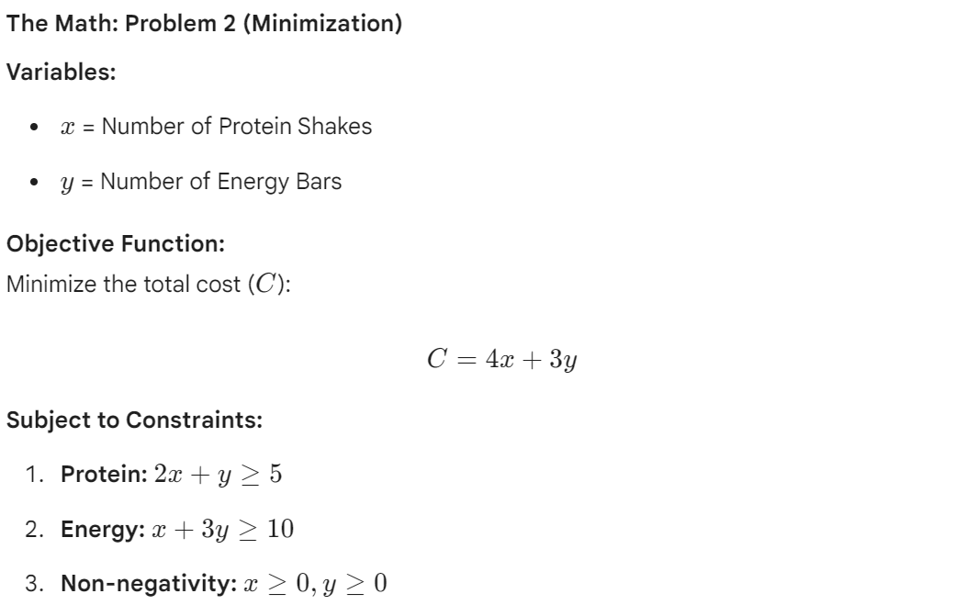

You try
A landscaping company needs to spread mulch and stone using two sizes of trucks: Small Trucks (x) and Large Trucks (y).
- Mulch Capacity Constraint: A Small Truck carries 1 ton, and a Large Truck carries 3 tons. They need to deliver at least 6 tons of mulch.
- Stone Capacity Constraint: A Small Truck carries 2 tons, and a Large Truck carries 1 ton. They need to deliver at least 7 tons of stone.
- Objective: Running a Small Truck costs $100 and a Large Truck costs $200. Find the number of Small Trucks (x) and Large Trucks (y) that minimize the cost.

