Exponential Applications 2

- Annuity

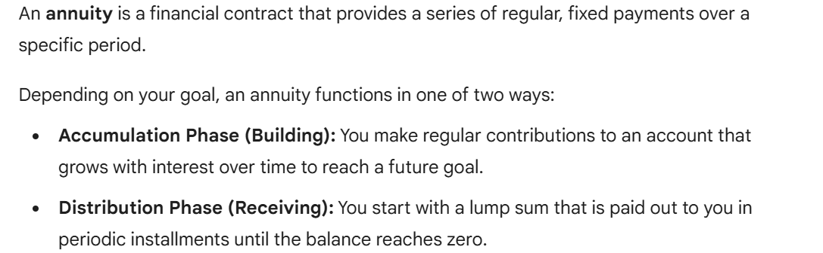

  - Building An Annuity - Future Value

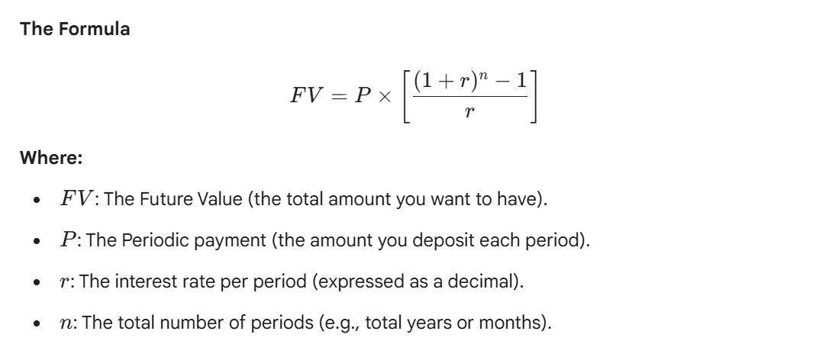

Example: A rookie player in the NFL just signed his first 7-year contract. To prepare for his future, he deposits $150,000 at the end of each year for 7 years in an account with 3.1% compounded annually.

- How much will he have in his account after 7 years?

- How much interest was earned over the 7 years?
You try: A new professional basketball player signs a 6-year contract. To save for the future, he deposits $120,000 at the end of each year into an investment account that earns 3.4% interest compounded annually.
a. How much money will be in the account after 6 years?
b. How much interest was earned during the 6 years?

  - Receiving An Annuity- Present Value

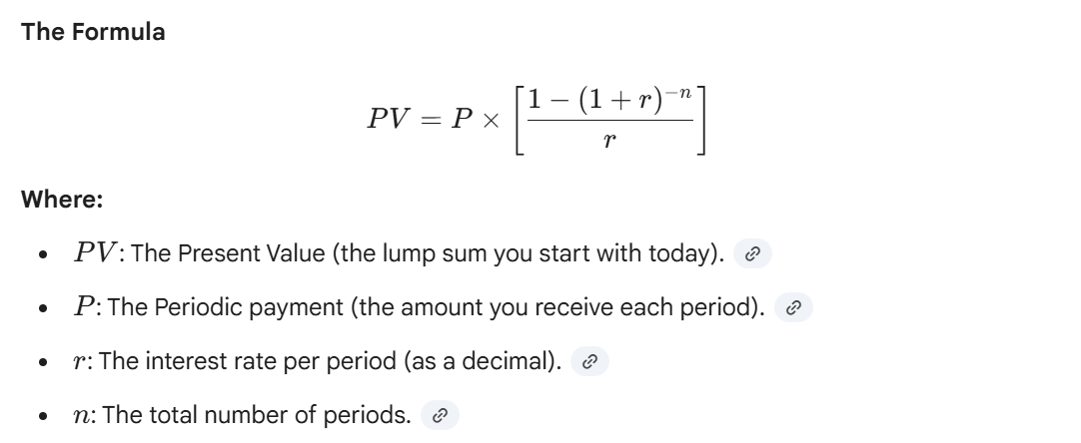

Example : A wealthy family member has funded an annuity that will pay you $1500 at the end of each year for six years. If the interest rate is 8%, compounded annually, find the present value of the annuity.

You try: A relative has set up an annuity that will pay you $2,000 at the end of each year for 5 years. The account earns 7% interest compounded annually. Find the present value of the annuity today.

Example: To supplement his pension in the early years of his retirement, Ryan plans to use $124,500 of his savings as an ordinary annuity that will make monthly payments to him for 20 years. If the monthly interest rate is 2.8%, how much will each payment be?

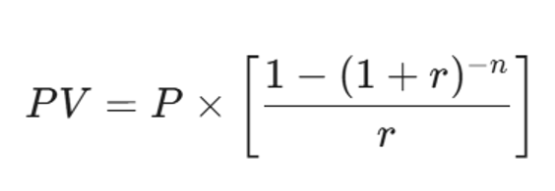

You try: To fund his extensive pickleball tournament travel and new paddle upgrades for the next 15 years, Sarah decides to invest $\$150,000$ into an ordinary annuity. If the annuity offers an annual interest rate of 3.5% compounded monthly, how much will Sarah receive in monthly payments?

- Loans and Amortization

Amortization is the process of paying off a debt over a set period through a series of regular, fixed payments.

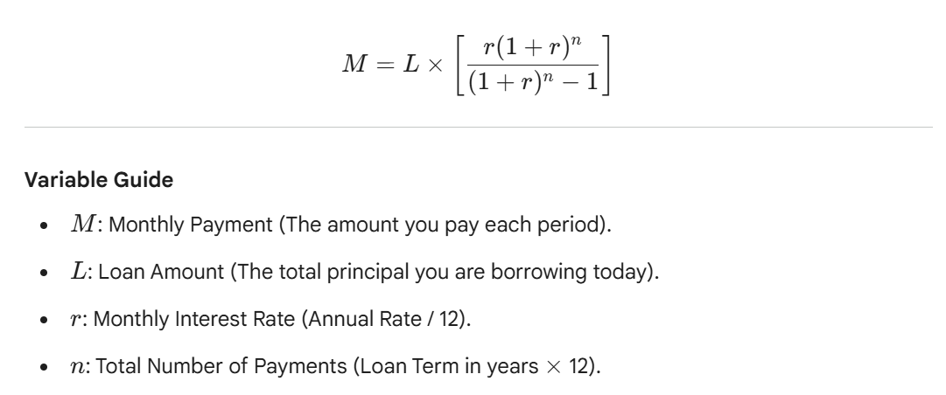

Example: The average used car price is $32,000. The average annual interest rate is currently 6.39% for a 60-month loan (5 years). If you have $5,000 for a down payment,

- what can you expect the monthly payment to be?
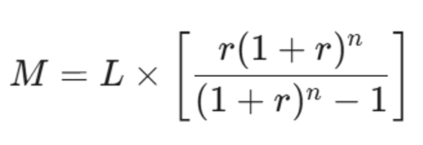

- How much will you pay in total for the car?

You try 1: The annual average rate for a 30-year fixed mortgage is 7.5%. Assume a down payment of 20% on a home purchase of $315,000.
- Find the monthly payments needed.
- How much will be paid in total over the life of the loan?

You try 2: In 2023, the average amount of student loan debt for a bachelor’s degree recipient at a private university was $54,921. Assume an interest rate of 6.87%
- Find the monthly payment and calculate the total interest paid over the course of the loan for a 10-year payment plan.

- Find the monthly payment and calculate the total interest paid over the course of the loan for a 20-year payment plan.

