Name: ____________________________________ Date: _________
$$/50$$
Math 110
Quiz 1 – Linear Functions

Show all work for full credit.
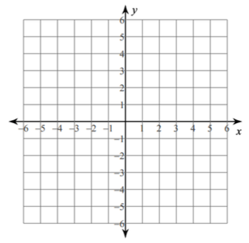
- (3 pts) Given $5x-6y=12$
  - Rewrite in slope-intercept form

  - Graph the line

- (4 pts) Find the slope of the line through each pair of points:
  - $(-8,5)$ and $\left(2,1\right)$ b. $(3,-8)$ and $\left(-7,-8\right)$

- (16 pts) A fashion company can sell 125 shirts at a price of $35 each. If the price drops to $25 apiece, the company can sell 375 shirts. The company’s suppliers are willing to supply only 150 shirts if the price per shirt is $35. However, if the price per shirt increases to $50 per shirt, the suppliers are willing to provide 400 shirts.
(q, p) = (quantity, price) p = mq + b

- Write the demand function b. Write the supply function

- Find the equilibrium point. For supply to equal demand, the shirts must be priced at how much apiece?

- Graph both the demand and supply function on the same axis. Label each line.

- At q = 200, will the company have a surplus or shortage of shirts? Explain why.

- (5 pts) Given $8x-5y=20$
  - Find the x-intercept

  - Find the y-intercept

  - Graph the line

- (6 pts) A machine is now worth $110,000 and will be depreciated linearly over an 8-year period, at which time it will be worth $20,000 as scrap.
- Find the depreciation function that gives the value of the machine in year x.

- What will the machine be worth in 3 years?

- When will the machine be worth half its original value?

- (16 pts) Ink cartridges are produced with a fixed monthly cost of $24,000 and variable costs of $15 per ink cartridge produced. The ink cartridges sell for $31 each.

- Find the cost function

- Find the revenue function

- Find the break-even point

- Graph and label the cost and revenue functions on the same set of axes. Label the break-even point.

- At a production level of 1000 ink cartridges, is the company making money or losing money? Explain why.

- Find the profit function

- How much profit will they make by producing and selling 2000 ink cartridges?

- How many ink cartridges must be produced and sold in order to obtain a profit of $100,000?

