Name: ____________________________________ Date: _________
$$/50$$
Math 110
Quiz 1 – Linear Functions

Show all work for full credit.

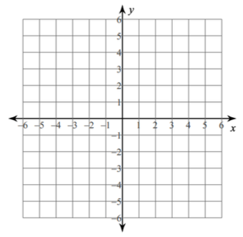
- (5 pts) Given $-4x+5y=10$
  - Find the x-intercept

  - Find the y-intercept

  - Graph the line

- (6 pts) A machine is now worth $120,000 and will be depreciated linearly over an 8-year period, at which time it will be worth $25,000 as scrap.
- Find the depreciation function that gives the value of the machine in year x.

- What will the machine be worth in 3 years?

- When will the machine be worth half its original value?

- (16 pts) Ink cartridges are produced with a fixed monthly cost of $18,000 and variable costs of $12 per ink cartridge produced. The ink cartridges sell for $28 each.

- Find the cost function

- Find the revenue function

- Find the break-even point

- Graph and label the cost and revenue functions on the same set of axes. Label the break-even point.

- At a production level of 800 ink cartridges, is the company making money or losing money? Explain why.

- Find the profit function

- How much profit will they make by producing and selling 2000 ink cartridges?

- How many ink cartridges must be produced and sold in order to obtain a profit of $100,000?

- (4 pts) Find the slope of the line through each pair of points:
  - $(11,-3)$ and $\left(5,6\right)$ b. $(-3,8)$ and $\left(-3,2\right)$

- (3 pts) Given $5x-4y=8$
  - Rewrite in slope-intercept form

  - Graph the line

- (16 pts) A fashion company can sell 150 shirts at a price of $35 each. If the price drops to $20 apiece, the company can sell 300 shirts. The company’s suppliers are willing to supply only 130 shirts if the price per shirt is $25. However, if the price per shirt increases to $40 per shirt, the suppliers are willing to provide 430 shirts.

- Write the demand function b. Write the supply function

- Find the equilibrium point. For supply to equal demand, the shirts must be priced at how much apiece?

- Graph both the demand and supply function on the same axis. Label both lines.

- At q = 100, will the company have a surplus or a shortage of shirts? Explain why.

