Exam 1 – Practice 1
Exam Guidelines This is an in-class, written exam with a 75-minute time limit.
- Permitted Materials: You may use a basic calculator and a formula sheet.
- Formula Sheet Restrictions: Your sheet must contain formulas only; no examples or worked problems are permitted. All sheets will be inspected at the start of the exam.
- Prohibited Items: Phones and all other smart devices are strictly forbidden.
- Academic Integrity: The use of AI is prohibited. Any AI usage will result in an automatic F for the exam and may lead to failing the entire course.
- Graph the below line.
- $y=2x+1$

To graph a linear function, we just need to plot two points and connect them to make a line.
Choose any value for x, says,
Choose x = 0, y = 2*0+1 =1. We have a point (0,1)
Choose x = 1, y = 2*1+1 = 3. We have a point (1, 3).

- $y=5$

- $x=3$

- Write the equation of the line
- passing through two points (1, 2) and (4, 3)

- with the slope of 3 and passing through (1, 2)

- Match each equation to its corresponding graph.
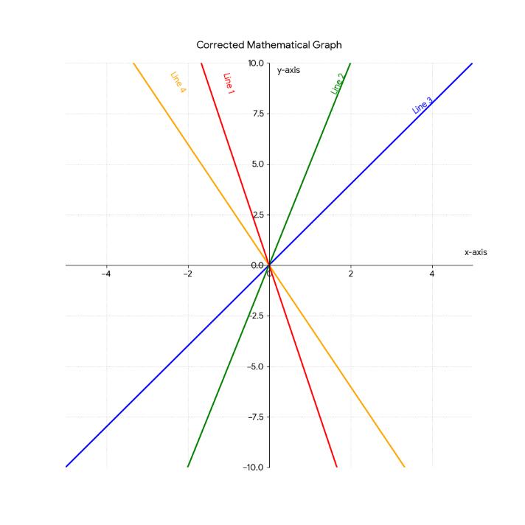
- $y=2x$
- $y=5x$
- $y=-3x$
- $y=-6x$
Notice:
  - A line with positive slope goes up. The greater the slope, the faster it goes up.
  - A line with negative slope goes down. The smaller the slope, the faster it goes down.

- You manage a local craft shop that sells handmade artisan coffee mugs.
Market research indicates that you can sell 150 mugs per month if they are priced at $10 each, but you will only sell 50 mugs per month if the price is increased to $20 each.
On the other side, your supplier is willing to provide 30 mugs per month if the retail price is $8 each but will increase production to 130 mugs per month if the retail price reaches $18 each.
    - Write the linear demand and supply functions.

    - Find the equilibrium point. At what price must the mugs be sold for supply to exactly equal demand?

c. Graph both the demand and supply functions on the same axis.

- A company that prints custom T-shirts has fixed monthly costs of $60,000 and variable costs of $30 per T-shirt produced. Each T-shirt sells for $90.

- Find the cost function.

- Find the revenue function.

- Graph and clearly label the cost and revenue functions on the same set of axes. Identify and label the break-even point.

- Find the profit function.

e. How much profit will the company make by producing and selling 1,500 T-shirts?
f. How many T-shirts must be produced and sold in order to obtain a profit of $60,000?

- Two investment options that earn simple interest are available.

Investment A starts with $1,200 and earns simple interest at an annual rate of 4%.
Investment B starts with $2,000 and earns simple interest at an annual rate of 2%.

- Write a linear equation that represents the total amount of money in each investment after t years.
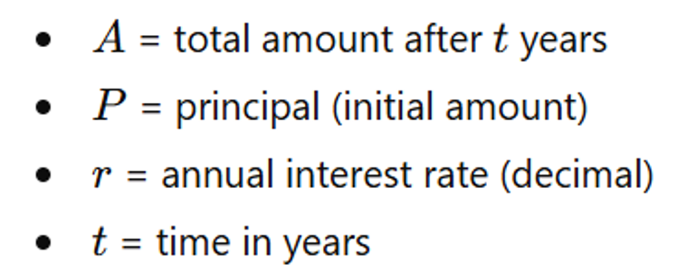

- How much money will there be in Investment A in 3 years?

- When will investment A reaches $1488?

- Determine which investment grows faster and explain your answer by comparing the slopes of the two equations.

- Determine whether the two investments will ever have the same total value. If so, find when this occurs.
- Plot both investment functions on the same coordinate system.

