M122 - Calculus and Analytical Geometry II
Spring 2026
Dr. John Quinn


Office: Suite F, Room 2413 Telephone: 401-232-6392
e-mail: jquinn@bryant.edu
Suite F Coordinator: 401-232-6366

Welcome to M122 for the spring 2026 semester. My name is Professor John Quinn and I endorse an inclusive learning environment where diversity and individual differences are understood, accepted, respected, appreciated, and recognized as a source of strength. In this class, we will recognize, respect, and support a diverse range of thoughts, perspectives, and experiences in effort to honor and respect your identities.

To help accomplish this:
If you use pronouns and/or a name which is different than what may be listed, please do not hesitate to inform me.
If you are struggling outside the classroom and it is impacting your performance within the class, please let me know so that I can serve as a resource for you.
If something said or done in class offends you, please feel encouraged and safe to let me know so that we may be able to address it.

There are various campus resources that are available to support you, including:
Academic Center for Excellence (ACE) and the Writing Center
The Counseling Center
The Office of Accessibility Services
Campus Ministry

PwC Center which includes:
Hochberg Women’s Center
The Intercultural Center
The Pride Center

Bias Incident Committee

The following is a link for Student Services:
https://catalog.bryant.edu/undergraduate/studentservicesandaccommodations/studentservices/

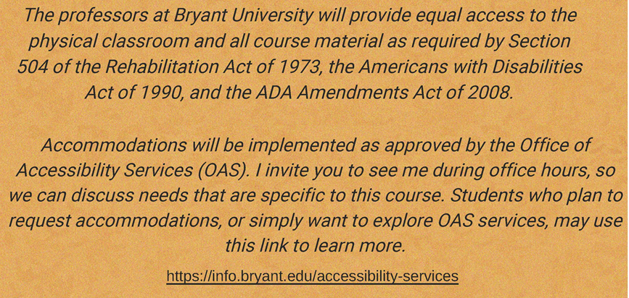

Course Schedule
Monday & Thursday 11:10am – 12:25pm Unistructure 359

Office Hours (Including Zoom): Monday 12:30 p.m. – 3:00 p.m.

Thursday 12:30 p.m. – 3:00 p.m.

or by appointment

Link for Virtual Office Hours:
https://bryant.zoom.us/j/95674238688?pwd=LgUnoDi3Dj6MWYbSehBrt3yPqtThgl.1

Note that since Monday, February 16, 2026 is a holiday, then Monday classes will be held on Tuesday, Monday, February 17, 2026.

Recommended Text
Calculus Late Transcendentals Combined, 10th Edition by Howard Anton, Irl C. Bivens, Stephen Davis, Wiley& Sons, Inc. ©2012, ISBN: 978-0-470-64772-1

Course Description
This course is the second of three calculus courses required of actuarial majors. These courses will provide part of the material necessary to prepare for the first professional actuarial exam (Exam P - Probability). This course covers a variety of concepts and techniques in differential and integral calculus.

Objectives
The primary goals of this course are to provide the student with the capabilities to understand problems in differential and integral calculus and apply the appropriate methods to solve them. After taking this course, the student should be able to do such things as:

- find volumes of different solids
- find lengths of plane curves
- use L’Hopital’s rule
- use different methods of integration (by parts, trigonometric substitution, etc.)
- understand elementary first-order separable differential equations
- understand sequences
- determine whether series diverge or converge
- determine sums of infinite series

Evaluation and Grading Policy

There will be three in-class examinations, and in addition, there will be timed online quizzes given through Canvas. Each quiz will be available to take outside of class during a given week. These quizzes will be closed book, closed notes and no use of outside resources (such as the internet) is allowed. Solutions to a given quiz may be submitted only once and you must work alone.

Grading Policy

Test 1 25%
Test 2 25%
Test 3 25%
Quizzes (Combined) 20%
Homework/Participation 5%

The final numerical grade will be translated into a final letter grade for the course as follows:

94 - 100 ............ A
90 - 93 ............ A-
87 - 89 .............. B+
83 - 86 .............. B
80 - 82 .............. B-
77 - 79 ............. C+
73 - 76 ............. C
70 - 72 ............. C-
67 - 69 ..............D+
60 - 66 ............. D
59 and below .... F

Attendance Policy
Attendance will be taken at the beginning of each class period. Absence is discouraged since it interrupts the continuity of course material and usually is detrimental to learning. ANY STUDENT WHO MISSES A LECTURE IS REQUIRED TO OBTAIN NOTES AND HOMEWORK ASSIGNMENTS FROM A CLASSMATE AND MAKE UP THE MATERIAL THAT WAS MISSED. IF YOU MISS MORE THAN 2 WEEKS OF CLASSES (THAT IS, FOUR CLASSES), I RESERVE THE RIGHT TO LOWER YOUR FINAL GRADE.

A student who has an excused absence from an examination will be given a make-up examination as soon as possible. However, the professor will choose one of two options for the make-up examination: 1) a make-up examination with the same number of problems as the original that is worth only 90 points, at most; 2) a make-up examination that contains more problems than the original that is worth 100 points, at most. In either case, the make-up examination can be much more difficult than the original.

There will be no make-up quizzes, so that a quiz that is missed will be worth zero points.

Withdrawals
Withdrawals
From the Provost email dated 8/14/24 : “Going forward, the WP and WF options will be eliminated. As of September 3rd, undergraduate students will be allowed to withdraw from a course after the add/drop period and up until the end of the 10th week of regularly scheduled classes for on-campus programs, as designated by the university calendar by making a written request to the Office of the Registrar with no academic penalty incurred.” For spring 2026, the final day for the “W” grade is Tuesday, April 7, 2026.

Homework Assignments
Questions about homework problems will be answered at the beginning of class, or if more time is needed, can be discussed during office hours.

IN-CLASS EXAMINATION SCHEDULE:

EXAM I Monday February 23, 2026

EXAM II Monday April 6, 2026

EXAM III As scheduled in the final examination period:
Thursday, May 7, 2026 3:00pm - 5:30pm

Quizzes: Each quiz will be available for one week online through Canvas. They will all be timed quizzes, generally with a time limit of one hour. They will also contain mainly multiple choice and true/false types of problems.

Use of calculators:
Calculators will be allowed on some tests and quizzes but might not be allowed on other tests and quizzes, especially where the student is supposed to envision the graphs of specific functions, based on techniques learned in class. Students will be told beforehand if a calculator is not allowed on a specific test or quiz.

TENTATIVE COURSE OUTLINE

I. APPLICATIONS OF THE DEFINITE INTEGRAL (Chapter 5)
A. Area Between Two Curves (Brief Review) (Section 5.1)
B. Volumes by Slicing; Disks and Washers (Review) (Section 5.2)
C. Volumes by Cylindrical Shells (Review) (Section 5.3)
D. Length of a Plane Curve (Section 5.4)
(Parts of these Sections in Chapter 5, particularly 5.1, are covered in M121)
E. Average Value of a Function (Possible Very Brief Review) (Section 4.8)

II. EXPONENTIAL, LOGARITHMIC, INVERSE TRIGONOMETRIC FUNCTIONS (Chapter 6)
A. L’Hopital’s Rule; Indeterminate Forms (Section 6.5)
B. Inverse Trigonometric Functions (Section 6.7)
(Note that Derivatives and Integrals of Exponential and Logarithmic Functions, Sections 6.2 and 6.3, are covered in detail in M121.)

III. PRINCIPLES OF INTEGRAL EVALUATION (Chapter 7)
A. An Overview of Integration Methods (Section 7.1)
B. Integration by Parts (Section 7.2)
C. Integrating Trigonometric Functions (Section 7.3)
D. Trigonometric Substitutions (Section 7.4)
E. Rational Functions – Partial Fractions (Section 7.5)
F. Improper Integrals (Section 7.8)

IV. MATHEMATICAL MODELING WITH DIFFERENTIAL EQUATIONS (Chapter 8) (Depending on time)
A. Modeling With Differential Equations (Section 8.1)
B. Separation of Variables (Section 8.2)

V. INFINITE SERIES (Chapter 9)
A. Sequences (Section 9.1)
B. Monotone Sequences (Section 9.2)
C. Infinite Series (Section 9.3)
D. Convergence Tests (Section 9.4)
E. The Comparison, Ratio, and Root Tests (Section 9.5)
F. Alternating Series; Abs. and Cond. Convergence (Section 9.6)
G. Maclaurin and Taylor Polynomial (Section 9.7)
H. Maclaurin and Taylor Series; Power Series (Section 9.8)
I. Convergence of Taylor Series (Section 9.9)
J. Differentiating and Integrating Power Series (Section 9.10)

If there is time available, Partial Derivatives and Multiple Integrals might be considered.
FROM THE BRYANT UNIVERSITY STUDENT HANDBOOK AND ADMINISTRATION MEMO

ACADEMIC BEHAVIOR

Bryant University Academic Honesty Policy

A student’s education is the result of individual initiative and industry. A student indisposed to such an academic commitment will not gain an education at Bryant University. Each Bryant student, accordingly, understands that to submit work that is not his or her own is not only a transgression of University policy but a violation of personal integrity. A high standard of conduct in academic experiences is expected of each student.
The academic community, therefore, does not tolerate any form of “cheating” – the dishonest use of assistance in the preparation of outside or in-class assignments. Such violations, which include forms of plagiarism, are subject to disciplinary action.

To preserve its commitment to the high standards of intellectual and professional behavior, Bryant University rewards intellectual excellence and expects intellectual honesty.

Academic dishonesty includes but is not limited to:
- plagiarism in any form;
- using an illegal cheat sheet during a quiz or examination;
- copying from another student's examination, term paper, or lab report;
- intentionally missing (or delaying taking) an exam to gain an unfair advantage;
- submitting the same paper or report in more than one course without permission of the instructors;
- falsification or invention of data;
- unauthorized access to or the use of the computerized work of others;
- obtaining questions for an examination from another student who had already taken it;
- obtaining answers for an examination from another student who had already taken it;
- misappropriation of examination materials or information;
- changing a response after a paper, examination, or quiz is graded, then reporting a misgrade and asking for credit for the altered response;
- taking an examination for another student;
- giving illicit aid on exams, papers, or projects.

Lack of knowledge of the above is unacceptable as an excuse for dishonest efforts. Any form of cheating could result in failure of a test, failure of the course, or some other disciplinary action.

