**Math 201 - Statistics 1 (12:30PM)**

# Class Information

This is Math201, section 4064, meeting at 12:30-13:45PM on Tuesday and Thursday at Unistructure 252.

# Instructor

Son Nguyen. Email: [snguyen4@bryant.edu](mailto:snguyen4@bryant.edu). Office: Suite A Room 8 in Unistructure.

**Class Website:**

<https://bryantstats.github.io/math201_1230/>

# Course Description

In this course students are taught the concepts necessary for statistical analysis and inference. Topics include descriptive statistics, classical probability, probability distributions, confidence intervals, and hypothesis testing, chi-square analysis, simple linear regression and correlation.

**Prerequisites**

MATH 110 or equivalent

# Desired Learning Outcomes

After completing this course, you should be able to

* Form hypothesis and collect data to test the hypothesis.
* Understand and implement statistical inferences, such as hypothesis testing, confidence interval, using a statistical software/package.
* Understand and implement descriptive statistics using a statistical software/package.
* Understand and implement linear regression and correlation analysis using a statistical software/package.

# Office Hours

Office hours (A8 - Suite A) from 11:30AM-12:30PM on Tuesday and Thursday. Office hour can be scheduled over Zoom ([https://bryant.zoom.us/j/4419675207)](https://bryant.zoom.us/j/4419675207) during these times. If the office hours do not work, please feel free to schedule another time with me. If there is a change in office hours, it will be notified in class and Canvas.

**Course Materials**

All the course materials will be provided on Canvas and the class website.

# Grades

## Attendance

Attendance will be an important part of the class and checked in every class meeting. Missing less than three class meetings will guarantee you the full credits for attendance**.** We expect many of the assignments will be done and graded in class so your attendance will be a key to complete those assignments.

## Assignments

The assignments may be assigned and checked in class (hence, attendance is important!). Assignments may be in group or individual.

## Projects

Projects can be done in groups of no more than three or individually. The logistics and other details of the projects will be updated on the class webpage and Canvas.

## Late Work

Late assignments are penalized 10% for each day late. You can resubmit your work to improve your score, but the late penalty will apply.

# Grading Scale

A 92.45 - 100% C 72.45 - 76.44%

A- 89.45 - 92.44% C- 69.45 - 72.44%

B+ 86.45 - 89.44% D+ 66.45 - 69.44%

B 82.45 - 86.44% D 62.45 - 66.44%

B- 79.45 - 82.44% D- 59.45 - 62.44%

C+ 76.45 - 79.44% F Below 59.44%

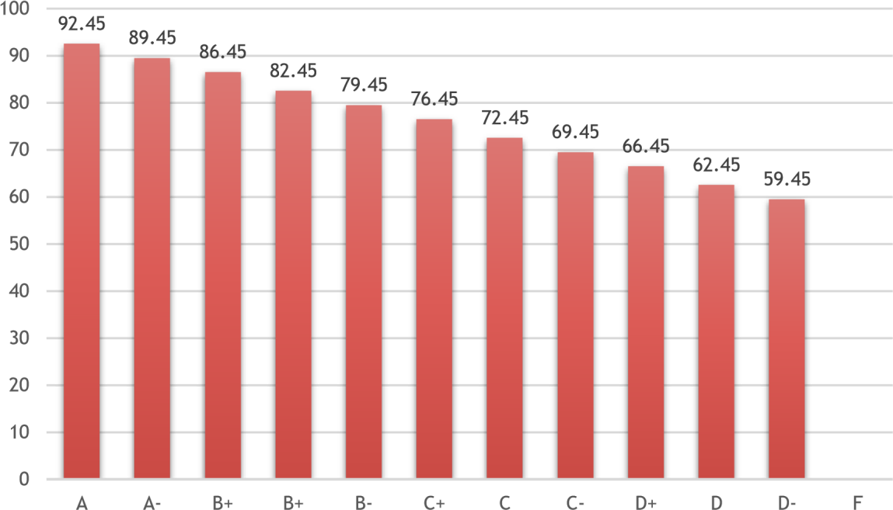

# Tentative Schedule

|  |  |  |
| --- | --- | --- |
| **Week** | **Tuesday** | **Topics** |
| 1 | 01/24 | Hypothesis and the Sampling – Population Approach |
| 2 | 01/31 | Sampling Techniques, Data Collection and Survey |
| 3 | 02/7 | Descriptive Statistics |
| 4 | 02/14 | Hypothesis Testing with existing Data – One Sample |
| 5 | 02/21 | Project 1: Hypothesis Testing with Survey Data – One Sample |
| 6 | 02/28 | Hypothesis Testing with Existing Data – Two Sample |
| 7 | 03/7 | Project 2: Hypothesis Testing with Survey Data – Two Sample |
| 8 | Spring Break | |
| 9 | 03/21 | Project 2: Hypothesis Testing with Survey Data – Two Sample |
| 10 | 03/28 | Probability and Probability Distribution  Generating Data from Distribution |
| 11 | 04/4 | Different Distributions |
| 12 | 04/11 | Linear Regression and Correlation with existing Data |
| Research and Engagement on 04/12 | | |
| 13 | 04/18 | Project 3: Linear Regression and Correlation with Survey Data |
| 14 | 04/25 | Project 3: Linear Regression and Correlation with Survey Data |
| 15 | 05/2 | Project 3: Linear Regression and Correlation with Survey Data |
| Day Classes End on Friday, May 5 | | |
| Final Exam on May 8 from 2:00 pm to 4:30 pm | | |

# Academic Misconduct

Cheating will result in an “F” as your final grade and may result in your expulsion from the University. All cheating will be reported to the Chair of the Mathematics Department and Academic Advising.

# Regarding Diversity

In this course, and all your courses at Bryant, and throughout the Bryant learning community, we value and respect diversity. This includes differences in race, ethnicity, nationality, gender, gender identity, sexuality, socioeconomic status, ability, and religion.