**Descriptive Statistics**

* Measure of Central Tendency
* Measure of Variation
* Measure of Position
* Visualization

**Measure of Variation:**

This is to measure how the data values spread. If the measure of variation is large, then the data values more spread out.

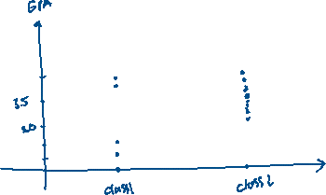

We notice that the Class 1’s GPA are more spread out than Class 2’s GPA.

We will cover:

* Range
* Variance and Standard Deviation
* Chebyshev’s Theorem
* The Empirical (Normal) Rule

1. Range:

The range of the data = maximum – minimum

Example:

Given the data: 2.0, 2.1, 4.0, 1.9, 3.6

Maximum = 4.0

Minimum = 1.9

Range = 4.0 – 1.9 = 2

1. Summation Notation

