**Measure of Variation:**

This is to measure how the data values spread. If the measure of variation is large, then the data values more spread out.

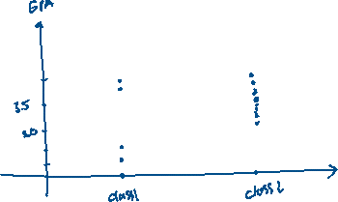

We notice that the Class 1’s GPA are more spread out than Class 2’s GPA.

We will cover:

* Range
* Variance and Standard Deviation
* Chebyshev’s Theorem
* The Empirical (Normal) Rule

1. Range:

The range of the data = maximum – minimum

Example:

Given the data: 2.0, 2.1, 4.0, 1.9, 3.6

Maximum = 4.0

Minimum = 1.9

Range = 4.0 – 1.9 = 2

1. Summation Notation



1. Variance and Standard Deviation

Other formulas for Variance and Standard Deviation.

**Example:**

***Practice Problem:***

*The number of incidents in which police were needed for a sample of 10 schools in Allegheny County is 7, 37, 3, 8, 48, 11, 6, 0, 10, 3. Calculate the range, variance and standard deviation.*

1. **Coefficient of Variation**

**Example**

***Practice Problem***

*(Coefficient of Variation) The mean for the number of pages (variable 1) of a sample of women’s fitness magazines is 132, with a variance of 23; the mean for the number of advertisements (variable 2) of a sample of women’s fitness magazines is 182, with a variance of 62. Which variable is more variable?*

1. **Chebyshev’s Theorem**

**Example:**

***Practice Problem***

1. *(Chebyshev’s theorem) The average number of calories in a regularsize bagel is 240. If the standard deviation is 38 calories, find the range in which at least 75% of the data will lie.*
2. *(Chebyshev’s theorem) Americans spend an average of 3 hours per day online. If the standard deviation is 32 minutes, find the range in which at least 88.89% of the data will lie.*

**Example:**

***Practice Problem***

*(Chebyshev’s theorem) The average of the number of trials it took a sample of mice to learn to traverse a maze was 12. The standard deviation was 3. Using Chebyshev’s theorem, find the minimum percentage of data values that will fall in the range of 4–20 trials.*