Math 421 Statistical Analysis with R. Fall 22.

Instructor Email Office Location & Hours
Son Nguyen snguyen4@bryant.edu 11:55AM-12:55PM MWF at
A8 (Suite A) Course Website:
Canvas and https://bryantstats.github.io/math421/

Course Description
This course covers the application of R in a wide range of subjects in data analysis. The statistics subjects include descriptive statistics; hypothesis testing; probability distribution; Bayesian statistics; predictive modelling; unsupervised learning. Students also learn about how to write functions in R, Rmarkdown, and various R famous packages such as ggplot2, caret, dplyr.
Prerequisites
MATH 350 or AM 332

Desired Learning Outcomes
After completing this course, you should be able to

- implement a variety of data exploration techniques (such as plot variables, histograms, calculating statistics) on data using R.
- perform statistical inferences, such as hypothesis testing, confidence interval, ANOVA on data using R.
- build statistical models, such as linear regression, logistic regression, decision tree on data using R.
- implement a variety of techniques in statistical unsupervised learning on data using R.
- produce a data-interactive document and slides presentation to communicate their works using R.

Office Hours
You can find me at my office (A8 - Suite A) from 11:55AM-12:55PM on MWF. I am also available over Zoom (https://bryant.zoom.us/j/4419675207) during these times. If the office hours do not work, please feel free to schedule another time with me.
Course Materials
All the course materials will be provided online.

Grades


Attendance

5

%

Assignments

45

%

Mid

-

term Projects

20

%

Final Project

30

%

Attendance
Attendance will be checked in every class meeting. Missing less than four class meetings will guarantee you the full credits for attendance.

Assignments
The assignments include, but not limited to, solving statistical problems, writing reports about a statistical technique, and presenting statistical analysis on a dataset.

Datacamp
You are required to register an account in Datacamp and to be added to the class. You will be assigned to take Datacamp courses throughout the semester. You are responsible for the materials mentioned in the assigned Datacamp courses.

Midterm and Final Projects
Projects should be done individually. The logistics and other details of the projects will be updated on the class webpage and Canvas.

Late Work
Late assignments are penalized 10% for each day late. You can resubmit your work to improve your score, but the late penalty will apply.

Grading Scale
A 92.45 - 100% C 72.45 - 76.44%
A- 89.45 - 92.44% C- 69.45 - 72.44%
B+ 86.45 - 89.44% D+ 66.45 - 69.44%
B 82.45 - 86.44% D 62.45 - 66.44%
B- 79.45 - 82.44% D- 59.45 - 62.44%
C+ 76.45 - 79.44% F Below 59.44%

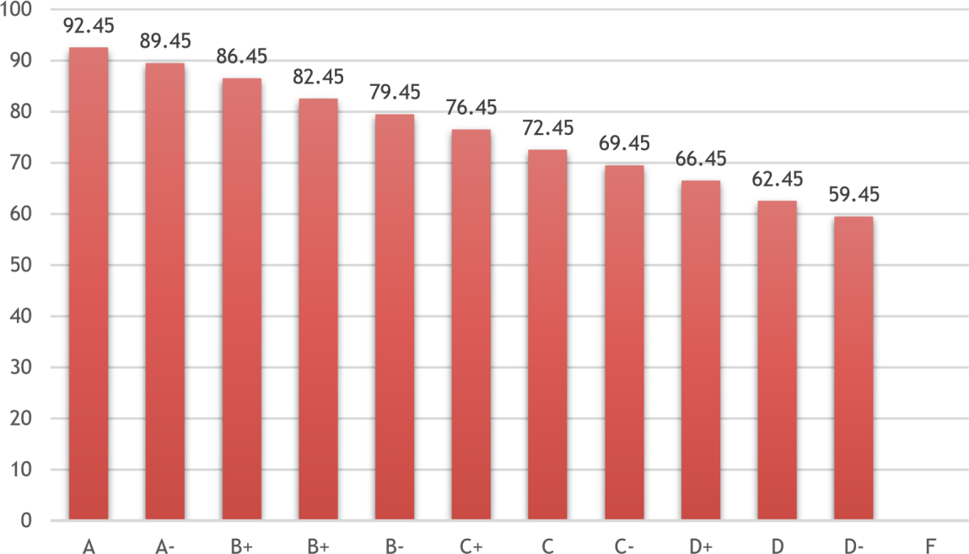

Tentative Schedule

Week 1st Day of the Week Topic
1 09/07 | R Basics
2 09/12 | Data wrangling with dplyr and tidyverse
3 09/19 | Data wrangling with dplyr and tidyverse
4 09/26 | Handle Missing Values
5 10/03 | Data Visualization with ggplot2
Indigenous Peoples' Day on 10/10
6 10/10 | Data Visualization with ggplot2
7 10/17 | Predictive Modelling
8 10/24 | Midterm Project
9 10/31 | Predictive Modelling
10 11/07 | Text Mining
11 11/14 | Text Mining: Twitter Data
12 11/21 | Writing a function: Basic and  If-Statement
Begins with Tuesday classes at 5 p.m. on November 22 and ends on Sunday, November 27

13 11/28 | Final Project - Writing Shiny apps
14 12/05 | Final Project - Writing Shiny apps
15 12/12 | Final Project Presentation at 10AM on December 12.

Academic Misconduct
Cheating will result in an “F” as your final grade and may result in your expulsion from the University. All cheating will be reported to the Chair of the Mathematics Department and Academic Advising.

Regarding Diversity
In this course, and all your courses at Bryant, and throughout the Bryant learning community, we value and respect diversity. This includes differences in race, ethnicity, nationality, gender, gender identity, sexuality, socioeconomic status, ability, and religion.

