Practice Problems for Exam 1
Son Nguyen
9/25/2019

Problem 1.
Given outcomes of a predictive model:
Passenger ID | Probability of Survived | Truth
1 | 0.55 | Survived
2 | 0.2 | Survived
3 | 0.94 | Survived
4 | 0.63 | Not Survived
5 | 0.9 | Survived
6 | 0.35 | Not Survived
7 | 0.84 | Not Survived
8 | 0.38 | Not Survived
9 | 0.01 | Not Survived
10 | 0.68 | Survived
11 | 0.71 | Survived
12 | 0.45 | Survived
- Form the confusion matrix when the cutoff value for positive outcome is c=0.5. Calculate the sensitivity, specificity, precision, and F1-Score when c = 0.5
- Sketch the ROC curve.
- Sketch and interpret the Cumulative Lift
- Sketch the Cumulative % Response

Solution
- Confusion Matrices
 | Predicted Positive | Predicted Negative
Actual Positive | TP = 5 | FN = 2
Actual Negative | FP = 2 | TN = 3
- ROC Curve
Order | Predicted Probabilities | True Values
1 | 0.94 | 1
2 | 0.90 | 1
3 | 0.84 | 0
4 | 0.71 | 1
5 | 0.68 | 1
6 | 0.63 | 0
7 | 0.55 | 1
8 | 0.45 | 1
9 | 0.38 | 0
10 | 0.35 | 0
11 | 0.20 | 1
12 | 0.01 | 0
Cut-off Values | Sensitivity | Specificity
c = 0 | 1.0000000 | 0.0
c = 0.1 | 1.0000000 | 0.2
c = 0.2 | 0.8571429 | 0.2
c = 0.3 | 0.8571429 | 0.2
c = 0.4 | 0.8571429 | 0.6
c = 0.5 | 0.7142857 | 0.6
c = 0.6 | 0.5714286 | 0.6
c = 0.7 | 0.4285714 | 0.8
c = 0.8 | 0.2857143 | 0.8
c = 0.9 | 0.1428571 | 1.0
c = 1 | 0.0000000 | 1.0
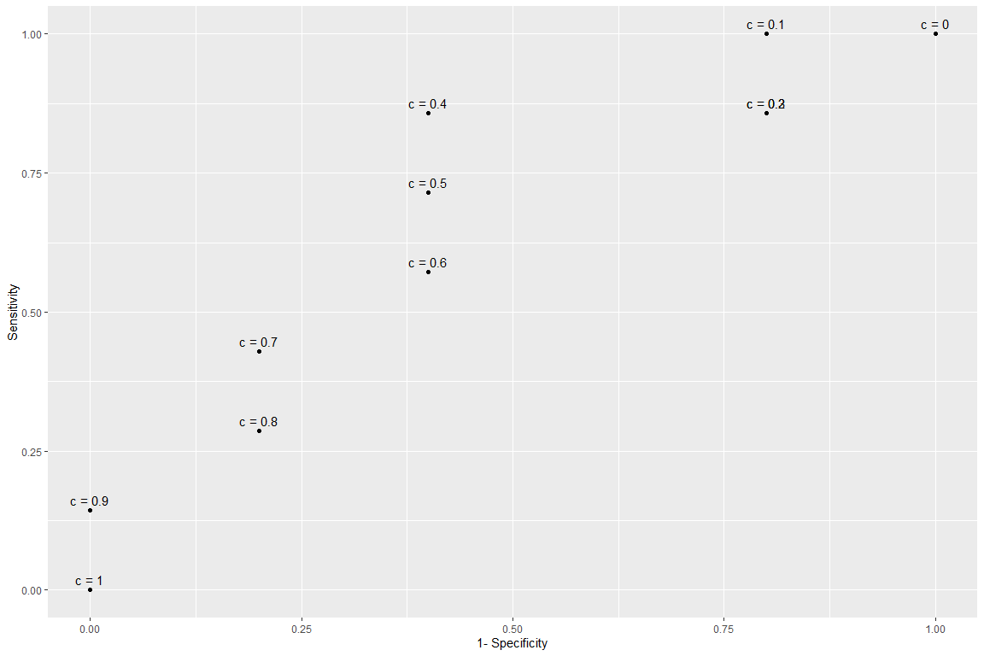
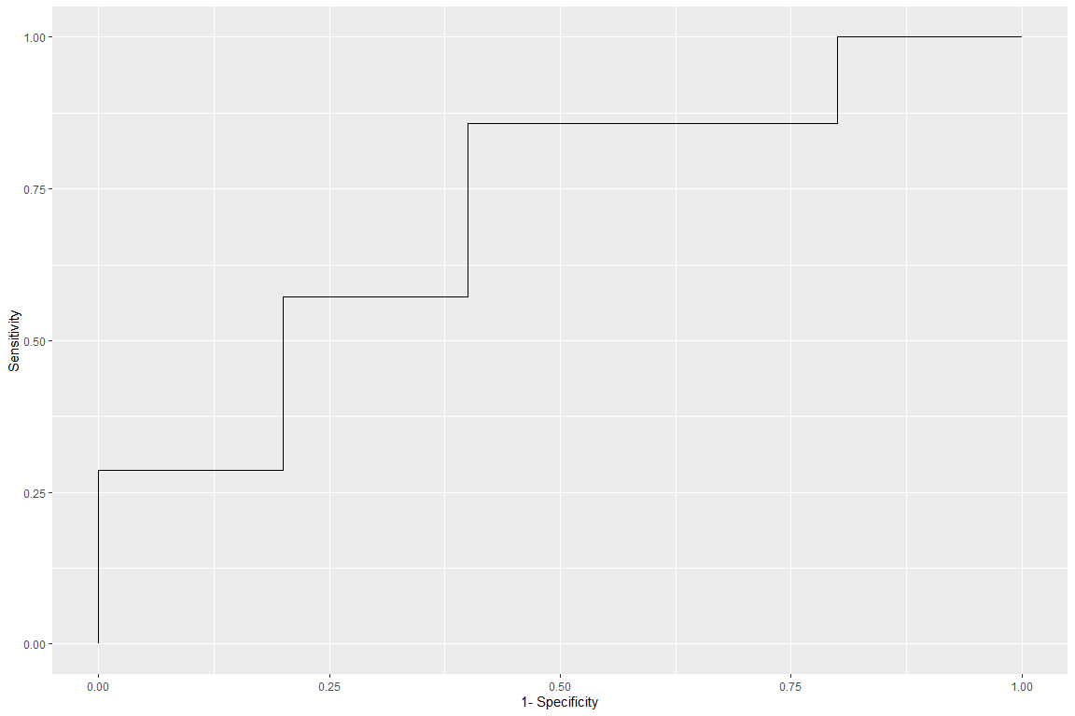
- Cumulative Lift
Percentage | Lift
0.0833333 | 1.714286
0.1666667 | 1.714286
0.2500000 | 1.142857
0.3333333 | 1.285714
0.4166667 | 1.371429
0.5000000 | 1.142857
0.5833333 | 1.224490
0.6666667 | 1.285714
0.7500000 | 1.142857
0.8333333 | 1.028571
0.9166667 | 1.090909
1.0000000 | 1.000000
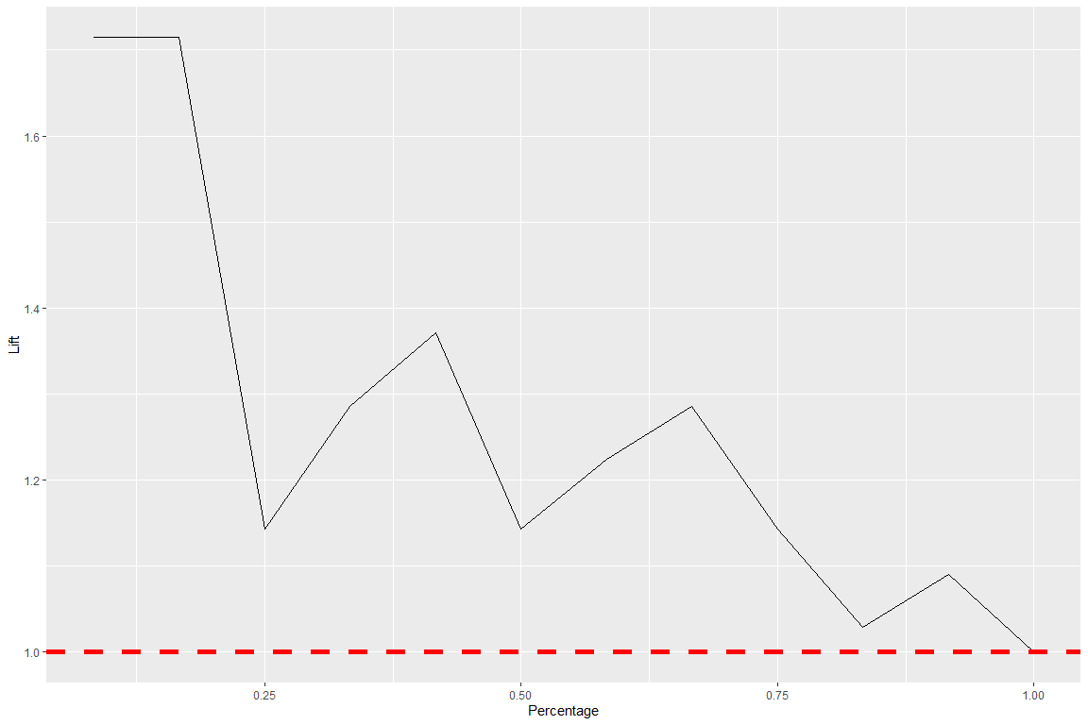
- Cumulative % Response
Percentage | Percent_Response
0.0833333 | 1.0000000
0.1666667 | 1.0000000
0.2500000 | 0.6666667
0.3333333 | 0.7500000
0.4166667 | 0.8000000
0.5000000 | 0.6666667
0.5833333 | 0.7142857
0.6666667 | 0.7500000
0.7500000 | 0.6666667
0.8333333 | 0.6000000
0.9166667 | 0.6363636
1.0000000 | 0.5833333
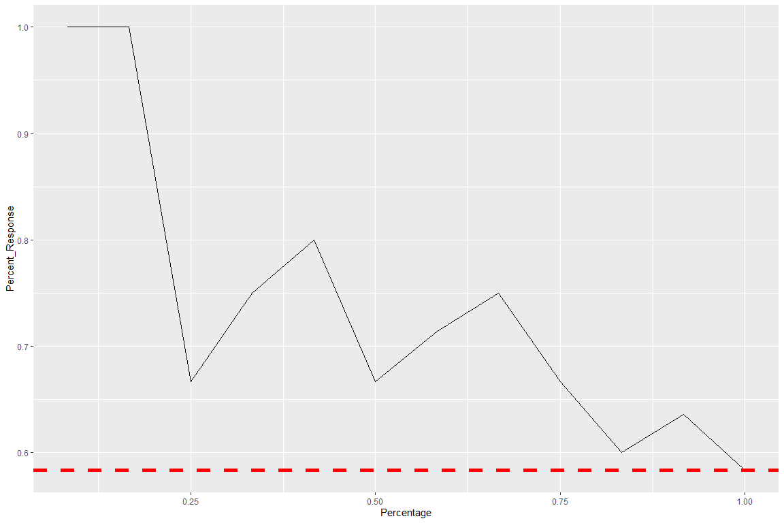

Problem 2
Given the data points. Calculate the impurity gain of all possible splits by (1) Classification Errors, (2) Gini Index and (3) Entropy. Decide the best split based on each measure.
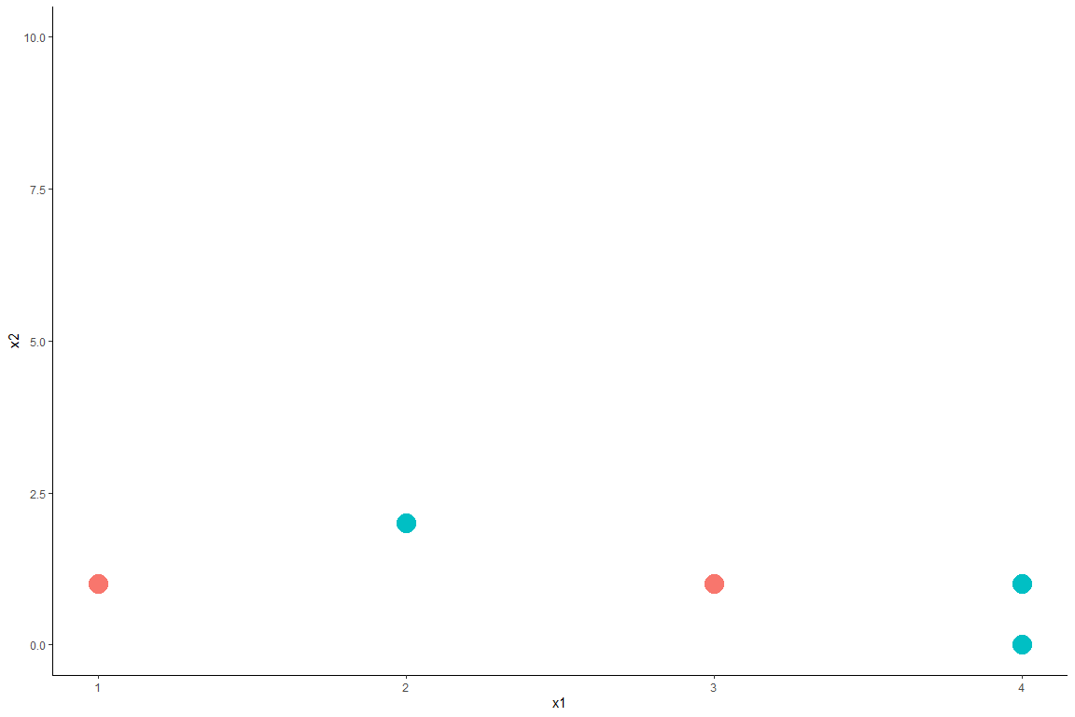

Solution

(1) IG By Classification Error:
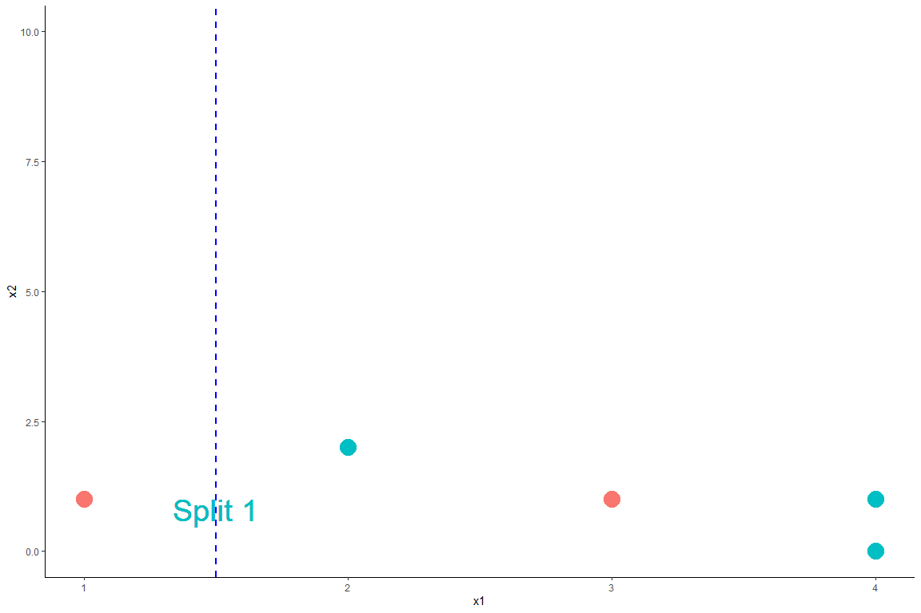
- Let green and red be class 0 and class 1, respectively.
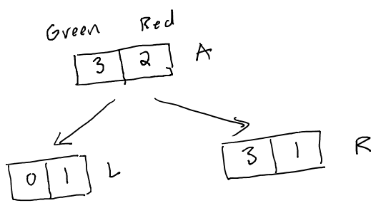
IG By Classification Error of Split 1
- For this split: $N=5,N_{left}=1,N_{right}=4$
- Node parent, A: $p_{0}=\frac{2}{5},p_{1}=\frac{3}{5}$. Thus, $I_{A}=\text{min}(\frac{2}{5},\frac{3}{5})=\frac{2}{5}$
- Node child left, L: $p_{0}=\frac{0}{1}=0,p_{1}=\frac{1}{1}=1$. Thus, $I_{L}=\text{min}(0,1)=0$
- Node child right, R: $p_{0}=\frac{3}{4},p_{1}=\frac{1}{4}$. Thus, $I_{R}=\text{min}(\frac{3}{4},\frac{1}{4})=\frac{1}{4}$
- Impurity Gain of Split 1 By Classification Error:
$$IG=\frac{2}{5}−\frac{1}{5}⋅0−\frac{4}{5}⋅\frac{1}{4}=0.2$$
IG By Classification Error of Split 2
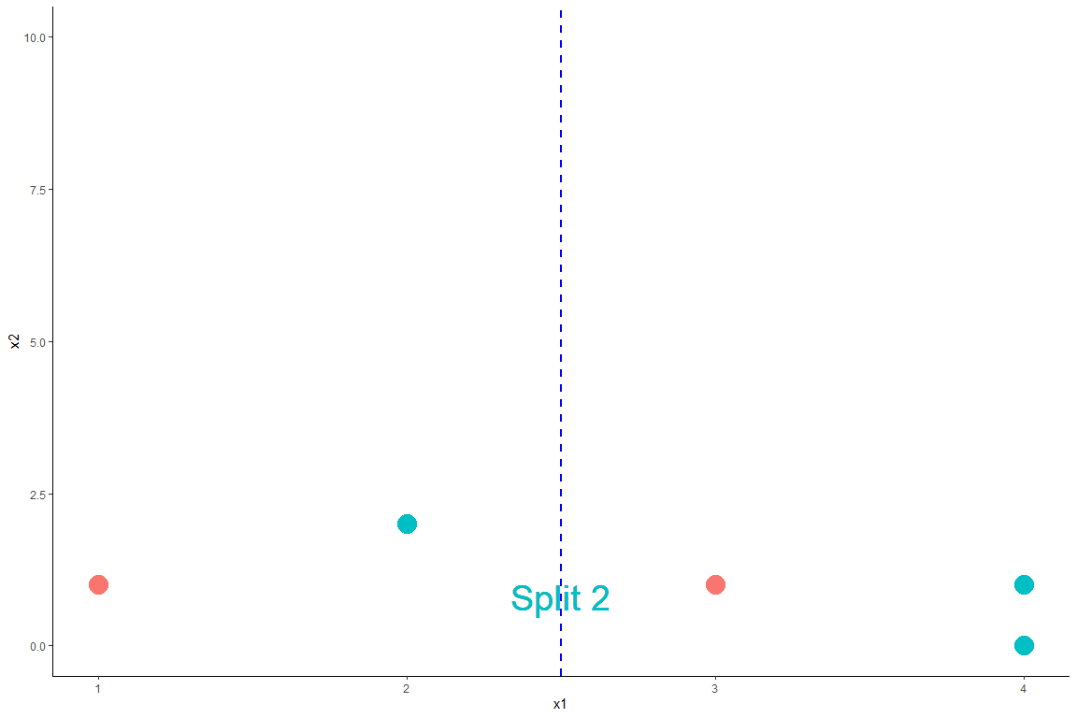
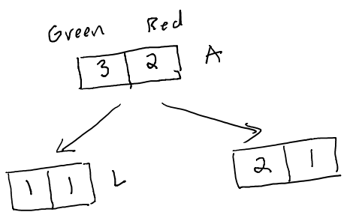
- $N=5,N_{left}=2,N_{right}=3$
- Node parent, A: $p_{0}=\frac{2}{5},p_{1}=\frac{3}{5}$. Thus, $I_{A}=\text{min}(\frac{2}{5},\frac{3}{5})=\frac{2}{5}$
- Node child left, L: $p_{0}=\frac{1}{2},p_{1}=\frac{1}{2}$. Thus, $I_{L}=\frac{1}{2}$
- Node child right, R: $p_{0}=\frac{2}{3},p_{1}=\frac{1}{3}$. Thus, $I_{R}=\text{min}(\frac{2}{3},\frac{1}{3})=\frac{1}{3}$
- Impurity Gain of Split 2:
$$IG=\frac{2}{5}−\frac{2}{5}⋅\frac{1}{2}−\frac{3}{5}⋅\frac{1}{3}=0$$
IG By Classification Error of Split 3
For Split 3: $N=5,N_{left}=3,N_{right}=2$
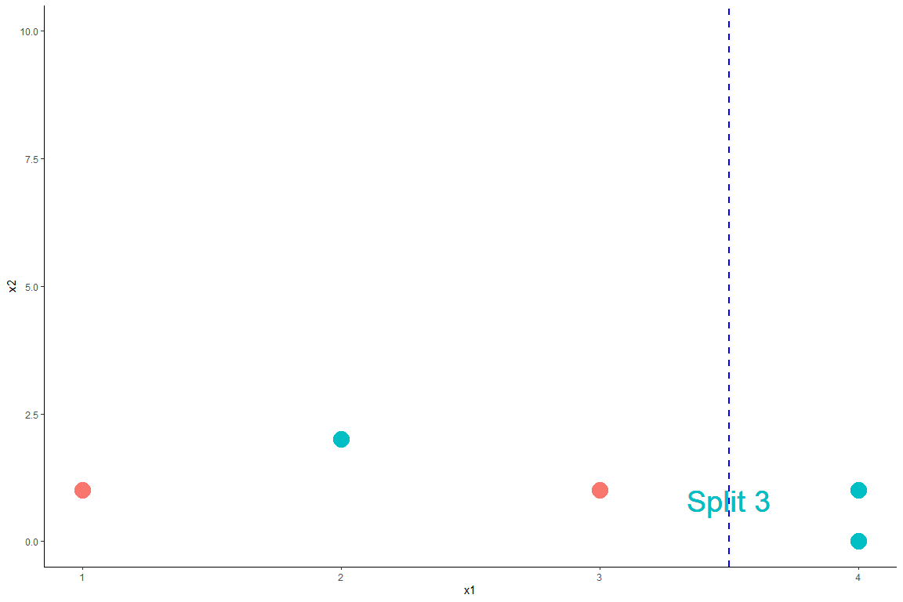
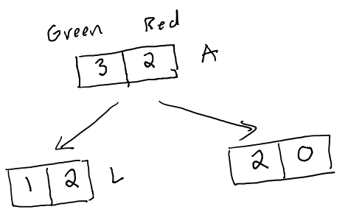
- Node parent, A: $p_{0}=\frac{2}{5},p_{1}=\frac{3}{5}$. Thus, $I_{A}=\text{min}(\frac{2}{5},\frac{3}{5})=\frac{2}{5}$
- Node child left, L: $p_{0}=\frac{1}{3},p_{1}=\frac{2}{3}$. Thus, $I_{A}=\text{min}(\frac{1}{3},\frac{2}{3})=\frac{1}{3}$
- Node child right, R: $p_{0}=\frac{2}{2},p_{1}=\frac{0}{2}$. Thus, $I_{R}=\text{min}(1,0)=0$
- Impurity Gain of Split 3:
$$IG=\frac{2}{5}−\frac{3}{5}⋅\frac{1}{3}−\frac{2}{5}⋅0=0.2$$
Comparing IG By Classification Error
 | IG
Split 1 | 0.2
Split 2 | 0
Split 3 | 0.2
By classification error, Split 1 and Split 3 are tie as the best because they have the same impurity gain.

(2) IG By Gini Index
For Split 1: $N=5,N_{left}=1,N_{right}=4$

- Node parent, A: $p_{0}=\frac{2}{5},p_{1}=\frac{3}{5}$. Thus, $I_{A}=1−(\frac{2}{5})^{2}−(\frac{3}{5})^{2}=0.48$
- Node child left, L: $p_{0}=\frac{0}{1}=0,p_{1}=\frac{1}{1}=1$. Thus,
$$I_{L}=1−0^{2}−1^{2}=0$$
- Node child right, R: $p_{0}=\frac{3}{4},p_{1}=\frac{1}{4}$. Thus,
$$I_{R}=1−(\frac{3}{4})^{2}−(\frac{1}{4})^{2}=0.375$$
- Impurity Gain of Split 1:
$$IG=0.48−\frac{1}{5}⋅0−\frac{4}{5}⋅0.375=0.18$$
For Split 2: $N=5,N_{left}=2,N_{right}=3$

- Node parent, A: $p_{0}=\frac{2}{5},p_{1}=\frac{3}{5}$. Thus, $I_{A}=1−(\frac{2}{5})^{2}−(\frac{3}{5})^{2}=0.48$
- Node child left, L: $p_{0}=\frac{1}{2},p_{1}=\frac{1}{2}$. Thus, $I_{L}=1−(\frac{1}{2})^{2}−(\frac{1}{2})^{2}=0.5$
- Node child right, R: $p_{0}=\frac{2}{3},p_{1}=\frac{1}{3}$. Thus, $I_{R}=1−(\frac{2}{3})^{2}−(\frac{1}{3})^{2}=0.44$
- Impurity Gain of Split 2:
$$IG=0.48−\frac{2}{5}⋅\frac{1}{2}−\frac{3}{5}⋅0.44=0.016$$
For Split 3: $N=5,N_{left}=3,N_{right}=2$

- Node parent, A: $I_{A}=0.48$
- Node child left, L: $p_{0}=\frac{1}{3},p_{1}=\frac{2}{3}$. Thus, $I_{A}=1−(\frac{1}{3})^{2}−(\frac{2}{3})^{2}=0.44$
- Node child right, R: $p_{0}=\frac{2}{2},p_{1}=\frac{0}{2}$. Thus, $I_{R}=1−0^{2}−1^{2}=0$
- Impurity Gain of Split 3:
$$IG=0.48−\frac{3}{5}⋅0.44−\frac{2}{5}⋅0=0.216$$
Comparing IG By Gini Index
 | IG
Split 1 | 0.18
Split 2 | 0.016
Split 3 | 0.216
By Gini Index, Split 3 is the best because it has the greatest impurity gain.

(3) IG By Entropy
For Split 1: $N=5,N_{left}=1,N_{right}=4$

- Node parent, A: $p_{0}=\frac{2}{5},p_{1}=\frac{3}{5}$. Thus, $I_{A}=−log_{2}(\frac{2}{5})−log_{2}(\frac{3}{5})=0.971$
- Node child left, L: $p_{0}=\frac{0}{1}=0,p_{1}=\frac{1}{1}=1$. Thus, $I_{L}=0$
- Node child right, R: $p_{0}=\frac{3}{4},p_{1}=\frac{1}{4}$. Thus,
$$I_{R}=−log_{2}(\frac{3}{4})−log_{2}(\frac{1}{4})=0.811$$
- Impurity Gain of Split 1:
$$IG=0.971−\frac{1}{5}⋅0−\frac{4}{5}⋅0.811=0.322$$
For Split 2: $N=5,N_{left}=2,N_{right}=3$

- Node parent, A: $p_{0}=\frac{2}{5},p_{1}=\frac{3}{5}$. Thus, $I_{A}=0.971$
- Node child left, L: $p_{0}=\frac{1}{2},p_{1}=\frac{1}{2}$. Thus, $I_{L}=−log_{1}(\frac{1}{2})−log_{2}(\frac{1}{2})=1$
- Node child right, R: $p_{0}=\frac{2}{3},p_{1}=\frac{1}{3}$. Thus, $I_{R}=−log_{2}(\frac{2}{3})−log_{2}(\frac{1}{3})=0.918$
- Impurity Gain of Split 2:
$$IG=0.971−\frac{2}{5}⋅1−\frac{3}{5}⋅0.918=0.02$$
For Split 3: $N=5,N_{left}=3,N_{right}=2$

- Node parent, A: $I_{A}=0.971$
- Node child left, L: $p_{0}=\frac{1}{3},p_{1}=\frac{2}{3}$. Thus, $I_{A}=−log_{2}(\frac{1}{3})−log_{2}(\frac{2}{3})=0.918$
- Node child right, R: $p_{0}=\frac{2}{2},p_{1}=\frac{0}{2}$. Thus, $I_{R}=0$
- Impurity Gain of Split 3:
$$IG=0.971−\frac{3}{5}⋅0.918−\frac{2}{5}⋅0=0.42$$
Comparing IG By Entropy
 | IG
Split 1 | 0.322
Split 2 | 0.02
Split 3 | 0.42
By Gini Index, Split 3 is the best because it has the greatest impurity gain.

Problem 3.
Compute the Chi-square values of all possible splits in Problem 2 then decide the best split based on this measure.

For Split 1

 | Greens | Reds
Left Branch | 0 (Cell 1) | 1 (Cell 2) | 1
Right Branch | 3 (Cell 3) | 1 (Cell 4) | 4
 | 3 | 2
$$χ^{2}=\frac{(e_{1}−o_{1})^{2}}{e_{1}}+\frac{(e_{2}−o_{2})^{2}}{e_{2}}+\frac{(e_{3}−o_{3})^{2}}{e_{3}}+\frac{(e_{4}−o_{4})^{2}}{e_{4}}$$
- $i=1$ (Cell 1): $e_{1}=\frac{1⋅3}{5}$, $o_{1}=0$
- $i=2$ (Cell 2): $e_{2}=\frac{1⋅2}{5}$, $o_{2}=1$
- $i=3$ (Cell 3): $e_{3}=\frac{3⋅4}{5}$, $o_{3}=3$
- $i=4$ (Cell 4): $e_{4}=\frac{2⋅4}{5}$, $o_{4}=1$
- Plug in, we have:
$$χ^{2}=1.875$$

For Split 2

 | Greens | Reds
Left Branch | 1 (Cell 1) | 1 (Cell 2) | 2
Right Branch | 2 (Cell 3) | 1 (Cell 4) | 3
 | 3 | 2
$$χ^{2}=\frac{(e_{1}−o_{1})^{2}}{e_{1}}+\frac{(e_{2}−o_{2})^{2}}{e_{2}}+\frac{(e_{3}−o_{3})^{2}}{e_{3}}+\frac{(e_{4}−o_{4})^{2}}{e_{4}}$$
- $i=1$ (Cell 1): $e_{1}=\frac{2⋅3}{5}$, $o_{1}=1$
- $i=2$ (Cell 2): $e_{2}=\frac{2⋅2}{5}$, $o_{2}=1$
- $i=3$ (Cell 3): $e_{3}=\frac{3⋅3}{5}$, $o_{3}=2$
- $i=4$ (Cell 4): $e_{4}=\frac{3⋅2}{5}$, $o_{4}=1$
- Plug in, we have:
$$χ^{2}=0.139$$

For Split 3

 | Greens | Reds
Left Branch | 1 (Cell 1) | 2 (Cell 2) | 3
Right Branch | 2 (Cell 3) | 0 (Cell 4) | 2
 | 3 | 2
$$χ^{2}=\frac{(e_{1}−o_{1})^{2}}{e_{1}}+\frac{(e_{2}−o_{2})^{2}}{e_{2}}+\frac{(e_{3}−o_{3})^{2}}{e_{3}}+\frac{(e_{4}−o_{4})^{2}}{e_{4}}$$
- (Cell 1): $e_{1}=\frac{2⋅3}{5}$, $o_{1}=1$
- (Cell 2): $e_{2}=\frac{2⋅2}{5}$, $o_{2}=2$
- (Cell 3): $e_{3}=\frac{3⋅3}{5}$, $o_{3}=2$
- (Cell 4): $e_{4}=\frac{3⋅2}{5}$, $o_{4}=0$
- Plug in, we have:
$$χ^{2}=2.222$$

Comparing the three splits
 | $χ^{2}$
Split 1 | 1.875
Split 2 | 0.139
Split 3 | 2.222
Split 3 is the best because it has the greatest $χ^{2}$!

Problem 4-7: Classification Tree Practice Problem

Problem 8: Random Forest Problem

