Classification Trees
Son Nguyen
10/14/2022

Reading Materials
- Max Kuhn. Chapter 14. Section 14.1

Decision Boundary in Classification
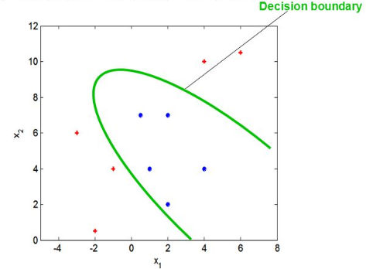
Classification is a process of finding the decision boundary that best separate two classes

Decision Boundary in Classification
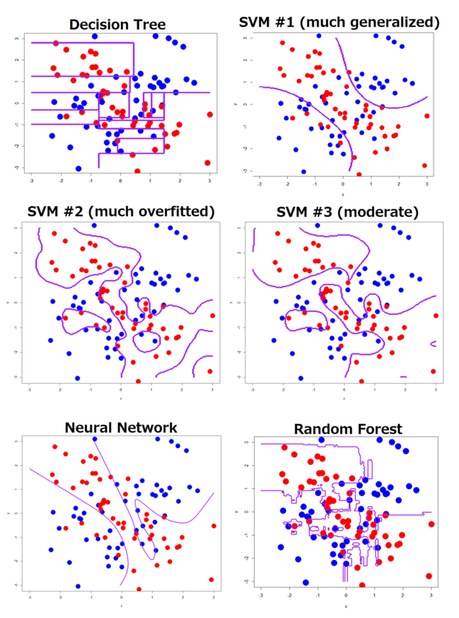
SVM = Support Vector Machine

Decision Tree
- Decision Tree for classification is Classification Tree
- Decision Tree for Regression is Regression Tree

Example of Classification Tree
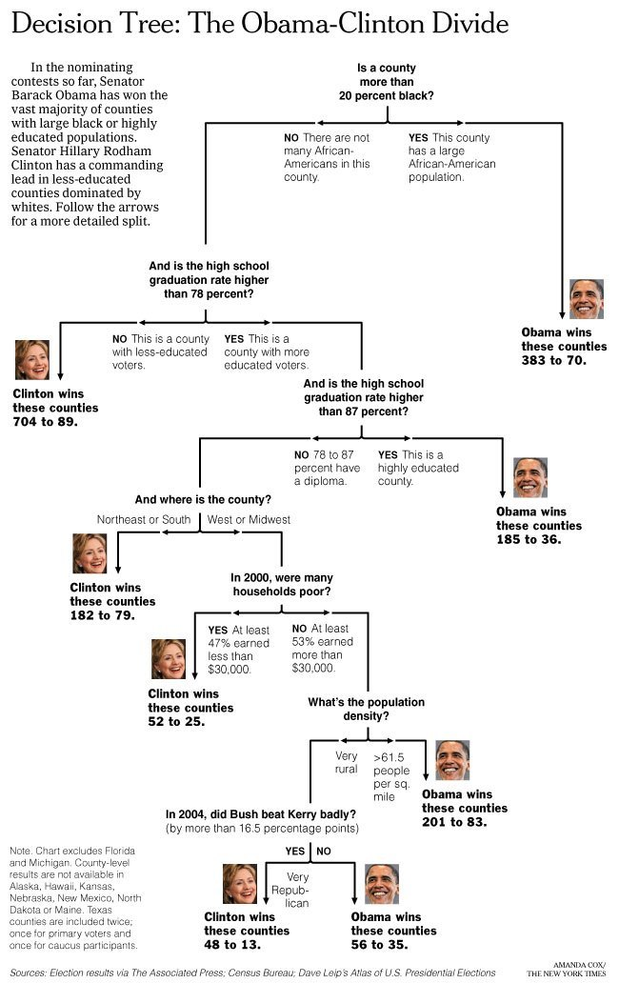
[Link] (http://graphics8.nytimes.com/images/2008/04/16/us/0416-nat-subOBAMA.jpg)

Classification Tree
- In two dimension, classification Tree’s decision boundary is a collection of horiontal and vertical line

Data
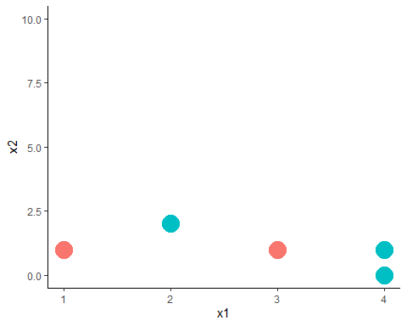
- The tree starts by a vertical or horizontal line that best seperate the data
- Question: Find a vertical line that best seperate red and green.

One way to seperate the reds and greens
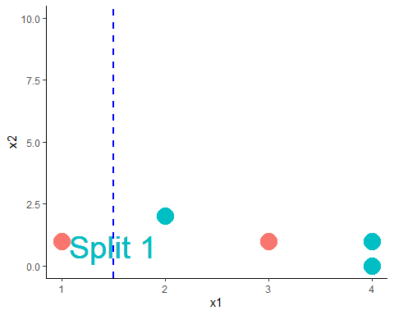

One way to seperate the reds and greens
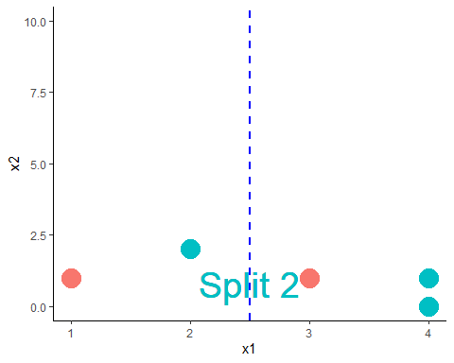

One way to seperate the reds and greens
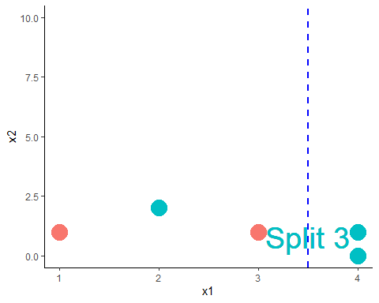

Question
- Question: Which is the best split?

Partial Answer
- It looks like Split 1 and 3 are better than Split 2 since it misclassifies less
- Which is the better split between Split 1 and Split 3?
- We need to find a way to measure how good a split is

Impurity Measure
- The impurity of a node (a node = a subset of the data or the original data) measure how uncertain the node is.
- For example, node A with 50% reds and 50% greens would be more uncertained than node B with 90% reds and 10% greens. Thus, node A has greater impurity than node B.
- More uncertained $=$ Greater impurity

Impurity Measure
- A split that gains more impurity is the better split!

Impurity Gain
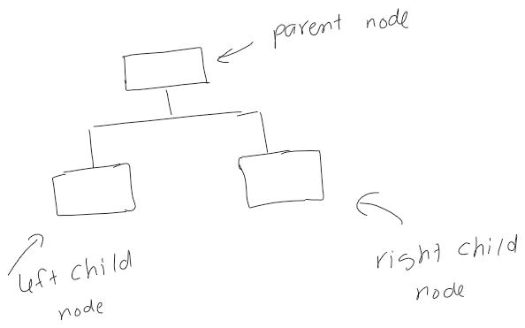
$$IG=I_{parent}−\frac{N_{left}}{N}I_{left}−\frac{N_{right}}{N}I_{right}$$
- IG is Impurity Gain of the split
- $N_{left}$ and $N_{right}$ are the number of points in the left child node and right child node, respectively.
- $N_{left}+N_{right}=N$

Impurity Measure
- Impurity can be measured by: classification error, Gini Index, and Entropy.

Impurity Measure
- Let $p_{0}$ and $p_{1}$ be the proportion of class 0 and class 1 in a node.
$$
$$

Calculation
- Let’s calculate the impurity gain of the three splits to decide which split is the best

IG By Classification Error
- Let green and red be class 0 and class 1, respectively.
For Split 1: $N=5,N_{left}=1,N_{right}=4$
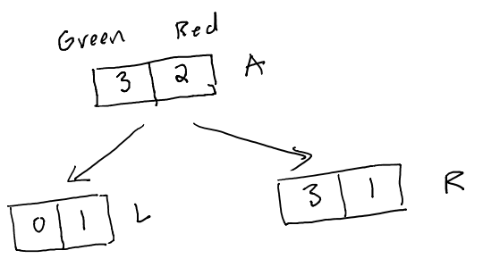
- Node parent, A: $p_{0}=\frac{2}{5},p_{1}=\frac{3}{5}$. Thus, $I_{A}=\text{min}\left(\frac{2}{5},\frac{3}{5}\right)=\frac{2}{5}$
- Node child left, L: $p_{0}=\frac{0}{1}=0,p_{1}=\frac{1}{1}=1$. Thus, $I_{L}=\text{min}\left(0,1\right)=0$
- Node child right, R: $p_{0}=\frac{3}{4},p_{1}=\frac{1}{4}$. Thus, $I_{R}=\text{min}\left(\frac{3}{4},\frac{1}{4}\right)=\frac{1}{4}$
- Impurity Gain of Split 1:
$$IG=\frac{2}{5}−\frac{1}{5}⋅0−\frac{4}{5}⋅\frac{1}{4}=0.2$$

IG By Classification Error
For Split 2: $N=5,N_{left}=2,N_{right}=3$
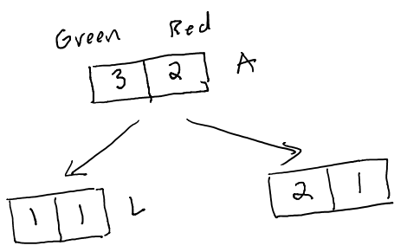
- Node parent, A: $p_{0}=\frac{2}{5},p_{1}=\frac{3}{5}$. Thus, $I_{A}=\text{min}\left(\frac{2}{5},\frac{3}{5}\right)=\frac{2}{5}$
- Node child left, L: $p_{0}=\frac{1}{2},p_{1}=\frac{1}{2}$. Thus, $I_{L}=\frac{1}{2}$
- Node child right, R: $p_{0}=\frac{2}{3},p_{1}=\frac{1}{3}$. Thus, $I_{R}=\text{min}\left(\frac{2}{3},\frac{1}{3}\right)=\frac{1}{3}$
- Impurity Gain of Split 2:
$$IG=\frac{2}{5}−\frac{2}{5}⋅\frac{1}{2}−\frac{3}{5}⋅\frac{1}{3}=0$$

IG By Classification Error
For Split 3: $N=5,N_{left}=3,N_{right}=2$
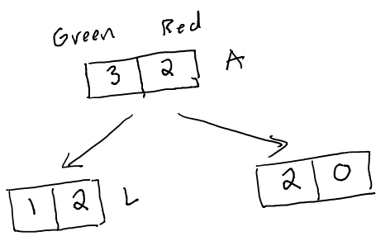
- Node parent, A: $p_{0}=\frac{2}{5},p_{1}=\frac{3}{5}$. Thus, $I_{A}=\text{min}\left(\frac{2}{5},\frac{3}{5}\right)=\frac{2}{5}$
- Node child left, L: $p_{0}=\frac{1}{3},p_{1}=\frac{2}{3}$. Thus, $I_{A}=\text{min}\left(\frac{1}{3},\frac{2}{3}\right)=\frac{1}{3}$
- Node child right, R: $p_{0}=\frac{2}{2},p_{1}=\frac{0}{2}$. Thus, $I_{R}=\text{min}\left(1,0\right)=0$
- Impurity Gain of Split 3:
$$IG=\frac{2}{5}−\frac{3}{5}⋅\frac{1}{3}−\frac{2}{5}⋅0=0.2$$

Comparing IG By Classification Error
 | IG
Split 1 | 0.2
Split 2 | 0
Split 3 | 0.2
- By classification error, Split 1 and Split 3 are tie as the best because they have the same impurity gain.

IG By Gini Index
For Split 1: $N=5,N_{left}=1,N_{right}=4$

- Node parent, A: $p_{0}=\frac{2}{5},p_{1}=\frac{3}{5}$. Thus, $I_{A}=1−{\left(\frac{2}{5}\right)}^{2}−{\left(\frac{3}{5}\right)}^{2}=0.48$
- Node child left, L: $p_{0}=\frac{0}{1}=0,p_{1}=\frac{1}{1}=1$. Thus,
$$I_{L}=1−0^{2}−1^{2}=0$$
- Node child right, R: $p_{0}=\frac{3}{4},p_{1}=\frac{1}{4}$. Thus,
$$I_{R}=1−{\left(\frac{3}{4}\right)}^{2}−{\left(\frac{1}{4}\right)}^{2}=0.375$$
- Impurity Gain of Split 1:
$$IG=0.48−\frac{1}{5}⋅0−\frac{4}{5}⋅0.375=0.18$$

IG By Gini Index
For Split 2: $N=5,N_{left}=2,N_{right}=3$

- Node parent, A: $p_{0}=\frac{2}{5},p_{1}=\frac{3}{5}$. Thus, $I_{A}=1−{\left(\frac{2}{5}\right)}^{2}−{\left(\frac{3}{5}\right)}^{2}=0.48$
- Node child left, L: $p_{0}=\frac{1}{2},p_{1}=\frac{1}{2}$. Thus, $I_{L}=1−{\left(\frac{1}{2}\right)}^{2}−{\left(\frac{1}{2}\right)}^{2}=0.5$
- Node child right, R: $p_{0}=\frac{2}{3},p_{1}=\frac{1}{3}$. Thus, $I_{R}=1−{\left(\frac{2}{3}\right)}^{2}−{\left(\frac{1}{3}\right)}^{2}=0.44$
- Impurity Gain of Split 2:
$$IG=0.48−\frac{2}{5}⋅\frac{1}{2}−\frac{3}{5}⋅0.44=0.016$$

IG By Gini Index
For Split 3: $N=5,N_{left}=3,N_{right}=2$

- Node parent, A: $I_{A}=0.48$
- Node child left, L: $p_{0}=\frac{1}{3},p_{1}=\frac{2}{3}$. Thus, $I_{A}=1−{\left(\frac{1}{3}\right)}^{2}−{\left(\frac{2}{3}\right)}^{2}=0.44$
- Node child right, R: $p_{0}=\frac{2}{2},p_{1}=\frac{0}{2}$. Thus, $I_{R}=1−0^{2}−1^{2}=0$
- Impurity Gain of Split 3:
$$IG=0.48−\frac{3}{5}⋅0.44−\frac{2}{5}⋅0=0.216$$

Comparing IG By Gini Index
 | IG
Split 1 | 0.18
Split 2 | 0.016
Split 3 | 0.216
- By Gini Index, Split 3 is the best because it has the greatest impurity gain.

IG By Entropy
For Split 1: $N=5,N_{left}=1,N_{right}=4$

- Node parent, A: $p_{0}=\frac{2}{5},p_{1}=\frac{3}{5}$. Thus, $I_{A}=−log_{2}\left(\frac{2}{5}\right)−log_{2}\left(\frac{3}{5}\right)=0.971$
- Node child left, L: $p_{0}=\frac{0}{1}=0,p_{1}=\frac{1}{1}=1$. Thus, $I_{L}=0$
- Node child right, R: $p_{0}=\frac{3}{4},p_{1}=\frac{1}{4}$. Thus,
$$I_{R}=−log_{2}\left(\frac{3}{4}\right)−log_{2}\left(\frac{1}{4}\right)=0.811$$
- Impurity Gain of Split 1:
$$IG=0.971−\frac{1}{5}⋅0−\frac{4}{5}⋅0.811=0.322$$

IG By Entropy
For Split 2: $N=5,N_{left}=2,N_{right}=3$

- Node parent, A: $p_{0}=\frac{2}{5},p_{1}=\frac{3}{5}$. Thus, $I_{A}=0.971$
- Node child left, L: $p_{0}=\frac{1}{2},p_{1}=\frac{1}{2}$. Thus, $I_{L}=−log_{1}\left(\frac{1}{2}\right)−log_{2}\left(\frac{1}{2}\right)=1$
- Node child right, R: $p_{0}=\frac{2}{3},p_{1}=\frac{1}{3}$. Thus, $I_{R}=−log_{2}\left(\frac{2}{3}\right)−log_{2}\left(\frac{1}{3}\right)=0.918$
- Impurity Gain of Split 2:
$$IG=0.971−\frac{2}{5}⋅1−\frac{3}{5}⋅0.918=0.02$$

IG By Entropy
For Split 3: $N=5,N_{left}=3,N_{right}=2$

- Node parent, A: $I_{A}=0.971$
- Node child left, L: $p_{0}=\frac{1}{3},p_{1}=\frac{2}{3}$. Thus, $I_{A}=−log_{2}\left(\frac{1}{3}\right)−log_{2}\left(\frac{2}{3}\right)=0.918$
- Node child right, R: $p_{0}=\frac{2}{2},p_{1}=\frac{0}{2}$. Thus, $I_{R}=0$
- Impurity Gain of Split 3:
$$IG=0.971−\frac{3}{5}⋅0.918−\frac{2}{5}⋅0=0.42$$

Comparing IG By Entropy
 | IG
Split 1 | 0.322
Split 2 | 0.02
Split 3 | 0.42
- By Gini Index, Split 3 is the best because it has the greatest impurity gain.

Comparing Impurity Measures
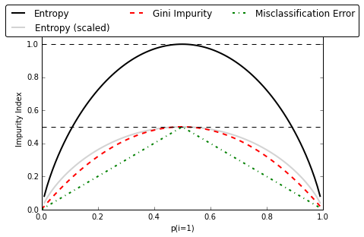 - Relation between impurity and the class probabilities. All impurity measures are maximized at $p_{1}=1/2$ and minimized at $p_{1}=0$ and $p_{1}=1$.

Another Example
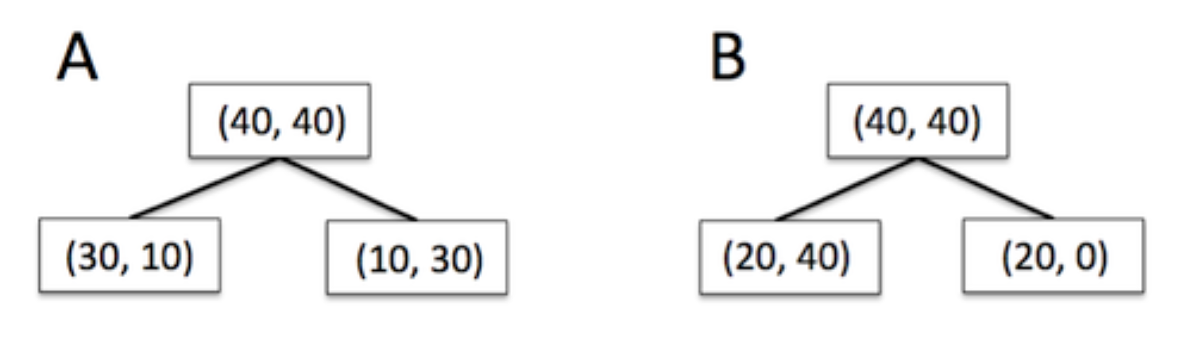 - Which split is better?

Decide the best split using Chi-Square test of Independence
- Besides impurity gain, one can use the Chi-square, $χ^{2}$, test of independence to decide the best split.

Review of Chi-Square test of Independence
- Let $X$ and $Y$ be two categorical variables.
- We want to test if $X$ and $Y$ are independent/associated
  - $H_{0}$: $X$ and $Y$ are independent
  - $H_{α}:$ $X$ and $Y$ are dependent
- Test statistic:
$$∑\frac{{\left(e_{i}−o_{i}\right)}^{2}}{e_{i}}∼χ^{2}\text{ distribution with degree of freedom}\left(n−1\right)\left(m−1\right)$$

Review of Chi-Square test of Independence
- In our context, the greater the $χ^{2}$ value, the smaller the $p−value$
- The smaller the $p−value$, the more dependent the two variables are. Thus the better the split is.
- Therefore, we look for the split with the greatest $χ^{2}$ value.

Applying to Our Example
- We will calculate the $χ^{2}$ values of the three splits.
- The best split is the split with the greatest $χ^{2}$ value.

Split 1

 | Greens | Reds
Left Branch | 0 (Cell 1) | 1 (Cell 2) | 1
Right Branch | 3 (Cell 3) | 1 (Cell 4) | 4
 | 3 | 2
$$χ^{2}=\frac{{\left(e_{1}−o_{1}\right)}^{2}}{e_{1}}+\frac{{\left(e_{2}−o_{2}\right)}^{2}}{e_{2}}+\frac{{\left(e_{3}−o_{3}\right)}^{2}}{e_{3}}+\frac{{\left(e_{4}−o_{4}\right)}^{2}}{e_{4}}$$
- $i=1$ (Cell 1): $e_{1}=\frac{1⋅3}{5}$, $o_{1}=0$
- $i=2$ (Cell 2): $e_{2}=\frac{1⋅2}{5}$, $o_{2}=1$
- $i=3$ (Cell 3): $e_{3}=\frac{3⋅4}{5}$, $o_{3}=3$
- $i=4$ (Cell 4): $e_{4}=\frac{2⋅4}{5}$, $o_{4}=1$
- Plug in, we have:
$$χ^{2}=1.875$$

Split 2

 | Greens | Reds
Left Branch | 1 (Cell 1) | 1 (Cell 2) | 2
Right Branch | 2 (Cell 3) | 1 (Cell 4) | 3
 | 3 | 2
$$χ^{2}=\frac{{\left(e_{1}−o_{1}\right)}^{2}}{e_{1}}+\frac{{\left(e_{2}−o_{2}\right)}^{2}}{e_{2}}+\frac{{\left(e_{3}−o_{3}\right)}^{2}}{e_{3}}+\frac{{\left(e_{4}−o_{4}\right)}^{2}}{e_{4}}$$
- $i=1$ (Cell 1): $e_{1}=\frac{2⋅3}{5}$, $o_{1}=1$
- $i=2$ (Cell 2): $e_{2}=\frac{2⋅2}{5}$, $o_{2}=1$
- $i=3$ (Cell 3): $e_{3}=\frac{3⋅3}{5}$, $o_{3}=2$
- $i=4$ (Cell 4): $e_{4}=\frac{3⋅2}{5}$, $o_{4}=1$
- Plug in, we have:
$$χ^{2}=0.139$$

Split 3

 | Greens | Reds
Left Branch | 1 (Cell 1) | 2 (Cell 2) | 3
Right Branch | 2 (Cell 3) | 0 (Cell 4) | 2
 | 3 | 2
$$χ^{2}=\frac{{\left(e_{1}−o_{1}\right)}^{2}}{e_{1}}+\frac{{\left(e_{2}−o_{2}\right)}^{2}}{e_{2}}+\frac{{\left(e_{3}−o_{3}\right)}^{2}}{e_{3}}+\frac{{\left(e_{4}−o_{4}\right)}^{2}}{e_{4}}$$
- (Cell 1): $e_{1}=\frac{2⋅3}{5}$, $o_{1}=1$
- (Cell 2): $e_{2}=\frac{2⋅2}{5}$, $o_{2}=2$
- (Cell 3): $e_{3}=\frac{3⋅3}{5}$, $o_{3}=2$
- (Cell 4): $e_{4}=\frac{3⋅2}{5}$, $o_{4}=0$
- Plug in, we have:
$$χ^{2}=2.222$$

Comparing the three splits
 | $χ^{2}$
Split 1 | 1.875
Split 2 | 0.139
Split 3 | 2.222
- Split 3 is the best because it has the greatest $χ^{2}$!

Logworth
- The quality of the split can be measured by Logworth
- Formula:
$$logworth=−log\left(p\text{_}value\right)$$
- The greater the logworth, the better the split

Logworth
 | $χ^{2}$ | p-value | logworth
Split 1 | 1.875 | 0.114 | 0.943
Split 2 | 0.139 | 0.998 | 0.0008
Split 3 | 2.222 | 0.088 | 1.055
- Greatest $χ^{2}$ = Lowest $p−value$ = Greatest logworth = Best Split
- Split 3 is the best split!

What happens after the first split?
- After the first split, the data are divided into to subsets.
- The splitting process is repeated for each subset.
- The process ends when a stopping criteria is satisfied

Stopping Criteria
- Minimum Leaf Size: The minimum of observations in the leaves
- Maximum Number of Leaves
- Maximum Depth
- Others

Stopping Criteria
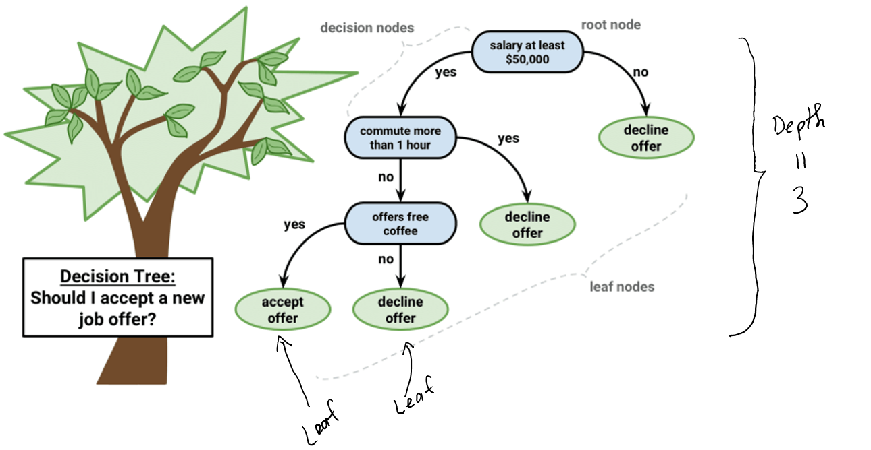

Decision Tree Algorithm - How to grow a tree
- Step 1: Calculate the impurity gain or $p−value$ of all possible splits at all variables
- Step 2: Select the split that give the maximum impurity gain or lowest $p−value$ to split the data into two subdata $D_{1}$ and $D_{2}$
- Repeat Step 1 and Step 2 to both $D_{1}$ and $D_{2}$.
- Until a stopping criteria is satisfied

Complexity of Decision Tree
- A complexity of a tree can be measured by the number of leaves the tree has
- The more leaves a tree has, the more complex the tree is.
- A complex tree may be overfitted, i.e. having low training error but high testing error.

Prunning a tree
- For any given data, one can construct a tree that achives 0 misclassification on training data
- After growing the tree one needs to prune it to avoid overfittted

Prunning a tree
- The tree with maximum number of leaves is called the maximal tree (still satisfied the stopping rule)
- From the maximal tree, leaves are cut down, one by one, to obatined all possible subtrees
- The subtree with lowest error on validation data, is the optimal tree

Maximal vs Optimal Tree
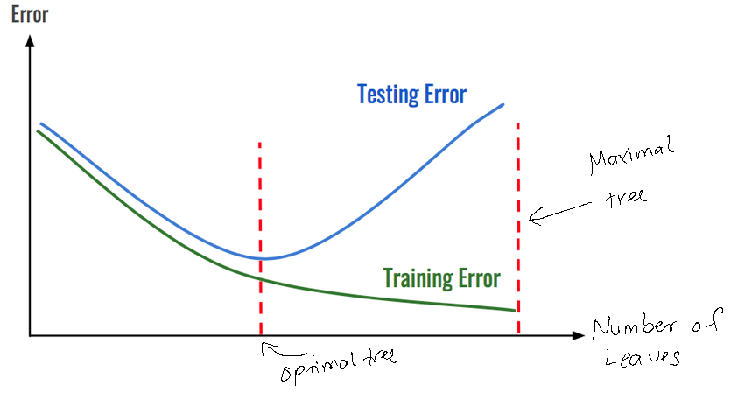

Example of Tree Prunning
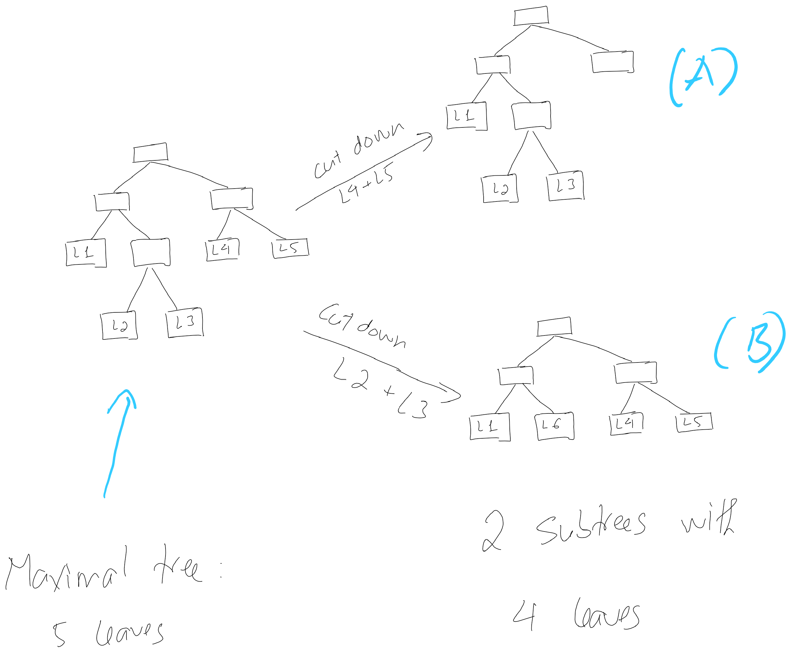

Example of Tree Prunning
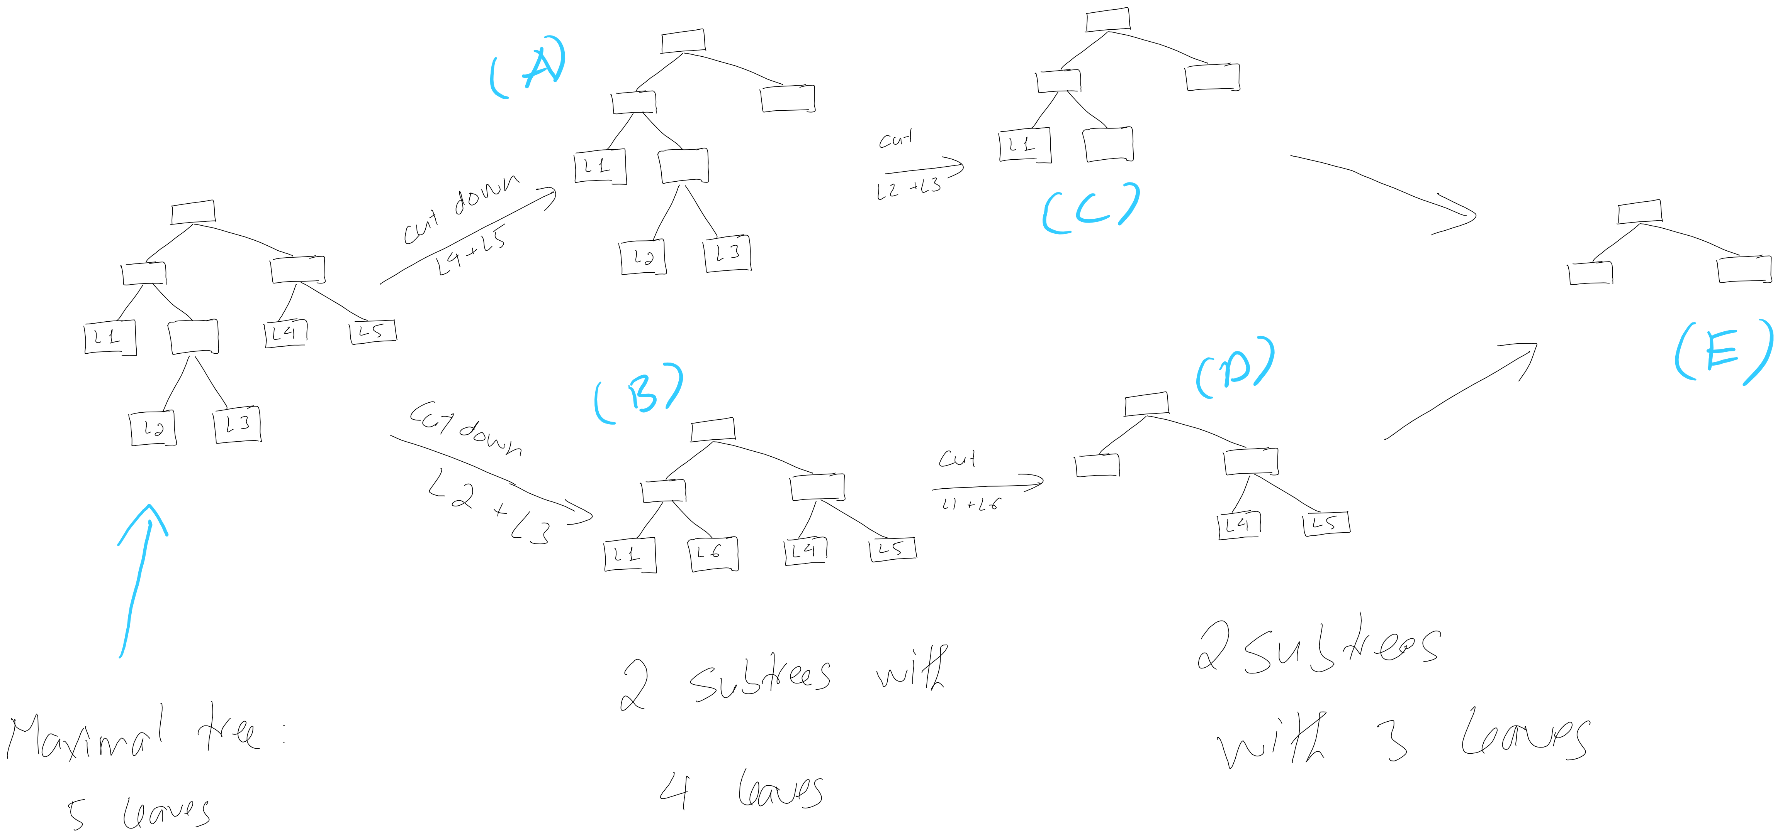 - All the subtrees A, B, C, D, and E will be validated with the validation data to find the optimal tree - The optimal tree could be the maximal tree!

Question
 - What if both B and C give the lowest error on the validation data? Which tree should be selected as the final model?

