Untitled

# Measuring Performance in Classification Models

author: Son Nguyen font-family: Garamond

# Reading Materials

* Max Kuhn. Chapter 11.

# Two outcomes of classification models

* Predicted Probabilities
* Class Prediction

# Examples

* Predicting if a passenger in the titanic is survived or not survived
* The outcome could look like this.

|  |  |  |
| --- | --- | --- |
| Passenger ID | Probability of Survived | Prediction |
| 1 | 0.55 | Survived |
| 2 | 0.2 | Not Survived |
| 3 | 0.94 | Survived |
| 4 | 0.63 | Survived |
| 5 | 0.9 | Survived |
| 6 | 0.35 | Not Survived |
| 7 | 0.84 | Survived |
| 8 | 0.38 | Not Survived |
| 9 | 0.01 | Not Survived |
| 10 | 0.68 | Survived |
| 11 | 0.71 | Survived |
| 12 | 0.45 | Not Survived |

# Examples

* Notice that this model predicts “Survived” for passengers with the probabilities of being greater than 0.5
* 0.5 is called **cut-off value**.
* The cuff-off value is set by 0.5 by default.
* The cut-off value can be changed by the modeler.

# Confusion Matrices

|  |  |  |
| --- | --- | --- |
|  | Predicted Positive | Predicted Negative |
| **Actual Positive** | True Positive (TP) | False Negative (FN) |
| **Actual Negative** | False Positive (FP) | True Negative (TN) |

# Confusion Matrices

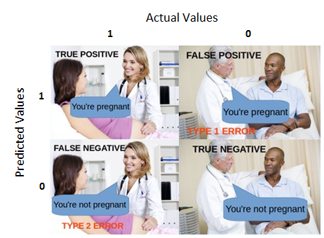

# Confusion Matrices - Example

* “Survived” = **“Positive”**
* “Not Survived” = **“Negative”**

|  |  |  |  |  |
| --- | --- | --- | --- | --- |
| Passenger ID | Probability of Survived | Prediction | Truth | Evaluation |
| 1 | 0.55 | Survived | Survived | TP |
| 2 | 0.2 | Not Survived | Survived | FN |
| 3 | 0.94 | Survived | Survived | TP |
| 4 | 0.63 | Survived | Not Survived | FP |
| 5 | 0.9 | Survived | Survived | TP |
| 6 | 0.35 | Not Survived | Not Survived | TN |
| 7 | 0.84 | Survived | Not Survived | FP |
| 8 | 0.38 | Not Survived | Not Survived | TN |
| 9 | 0.01 | Not Survived | Not Survived | TN |
| 10 | 0.68 | Survived | Survived | TP |
| 11 | 0.71 | Survived | Survived | TP |
| 12 | 0.45 | Not Survived | Survived | FN |

# Confusion Matrices

|  |  |  |
| --- | --- | --- |
|  | Predicted Positive | Predicted Negative |
| **Actual Positive** | 5 | 2 |
| **Actual Negative** | 2 | 3 |

# Model evaluation from Confusion Matrices

|  |  |  |
| --- | --- | --- |
|  | Predicted Positive | Predicted Negative |
| **Actual Positive** | True Positive (TP) | False Negative (FN) |
| **Actual Negative** | False Positive (FP) | True Negative (TN) |

$$ &= = \ &= \ &= = \ & = = \ &= \ &=2 =

$$

# Confusion Matrices

|  |  |  |
| --- | --- | --- |
|  | Predicted Positive | Predicted Negative |
| **Actual Positive** | TP = 5 | FN = 2 |
| **Actual Negative** | FP = 2 | TN = 3 |

$$ &=4/12 \ &= 8/12 \ &= 5/7 \ & = 3/5 \ &= 5/7 \ &= 5/7

$$

# ROC Curves

* Notice that all of the measures calculated in the last slide are based on the **cut-off 0.5**
* What if we change the cut-off value, **c**?

# ROC Curves

* What is the best cut-off value?

## Loading required package: lattice

## Loading required package: ggplot2

## Warning in confusionMatrix.default(as.factor(as.numeric(pp)), as.factor(t), :  
## Levels are not in the same order for reference and data. Refactoring data to  
## match.  
  
## Warning in confusionMatrix.default(as.factor(as.numeric(pp)), as.factor(t), :  
## Levels are not in the same order for reference and data. Refactoring data to  
## match.

|  |  |  |
| --- | --- | --- |
| Cut-off Values | Sensitivity | Specificity |
| c = 0 | 1.0000000 | 0.0 |
| c = 0.1 | 1.0000000 | 0.2 |
| c = 0.2 | 0.8571429 | 0.2 |
| c = 0.3 | 0.8571429 | 0.2 |
| c = 0.4 | 0.8571429 | 0.6 |
| c = 0.5 | 0.7142857 | 0.6 |
| c = 0.6 | 0.5714286 | 0.6 |
| c = 0.7 | 0.4285714 | 0.8 |
| c = 0.8 | 0.2857143 | 0.8 |
| c = 0.9 | 0.1428571 | 1.0 |
| c = 1 | 0.0000000 | 1.0 |

# ROC

* **Question**: What is the best cut-off value?

## Warning in confusionMatrix.default(as.factor(as.numeric(pp)), as.factor(t), :  
## Levels are not in the same order for reference and data. Refactoring data to  
## match.  
  
## Warning in confusionMatrix.default(as.factor(as.numeric(pp)), as.factor(t), :  
## Levels are not in the same order for reference and data. Refactoring data to  
## match.

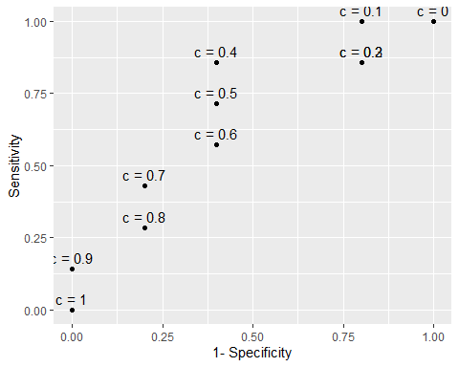

# ROC Curve

* **Question**: What is the best cut-off value?
* **Answer**: $c=0.4$ is the best cut-off value

# ROC Curve

* Each cut-off value **c** results a pair of (1-Specificity, Sensitivity) or (TP Rate, FP Rate)
* The collections of all these pairs/points for all the cut-off values is the Receiver operating characteristic Curve (ROC Curve)

# ROC Curve of the example model

## Warning in confusionMatrix.default(as.factor(as.numeric(pp)), as.factor(t), :  
## Levels are not in the same order for reference and data. Refactoring data to  
## match.  
  
## Warning in confusionMatrix.default(as.factor(as.numeric(pp)), as.factor(t), :  
## Levels are not in the same order for reference and data. Refactoring data to  
## match.  
  
## Warning in confusionMatrix.default(as.factor(as.numeric(pp)), as.factor(t), :  
## Levels are not in the same order for reference and data. Refactoring data to  
## match.

## -- Attaching packages -------------------------------------------------------------------------------- tidyverse 1.3.0 --

## v tibble 3.0.2 v dplyr 1.0.0  
## v tidyr 1.1.0 v stringr 1.4.0  
## v readr 1.3.1 v forcats 0.5.0  
## v purrr 0.3.4

## -- Conflicts ----------------------------------------------------------------------------------- tidyverse_conflicts() --  
## x dplyr::filter() masks stats::filter()  
## x dplyr::lag() masks stats::lag()  
## x purrr::lift() masks caret::lift()

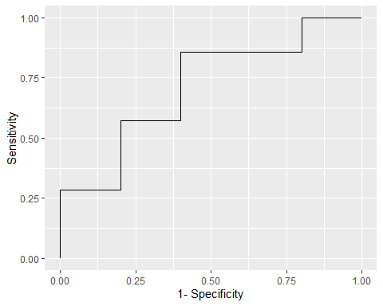

* The curve is not very smooth because the data is very small
* With bigger data, the ROC curve will be very “smooth”

# ROC Curve

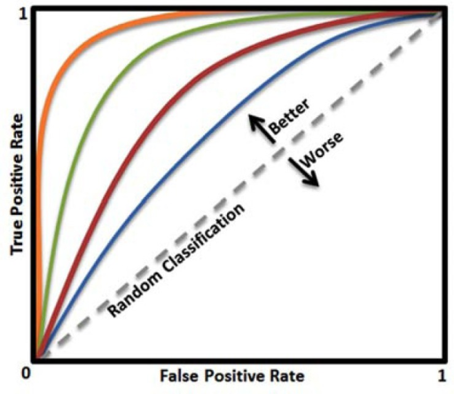 - The closer the curve to the point (0,1) the better the model - The best cut-off value is at the point closest to (0,1) - (0,1) is the **perfect point**, resulting 0 misclassification model.  
- At (0,0) the model predicts everything positive - At (1,1) the model predicts everything negative - The ROC of the random guess model is the diagonal

# ROC Curve

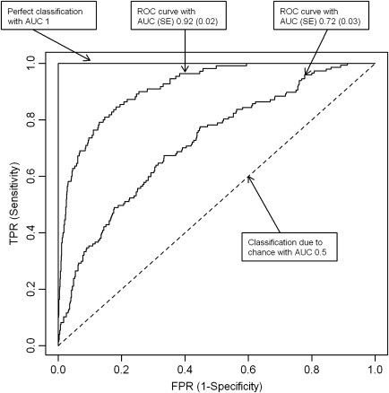

* AUC = Area Under the (ROC) Curve

# ROC Curve

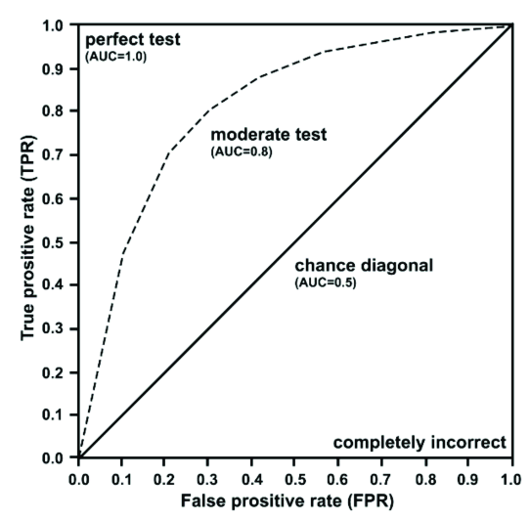

# ROC Index

* ROC Index is the area under the ROC Curve

# ROC Index - Area Under the Curve (AUC)

* The closer the AUC to 1 the better the model
* The closer the AUC to 1/2 the worse the model
* Model with AUC = 1/2 is as good as a random guess or guessing by tossing a coin
* **Question**: What if the AUC less than 1/2? Are models with AUC less than 1/2 **useless**?

# Another Question

* **Question**: Is the model with the misclassification rate of 100% the most **useless** model?

# Answer

* **Question**: Is the model with the misclassification rate of 100% an useless model?
* *Answer*: No, by flipping the predictions of the models, one gets the **perfect model** with 0 misclassification rate.

# Back to the Question

* **Question**: What if the AUC less than 1/2? Are models with AUC less than 1/2 **useless**?
* **Answer**: Model with AUC less than 1/2 could be made to be better by flipping the predictions (if the model predicts positve, flip it to predict negative)

# Cumulative Lift

* In the dataset, the ratio of “Survived” is 7/12 = 58.33%
* This mean that if we pick **randomly** a passenger in the this group, the chance of picking a “Survived” passenger is 58.33%
* **Question**: If we want to pick a “Survived” passenger, is there a better way than pick randomly?

# Cumulative Lift

* **Question**: If we want to pick a “Survived” passenger, is there a better way than pick randomly?
* **Answer**: Yes, we should pick the one with the highest predictied probability.

# Cumulative Lift

|  |  |  |
| --- | --- | --- |
| Order | Predicted Probabilities | True Values |
| 1 | 0.94 | 1 |
| 2 | 0.90 | 1 |
| 3 | 0.84 | 0 |
| 4 | 0.71 | 1 |
| 5 | 0.68 | 1 |
| 6 | 0.63 | 0 |
| 7 | 0.55 | 1 |
| 8 | 0.45 | 1 |
| 9 | 0.38 | 0 |
| 10 | 0.35 | 0 |
| 11 | 0.20 | 1 |
| 12 | 0.01 | 0 |

* Pick randomly, “success rate” is 58.33%
* Pick the top 1, success rate is 1/1 = 100%
* We say, at 1/12 = 8.33%, the model lift is 100/58.33 = 1.71

# Cumulative Lift

|  |  |  |
| --- | --- | --- |
| Order | Predicted Probabilities | True Values |
| 1 | 0.94 | 1 |
| 2 | 0.90 | 1 |
| 3 | 0.84 | 0 |
| 4 | 0.71 | 1 |
| 5 | 0.68 | 1 |
| 6 | 0.63 | 0 |
| 7 | 0.55 | 1 |
| 8 | 0.45 | 1 |
| 9 | 0.38 | 0 |
| 10 | 0.35 | 0 |
| 11 | 0.20 | 1 |
| 12 | 0.01 | 0 |

* Pick randomly, “success rate” is 58.33%
* Pick the top 2, success rate is 2/2 = 100%
* We say, at 2/12 = 16.67%, the model lift is 100/58.33 = 1.71

# Cumulative Lift

|  |  |  |
| --- | --- | --- |
| Order | Predicted Probabilities | True Values |
| 1 | 0.94 | 1 |
| 2 | 0.90 | 1 |
| 3 | 0.84 | 0 |
| 4 | 0.71 | 1 |
| 5 | 0.68 | 1 |
| 6 | 0.63 | 0 |
| 7 | 0.55 | 1 |
| 8 | 0.45 | 1 |
| 9 | 0.38 | 0 |
| 10 | 0.35 | 0 |
| 11 | 0.20 | 1 |
| 12 | 0.01 | 0 |

* Pick randomly, “success rate” is 58.33%
* Pick the top 2, success rate is 2/2 = 100%
* We say, at 2/12 = 16.67%, the model lift is 100/58.33 = 1.71

# Cumulative Lift

|  |  |  |
| --- | --- | --- |
| Order | Predicted Probabilities | True Values |
| 1 | 0.94 | 1 |
| 2 | 0.90 | 1 |
| 3 | 0.84 | 0 |
| 4 | 0.71 | 1 |
| 5 | 0.68 | 1 |
| 6 | 0.63 | 0 |
| 7 | 0.55 | 1 |
| 8 | 0.45 | 1 |
| 9 | 0.38 | 0 |
| 10 | 0.35 | 0 |
| 11 | 0.20 | 1 |
| 12 | 0.01 | 0 |

* Pick randomly, “success rate” is 58.33%
* Pick the top 3, success rate is 2/3 = 66.66%
* We say, at 3/12 = 25%, the model lift is 66.66/58.33 = 1.14

# Cumulative Lift

|  |  |  |
| --- | --- | --- |
| Order | Predicted Probabilities | True Values |
| 1 | 0.94 | 1 |
| 2 | 0.90 | 1 |
| 3 | 0.84 | 0 |
| 4 | 0.71 | 1 |
| 5 | 0.68 | 1 |
| 6 | 0.63 | 0 |
| 7 | 0.55 | 1 |
| 8 | 0.45 | 1 |
| 9 | 0.38 | 0 |
| 10 | 0.35 | 0 |
| 11 | 0.20 | 1 |
| 12 | 0.01 | 0 |

* Pick randomly, “success rate” is 58.33%
* Pick the top 4, success rate is 3/4 = 75%
* We say, at 4/12 = 25%, the model lift is 75/58.33 = 1.28

# Cumulative Lift

|  |  |
| --- | --- |
| Percentage | Lift |
| 0.0833333 | 1.714286 |
| 0.1666667 | 1.714286 |
| 0.2500000 | 1.142857 |
| 0.3333333 | 1.285714 |
| 0.4166667 | 1.371429 |
| 0.5000000 | 1.142857 |
| 0.5833333 | 1.224490 |
| 0.6666667 | 1.285714 |
| 0.7500000 | 1.142857 |
| 0.8333333 | 1.028571 |
| 0.9166667 | 1.090909 |
| 1.0000000 | 1.000000 |

# Cumulative Lift

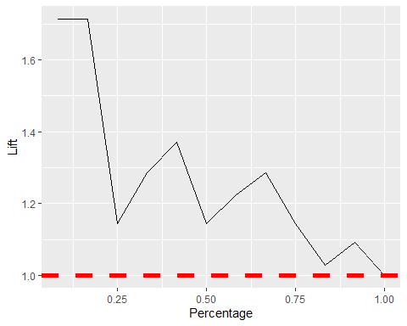

# Cumulative % Response

|  |  |
| --- | --- |
| Percentage | Percent_Response |
| 0.0833333 | 1.0000000 |
| 0.1666667 | 1.0000000 |
| 0.2500000 | 0.6666667 |
| 0.3333333 | 0.7500000 |
| 0.4166667 | 0.8000000 |
| 0.5000000 | 0.6666667 |
| 0.5833333 | 0.7142857 |
| 0.6666667 | 0.7500000 |
| 0.7500000 | 0.6666667 |
| 0.8333333 | 0.6000000 |
| 0.9166667 | 0.6363636 |
| 1.0000000 | 0.5833333 |

# Cumulative % Response

