Assignment 3

2024-02-08

## Questions

data("AirPassengers")  
plot(AirPassengers)

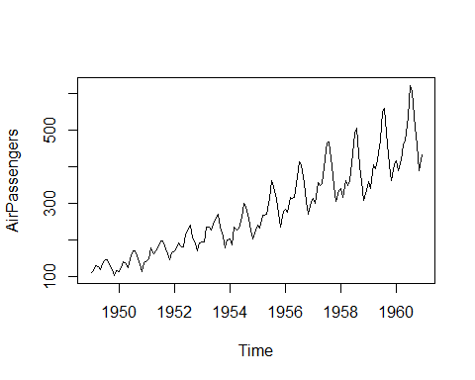

ourDecomposition <- decompose(AirPassengers, type="additive")  
plot(ourDecomposition)

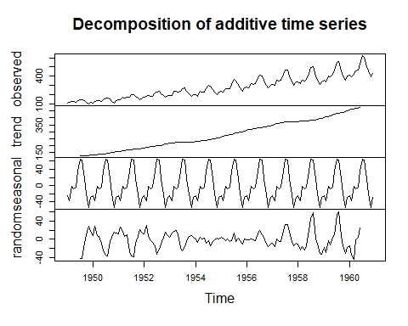

data("AirPassengers")  
plot(AirPassengers)



ourDecomposition <- decompose(AirPassengers, type="multiplicative")  
plot(ourDecomposition)

