Exponential Smoothing

Table of contents

## 1. Single Exponential Smoothing

library(forecast)

Warning: package 'forecast' was built under R version 4.3.3

Registered S3 method overwritten by 'quantmod':  
 method from  
 as.zoo.data.frame zoo

rain = read.csv('https://bryantstats.github.io/math475/slides/rainfall_london.csv')  
ts1 = ts(rain, start = 1813, frequency = 1)  
ts1_forecast = HoltWinters(ts1, alpha = TRUE, gamma = FALSE, beta = FALSE)  
plot(ts1_forecast)

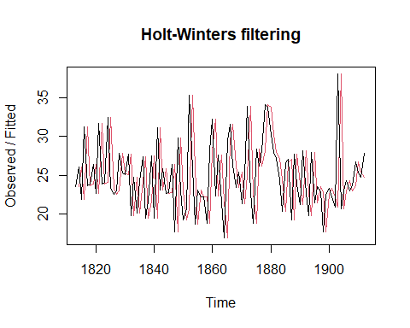

ts1_forecasts2 <- forecast(ts1_forecast, h=48)  
plot(ts1_forecasts2)

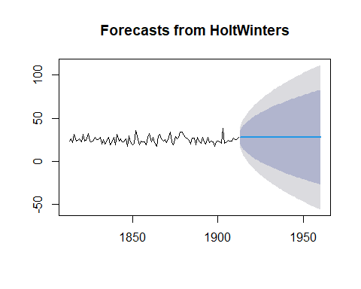

## 2. Double Exponential Smoothing

skirts <- read.csv('https://bryantstats.github.io/math475/slides/skirts.csv')  
  
ts2 <- ts(skirts,start=c(1866), frequency = 1)  
  
plot(ts2)

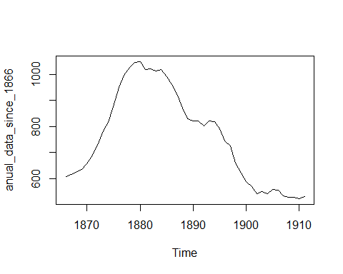

ts2_forecast <- HoltWinters(ts2, alpha=TRUE,   
 beta = TRUE,   
 gamma = FALSE)  
plot(ts2_forecast)

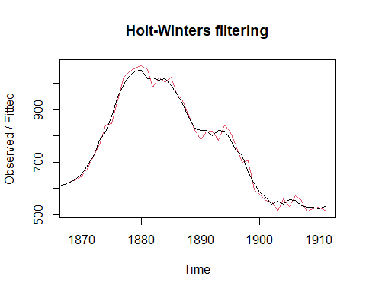

ts2_forecast2 <- forecast(ts2_forecast, h=19)  
plot(ts2_forecast2)

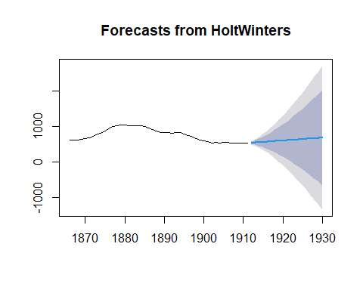

ts2_forecast2

Point Forecast Lo 80 Hi 80 Lo 95 Hi 95  
1912 539 512.16276 565.8372 497.955979 580.0440  
1913 547 486.99010 607.0099 455.222779 638.7772  
1914 555 454.58423 655.4158 401.427335 708.5727  
1915 563 416.00637 709.9936 338.192638 787.8074  
1916 571 371.96968 770.0303 266.609393 875.3906  
1917 579 322.98902 835.0110 187.464993 970.5350  
1918 587 269.45746 904.5425 101.360593 1072.6394  
1919 595 211.68750 978.3125 8.774122 1181.2259  
1920 603 149.93520 1056.0648 -89.902825 1295.9028  
1921 611 84.41527 1137.5847 -194.341848 1416.3418  
1922 619 15.31115 1222.6889 -304.262424 1542.2624  
1923 627 -57.21813 1311.2181 -419.421322 1673.4213  
1924 635 -133.03294 1403.0329 -539.605021 1809.6050  
1925 643 -212.00946 1498.0095 -664.624121 1950.6241  
1926 651 -294.03684 1596.0368 -794.309125 2096.3091  
1927 659 -379.01515 1697.0152 -928.507182 2246.5072  
1928 667 -466.85366 1800.8537 -1067.079533 2401.0795  
1929 675 -557.46952 1907.4695 -1209.899468 2559.8995  
1930 683 -650.78667 2016.7867 -1356.850685 2722.8507

## Triple Exponential Smoothing

souvenir <- read.csv('https://bryantstats.github.io/math475/slides/souvenir.csv')  
ts3 <- ts(souvenir, frequency=12, start=c(1987,1))  
plot(ts3)

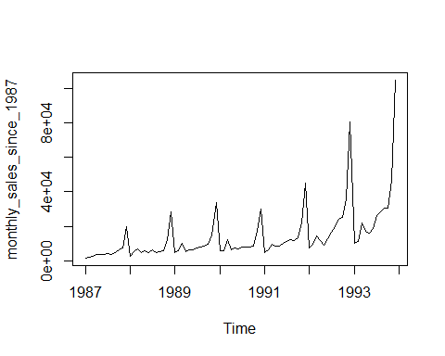

ts3_forecasts <- HoltWinters(ts3, alpha=TRUE,   
 beta=TRUE,   
 gamma=TRUE)  
plot(ts3_forecasts)

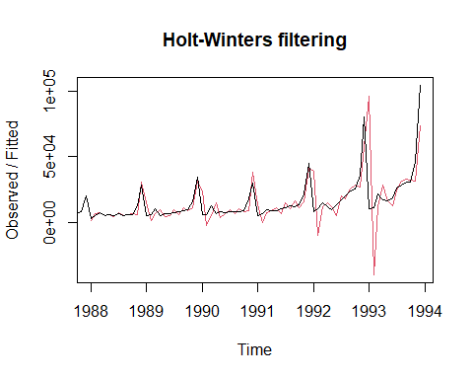

ts3_forecasts2 <- forecast(ts3_forecasts, h=48)  
plot(ts3_forecasts2)

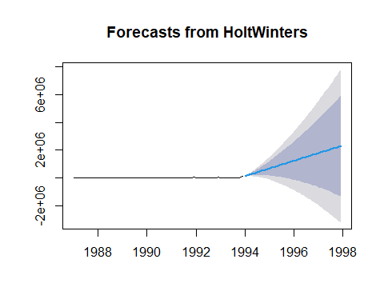

## Log Transformation

logts3 <- log(ts3)  
ts3_forecasts <- HoltWinters(logts3)  
plot(ts3_forecasts)

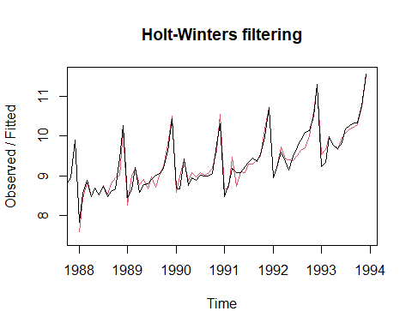

ts3_forecasts2 <- forecast(ts3_forecasts, h=48)  
plot(ts3_forecasts2)

