Research Plan

ASSESSING PEDESTRIANS’ EXPOSURE TO TRAFFIC NOISE WITH SPATIAL ANALYSIS: THE EFFECTS OF HOME LOCATION AND ROUTE CHOICE

(Working title)

Master’s thesis  
Joose Helle  
Department of Geosciences and Geography  
University of Helsinki

### Introduction

In the growing cities, active transport modes are getting increasing amount of attention among policy makers and urban planners. The term active transport is usually used to reference to walking and cycling but also other active transport modes such as E-scooters and even city rowboats are emerging. Undoubtedly, walking remains as the most popular mode of active transport since it doesn’t require any accessories and is essential part of all itineraries made by public transport.

It has been shown that active transport modes provide strong health benefits to their users (Pucher & Buehler, 2010) and also for others since they can help to reduce congestion. Hence, cities often have a strong willingness to facilitate active transport modes as urban mobility. In encouraging people to e.g. walking, it is essential for the cities to provide sufficient infrastructure and comfortable environments to make walking secure and easy.

Multiple factors affect the ease with which active transport is applicable in different urban environments. While infrastructure for cycling is predominantly defined by the more or less exclusive network of cycleways and bike lanes, the one for walking (footpaths, sidewalks etc.), in the other hand, is denser and more evenly distributed. However, not only the physical properties of the walking network define its applicability and desirability (walkability), but also multiple more or less subjective factors need to be considered (Maghelal & Capp, 2011). These include variables such as safety, building design, openness of spaces, proximity to opportunities, air quality and green spaces.

Many of the factors limiting walkability and other active transport modes are often caused by (or at least related to) other, “non-human”, users of the urban space. Evidently, one of the most significant of these is vehicular traffic and the infrastructures supporting it. Vehicular traffic affects walkability and bikeability by introducing large and typically unpleasant structures to urban spaces. From the active transport point of view, these structures act as barriers that fragment the active transportation networks and thus reduce the opportunities for walking and cycling.

Furthermore, vehicular traffic consumes the opportunities for active transport with at least two “invisible” ways. Firstly, since most of the traffic is powered by gasoline engines, it has a strong negative impact on air quality due to the exhaust gases. According to numerous studies, these urban air pollutions can cause or worsen many lung diseases such as asthma or even cancer. Secondly, both the engines and the wheels of the vehicles cause noise. Amount of noise is related to the flow and speed of the traffic and to the type of the surface of the road. Increased but also varying traffic noise levels are typical to highways and other major roads. According to several studies, there seem to be some kind of relationship between pedestrians’ exposure to traffic noise and health, namely stress levels and problems related to blood circulation (Babisch, Beule, Schust, Kersten, & Ising, 2005; Ising, Dienel, Günther, & Markert, 1980).

Given this context, the main objectives of the study are defined as follows:

1. Develop a “quiet path” routing method that optimizes more pedestrian-friendly walking routes by minimizing exposure to traffic noise pollution.
2. Explore spatial patterns in pedestrians’ exposures to traffic noise on the walks to local public transport hubs (stations) and to local grocery stores:
   1. Which residential areas accumulate the highest pedestrians’ exposures to traffic noise?
   2. How the opportunities to choose healthier (less noisy) walking routes are distributed spatially?
3. Publish the quiet path routing method as a stand-alone proof-of-concept (POC) quiet path planner app with web user interface.
4. Explore opportunities to implement quiet path routing in HRT’s route planner and to utilize real-time traffic noise (or air pollution) data (only if schedule is dynamic).

In this study, the broad and comprehensive definition of walkability is not trying to be addressed per se. Instead, from the perspective of walkability research, this study can be seen as an attempt to capture a narrow but important component of walkability; exposures to traffic noises have the potential to offer relevant spatial information of routes and areas of low walkability.

It is anticipated, yet not explicitly verified in the study, that traffic noise levels have a strong spatial correlation with also other negative impacts of traffic such as air pollution and presence of large unwalkable (and unpleasant) infrastructures. With respect to this assumption, the methods developed in the study will be suitable for identifying areas where improvements to walking conditions are most needed.

Also, the methods will have the potential to contribute in finding better, healthier walking routes – or at least to avoiding the worst ones. The “quiet path routing” method will require constructing network where traffic noise information is assigned to every road segment. Adjusted shortest path algorithm can then be used to find (short) routes off less noise exposure as alternatives to shortest paths. Moreover, the method will be published as a stand-alone proof-of-concept web service with accompanying interactive web map application to serve as a route planner user interface. This way, the methods developed in this study gain the utility to actually help citizens to compare and choose healthier (less noisy) walking routes. Yet, there are several conceptual and technical issues regarding the implementation of such service, and hence it cannot be considered as the main output of this study at this stage. Still, it is important to evaluate opportunities for implementing healthy (or quiet) path routing also within the route planner application of Helsinki Region Transport (HRT). HRT’s route planner has recently been re-implemented with OpenTripPlanner (OTP) and open sourced, both of which facilitate its further development and enable distributed contributions from different stakeholders.

**Background**

Since negative health impacts of vehicular traffic to pedestrians can compromise the potential health benefits of walking (Tainio et al., 2016), means for assessing pedestrians’ exposure to the negative effects of traffic have been developed in the previous literature. Clearly, two distinguishable approaches exist for addressing moving individuals’ exposures to traffic noise and air pollution:

1. Direct way: using measurement instruments attached to members of a study group and tracking them temporally and spatially (e.g. Apparicio, Carrier, Gelb, Séguin, & Kingham, 2016; Cole-Hunter, Morawska, Stewart, Jayaratne, & Solomon, 2012).
2. Indirect way: using spatial analysis combining modelled traffic noise or air pollution data and either tracked or modelled routes of people (e.g. Sheng & Tang, 2011; Whyatt et al., 2007).

While air pollution is often be challenging to quantify, measure and model (and tends to be highly dynamic with respect to weather conditions), traffic noise can be measured and modelled in a more straightforward manner. Also, the latter has the potential to offer spatially accurate information of urban traffic flows and their side-effects. Vehicular traffic noise levels have been spatially modelled in many cities with fairly high spatial resolution. The modeling has been done using mathematical models that consider traffic count data, noise measurements and data of materials and geometries of urban infrastructures (buildings, roads, walls etc.).

In the previous literature, the concepts green, healthy, sustainable, safe and quiet paths have been introduced to address the problem of finding alternative walking routes. Taking environmental factors into account in solving route optimization problems clearly seem to have the potential to generate healthier or in other ways better walking routes (e.g. Lwin & Murayama, 2011, 2013; Quercia, Schifanella, & Aiello, 2014; Ribeiro & Mendes, 2011). In the context of this study, the concept *quiet path* is used to refer to routes of less noise exposure.

### Materials

Table 1. Materials that will be used in the study.

|  |  |  |  |
| --- | --- | --- | --- |
| Name | Source | Description | Use in the study |
| Traffic noise zones in Helsinki 2017 | Urban Environment Division of city of Helsinki  (Helsingin kaupunkiympäristön toimiala) | Modelled traffic noise zones as polygon layer covering the city of Helsinki. Minimum and maximum noise levels are stored as attribute information. | Traffic noise exposures will be based on traffic noise zones of this dataset. |
| Traffic noise zones in Helsinki metropolitan area 2012 | Urban Environment Divisions of cities of Helsinki, Vantaa and Espoo | Modelled traffic noise zones as polygon layers covering the Helsinki metropolitan area. Minimum and maximum noise levels are stored as attribute information. | If the analysis is done for the whole Helsinki metropolitan area (i.e. Greater Helsinki?), this dataset will be used as the traffic noise data. |
| YKR population grid | Finnish Environment Institute (SYKE) | 250m * 250m grid layer. | Center points of the grid layer are used as origins of the routing analysis. |
| YKR workplaces grid | Finnish Environment Institute (SYKE) | 250m * 250m grid layer.  Commutes to work from homes to workplaces aggregated to the grid cells. | Public transport itineraries will be planned for all commutes to work and the walks extracted from those itineraries for exposure analysis. |
| Grocery stores | Digital Geography Lab / Claudia Bergroth ? | Grocery stores in the Helsinki metropolitan area | Walking routes are also planned to local grocery stores (from inhabited YKR grid cells). |
| OpenStreetMap: highways | © OpenStreetMap contributors | All walkable highways and paths will be extracted from the data as vector lines. | A graph suitable for solving route optimization problems will be constructed from the data. |
| Digitransit Routing API | Helsinki Region Transport (HRT) | Routing service for public transport provides routing results (geometries and itinerary information) as an application programming interface (API). | Identification of areal transit hubs to which pedestrian walking routes are calculated from residential locations. |
|  |  |  |  |

**Planned (and already partly implemented) methods**

In this chapter, the method for assessing pedestrians’ exposure to traffic noise is explained within the planned workflow of the case study (Figure 1). In the last paragraphs of the chapter, some considerations regarding the quiet path routing tool and web service are discussed.

A method for assessing pedestrians’ cumulative exposure to traffic noise with spatial analysis will be developed in the study. The definition of pedestrian’s exposure to traffic noise will be based on the time spent at different noise levels (as in Apparicio et al., 2016). Similarly, pedestrians’ cumulative exposures to traffic noise will be calculated as the total amount of time spent in different noise levels. However, since the sensitivity to different traffic noise levels is fundamentally subjective, no single indicator describing the total exposure (to noise) can be quantified, but the exposures to different noise level ranges have to be considered in the analysis and the results somehow separately. Indeed, more literature needs to be gathered to find information about 1) quantifying total cumulative exposures to noise and 2) official and studied thresholds of tolerable levels of traffic noise.

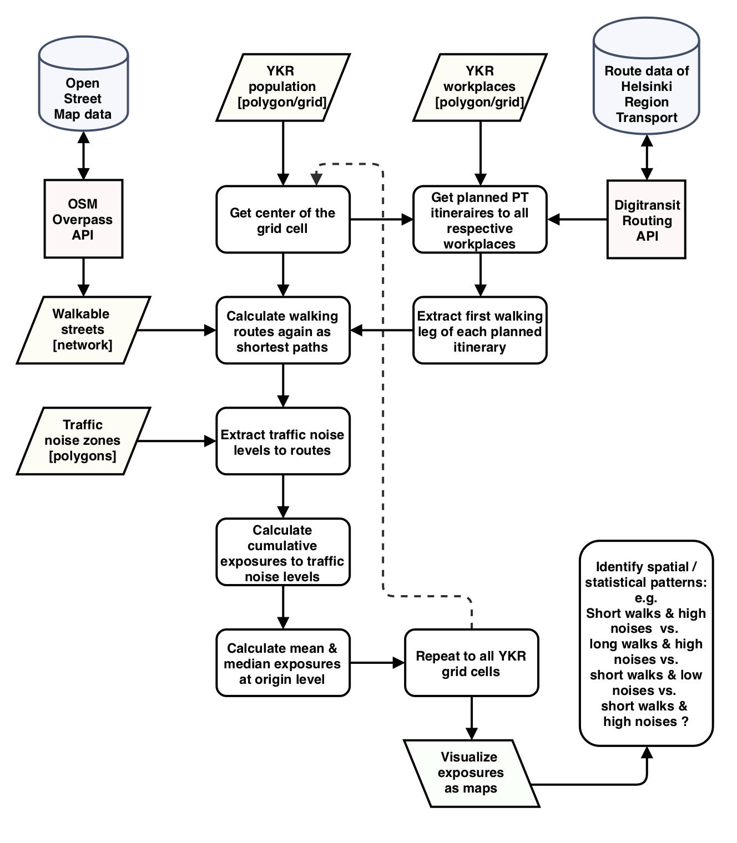

Figure 1. Planned workflow of the exposure analysis.

In order to find the most used walking routes of local daily mobility, walking itineraries are calculated (planned) to local public transport hubs and stations (PT hubs). PT hubs are determined by executing an extensive routing analysis from all inhabited YKR grid cells (cell centers) to the corresponding workplace locations obtained from the YKR workplaces dataset. Importance, or more precisely: utilization rate, of each hub with respect to the origin can be defined as the count of itineraries using the same PT hub.

Routing analysis is implemented as a batch of routing requests to Digitransit Routing API (application programming interface), that is run by Helsinki Region Transport (HSL / HRT). The routing API is utilized by the most popular route planner applications in Helsinki and fine-tuned to consider many aspects of public transport itineraries. Thus, it will provide realistic route plans from a user perspective.

### Subsequently, shortest walking routes to local PT hubs (or stations) are calculated from each origin (inhabited YKR grid cell). The routing analysis requires acquisition of road data from OpenStreetMap and constructing a network graph from it. Shortest paths are calculated with Dijkstra’s algorithm using NetworkX Python library. Focusing on the first walks (from homes to PT hubs) of the itineraries can be justified with at least three arguments; 1) they cover majority of the walking of the complete PT itineraries (this will be demonstrated in the analysis), 2) using them in the exposure (to traffic noise) analysis will reveal more interesting spatial differences 3) analyzing all of the walks of the itineraries would make the results harder to interpret and analysis overly complicated.

### Traffic noise information is extracted from the modelled traffic noise data (Table 1) and added to the walks of each origin-PT-hub pair with a spatial join based on line-polygon intersections. Total cumulative walking distances at different traffic noise levels are aggregated to each walk route as total exposures to traffic noise. Statistics of origin-level routes and exposures to traffic noises are aggregated from the individual walking routes to PT hubs and weighted by the local (origin-level) importance of each PT hub. At some part of the analysis, the exposure distances are converted to exposure times to address the real nature of exposure.

### Local (grid cell level) pedestrians’ cumulative exposures to traffic noises are visualized as a choropleth map. It is yet to be decided how the cumulative exposures to different traffic noise level ranges will be converted into a single metric describing the total exposure to traffic noise during a walk.

Shortest path and exposure analysis will also be implemented by local grocery stores. The advantage of this (second) approach is its simplicity compared to the one using local PT hubs; from each origin, only one shortest path to the closest grocery store will be calculated and the exposure along it extracted. Thus, the results will be obtained directly at origin level and no aggregation of exposures is needed (as opposed to the situation of having multiple PT hubs per origin). This part of the analysis (and results) will be conceptually more straightforward and hence the results easier to interpret.

Furthermore, a “quiet path” routing method for finding short but less noisy walking routes will be developed in the study. The planned workflow and structure for it is illustrated in Figure 2. It is yet to be decided what exactly will be the role of the quiet path routing method in the study. Undoubtedly, at least two applications for it exist in the context:

1. Routing alternative walking routes from each YKR grid cell to local PT hubs and quantifying the level of opportunities to choose less noisy routes at neighborhood (YKR grid cell) level. Avoided exposure to traffic noise and differences in route lengths need to be considered.
2. Setting up a server-side application that calculates walking routes of less noise exposure on demand. Developing a client-side web map application that user can use to plan walking itineraries of less noise exposure. The application would show several optional walking routes with different lengths and different exposures to traffic noise to choose from.

However, a critical challenge is posed to the quiet path routing by highly subjective definition of tolerable level of traffic noise. Thus, special attention has to be paid to also assessing the sensitivity of the routing model to varying tolerances to different noise levels. In Figure 2, the constant ‘Personal noise tolerance’ (PNT) is introduced to the workflow to conceptualize this subjectivity within the environmental impedance function. Here, an important question is: can PNT be compressed into one constant, or should it be defined separately for different noise level ranges? Nevertheless, the sensitivity of the quiet path routing to PNT could be quantified to some extent with systematically altering it and comparing the routing results and their cumulative noise exposures.

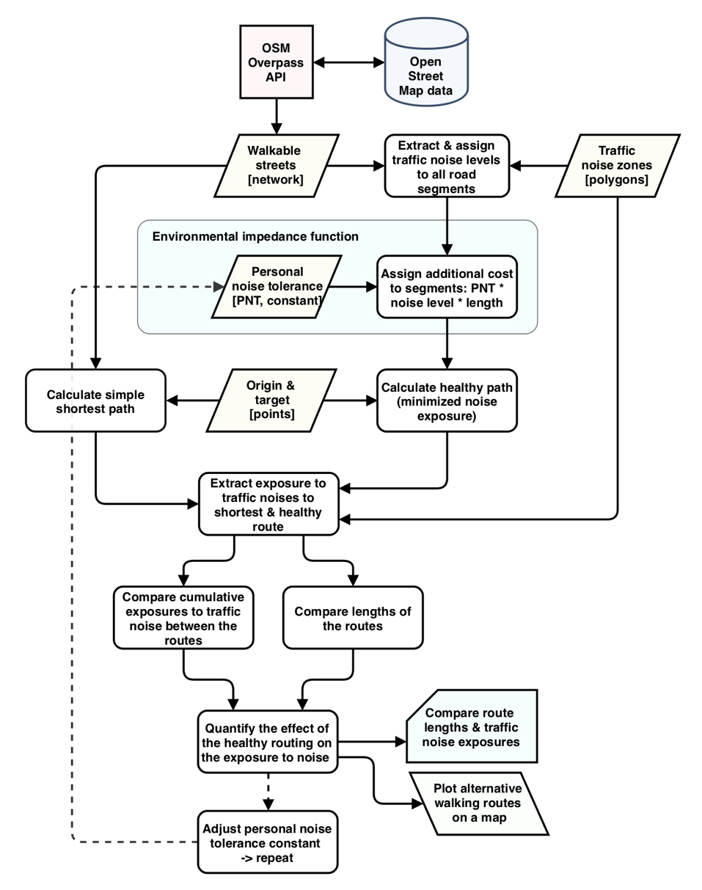

Figure 2. Potential workflow & structure of the "quiet path” analysis.

As explained before, publishing the quiet path routing method as a web application will enable citizens to find better, less noisy, walking route alternatives to their daily walks. The implementation of such service would generally follow the technical architecture illustrated in Figure 3.

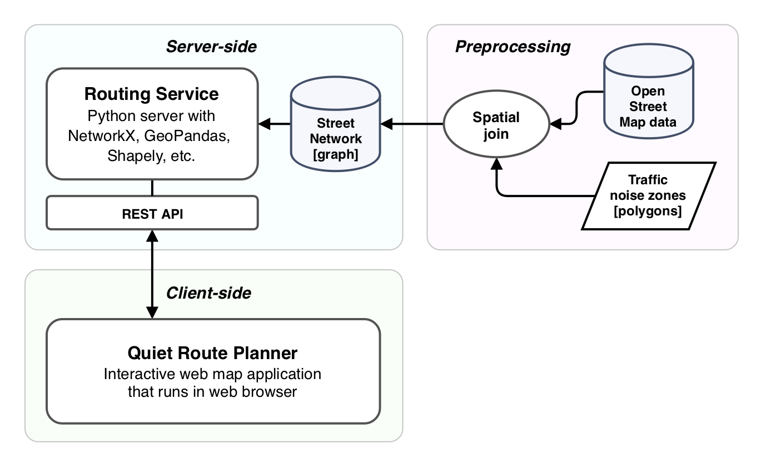

Figure 3. Potential technical architecture of the quiet path routing web application.

**Technical considerations**

Majority of the data acquisition, manipulation and analysis will be implemented in Python programming environment using exclusively open source tools and libraries. Thus, most, if not all, of the scripts and results of the study can be published in e.g. GitHub to facilitate future research on related themes. All of the scripts written by now are already in a public GitHub repository ([github.com/hellej/gradu-pocs](http://github.com/hellej/gradu-pocs)). A reasonable goal would be to organize the codebase into modules and functions that would potentially be useful in other studies on exposures to environmental variables.

Python libraries OSMnx and NetworkX will be used for network acquisition, manipulation and analysis. Libraries Shapely and GeoPandas will be used for general manipulation of geospatial data. GeoPackage file format will be used in storing temporary and final results due to its better performance and structure compared to e.g. Esri Shapefiles. GIS Software QGIS will be used for producing the visualizations.

Since the walkable network of the whole municipality is likely to be extensive with respect to number of nodes & edges in the graph, extra computing power is needed for manipulating and analyzing it efficiently. Computing resources will be requested from CSC (IT Center for Science Ltd.) to enable executing Python runs in parallel.

**Expected results**

It is expected, that in some areas residents (pedestrians) are exposed to higher traffic noise levels and for longer times than in other areas. Considering the potential (negative) health effects of traffic noise, this result is interesting already per se. Higher exposures to traffic noise are anticipated for areas where vehicular traffic flows are high, road infrastructure (for cars) is massive, walking distances are long, and important walkways are exposed to traffic noise. In the other hand, lower exposures to traffic noise are anticipated for areas where walkable street network is denser, sheltered walkways exist, walking distances are short and vehicular traffic flows are lower.

When also the opportunities for choosing less noisy walking routes are considered, conclusions can be drawn about the (areal) needs for improvement in walking conditions. In other words, it is not sufficient to only asses the exposures along the very shortest paths, but it is essential to know also the exposures along the alternative, almost as short, paths.

To conclude, the best possible outcome of this study would be to facilitate both 1) city planners to discover areal needs for improving walking conditions and 2) citizens to choose healthier (quieter) walking routes for their daily mobility (via the “quiet route planner” web application).

**Schedule**

|  |  |
| --- | --- |
| February | Gathering literature and preparing the analysis. |
| March | Building the analysis by writing & running Python scripts. |
| April | Adjusting & finishing the analysis and writing the thesis. |
| May | Writing the thesis and preparing the scripts and tools for publication. |
| June | Mostly done? |

**References**

Apparicio, P., Carrier, M., Gelb, J., Séguin, A.-M., & Kingham, S. (2016). Cyclists’ exposure to air pollution and road traffic noise in central city neighbourhoods of Montreal. *Journal of Transport Geography*, *57*, 63–69.

Babisch, W., Beule, B., Schust, M., Kersten, N., & Ising, H. (2005). Traffic noise and risk of myocardial infarction. *Epidemiology*, 33–40.

Cole-Hunter, T., Morawska, L., Stewart, I., Jayaratne, R., & Solomon, C. (2012). Inhaled particle counts on bicycle commute routes of low and high proximity to motorised traffic. *Atmospheric Environment*, *61*, 197–203. https://doi.org/10.1016/j.atmosenv.2012.06.041

Ising, H., Dienel, D., Günther, T., & Markert, B. (1980). Health effects of traffic noise. *International Archives of Occupational and Environmental Health*, *47*(2), 179–190.

Jäppinen, S., Toivonen, T., & Salonen, M. (2013). Modelling the potential effect of shared bicycles on public transport travel times in Greater Helsinki: An open data approach. *Applied Geography*, *43*, 13–24. https://doi.org/10.1016/j.apgeog.2013.05.010

Lwin, K. K., & Murayama, Y. (2011). Modelling of urban green space walkability: Eco-friendly walk score calculator. *Computers, Environment and Urban Systems*, *35*(5), 408–420. https://doi.org/10.1016/j.compenvurbsys.2011.05.002

Lwin, K. K., & Murayama, Y. (2013). Smart eco-path finder for mobile GIS users. *URISA Journal*, *25*(2), 5–14.

Maghelal, P. K., & Capp, C. J. (2011). Walkability: A Review of Existing Pedestrian Indices. *Journal of the Urban & Regional Information Systems Association*, *23*(2).

Pucher, J., & Buehler, R. (2010). Walking and cycling for healthy cities. *Built Environment*, *36*(4), 391–414.

Quercia, D., Schifanella, R., & Aiello, L. M. (2014). The shortest path to happiness: Recommending beautiful, quiet, and happy routes in the city. In *Proceedings of the 25th ACM conference on Hypertext and social media* (pp. 116–125). ACM.

Ribeiro, P., & Mendes, J. F. (2011). Route planning for soft modes of transport: healthy routes. *WIT Transactions on The Built Environment*, *116*, 677–688.

Sheng, N., & Tang, U. W. (2011). Spatial analysis of urban form and pedestrian exposure to traffic noise. *International Journal of Environmental Research and Public Health*, *8*(6), 1977–1990.

Tainio, M., de Nazelle, A. J., Götschi, T., Kahlmeier, S., Rojas-Rueda, D., Nieuwenhuijsen, M. J., … Woodcock, J. (2016). Can air pollution negate the health benefits of cycling and walking? *Preventive Medicine*, *87*, 233–236. https://doi.org/10.1016/j.ypmed.2016.02.002

Whyatt, J. D., Pooley, C., Coulton, P., Moser, M., Bamford, W., & Davies, G. (2007). Estimating personal exposure to air pollution on the journey to and from school using GPS, GIS and mobile phone technology. In *11th International Conference on Harmonisation within Atmospheric Dispersion Modelling for Regulatory Purposes* (Vol. 1, pp. 2–5).