

Master’s thesis  
Geoinformatics

ASSESSING PEDESTRIANS’ EXPOSURE TO TRAFFIC NOISE WITH SPATIAL ANALYSIS: THE EFFECTS OF HOME LOCATION AND ROUTE CHOICE

Joose Helle  
2019

Supervisors:  
Tuuli Toivonen  
Henrikki Tenkanen

University of Helsinki  
Faculty of Science  
Department of Geosciences and Geography

PL 64 (Gustaf Hällströmin katu 2)   
00014 University of Helsinki

|  |  |  |  |
| --- | --- | --- | --- |
| Tiedekunta/Osasto Fakultet/Sektion – Faculty  Faculty of science | | Laitos/Institution– Department  Department of Geosciences and Geography | |
| Tekijä/Författare – Author  Joose Helle | | | |
| Työn nimi / Arbetets titel – Title  Assessing pedestrians’ exposure to traffic noise with spatial analysis: the effects of home location and route choice | | | |
| Oppiaine /Läroämne – Subject  Geography, geoinformatics | | | |
| Työn laji/Arbetets art – Level  Master’s thesis | Aika/Datum – Month and year  August 2019 | | Sivumäärä/ Sidoantal – Number of pages |
| Tiivistelmä/Referat – Abstract | | | |
| Avainsanat – Nyckelord – Keywords | | | |
| Säilytyspaikka – Förvaringställe – Where deposited  HELDA | | | |
| Muita tietoja – Övriga uppgifter – Additional information | | | |





|  |  |  |  |
| --- | --- | --- | --- |
| Tiedekunta/Osasto Fakultet/Sektion – Faculty  Matemaattis-luonnontieteellinen tiedekunta | | Laitos/Institution– Department  Geotieteiden ja maantieteen laitos | |
| Tekijä/Författare – Author  Joose Helle | | | |
| Työn nimi / Arbetets titel – Title | | | |
| Oppiaine /Läroämne – Subject  Maantiede, geoinformatiikka | | | |
| Työn laji/Arbetets art – Level  Pro gradu -tutkielma | Aika/Datum – Month and year  Elokuu 2019 | | Sivumäärä/ Sidoantal – Number of pages |
| Tiivistelmä/Referat – Abstract | | | |
| Avainsanat – Nyckelord – Keywords | | | |
| Säilytyspaikka – Förvaringställe – Where deposited  HELDA | | | |
| Muita tietoja – Övriga uppgifter – Additional information | | | |

**TABLE OF CONTENTS**

1 Introduction 1

2 Background 3

2.1. Noise 3

2.2. Traffic noise in legislation 3

2.3. Alternative measures of pedestrian accessibility - Travel time is not enough 3

2.4. Approaches in assessing exposure to traffic noise 4

2.5. Route optimization in GIS 5

2.5.1. Graph theory 5

2.5.2. Least cost path 5

2.5.3. Optimizing short and green paths 5

2.5.4. Environmental impedance function 5

2.6. Web GIS 5

2.6.1. Concepts and recent developments 5

2.6.2. Interactive web map applications 5

3 Material & Methods 6

3.1. Overview of the methods 6

3.2. Materials 6

3.2.1. Modelled traffic noise data 7

3.2.2. OpenStreetMap data 7

3.2.3. Register based origin-destination (OD) data 7

3.2.4. Routing service of the local public transport authority 7

3.3. Technical framework 7

3.4. Route optimization application 7

3.4.1. Environmental impedance function 7

3.4.2. Network acquisition and processing 8

3.4.1. Extraction of contaminated distances by noise levels to network edges 8

3.4.2. Optimization of short and quiet paths 9

3.5. Assessment of pedestrians’ exposure to traffic noise at neighborhood level 9

3.5.1. Workflow of the analysis 9

3.5.2. Extraction of commutes from aggregated OD data 11

3.5.3. Estimation of local PT stops’ utilization rates by commutes 11

3.5.4. Least cost path calculations – short and quiet paths 12

3.5.5. Spatial aggregation of exposures to traffic noise along the paths 12

3.5.6. Assessment of potential to reduce exposure to traffic noise with route choices 12

3.6. Quiet path route planner web application 12

3.6.1. Technical architecture 12

3.6.2. Functions and features 12

4 Results 13

4.1. Spatial patterns in pedestrians’ exposures to traffic noise 13

4.2. Quiet path route planner web application 13

5 Discussion 14

5.1. Could traffic noise be used as a proxy for overall walkability? 14

5.2. Indirect large-scale assessment of pedestrians’ exposures to traffic noise can reveal significant areal differences in walking conditions 14

5.3. Considerable share of the exposure to traffic noise can often be avoided by taking an alternative path 14

5.4. Definition of the environmental impedance function is critical yet somewhat arbitrary in quiet path optimization 14

5.5. Alternative quiet paths need to be calculated to suit different situations and users with varying preferences 14

5.6. Publishing a green path routing application online can facilitate citizens to choose healthier paths 14

5.7. More efficient technical implementation is required to enable real-time green path route optimization 14

6 Conclusions 14

7 References 14

# Introduction

In the growing cities, active transport modes are getting increasing attention among policy makers and urban planners. The term active transport is usually used to refer to walking and cycling but also other active transport modes such as E-scooters and even city rowboats are emerging in urban context. Undoubtedly, walking remains the most popular mode of active transport since it doesn’t require any accessories and is essential part of all itineraries made by public transport.

It has been shown that active transport modes provide strong health benefits to their users (Pucher & Buehler, 2010) and also to others since they can help to reduce congestion. Hence, cities often have a strong willingness to promote and facilitate active transport modes for urban mobility. In encouraging people to e.g. walking, it is essential for the cities to provide sufficient infrastructure and comfortable environments to make walking secure and easy.

Multiple factors affect the ease with which active transport is applicable in different urban environments. While infrastructure for cycling is predominantly defined by the more or less exclusive network of cycleways and bike lanes, the one for walking (footpaths, sidewalks etc.), in the other hand, is denser and more evenly distributed. However, not only the physical properties of the walking network define its applicability and desirability (walkability), but also multiple more or less subjective factors need to be considered (Maghelal & Capp, 2011). These include variables such as safety, building design, openness of spaces, proximity to opportunities, air quality and green spaces.

Many of the factors limiting walkability and other active transport modes are often caused by (or at least related to) other, “non-human”, users of the urban space. Evidently, one of the most significant of these is vehicular traffic and the infrastructures supporting it. Vehicular traffic affects walkability and bikeability by introducing large and typically unpleasant structures to urban spaces. From the active transport point of view, these structures act as barriers fragmenting the active transportation networks and thus reduce the opportunities for walking and cycling.

Furthermore, vehicular traffic consumes the opportunities for active transport with at least two “invisible” ways. Firstly, since most of the traffic is powered by gasoline engines, it has a strong negative impact on air quality due to the exhaust gases. According to numerous studies, these urban air pollutions can cause or worsen many lung diseases such as asthma or even cancer. Secondly, both the engines and the wheels of the vehicles cause noise. Amount of noise is related to the flow and speed of the traffic and to the type of the road surface. Increased but also varying traffic noise levels are typical to highways and other major roads. According to several studies, there seem to be some kind of relationship between pedestrians’ exposure to traffic noise and health, namely stress levels and problems related to blood circulation (Babisch, Beule, Schust, Kersten, & Ising, 2005; Ising, Dienel, Günther, & Markert, 1980).

In this study, the broad and comprehensive definition of walkability is not trying to be addressed per se. Instead, from the perspective of walkability research, this study can be seen as an attempt to capture a narrow but important component of walkability; exposures to traffic noises have the potential to offer relevant spatial information of routes and areas of low walkability.

It is anticipated, yet not explicitly verified in the study, that traffic noise levels have a strong spatial correlation with also other negative impacts of traffic such as air pollution and presence of large unwalkable (and unpleasant) infrastructures. With respect to this assumption, the methods developed in the study are suitable for identifying areas where improvements to walking conditions are most needed.

Given this context, the main objectives of the study were defined as follows:

1. Discover neighborhood-level spatial patterns in pedestrians’ exposures to traffic noise with respect to citizens’ daily pedestrian activities.
2. Develop and implement a “quiet path” routing application that optimizes more pedestrian-friendly walking routes by minimizing exposure to traffic noise pollution.
3. Publish the quiet path routing application as proof-of-concept (POC) quiet path planner web application.

In other words, the study aims to facilitate both 1) city planners to discover areas of problematic walking conditions (with respect to traffic noise) and 2) citizens to choose healthier (quieter) walking routes for their daily mobility (via the “quiet route planner” web application). Latter can be seen as a short-term and the first as long-term solution to the problem of minimizing pedestrians’ exposure to traffic noise.

# Background

## Noise

Noise, in general, can be defined simply as undesirable sound. Other defining words unwanted, loud, unpleasant, disruptive and unintended aim to address the subjective nature of noise. The lack of explicit definition of noise derives from noise being indistinguishable from sound in physics; both are fundamentally just vibrations through air (or other transmission medium). Yet, the concept of noise is crucial in the research of negative health effects of high and unpleasant sounds. If a sound is described as noise, it implies that its assumed perception or health effect is negative as opposed to neutral or positive.

While there are major differences in how different people experience sound and which of all sounds are regarded as noise, some loud sounds are generally regarded as noise. Moreover, all sounds can be coarsely divided into three classes based on the general perception of them:

1. Sounds which most people perceive as desirable, pleasant or harmless (e.g. the sounds of flowing water and light wind)
2. Sounds which some people perceive as pleasant and some as noise depending on the individual, sound level, other sounds and circumstances (e.g. the sounds of dishwasher, quiet background chat and calm bird singing).
3. Sounds that most people regard as noise (e.g. the sounds of vehicular and aerial traffic, construction sits, babies crying and people yelling).

Previous research on health impacts of noise is usually focused on the sounds that most people perceive as noise (3).

## Traffic noise in legislation

## Alternative measures of pedestrian accessibility - Travel time is not enough

In accessibility researh, travel time is often used as the main measure of accessibility; how many minutes it takes to get from origin to destination? The advantages of such approach are obvious: it is, by definition, simple and enables comparison of accessibility between different travel modes and study areas. In previous research, it has been pointed out that travel time has strong impact on route and travel mode choises.

However, several weaknesses in using only travel time as a measure of accessibility have been identified.

Pedestrian, as an individual who moves in space and time, is of all the road users most exposed to the environmental conditions surrounding the taken path. The perception of these conditions can be classified by the human senses to at least three major categories:

1. Touch: how does the environment feel like? Is the air cold, humid, hot or dry?
2. Taste and smell: how is the air to breathe; does it smell clean?
3. Visual: how does the environment look like? How many sights are visible throughout the path? What is the ratio between natural and artifical sights (e.g. green vs. built)?
4. Hearing; how does the environment sound like? Are there more sounds or noises, or is it mostly quiet?

When considering pedestrian’s perceptions with respect to these five senses, it becomes clear that only the travel time is rather fuzzy measure of the perceived impdeance of a given walk.

## Approaches in assessing exposure to traffic noise

While air pollution is often be challenging to quantify, measure and model (and tends to be highly dynamic with respect to weather conditions), traffic noise can be measured and modelled in a more straightforward manner. Also, the latter has the potential to offer spatially accurate information of urban traffic flows and their side-effects. Vehicular traffic noise levels have been spatially modelled in many cities with fairly high spatial resolution. The modeling has been done using mathematical models that consider traffic count data, noise measurements and 3D data of materials and geometries of urban infrastructures (buildings, roads, walls etc.).

Since negative health impacts of vehicular traffic (to pedestrians) can compromise the potential health benefits of walking (Tainio et al., 2016), means for assessing pedestrians’ exposure to the negative effects of traffic have been developed in the previous literature. Clearly, two distinguishable approaches exist for addressing mobile individuals’ exposures to traffic noise and air pollution:

1. Direct way: using measurement instruments attached to members of a study group and tracking them temporally and spatially (e.g. Apparicio, Carrier, Gelb, Séguin, & Kingham, 2016; Cole-Hunter, Morawska, Stewart, Jayaratne, & Solomon, 2012).
2. Indirect way: using spatial analysis combining modelled traffic noise or air pollution data and either tracked or modelled routes of people (e.g. Sheng & Tang, 2011; Whyatt et al., 2007).

## Route optimization in GIS

### Graph theory

### Least cost path

### Optimizing short and green paths

In the previous literature, the concepts green, healthy, sustainable, safe and quiet paths have been introduced to address the problem of finding alternative walking routes. Taking environmental factors into account in solving route optimization problems clearly seem to have the potential to generate healthier or in other ways better walking routes (e.g. Lwin & Murayama, 2011, 2013; Quercia, Schifanella, & Aiello, 2014; Ribeiro & Mendes, 2011). In the context of this study, the concept quiet path is used to refer to routes of less noise exposure.

### Environmental impedance function

## Web GIS

### Concepts and recent developments

### Interactive web map applications

# Material & Methods

## Overview of the methods

Overview of the methods and their internal dependencies is illustrated in Figure 1.

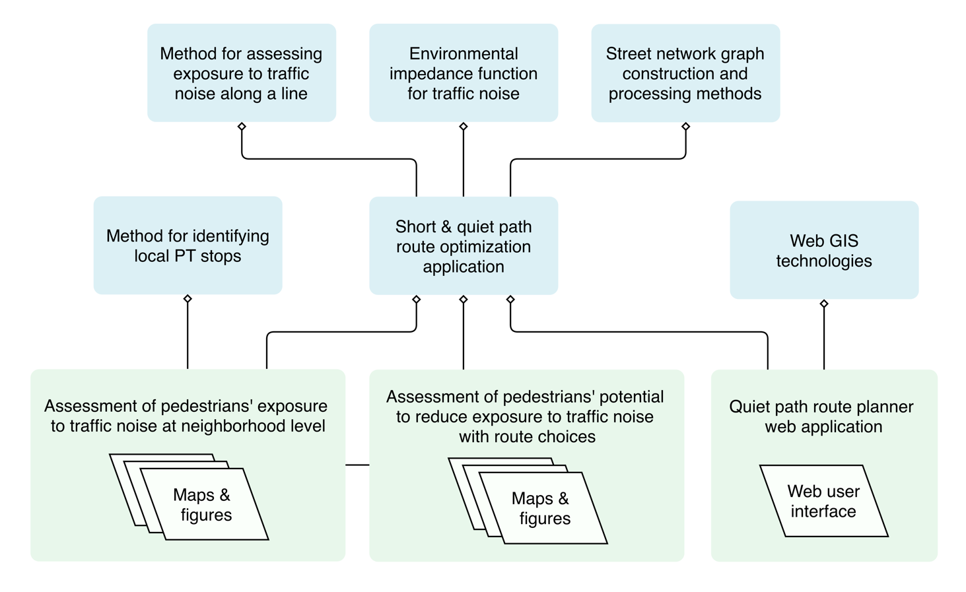

Figure 1. Illustration of the internal methodological dependencies of the study.

## Materials

Table 1. Materials that will be used in the study.

|  |  |  |  |
| --- | --- | --- | --- |
| Name | Source | Description | Use in the study |
| Traffic noise zones in Helsinki 2017 | Urban Environment Division of city of Helsinki  (Helsingin kaupunkiympäristön toimiala) | Modelled traffic noise zones as polygon layer covering the city of Helsinki. Minimum and maximum noise levels are stored as attribute information. | Traffic noise exposures will be based on traffic noise zones of this dataset. |
| 250m statistical grid | Statistics Finland | 250m * 250m polygon grid layer. | Center points of the grid layer are used as origins in the routing analysis. Grid cell polygons are used in visualizing the results. |
| YKR-commuting data | Finnish Environment Institute (SYKE) / Statistics Finland | Commutes between 250m statistical grid cells as table. One row in the table represents the total number of commutes between two grid cells. | Public transport (PT) itineraries will be planned for all commutes. The utilization rates of local PT stops will be estimated based on the PT itineraries. |
| OpenStreetMap: highways | © OpenStreetMap contributors | All walkable highways and paths will be extracted from the data as vector lines. | A graph suitable for solving route optimization problems will be constructed from the data. |
| Digitransit Routing API | Helsinki Region Transport (HRT) | Routing service for public transport provides routing results (geometries and itinerary information) as an application programming interface (API). | Identification of areal transit hubs to which pedestrian walking routes are calculated from residential locations. |

### Modelled traffic noise data

### OpenStreetMap data

### Register based origin-destination (OD) data

### Routing service of the local public transport authority

## Technical framework

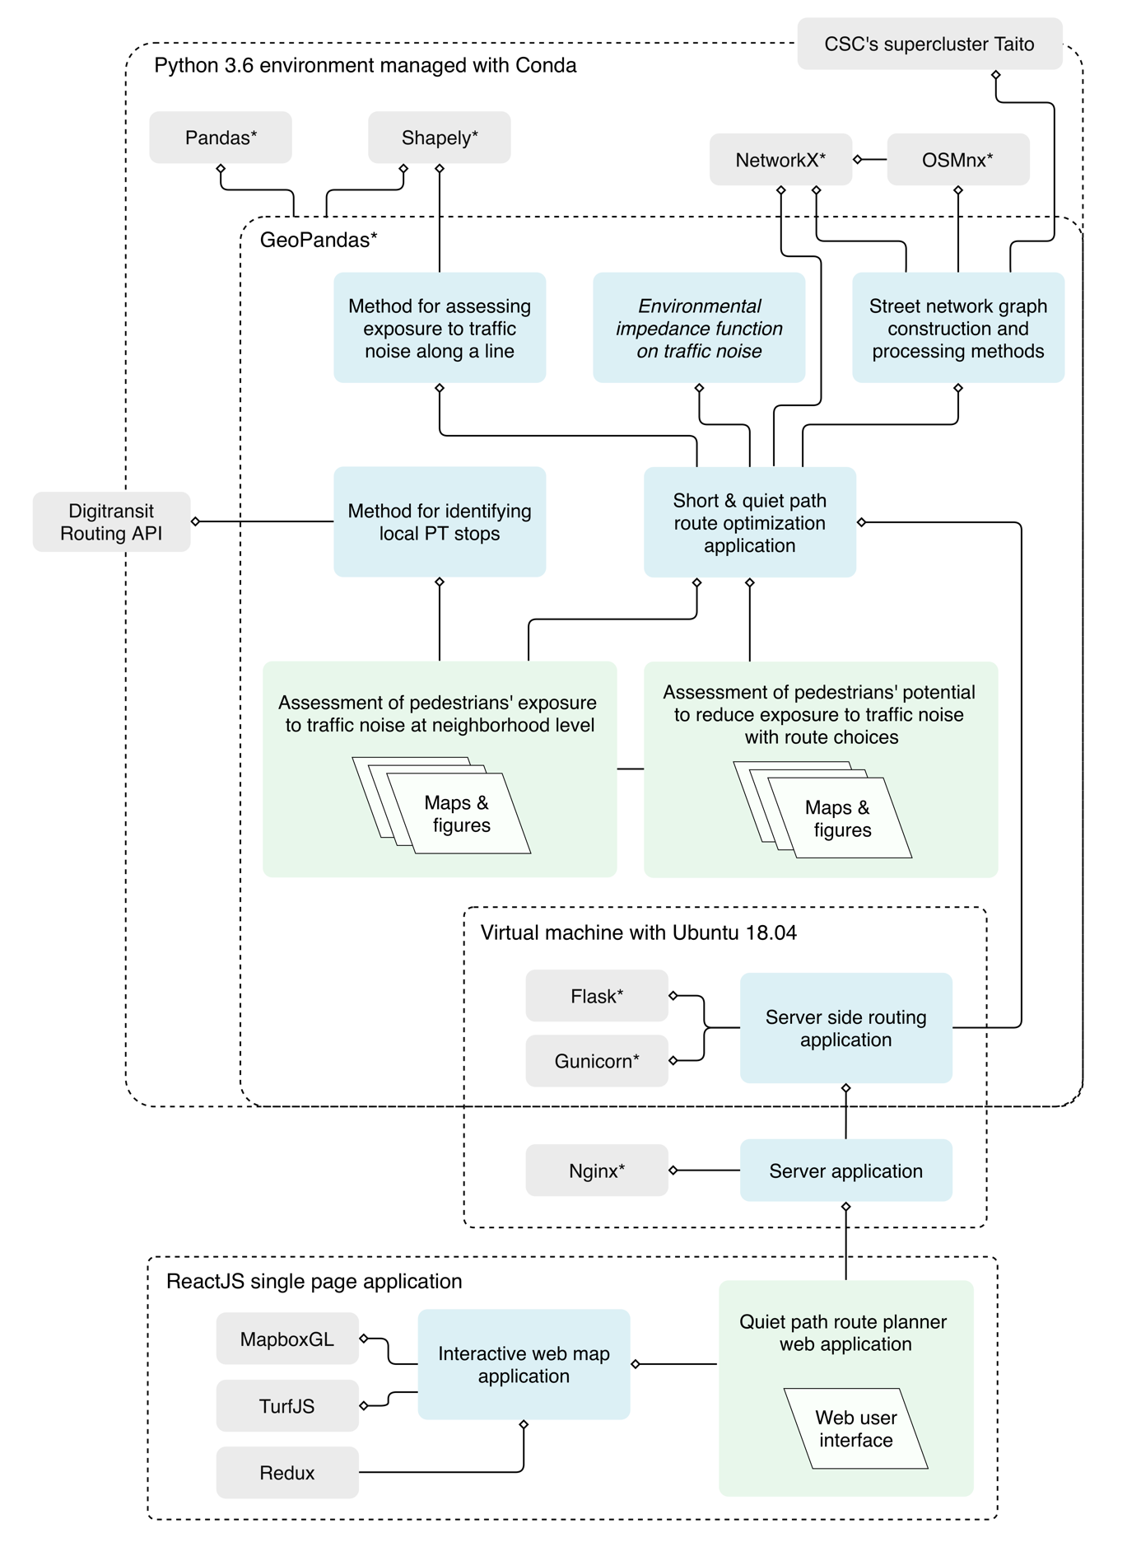

Figure 2. Technical framework of the study: internal (blue) and external (grey) technical dependencies.

## Route optimization application

### Environmental impedance function

The equation for calculating edge costs for quiet paht route optimization was defined as:

)

where is thetotal cost of the edge; is the length of the edge (in meters) and is the additional noise cost of the edge. The following equation was developed to model :

where is the contaminated distance of (e.g. 14 m of 65 dB) along the edge geometry; is a dB-specific noise cost coefficient (between 0.0–1.0, Table X) and 𝑛𝑡 is a “personal” noise tolerance coefficient (between e.g. 0.1–40).

### Network acquisition and manipulation

The following three steps were required to acquire and prepare network to a graph suitable for optimizing least cost paths paths:

1. Walkable network acquisition from OpenStreetMap (Figure 2).
2. Spatial join of contaminated distances to different noise levels to edges (Figure 3).
3. Calculating new noise tolerance specific edge costs to edge attributes (Figure 4).

Network of walkable streets was obtained from OpenStreetMap via Overpass API.

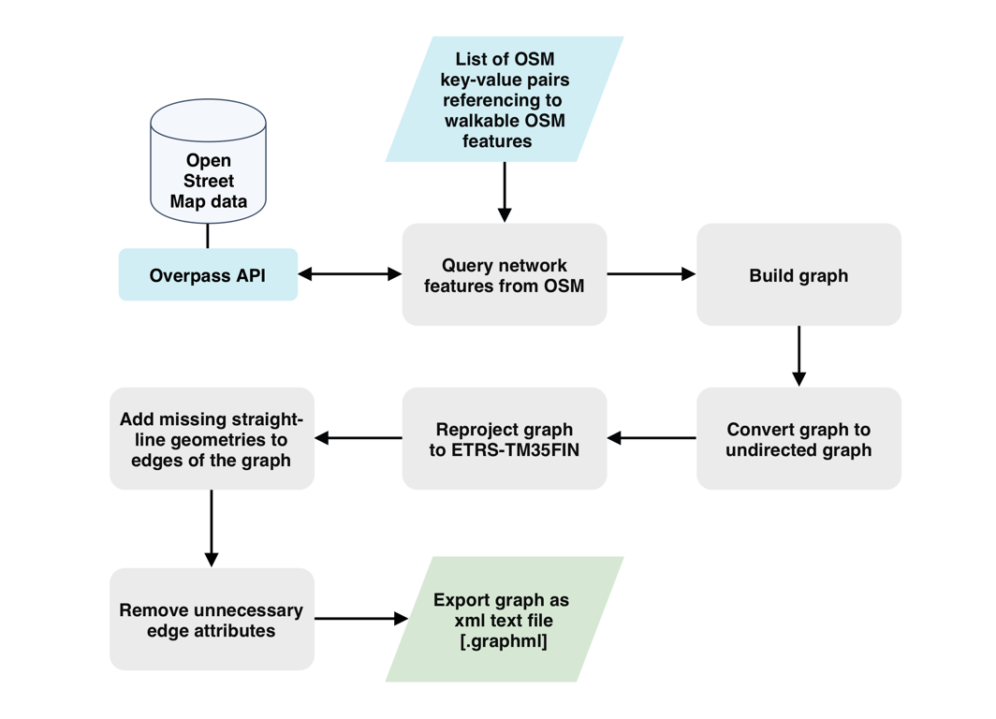

Figure 3. Workflow of network (graph) acquisition and construction.

Figure 4. Workflow of extracting exposures to traffic noise (contaminated distances) to the edges of the graph.

Figure 5. Workflow of setting noise tolerance specific edge costs as new edge attributes.

### Optimization of short and quiet paths

Figure 6. Workflow of least cost path routing method for short and quiet paths.

### Comparison of short and quiet paths

## Assessment of pedestrians’ exposure to traffic noise at neighborhood level

### Workflow of the analysis

Figure 7. Workflow of the analysis for identifying local PT stops and their utilization rates based on commutes.

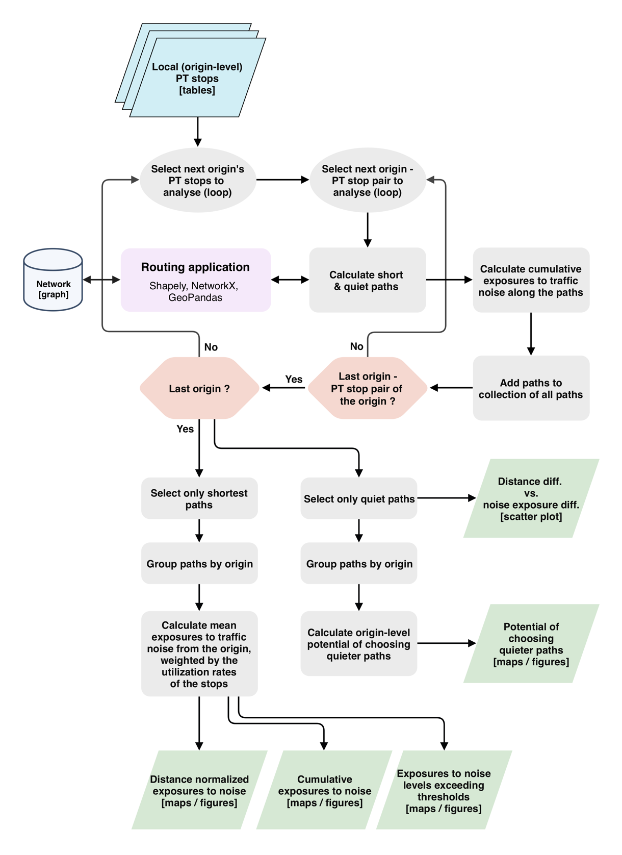

Figure 8. Workflow of the analysis for calculating paths between origins and PT stops.

### Extraction of commutes from aggregated OD data

### Estimation of local PT stops’ utilization rates by commutes

### Least cost path calculations – short and quiet paths

### Spatial aggregation of exposures to traffic noise along the paths

### Assessment of potential to reduce exposure to traffic noise with route choices

## Quiet path route planner web application

### Technical architecture

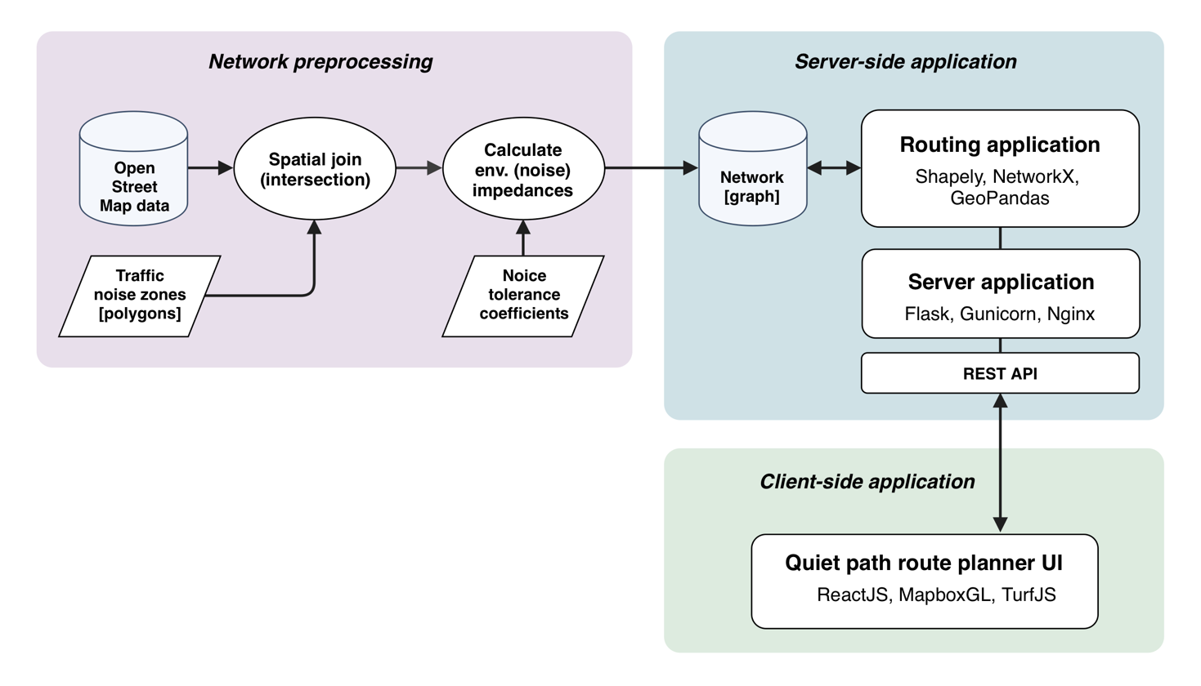

Figure 9. Technical architecture of the quiet path route planner web application.

### Functions and features

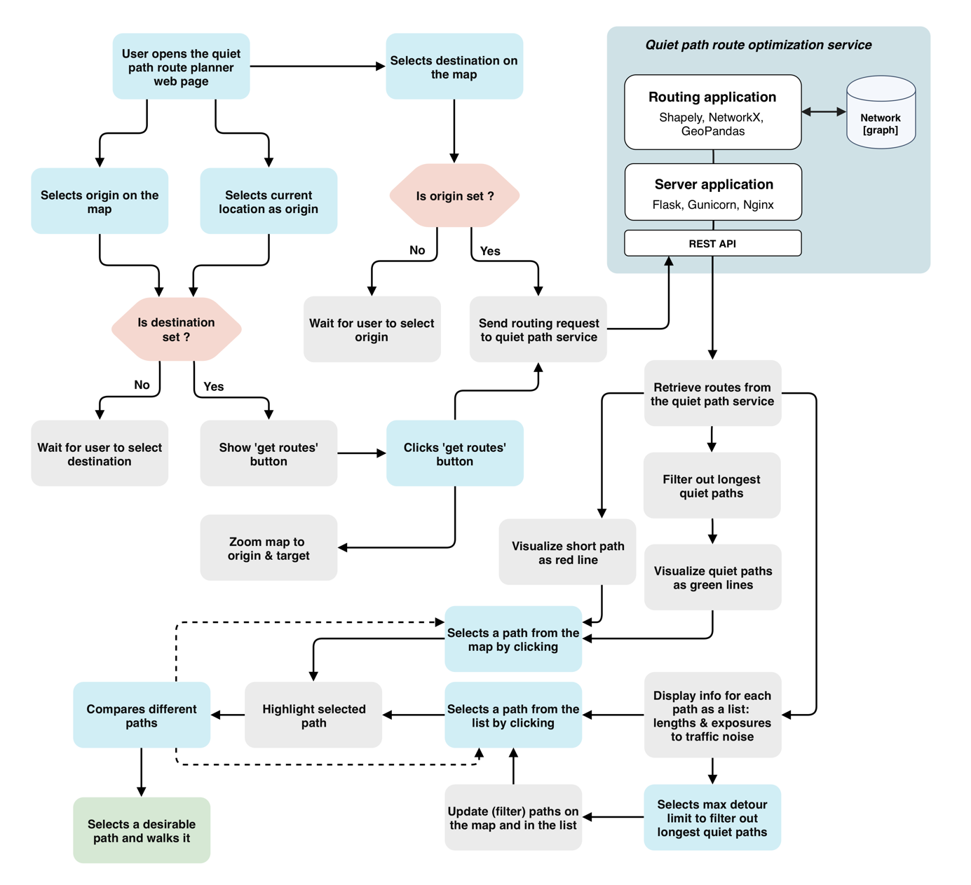

Figure 10. Typical user story demonstrating the core functionality of the quiet path route planner web application.

# Results

## Spatial patterns in pedestrians’ exposures to traffic noise

## Quiet path route planner web application

# Discussion

## Could traffic noise be used as a proxy for overall walkability?

## Indirect large-scale assessment of pedestrians’ exposures to traffic noise can reveal significant areal differences in walking conditions

## Considerable share of the exposure to traffic noise can often be avoided by taking an alternative path

## Definition of the environmental impedance function is critical yet somewhat arbitrary in quiet path optimization

## Alternative quiet paths need to be calculated to suit different situations and users with varying preferences

## Publishing a green path routing application online can facilitate citizens to choose healthier paths

## More efficient technical implementation is required to enable real-time green path route optimization

# Conclusions

# References

Apparicio, P., Carrier, M., Gelb, J., Séguin, A.-M., & Kingham, S. (2016). Cyclists’ exposure to air pollution and road traffic noise in central city neighbourhoods of Montreal. *Journal of Transport Geography*, *57*, 63–69.

Babisch, W., Beule, B., Schust, M., Kersten, N., & Ising, H. (2005). Traffic noise and risk of myocardial infarction. *Epidemiology*, 33–40.

Cole-Hunter, T., Morawska, L., Stewart, I., Jayaratne, R., & Solomon, C. (2012). Inhaled particle counts on bicycle commute routes of low and high proximity to motorised traffic. *Atmospheric Environment*, *61*, 197–203. https://doi.org/10.1016/j.atmosenv.2012.06.041

Ising, H., Dienel, D., Günther, T., & Markert, B. (1980). Health effects of traffic noise. *International Archives of Occupational and Environmental Health*, *47*(2), 179–190.

Lwin, K. K., & Murayama, Y. (2011). Modelling of urban green space walkability: Eco-friendly walk score calculator. *Computers, Environment and Urban Systems*, *35*(5), 408–420. https://doi.org/10.1016/j.compenvurbsys.2011.05.002

Lwin, K. K., & Murayama, Y. (2013). Smart eco-path finder for mobile GIS users. *URISA Journal*, *25*(2), 5–14.

Maghelal, P. K., & Capp, C. J. (2011). Walkability: A Review of Existing Pedestrian Indices. *Journal of the Urban & Regional Information Systems Association*, *23*(2).

Pucher, J., & Buehler, R. (2010). Walking and cycling for healthy cities. *Built Environment*, *36*(4), 391–414.

Quercia, D., Schifanella, R., & Aiello, L. M. (2014). The shortest path to happiness: Recommending beautiful, quiet, and happy routes in the city. *Proceedings of the 25th ACM Conference on Hypertext and Social Media*, 116–125. ACM.

Ribeiro, P., & Mendes, J. F. (2011). Route planning for soft modes of transport: healthy routes. *WIT Transactions on The Built Environment*, *116*, 677–688.

Sheng, N., & Tang, U. W. (2011). Spatial Analysis of Urban Form and Pedestrian Exposure to Traffic Noise. *International Journal of Environmental Research and Public Health*, *8*(6), 1977–1990. https://doi.org/10.3390/ijerph8061977

Tainio, M., de Nazelle, A. J., Götschi, T., Kahlmeier, S., Rojas-Rueda, D., Nieuwenhuijsen, M. J., … Woodcock, J. (2016). Can air pollution negate the health benefits of cycling and walking? *Preventive Medicine*, *87*, 233–236. https://doi.org/10.1016/j.ypmed.2016.02.002

Whyatt, J. D., Pooley, C., Coulton, P., Moser, M., Bamford, W., & Davies, G. (2007). Estimating personal exposure to air pollution on the journey to and from school using GPS, GIS and mobile phone technology. *11th International Conference on Harmonisation within Atmospheric Dispersion Modelling for Regulatory Purposes*, *1*, 2–5.