Terms for Partner Abuse

Bryan Victor

Monday, January 05, 2015

The phenomonon of partner abuse has been referred to by many names in the academic literature including battering, family violence, domestic violence and intimate partner violence. The following code produces analyses for use of these terms in the literature between 1974-2013.

PsycINFO indexes a number of biological and social science journals in its database. Each time an article is entered it is assigned a set of subject codes that help facilitate searches. This code looks at the frequency with which certain subject codes were assigned to all articles indexed since 1974 (the first year a term of interest was assigned as a subject value).

A search was done in psychINFO with the following terms:

TI "domestic violence" or TI "intimate partner violence" or TI "family violence" or TI "battering"

The search was limited to peer-reviewed journal articles, and returned 4,590 articles.

# Frequency of Terms in Article Titles

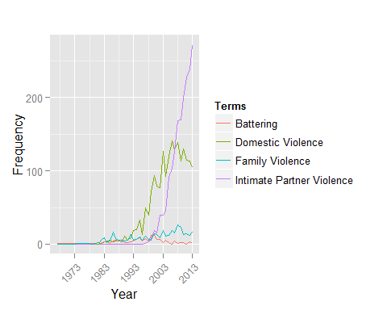

# Google Trend Data

