***Data Compression Competition 2015***

*Created and produced by Bryan Wieger,*

*Sophomore, Electrical Engineering & Computer Science, Chabot College*

*Sponsored by TIM DAVE,*

*Interim Dean of Science & Mathematics, Chabot College*

**Contact:** bryan.wieger@gmail.com

**Award:** Over $100, precise amount to be announced

**Info on the test file to be used:**

**Name:** FileToCompress.txt

**Size:** appx. 1,003,570 MB

**Number of lines:** appx. 141 million

**Min char per line:** 4

**Max char per line:** 7

**Website:** https://github.com/bryanwieger/Compression_Comp

**GOAL:** Create a program that can both compress files and decompress them based on user inputs.

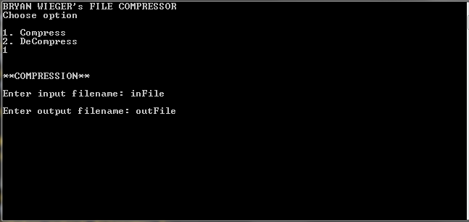

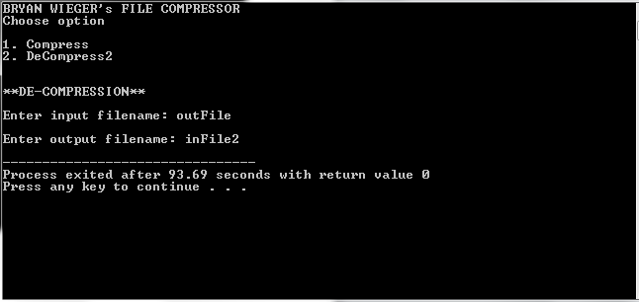

**INCENTIVE:** Team with the winning submission will receive $XXX

**CRITERIA:** Winner will have must have the smallest compressed file and the decompression of the compressed file must match original.

**TEAMS**: Each person in the competition may only help on 1 submission. Teams are allowed.

**TEAMS AWARD DIVISION**: The award money be the same for the submission regardless of the size of the team (ex: a team of size 1 will get the same sum of money as a team of size 5). It is to the advantage of the individual to have less members in a team than more. Money will be transferred as bank account wire.

**TIME:** There will XXX session of XXX hours.

**LOCATION:** Code writing will occur in room XXXX on Chabot College Campus

**STANDARDS:**

1. Cell Phones must be submitted to proctor. Cell phones will be returned at end of code writing period(s)
2. No reference materials are allowed. Including paper notes.
3. No internet access permitted.
4. No USBs or electronic/optical/magnetic storage devices. If you have a quantum one, I would love to see it, so please bring. Just you can’t use it during the coding period(s)
5. Permitted material will be proctor-provided scratch paper, Chabot College sponsored computers of proctor’s choice, proctor-approved IDEs (Quincy, DEV-C++, Xcode, CodeBlocks, MS-Visual Studio are approved), Windows Explorer (File Management System), computer’s native text editor program.
6. Contestants are encouraged to bring their own pen and/or pencil along with erase/whiteout
7. Each team will be provide with 100,1000,&1Million line text files to test their code on during the coding period(s)

**Summary:** Nothing goes in or out of the coding area. Basic materials are provided.

**PROCESS OF EVALUATION:**

1. Team writes code in coding area
2. Code is submitted to proctor at end of competition
3. Code is reviewed for compliancy and safety *
4. Code is compiled and the option to compress is selected in compiled program and input and output filenames are given by user.
5. Compressed file size is recorded in KB via Windows Explorer
6. Program is run and the option to decompress is selected in programs. Input and Output filenames are given by user.
7. De-compressed file is compared to original file. If there is a single error the comparison program will exit and no credit will be awarded to the program submitted. A trailing newline is in every file. Ex: if there are 10 lines of data, there will be an 11th line with no data (blank line).
8. Winner will be selected based on compressed file size and passing of comparison test. If there is a tie between compressed file sizes, proctor will write a program to test the submitted code for runtimes (a series of three test on each program). Runtimes will only be evaluated if there is tie for the compression size for first place. If compressed file sizes and runtimes are equivalent, both teams will split the award money equally.

**CODE RESTRICIONS:** All C++ libraries available on the computer without internet access via the IDE are allowed with the following restriction. If the library has been clearly been made to assist in data/file compression it is not allowed. Following headers are approved and NOT subject to review:

|  |  |  |  |  |  |
| --- | --- | --- | --- | --- | --- |
| cassert | cctype | cerrno | cfenv | cfloat | cinttypes |
| ciso646 | climits | clocale | cmath | csetjmp | csignal |
| cstdarg | cstdbool | cstddef | cstint | cstdio | cstdlib |
| cstring | ctgmath | ctime | cuchar | cwchar | cwctype |
| array | bitset | deque | forward_list | list | map |
| queue | set | stack | unordered_map | unordered_set | vector |
| algorithm | chrono | codecvt | complex | excpetion | functional |
| initializer_list | iterator | limits | locale | memory | new |
| numeric | ratio | regex | stdexcept | string | system_error |
| tuple | typeindex | typeinfo | type_traits | utility | valarray |