**Installing the Encore RMM client**

**Step 1: Getting the installation files from SharePoint**

From the Office 365 homepage select SharePoint to start he application:

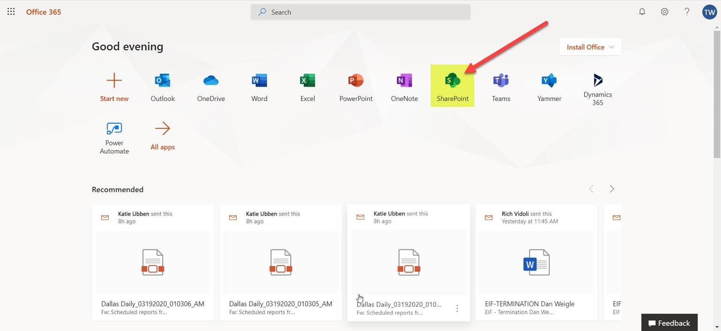

In the search bar type in “Corporate Information Technology” and select the Corporate Information Technology SharePoint site:

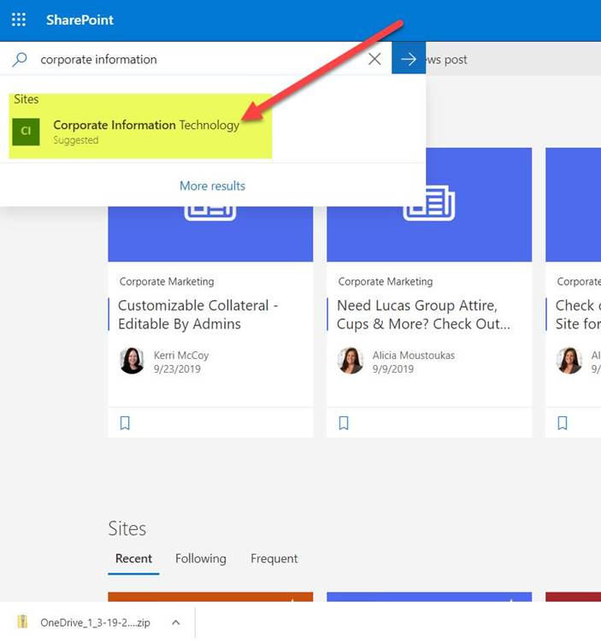

In the Site, click on the Documents folder:

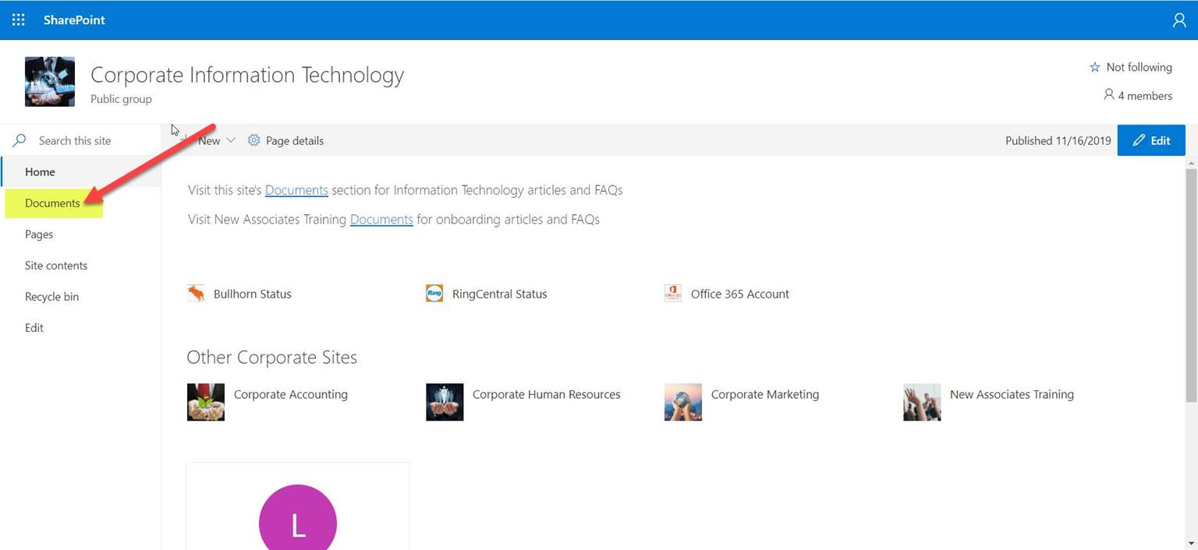

In Documents, select the EncoreRMMInstaller.zip and RunEncoreRMMInstall.bat files and then click **Copy To.**

**Note:** If you select Download, the two files will be added to a compressed file and you will have to extract the files shown once it has downloaded **

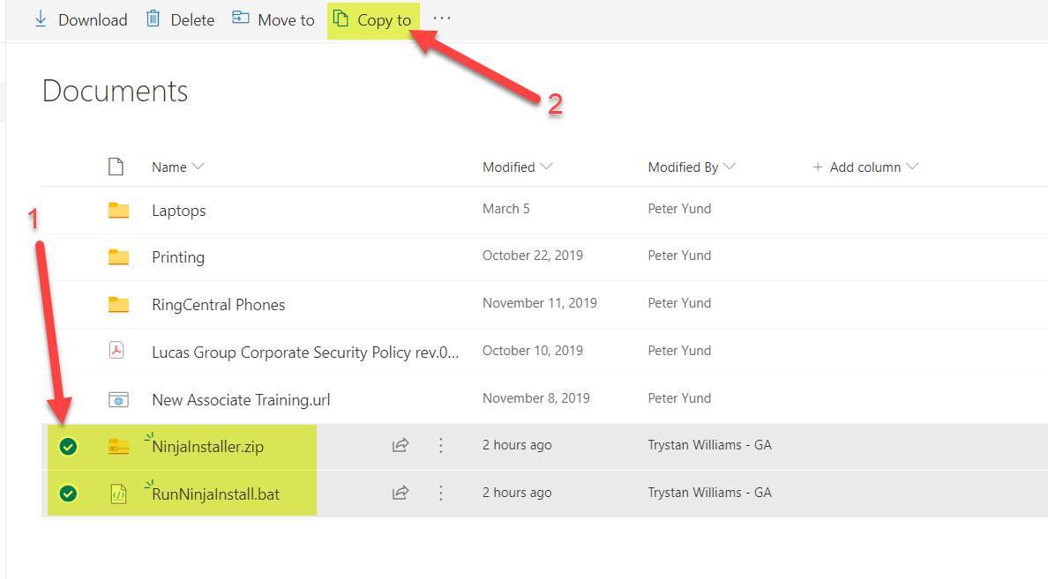

The Copy To Choose Destination window will open on the right – select “Your OneDrive”

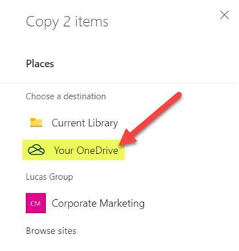

Select the folder where you want the files to placed – the Downloads folder is recommended but not required. You may see a selection similar to the that shown on the right below – the Downloads folder in that case is located under the Documents folder so just click on Documents and you should see it.

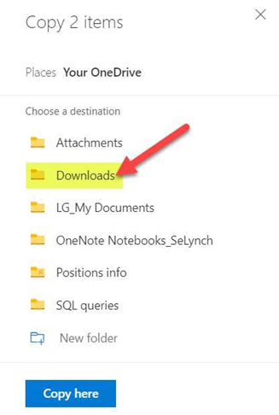 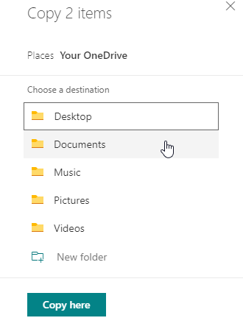

Once the folder has been selected, click the Copy Here button

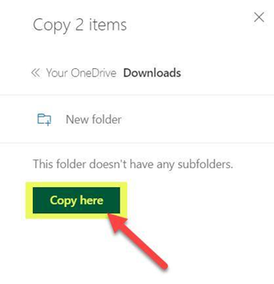

The files should download to the selected folder on your computer (we’ll continue to use the Downloads folder in these instructions). When both have completed downloading you will see them there:

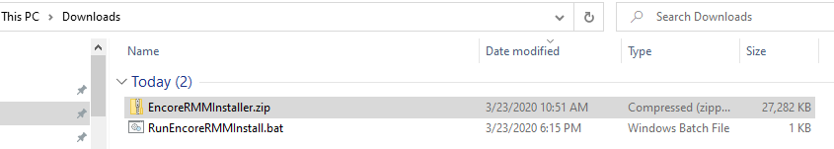

**Step 2: Running the installation:**

In your downloads folder in file explorer, double click on the RunEncoreRMMInstall file – this will begin the installation:

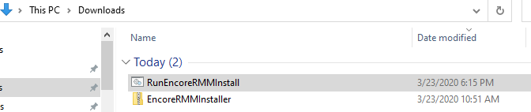

You will see a Windows Defender message - click “More Info” and then click “Run Anyway“ :

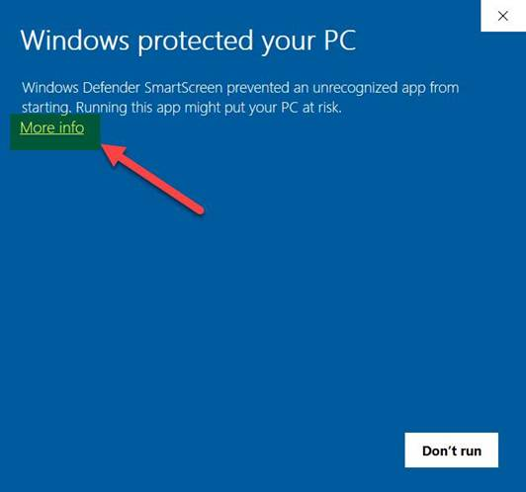 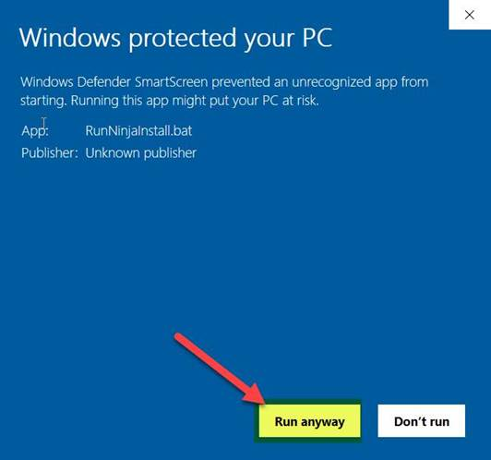

A command window will then open – it will briefly display the installation file extraction process:

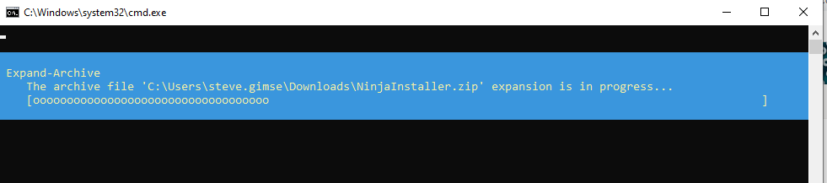

And then you will be presented with a confirmation screen asking if you want to allow the app to make changes to your device – click Yes:

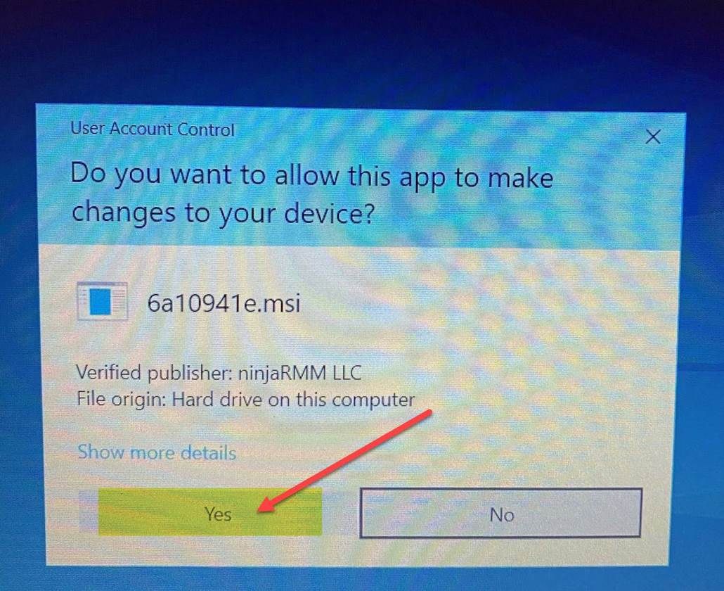

The Encore RMM client will install with no further action on your part. In a minute or two, you should see the completion message:

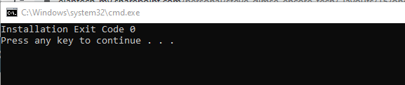

Press the space bar or any other key to close the window. The Encore RMM client is now installed on your computer