Bryan Paul Yabut
101407350
Lab11
Akansha Mandhana
S1
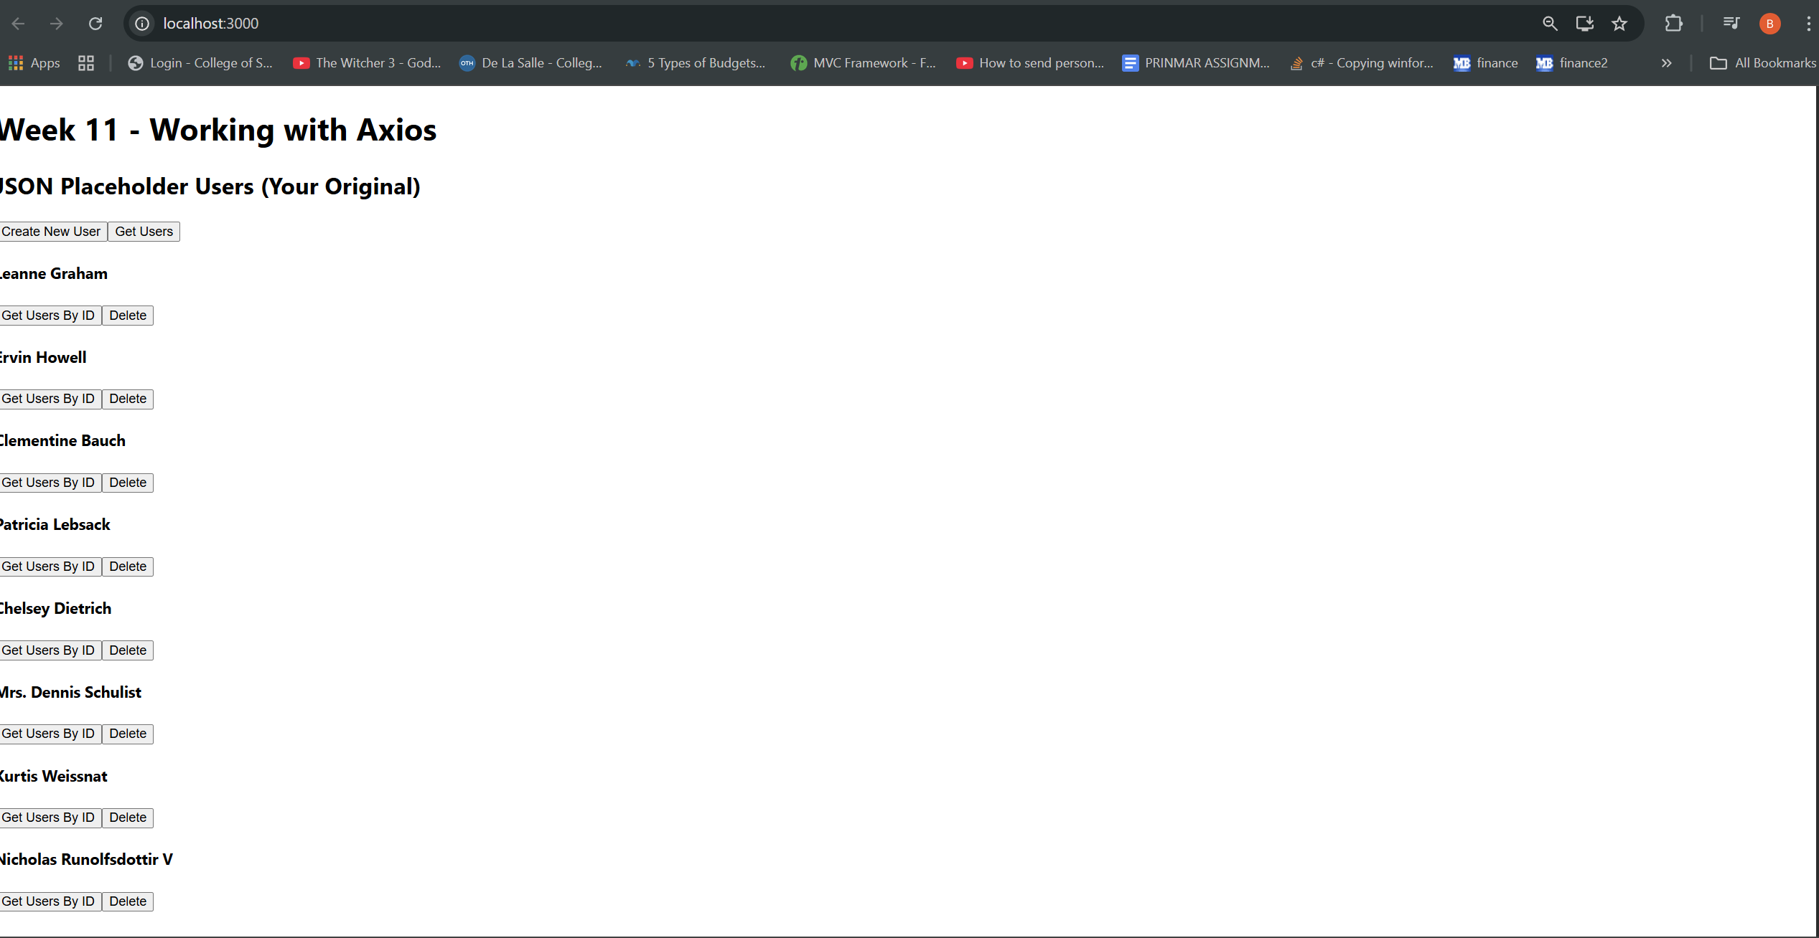
S2
