Bryan Paul Yabut
101407350
Lab06
COMP3123

S1 POST/CREATE NOTES
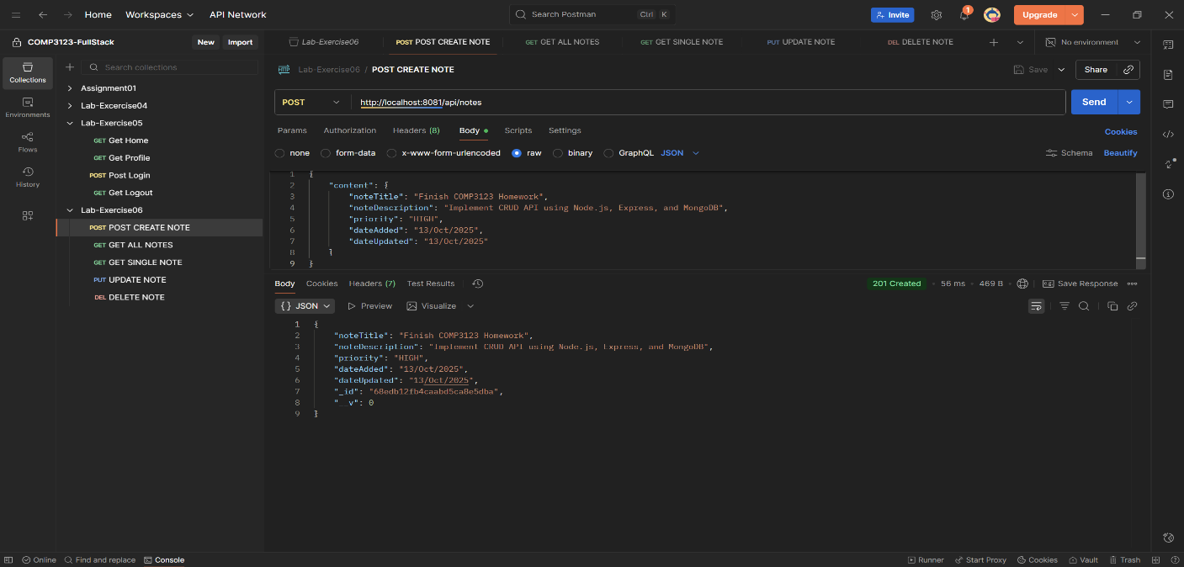
S2 GET ALL NOTES
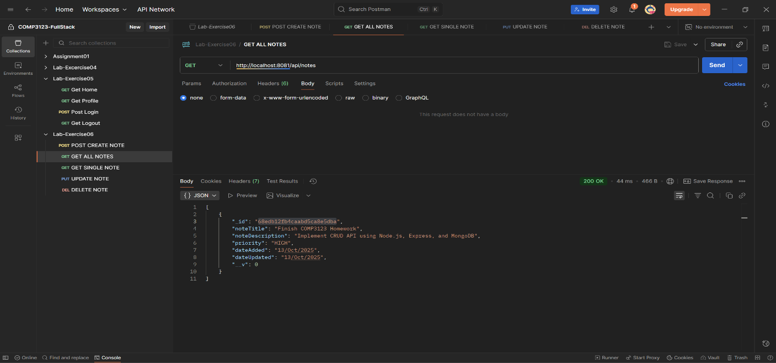
S3 GET NOTES BY ID
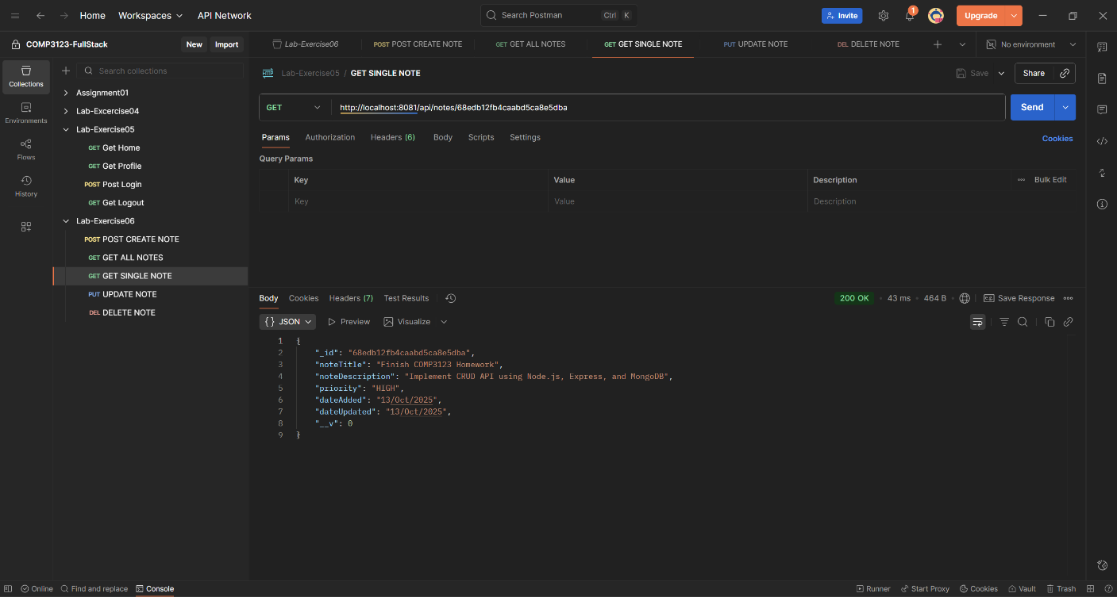
S4 UPDATE NOTES
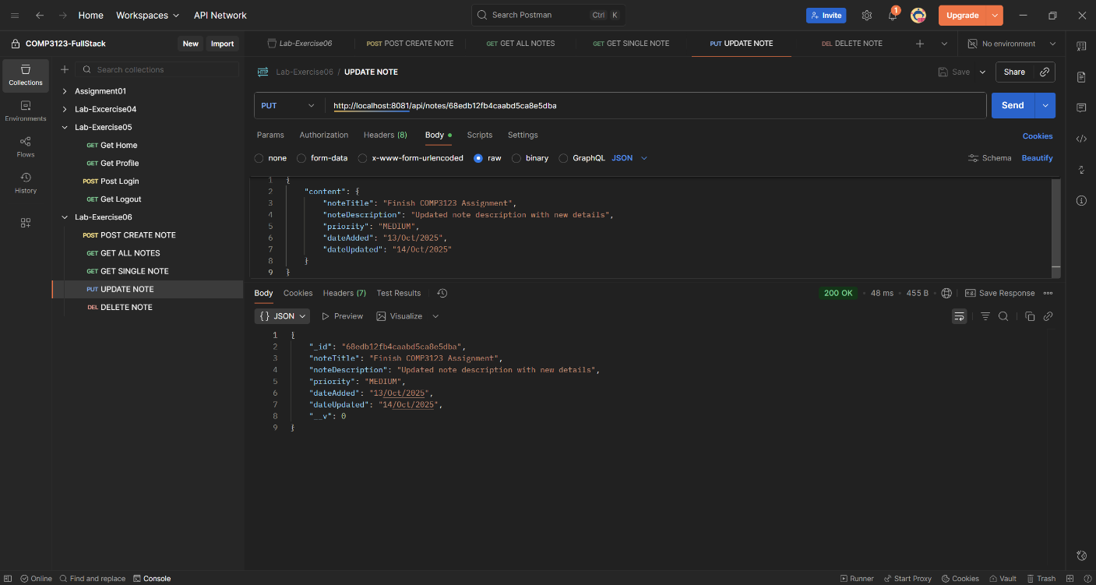

S6 DELETE NOTES
