Bryan Paul Yabut
101407350
COMP3123
Pro: Akansha Mandhana
S1
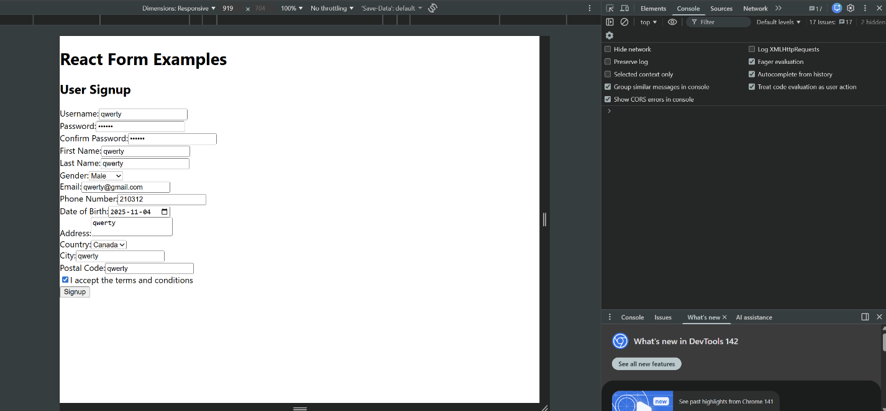
S2
