The University of British Columbia
Mini Project 4
ELEC 301 – Electronic Circuits
Bryan Zhang
69238335
12-7-2022

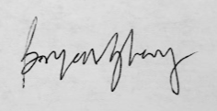
Contents
Part A – An Active Filter 2
1. Component Calculation 2
2. Oscillation midband gain 4
Part B – A Phase Shift Oscillator 6
Part C – Feedback Circuit 8
1. d.c. operating point 8
2. Open-loop & predicted Closed-loop frequency response 9
3. Closed loop frequency response while varying R_{f} 11
4. Estimate feedback values with I/O Impedances 13
5. Desensitivity Factor 13
References 15

Part A – An Active Filter

Component Calculation
To get a 3dB frequency of 10kHz calculate the capacitance value based on the resistor R value of 10kΩ.
$$C=\frac{1}{2πf_{3dB}∙R}=\frac{1}{2π∙10kHz∙10kΩ}=\underline{1.6nF}$$
From the given transfer function $H\left(s\right)=A_{M}\frac{1/{{(RC)}^{2}}}{s^{2}+s\frac{3-A_{M}}{RC}+\frac{1}{{\left(RC\right)}^{2}}}$ see that the denominator is of the form $s^{2}+2ζω_{n}s+ω_{n}^{2}$ so:
$$ζ=\frac{3-A_{M}}{2}$$ | $$ω_{n}=\frac{1}{RC}$$
A second order Butterworth filter is characterized by having the poles 45˚ from the real axis. Therefor the normalized characteristic equation of a 2nd order filter is $s^{2}+\sqrt{2}s+1$
$$∴A_{M}=3-\sqrt{2}=\underline{1.568V/V}$$
$$A_{M}=1+\frac{R_{2}}{R_{1}}$$ | $$R_{1}+R_{2}=10kΩ$$
$$\underset{→}{yields}R_{1}=6.306kΩ, R_{2}=3.694kΩ$$
C | A_{M} | R₁ | R₂
1.6nF | 1.586 V/V | 6.306kΩ | 3.694kΩ

Here is the simulated circuit with its magnitude & phase bode plots.
As expected, the cut-off point occurs at 10kHz and the midband gain is
$$4.067dB= {10}^{\frac{4.067}{20}}=1.5972V/V$$

Oscillation midband gain
The poles of the 2nd order Butterworth filter are shown here of the zeros are shown here. They lie on a circle of radius $ω_{c}=2π∙10k{rad}/s$. The poles complex conjugates located in the left half of the s-plane $\frac{π}{4}$ away from the real axis. Therefor the locations of the poles are given as $-ω_{c}\cos{\frac{π}{4}}±ω_{c}\sin{\frac{π}{4}}=\underline{-π\sqrt{2}∙10k±j\left(π\sqrt{2}∙10k\right)=44.43k±j44.43k}$.
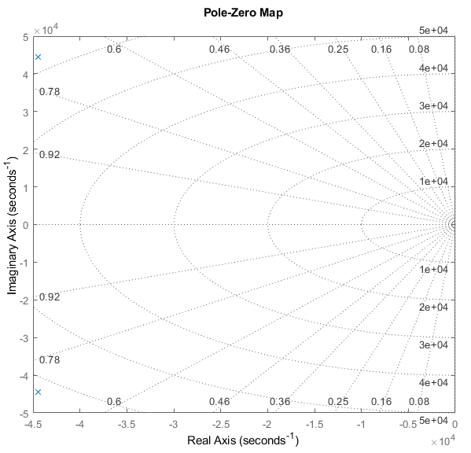
The circuit will begin oscillating when the poles reach $jω$ axis of the imaginary axis. This happens when the $s$ term in the denominator of the transfer function is equal to zero, which is when $A_{M}=3$.
$$A_{M}=3=1+\frac{R_{2}}{R_{1}}$$ | $$R_{1}+R_{2}=10kΩ$$
$$\underset{→}{yields}R_{1}=3.333kΩ, R_{2}=6.667kΩ$$
The simulated circuit with input grounded and its oscillatory transient response is shown.
The oscillation frequency is measured to be 9.5kHz which is close to the expected value of 10kHz. The poles will start approximately in the positions marked by ‘X’ on the root locus as shown from the pole-zero map above. As the midband gain A_{M} is increased the poles will move towards the $jω$ axis and at A_{M}=3 the system will be the poles will be on the $jω$ axis causing undamped oscillation. Once the poles cross into the right half plane the filter will become unstable.
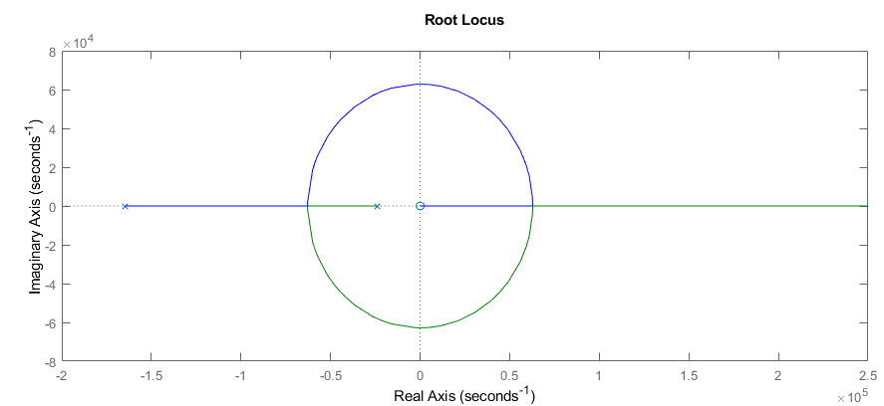

Part B – A Phase Shift Oscillator
Using 29R as a 29.2kΩ resistor is when the circuit starts stable oscillations at about 65Hz.
The oscillation frequency of this is calculated by $f=\frac{1}{2π\sqrt{6}RC}=\frac{1}{2π\sqrt{6}∙1kΩ∙1μF}=64.97Hz$which is closely approximated by the simulated result oof 64.98Hz.
Increasing the resistance and capacitance by a factor of 2 leads to the oscillation frequency of
$$f=\frac{1}{2π\sqrt{6}RC}=\frac{1}{2π\sqrt{6}∙2kΩ∙2μF}=16.24Hz$$
To simulate this, double the values of all resistors and capacitors, so 29R becomes 58.4kΩ.
The simulated frequency is 15.75Hz which matches closely with the calculated frequency of 16.24Hz. Decreasing the resistance and capacitance by a factor of 2 results in a frequency of:
$$f=\frac{1}{2π\sqrt{6}RC}=\frac{1}{2π\sqrt{6}∙\frac{1}{2}kΩ∙\frac{1}{2}μF}=260Hz$$
To simulate this, halve the values of all resistors and capacitors, so 29R becomes 14.6kΩ.
The simulated frequency is 258.8Hz which matches closely with the calculated frequency of 260Hz.

Circuit |  | Oscillation frequency (Hz) |  | Percent error
R | C | calculated | simulated | Percent error
1kΩ | 1µF | 64.97 | 65 | 0.046%
2kΩ | 2µF | 16.24 | 15.75 | 3.11%
500Ω | 0.5µF | 260 | 258.8 | 0.46%

Phase-Shift Oscillator Explanation
The phase-shift oscillator functions by applying a $-π$ phase shift through the feedback network of an inverting op amp which creates a positive feedback loop. A non-zero output regardless of the input is enabled by the oscillator having a pair of complex poles on the $jω$ axis. The value of 29R needed to be increased slightly which would increase the gain by moving the poles closer to the right half plane and avoid a decaying oscillation. This adjustment may be because in the calculations an ideal amplifier was assumed but a non-ideal one was used in the simulation. Nevertheless, the calculated results are extremely close to the simulated results.

Part C – Feedback Circuit
The feedback network senses the output voltage and then converts it into current that is mixed with the input signal at the base of Q1. So, since the input is adding current it must be connected in shunt and since the output voltage is being sensed, it must also be done in shunt. The feedback circuit is therefor shunt-shunt topology.
The first step is to vary R_{B2} to obtain the greatest open loop gain by opening the feedback resistor and measuring the output for several values of R_{B2}. The optimal R_{B2} is found to be about 20kΩ. The circuit is constructed like below.

d.c. operating point
The d.c. operating points are measured for both transistors.
 | V_{C} | V_{B} | V_{E} | I_{C} | I_{B} | I_{E}
Q₁ | 1.90V | 0.654V | 0V | 1.295mA | 10.77µA | 1.306mA
Q₂ | 15.0V | 1.90V | 1.235V | 2.184mA | 15.34µA | 2.199mA

The small signal parameters g_{m}, r_{π}, h_{FE} can be calculated from the d.c. operating point.

$$Q_{1}:$$ | $$g_{m}=\frac{I_{C}}{V_{T}}=\frac{1.295mA}{25mV}=\underline{0.0518S}$$ | $$r_{π}=\frac{V_{T}}{I_{B}}=\frac{25mV}{10.77μA}=\underline{2.32kΩ}$$ | $$h_{FE}=r_{π}\frac{I_{C}}{V_{T}}=\underline{120}$$
$$Q_{2}:$$ | $$g_{m}=\frac{I_{C}}{V_{T}}=\frac{2.184mA}{25mV}=\underline{0.0874S}$$ | $$r_{π}=\frac{V_{T}}{I_{B}}=\frac{25mV}{15.34μA}=\underline{1.63kΩ}$$ | $$h_{FE}=r_{π}\frac{I_{C}}{V_{T}}=\underline{142}$$

Open-loop & predicted Closed-loop frequency response
Open R_{f} and plot the open loop amplitude response. The 3dB points are identified.
$$f_{L3dB}=2.875Hz$$ | $$f_{H3dB}=91.48kHz$$
$$A_{M}=42.14dB=\left(-\right)127.4V/V$$
To measure the input/output impedances a test source of 1mV and 1kHz is used. Replace either the 5kΩ source resistor or the 10kΩ load resistor with the test source and then short the other resistor. Use the AC multimeter to probe the voltage & current at the test source.
$$R_{in}=\frac{706.2μV}{274.7nA}=2.567kΩ$$ | $$R_{out}=\frac{706.2μV}{11.29μA}=62.55Ω$$

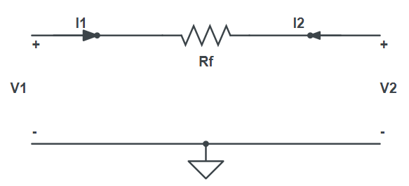
To predict closed-loop frequency response use y-parameters to represent the feedback network because it uses shunt-shunt topology. The related diagram and equations are shown.
$$\left[\begin{matrix}I_{1} \\ I_{2}\end{matrix}\right]=\left[\begin{matrix}y_{11} & y_{12} \\ y_{21} & y_{22}\end{matrix}\right]$$
$$y_{11}={\left.\frac{I_{1}}{V_{1}}\right|}_{V_{2}=0}=\frac{1}{R_{f}}$$ | $$y_{12}={\left.\frac{I_{1}}{V_{2}}\right|}_{V_{1}=0}=-\frac{1}{R_{f}}$$
$$y_{21}=0$$ | $$y_{22}={\left.\frac{I_{2}}{V_{2}}\right|}_{V_{1}=0}=\frac{1}{R_{f}}$$
For R_{f}=100kΩ, the feedback gain can be calculated as $β=y_{12}=-10μS$. From the open-loop amplitude bode plot, the midband gain is -127.4 V/V. Since this is shunt-shunt topology, calculate the open loop current to voltage amplification A_{i}, where R_{S} = 5kΩ. Then A_{f} can be calculated using A_{i}.
$$A_{i}=\frac{V_{out}}{I_{in}}=A_{M}∙R_{s}=-637{kV}/A$$
$$A_{f}=\frac{A_{i}}{1+A_{i}β}=-86.43 {kV}/A$$
$$A=\frac{A_{f}}{R_{s}}=-17.28V/V$$
Then to calculate the 3dB frequencies, apply the bandwidth extension of (1+A_{i}β) to the open loop 3dB points f_{L3dB} = 2.875Hz and f_{H3dB} = 91.48kHz.
$$f_{L3dB_{f}}=\frac{2.875Hz}{(1+A_{i}β)}=390mHz$$ | $$f_{H3dB_{f}}=91.48kHz∙(1+A_{i}β)=674.2kHz$$

Due to the shunt-shunt topology, the open-loop input and output impedances are reduced by a factor of (1+A_{i}β). Recall the open loop impedances R_{i}=2.567kΩ & R_{o}=62.55Ω.
$$R_{i_{f}}=\frac{R_{i}}{(1+A_{i}β)}=348.6Ω$$ | $$R_{o_{f}}=\frac{R_{o}}{(1+A_{i}β)}=8.487Ω$$

Now connect the feedback resistor and simulate the closed loop circuit to verify the results.
The midband gain is 24.73dB = (-)17.25V/V and the 3dB points are 508mHz and 691.5kHz.
Remeasure the input/output impedances like before but now with the feedback resistor R_{f} connected.
$$R_{i_{f}}=243Ω$$ | $$R_{o_{f}}=8.649Ω$$

Here are the calculated and simulated results of the closed loop amplifier. The midband gain prediction is excellent. The low 3dB point prediction is inaccurate which could be due to the overshoot at the low frequency cut-off. The input impedance has a higher error but is of similar magnitude, and the output is accurately calculated.
 | A (V/V) | $$f_{L_{3dB_{f}}}$$ | $$f_{H_{3dB_{f}}}$$ | R_{if} | R_{of}
Calculated | -17.28 V | 390mHz | 674.2kHz | 348.6 Ω | 8.487 Ω
Simulated | -17.25 | 508mHz | 691.5kHz | 243 Ω | 8.649 Ω
error | 0.17% | 23.2% | 2.50% | 43.5% | 1.87%

Closed loop frequency response while varying R_{f}
Here are the results of varying R_{f} from 1kΩ - 100kΩ. The plots for R_{f} = 1MΩ and 10MΩ are shown on a separate plot. 1kΩ corresponds to the bottom curve of the first plot, and 10MΩ corresponds to the top curve of the second plot. In the first plot notice that there is overshoot. It may be because at lower frequencies the coupling capacitors have not yet started conducting so the gain is a voltage division between the feedback and load resistance. Another possible explanation is that as R_{f} is increased, the poles are moved causing a shift in resonance frequency of the peaks.
To measure the feedback factor β first measure the midband gain (with feedback) in dB and then convert to V/V. A_{f} is determined by converting this value to V/A by multiplying by R_{s}. Then solve $A_{f}=\frac{A}{1+Aβ}$ where A is the open-loop midband gain previously determined as -637kV/A. The theoretical value of β is calculated by $\frac{-1}{R_{f}}$.

R_{f} | A_{f}(dB) | A_{f}(V/V) | A_{f}(kV/A) | Simulated β | Theoretical β
1kΩ | -14.07 | -0.1979 | -0.9895 | -1.009 mS | -1 mS
10kΩ | 5.845 | -1.960 | -9.8 | -100.5 µS | -100 µS
100kΩ | 24.73 | -17.24 | -86.2 | -10.03 µS | -10 µS
1MΩ | 37.82 | -77.80 | -389 | -1.001 µS | -1 µS
10MΩ | 41.57 | -119.8 | -599 | -99.59 nS | -100 nS
From these results, the theoretical and simulated feedback factor β are very similar.

Estimate feedback values with I/O Impedances
Measure the input and output impedances while varying the feedback resistor between 10kΩ, 100kΩ, 1MΩ using the same techniques as before. Now with these closed-loop input/output impedances, open-loop input/output impedances, and open-loop gain the feedback gain β can be used to determine the “amount of feedback”, $a_{theoretical}$, using the calculated β values for each feedback resistor from part 3 where A is the open loop gain (637 kV/A).
$$R_{if}=\frac{R_{i}}{1+A_{i}β}$$ | $$R_{of}=\frac{R_{o}}{1+A_{i}β}$$
$$a_{theoretical}=1+A_{i}β$$
The amount of feedback seen from the input and output $a_{in}$ and $a_{out}$ can be averaged to find the measured “amount of feedback”. R_{in} and R_{out} is the open loop impedance respectively.
$$a_{in}=\frac{R_{in}}{R_{if}}$$ | $$a_{out}=\frac{R_{out}}{R_{of}}$$

R_{f} | R_{if} (measured) | R_{of} (measured) | $$a_{theoretical}$$ | $$a_{in}$$ | $$a_{out}$$ | $$\frac{a_{in}+a_{out}}{2}$$ | Percentage error
10kΩ | 26.3Ω | 1.21Ω | 64.7 | 97.68 | 51.70 | 74.68 | 17.8%
100kΩ | 239Ω | 8.34Ω | 7.37 | 10.75 | 7.500 | 9.124 | 19.2%
1MΩ | 1.31kΩ | 38.1Ω | 1.637 | 1.961 | 1.642 | 1.801 | 9.1%
This method of averaging ends up being close to the theoretical value but with significant error.

Desensitivity Factor
The Desensitivity factor is given by taking the derivative of the feedback gain with respect to the open loop gain. d denotes the Desensitivity factor. A = 637kV/A
$$\frac{dA_{f}}{dA}=\frac{1}{{\left(1+Aβ\right)}^{2}}\underset{→}{yields}d=1+Aβ$$
When R_{f} = ∞, β = 0 because there is no feedback so $d=1$. This table summarizes the gains when R_{f} = ∞ and R_{c} is varied.
R_{C}(kΩ) | A (V/V)
9.9 | -126.765187
10 | -127.49701
10.1 | -128.085509
Change R_{f} to 100kΩ and repeat the measurements. The gains don’t change appreciably so it is desensitized by the feedback network.
R_{C}(kΩ) | A_{f} (V/V)
9.9 | -17.198873
10 | -17.258379
10.1 | -17.298164
The theoretical desensitization factor can be calculated as $1+637{kV}/A\left(10μS\right)=\underline{7.37}$
To measure the desensitization factor, use the formula below. Use 10k as the reference point and then for R_{C} = 9.9k and 10.1k determine the open and closed-loop gains like in previous parts.
$$d=\sqrt{\frac{dA}{dA_{f}}}$$
$$d_{9.9k}=\sqrt{\frac{A_{10k}-A_{9.9k}}{A_{f10k}-A_{f9.9k}}}$$ | $$d_{10.1k}=\sqrt{\frac{A_{10.1k}-A_{10k}}{A_{f10.1k}-A_{f10k}}}$$
$$d=\frac{d_{9.9k}+d_{10.1k}}{2}=\underline{7.91}$$
The calculated and measured desensitization factors are similar.

References
- ELEC 301 Course Notes
- A. Sedra and K. Smith, "Microelectronic Circuits,"5 th (or higher) Ed., Oxford University Press, New York
- CircuitMaker™ User’s Manual
- 2N3904 datasheet [https://datasheetspdf.com/pdf-file/1114626/Motorola/2N3904/1]

